Dataset Collection:
Alzheimer's disease (AD) gene expression data were obtained from the National Center for Biotechnology Information (NCBI) Gene Expression Omnibus (GEO) database. GEO was created by NCBI as a database open to the public for high throughput gene expression and hybridization experiments for a variety of diseases. The database include platforms, samples, and series. Platforms list probes and the corresponding molecules they detect. They are indicated with a "GPL" prefix followed by a unique GEO accession number. Samples are a collection of molecules that have been probed by a specific platform. Each sample has a unique GEO accession number preceded by "GSM". Series are datasets of samples used in an experiment. Each series is indicated by "GSE" and a unique GEO accession number (Edgar et al., 2002).
A GEO search was conducted using the keyword "Alzheimer". Inclusion and exclusion criteria are listed in Table 1. Studies with human post-mortem subjects that contained information indicating AD status, age, biological sex, and brain region of the tissue sample were included. Studies that did not have a publication were excluded. Samples that were non-human, cell lines, stem cells, or did not indicate AD status were excluded. Platforms that did not match a probe to a gene name were also excluded. GSE files were downloaded in the series matrix format. GPL files were downloaded as a full table or, when available, an annotated SOFT table.
Table1: Series Selection
Inclusion Criteria | Exclusion criteria
Human Samples | Cell Lines
Alzheimer's Disease Status Specified | Induced Pluriopotent Stem Cells (iPSC)
Brain Samples | <7000 Gene Names Matched
Age Specified | Blood
Sex Specified | Lack of Gene Names in GPL file
Microarray Study | Non-Alzheimer Disease Samples
Published study | Samples from the same subject and brain region
 | Samples with Missing Gene Expression Data
Unconfirmed Alzheimer Status (Possible/ Probable AD)
Deep Sequencing Studies

Cleaning the Data:
The GSE files selected were cleaned using an R code developed by Efrain Gonzalez. This code matched the gene names with the probe IDs on the GSE files using the GPL file. The gene expression data on each GSE file were normalized using z-scores. Z-scores were calculated for each dataset by finding the average and standard deviation of each gene expression value for the entire dataset. The z-score for the gene expression value for each sample in the dataset was determined using the equation below.
Z-score calculation:
These scores were then discretized as Low (z-score<-1), Normal (-1<z-score<1), or High (z-score>1) gene expression levels. The code also extracted clinical/demographic information from the GSE file.
The clinical/ demographic data was then cleaned on LibreOffice Calc or Microsoft Excel. AD status was simplified to either 1 (AD) or 0 (Non-AD). The hippocampus is important for memory and is frequently cited as the brain region most severely affected by AD. Brain regions from the datasets were categorized as either 1 (Hippocampus) or 2 (Non-Hippocampus). Ages were categorized as 1 (Age>65) or 1 (Age ≤65).

Analysis:
The data was analyzed using Bayesian Networks (BNs). BNs are system-based approaches in analyzing large datasets. Results are in the form of directed acyclic graphs where the nodes represent random variables of interest. In this study, different states of the random variables represent the different categories of gene expression, AD status, Brain Region, or Age.
The relationships between the nodes are represented by arcs, and the probabilities that further describe these relationships are assigned to these nodes based off the joint distributions of the nodes' parents. The connections of these nodes allow us to deduce relationships between nodes that are not directly connected to each other. There are three basic connections between these nodes:
Serial connections show the chain of variables that lead to a certain state. If the states of all modeled variables are unknown, all these modeled variables influence each other. However, when the state of a middle node is known, the nodes above and below that node are now independent of each other.
Figure 1: Example of a Serial Connection
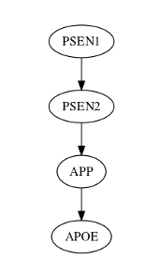
In this example, given no evidence, all the variables are dependent on each other. Each of the probabilities of High, Normal, and Low gene expression of lower nodes are dependent on the distribution of High, Normal, and Low gene expression of the node directly above it. The state of PSEN1 expression influences the states of PSEN2, APP, and APOE. However, if evidence is provided on the state of PSEN2, the states of APP and APOE are now independent of PSEN1.
In Figure 1 PSEN1 expression influences the expression of PSEN2, APP, and APOE when there is no evidence of any of the variables’ states. If the expression of PSEN2 was known, then PSEN1 expression would not influence APP or APOE expression. APP would still influence APOE expression given knowledge of PSEN2 expression, but APP and APOE expression would be independent of PSEN1 expression.
Diverging connections show how one node influences or affects two or more of the other nodes. Given evidence on the affected nodes or no evidence on the node where the diversion occurs, the children nodes influence and are connected to each other. However, given information on the node where the diversion occurs, the children of those nodes are independent of each other. This relationship is useful in distinguishing the difference between the causes of one node's state from other nodes that are also a result of a shared cause.
Figure 2: Example of a Diverging Connection
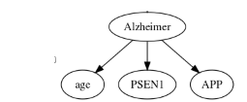
In this example, given no evidence, all the variables are dependent on each other. Each of states of Age, PSEN1, and APP are dependent on the state of the Alzheimer node. However, if evidence is provided on the state of Alzheimer, the states of Age, PSEN1, and APP are all independent of each other.
In Figure 2, if there is no information on the state of Alzheimer or there is information on age, PSEN1, or APP expression, information can be deduced for Alzheimer, age, APP, and PSEN1. However, if the state of Alzheimer is known, then the information on age, APP expression, and PSEN1 expression are independent of each other.
Converging connections demonstrate how several nodes cause or influence a common node. Without information on the common node, these nodes are independent from each other (Charniak, 1991).
Figure 3: Example of a Converging Connection
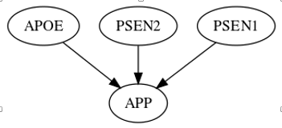
In this example, given no evidence, APOE, PSEN2, and PSEN1 are independent on each other. The probabilities of High, Normal, and Low gene expressions of APP are dependent on the different combinations of High, Normal, and Low gene expression of APOE, PSEN2, and PSEN1. However, if evidence is provided on the state of APP, the states of APOE, PSEN2, and PSEN1 now influence each other.
In Figure 3, the expression levels of APOE, PSEN2, and PSEN1 are independent of each other if the expression level of APP is unknown. However, if the expression level of APP is known, then information can be deduced for the expression levels of APOE, PSEN1, and PSEN2.

Finding Bayesian Networks:
There are a variety of programs available to construct a BN from data. Here the software Bayesian Networks Inference with Java Objects (BaNJO) (Version 2.2; Hartemink, A., 2010) was used to propose a network that likely models the observations found in the data (Sladeczec, J., Hartemink, A., & Robinsion, J., 2005). This program uses various search algorithms to propose a BN structure based off the data provided. The proposed structure is then given a BDe score which is a reflection of the likelihood of observing the data provided given the proposed structure. The BDe score is calculated by {?} and penalizes overly complicated graphs.
BaNJO searches other BN structures by adding or removing parent nodes or reversing parent/ child relationships. The BDe score is used to compare proposed structures. In this study, Simulated Annealing search strategy was used. Using the Simulated Annealing algorithm, BaNJO accepts the proposed network with a higher BDe score but will sometimes accept a proposed network with a lower score given a specified probability (Sladeczec, J., Hartemink, A., & Robinsion, J., 2005).
When BaNJO has finished testing all possible structures or runs out of time allotted to find structures, it reports on the structure with the highest BDe score found. In this study, BaNJO was given 1 hour, 2 hours, 4 hours, and 8 hours to search for structures in 3 different computers. The settings file can be found in [File]. The resulting graph does not guarantee that the proposed final BN structure is the structure with the highest probability of observing the data. BaNJO can provide multiple structures with strong likelihoods, but it may not always provide a consistent structure because there are many structures with strong likelihoods. The direction of the arcs in output structures do not guarantee causal connections but do show influence between nodes (Version 2.2; Hartemink, A., 2010). Background knowledge on the structure and its parameters must be used to determine a causal model.

Bayesian Networks Analysis:
The Markov Blanket (MB) of a node consists of its parents, children, and other parents of its children. The MB provides a structure that demonstrates the variables that directly influence and are affected by the node of interest. The parent nodes provide information on what variables directly influence a node of interest. Nodes further away from the parents (grand- and great-grandparent nodes) still have influence on the node of interest, but to a lesser degree the further away they are from the node of interest. Children nodes show the variables that are directly dependent on the node of interest. In order to have a full understanding of how the children nodes are influenced, parents other than the node of interest (co-parents) must be included (Pellet and Elisseff, 2008).
The MB makes all other nodes in the structure conditionally independent from the node of interest (Fu and Desmarais, 2010; Pellet and Elisseff, 2008). The MB helps identify important variables and features in a structure by removing the variables that do not predict the cause and effects of the node of interest very well (Fu and Desmarais, 2010). In this study the first and second degree MB of the Alzheimer node was used to find significant genes.
Figure 4: Example of the 1° and 2° Markov Blanket for Alzheimer
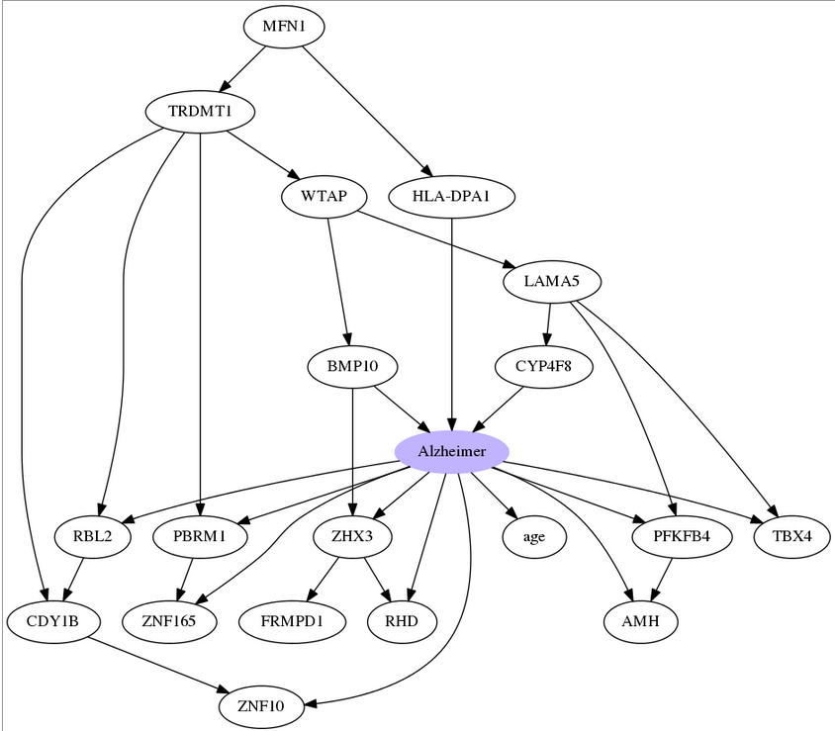
Influence scores were obtained from the BaNJO results files. Influence scores in BNs have been specifically developed to help determine the regulatory relationships among variables from gene expression data. They utilize the conditional probabilities that make up a BN into a number that describes the weight of the relationship between the node and its parent. Higher positive scores signify that the parent node of a gene is a strong activator of the gene. More negative scores denote that the parent node is a strong repressor of the gene. An influence score near zero indicates that it was difficult to determine whether the parent node of a gene acts as an activator or repressor (Yu et al., 2014).

Gene Ontology:
To better understand the functions and relationships between the genes identified as significant to AD through the MB, the list of MB genes were analyzed by Gene Ontology (GO).

