Methods

Dataset Collection:
Alzheimer's disease (AD) gene expression data were obtained from the National Center for Biotechnology Information (NCBI) Gene Expression Omnibus (GEO) database. GEO was created by NCBI as a database open to the public for high throughput gene expression and hybridization experiments for a variety of diseases. The database includes platforms, samples, and series. Platforms list probes and the corresponding molecules they detect. They are indicated with a "GPL" prefix followed by a unique GEO accession number. Samples are a collection of molecules that have been probed by a specific platform. Each sample has a unique GEO accession number preceded by "GSM". Series are datasets of samples used in an experiment. Each series is indicated by "GSE" and a unique GEO accession number (Edgar et al., 2002).
A GEO search was conducted using the keyword "Alzheimer". Inclusion and exclusion criteria are listed in Table 1. Studies with human post-mortem subjects that contained information indicating AD status, age, biological sex, and brain region of the tissue sample were included. Studies that did not have a publication were excluded. Samples that were non-human, cell lines, stem cells, or did not indicate AD status were excluded. Platforms that did not match a probe to a gene name were also excluded. GSE files were downloaded in the series matrix format. GPL files were downloaded as a full table or, when available, an annotated SOFT table.
Table1: Series Selection
Inclusion Criteria | Exclusion criteria
Human Samples | Cell Lines
Alzheimer's Disease Status Specified | Induced Pluriopotent Stem Cells (iPSC)
Brain Samples | <7000 Gene Names Matched
Age Specified | Blood
Sex Specified | Lack of Gene Names in GPL file
Microarray Study | Non-Alzheimer Disease Samples
Published study | Samples from the same subject and brain region
 | Samples with Missing Gene Expression Data
Unconfirmed Alzheimer Status (Possible/ Probable AD)
Deep Sequencing Studies

Data Cleanup:
The GSE files selected were cleaned using an R codes developed by Efrain Gonzalez. This code matched all the gene names with the probe IDs on the GSE files using the GPL file and found the genes common in all the GSM files provided. The gene expression data on each GSE file were normalized using z-scores as previously calculated. The z-score for the gene expression value for each sample in the dataset was determined using the equation below.
Z-score equation:
$$Z-score= \frac{Average gene expresion level-Sample gene expression level }{Standard Deviation gene expression level}$$
The code also extracted clinical/demographic information from the GSE file.
The clinical/ demographic data were then cleaned on LibreOffice Calc or Microsoft Excel. AD status was dichotemized as 1 (AD) or 0 (Non-AD). Brain regions from the datasets were categorized as either 1 (Hippocampus) or 2 (Non-Hippocampus). Ages were categorized as 1 (Age>65) or 0 (Age ≤65). Sex was categorized as Female (1) or Male (1).
The z-scores were used to calculate the correlation values between the genes and the clinical variables AD, Age, Brain Region, and Sex.

Analysis:
The dataset was analyzed using Bayesian Networks (BNs). In this study, different states of the random variables represent the different categories of gene expression, AD status, Brain Region, Age, or Sex.
The relationships between the nodes are represented by arcs, and the probabilities that further describe these relationships are assigned to these nodes based off the joint distributions of the nodes' parents. The connections of these nodes allow us to deduce relationships between nodes that are not directly connected to each other. There are three basic connections between these nodes:
Serial connections show the chain of variables that lead to a certain state. If the states of all modeled variables are unknown, all these modeled variables influence each other. However, when the state of a middle node is known, the nodes above and below that node are now independent of each other.
Figure 1: Example of a Serial Connection
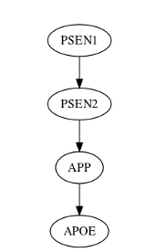
In this example, given no evidence, all the variables are dependent on each other. Each of the probabilities of High, Normal, and Low gene expression of lower nodes are dependent on the distribution of High, Normal, and Low gene expression of the node directly above it. The state of PSEN1 expression influences the states of PSEN2, APP, and APOE. However, if evidence is provided on the state of PSEN2, the states of APP and APOE are now independent of PSEN1.
In Figure 1 PSEN1 expression influences the expression of PSEN2, APP, and APOE when there is no evidence of any of the variables’ states. If the expression of PSEN2 was known, then PSEN1 expression would not influence APP or APOE expression. APP would still influence APOE expression given knowledge of PSEN2 expression, but APP and APOE expression would be independent of PSEN1 expression.
Diverging connections show how one node influences or affects two or more of the other nodes. Given evidence on the affected nodes or no evidence on the node where the diversion occurs, the children nodes influence and are connected to each other. However, given information on the node where the diversion occurs, the children of those nodes are independent of each other. This relationship is useful in distinguishing the difference between the causes of one node's state from other nodes that are also a result of a shared cause.
Figure 2: Example of a Diverging Connection
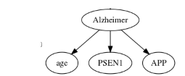 In this example, given no evidence, all the variables are dependent on each other. Each of states of Age, PSEN1, and APP are dependent on the state of the Alzheimer node. However, if evidence is provided on the state of Alzheimer, the states of Age, PSEN1, and APP are all independent of each other.

In Figure 2, information can be deduced for Alzheimer, age, APP, and PSEN1 if there is no information on the state of Alzheimer or there is information on age, PSEN1, or APP expression. If the state of Alzheimer is known, then the information on age, APP expression, and PSEN1 expression are independent of each other.
Figure 3: Example of a Converging Connection
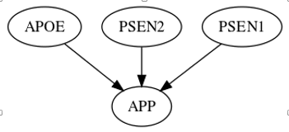 In this example, given no evidence, APOE, PSEN2, and PSEN1 are independent on each other. The probabilities of High, Normal, and Low gene expressions of APP are dependent on the different combinations of High, Normal, and Low gene expression of APOE, PSEN2, and PSEN1. However, if evidence is provided on the state of APP, the states of APOE, PSEN2, and PSEN1 now influence each other.

Converging connections demonstrate how several nodes cause or influence a common node. Without information on the common node, these nodes are independent from each other (Charniak, 1991).
In Figure 3, the expression levels of APOE, PSEN2, and PSEN1 are independent of each other if the expression level of APP is unknown. However, if the expression level of APP is known, then information can be deduced for the expression levels of APOE, PSEN1, and PSEN2.
The Markov Blanket (MB) of a node consists of its parents, children, and other parents of its children. The MB provides a structure that demonstrates the variables that directly influence and are affected by the node of interest. The parent nodes provide information on what variables directly influence a node of interest. Nodes further away from the parents (grand- and great-grandparent nodes) still have influence on the node of interest, but to a lesser degree the further away they are from the node of interest. Children nodes show the variables that are directly dependent on the node of interest. In order to have a full understanding of how the children nodes are influenced, parents other than the node of interest (co-parents) must be included (Pellet and Elisseff, 2008).
MB degree example
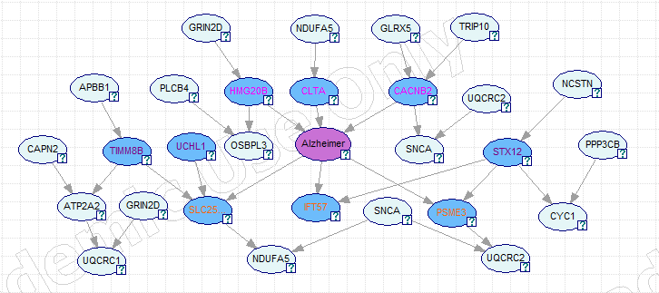
In this example, Alzheimer is the node of interest. The 1st degree MB consists of the parent nodes of Alzheimer (pink text), children nodes of Alzheimer (orange text), and other parents of Alzheimer children nodes (purple text). All the 1st degree MB genes for Alzheimer are colored in blue.
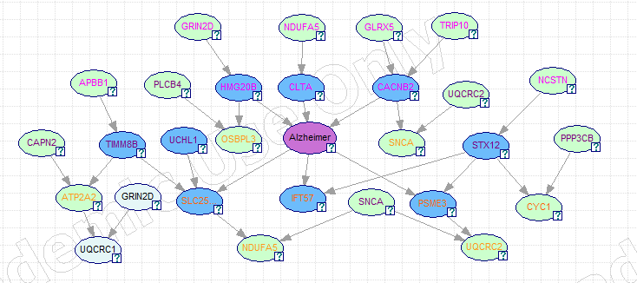
Here the 2nd degree MB genes for Alzheimer are colored in light green. The 2nd degree MB genes for Alzheimer consist of the parents, children, and other parents of the children for the 1st degree MB genes of Alzheimer.
The MB makes all other nodes in the structure conditionally independent from the node of interest (Fu and Desmarais, 2010; Pellet and Elisseff, 2008). The MB helps identify important variables and features in a structure by removing the variables that do not predict the cause and effects of the node of interest very well (Fu and Desmarais, 2010).
In this study the first and second degree MBs of the Alzheimer node were used to find significant potentially causal AD genes.
Figure 4: Example of the 1° and 2° Markov Blanket for Alzheimer
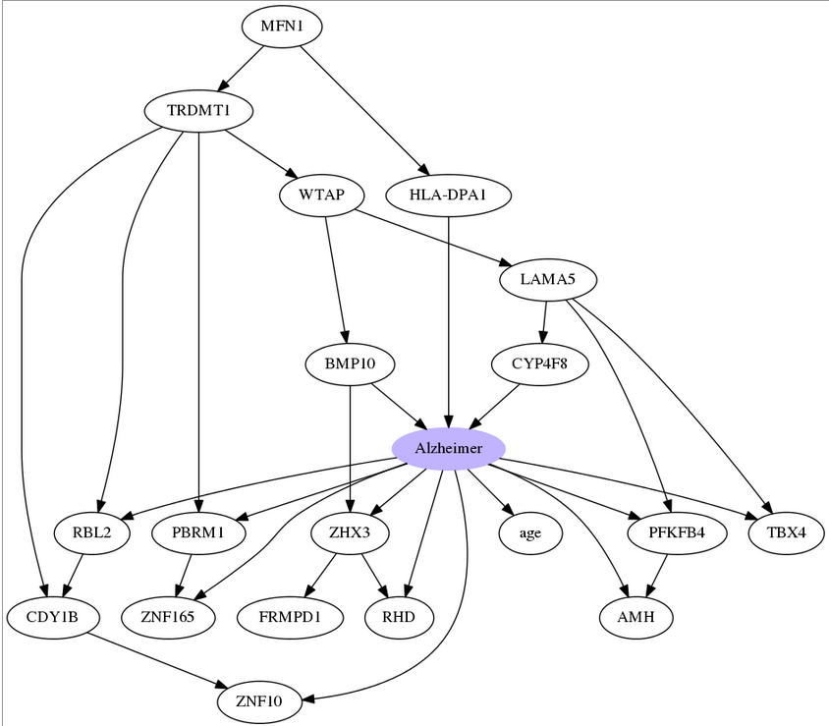
In this example, the 1⁰ MB for Alzheimer consists of BMP10, CYP4F8, TRDMT1, LAMA5, RBL2, PBRM1, ZHX3, age, PFKB4, TBX4, AMH, RHD, and ZNF165. The 2⁰ MB for Alzheimer consists of MFN1, WTAP, CDY1B, FRMPD1, and all the nodes included in the 1⁰ MB.

Tools for finding Bayesian Networks:
There are a variety of programs available to construct a BNs. In this study, three different BN software were used: Bene, Bayesian Networks Inference with Java Objects (BaNJO) (Version 2.2; Hartemink, A., 2010), and GeNIe (Version 2.0; Detection Systems Laboratory, 2014).
Bene is software that searches for the BN structure that provides the highest likelihood of the observed data using BDe scoring (Cooper and Herskovits, 1992). The BDe score is calculated by {?} and penalizes overly complicated graphs. Bene provides an order of how the variables relate to each other, which can be useful in finding out the causal relationships between variables (Silander and Myllymaki, 2012). This structure is usually a fully connected network since the input data rarely demonstrates true independent variables. This fully connected graph tends to over fit the data (Koller and Friedman, 2009).
Efrain codes are in the works to score orders of variables.
BaNJO uses various search algorithms to propose a BN structure from the data provided. The proposed structure is then given a BDe score. BaNJO searches other BN structures by adding or removing parent nodes or reversing parent and child node relationships. The BDe score is used to compare proposed structures. In this study, Simulated Annealing search strategy was used. Using the Simulated Annealing algorithm, BaNJO accepts the proposed network with a higher BDe score but will sometimes accept a proposed network with a lower score given a specified probability (Sladeczec, J., Hartemink, A., & Robinsion, J., 2005).
When BaNJO has finished testing all possible structures or runs out of time allotted to find structures, it reports on the structure with the highest BDe score found. The resulting graph does not guarantee that the proposed final BN structure is the structure with the highest probability of observing the data. BaNJO can provide multiple structures with strong likelihoods, but it may not always provide a consistent structure because there are many structures with strong likelihoods. The direction of the arcs in output structures do not guarantee causal connections but do show influence between nodes (Hartemink, A., 2010). Background knowledge on the structure and its parameters must be used to determine a causal model. BaNJO allows users to incorporate background knowledge by specifying relationships to start its search and/or specifying relationships it must include or exclude in its final structure.
BaNJO results also include influence scores which have been specifically developed to help determine the regulatory relationships among variables from gene expression data. They utilize the conditional probabilities that make up a BN into a number that describes the weight of the relationship between the node and its parent. Higher positive scores signify that the parent node of a gene is a strong activator of the gene. More negative scores denote that the parent node is a strong repressor of the gene. An influence score near zero indicates that it was difficult to determine whether the parent node of a gene acts as an activator or repressor (Yu et al., 2004). Influence scores are
GeNIe allows manipulation and validation of BN structures. Its user-friendly interface allowed easy access of variable distributions, ROC curves, and accuracy tests for prediction Alzheimer’s given the datasets and the structures determined by Bene and BaNJO.

Goal 1: Finding relationships between APOE, APP, PSEN1, and PSEN2
Bene was used to find the order of APOE, APP, PSEN1, and PSEN2. The resulting structure was scored using BaNJO. The order was scored using Efrain's code MyOrder.cpp.
BaNJO was used to score a Confounding Structure (CS) which was less complicated than the structure obtained from Bene. Age, Sex, and Brain Region were treated as confounding variables instead of being incorporated in the order of APOE, APP, PSEN1, and PSEN2. The other relationships among APOE, APP, PSEN1, PSEN2, and Alzheimer obtained from the Bene structure were maintained.
The accuracies of the CS and the Bene Structure in predicting Alzheimer were analyzed using ROC curves from GeNIe.
The likelihood of the CS was compared to the GMLS to determine whether the GMLS was statistically significantly better than the simpler, CS.
Equation measuring significance:
$$Minimum value= e^{\frac{CS BDe score-GMLS BDe score}{2}}$$
$$Maximum value= e^{\frac{CS BDe score-GMLS BDe score}{4}}$$
Efrain developed a code titled MyOrder.cpp to find a BDe score of a given order of these genes.
The relationships between these genes and clinical variables were also analyzed by finding the best scoring converging structures in sets of 4 variables comprised of 2 genes (APOE, APP, PSEN1, or PSEN2) and 2 clinical variables (AD, Age, Sex, or Brain Region). BDe scores were determined using BaNJo.
The files containing the data and settings files for each of these 4 sets of variables may be found in Path-3>Desktop>Link to Tools>banjo.2.2.0>data>release2.0>Summer>input>Y Structures.
The following were structures analyzed for each set of 4 variables:

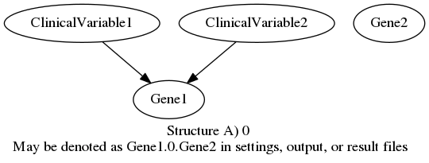
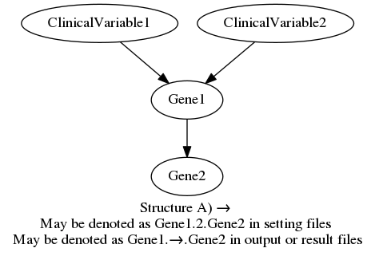
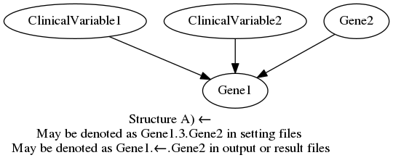
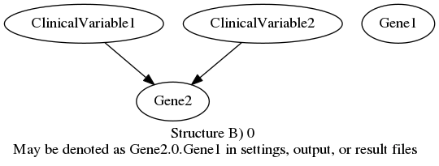
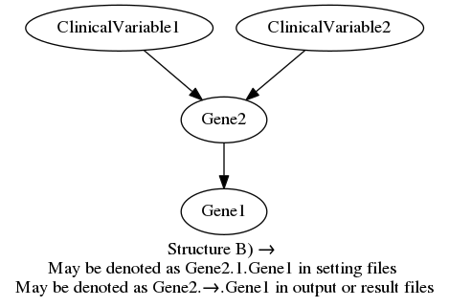
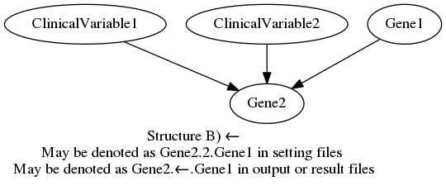
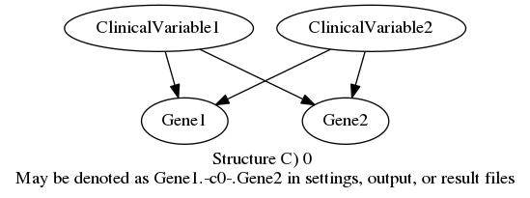
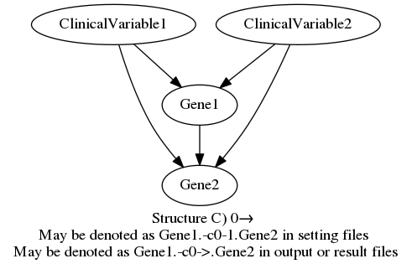
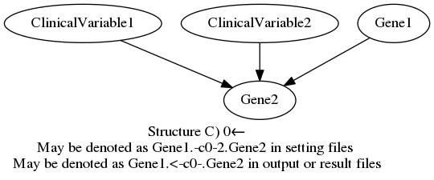
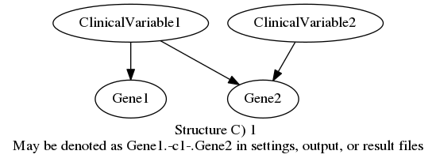
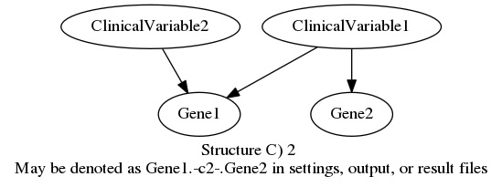
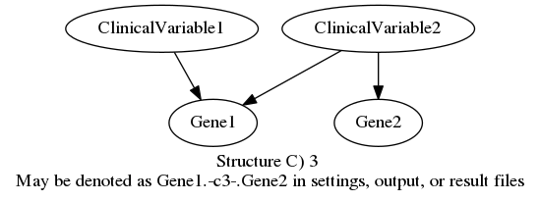
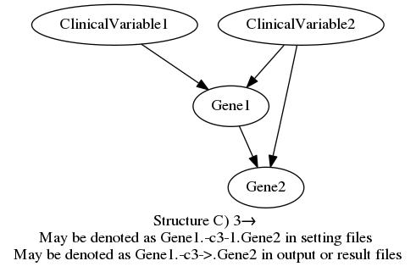
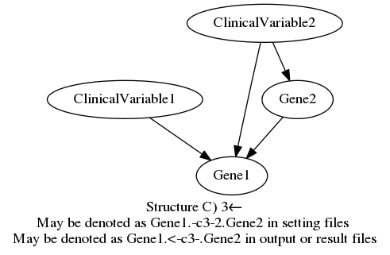
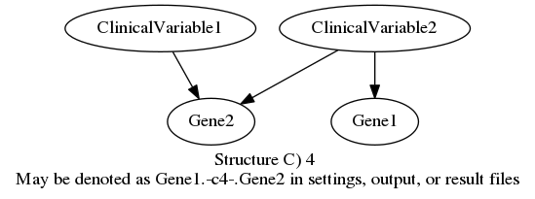
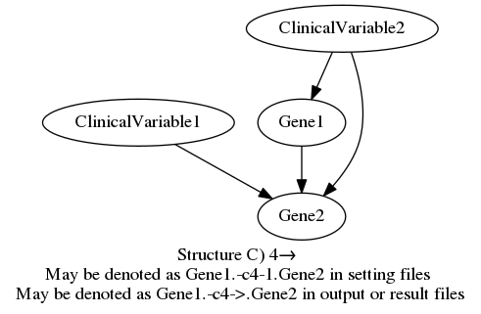
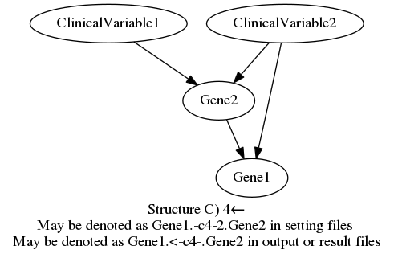
The different structures were compared according to each set of 4 variables by normalizing the BDe scores. The best scoring structures (≥95% of the total score) of each set were then compared to find relationship patterns between the variables using the Log Likelihood script log_norm.pl (Path-3>Desktop>Alzheimer>Tools>Log Likelihood>log_norm).

Goal 2: Finding the order of identified AD genes
Other Alzheimer risk factor genes and their relationships were identified using the Alzheimer’s disease Kyoto Encyclopedia of Genes and Genomes (KEGG) Pathway which demonstrates the current knowledge on molecular interaction, reaction, and relation networks within AD. The Alzheimer’s KEGG Pathway map was converted into a BN using GeNIe to determine an order of these AD risk factor genes to be used as background knowledge. This converted structure may be viewed in the file KEGGorder.xdsl (Path-3>Desktop>Alzheimer>Search Summaries).
BaNJO searched for a high-scoring Bayesian Network using the data obtained from GEO. Tests ran up to 48 hours in three different computers. The input files for BaNJO may be found in Path-2>Alzheimer>banjo.2.2.0>data>release2.0>Summer>input>All Genes, Path-3>Desktop>Link to Tools>banjo.2.2.0>data>release2.0>Summer>input>All Genes, Path-4>Alzheimer>banjo.2.2.0>data>release2.0>Summer>input, and Path-5>Alzheimer>Tools>banjo.2.2.0>data>release2.0>Summer>input>All Genes.
A second BaNJO search that maintained the KEGG order of AD risk factor genes as background knowledge was also conducted up to 48 hours. These input and settings files were the same as the files used to run the tests without background knowledge, but KEGG_order.txt was specified as the "mustNotBePresentEdgesFile."
The score of the best scoring structure from this analysis was compared to the best scoring structure that did not include background knowledge.
The order of the identified AD genes were compared between the top scoring networks derived with and without the KEGG AD Pathway background knowledge using MB degrees. Lower MB degree numbers indicate closer relationship of the variable to the variable of interest. For example, with AD as the variable of interest, a gene with a MB degree of 7 is more closely related to AD than another gene with a MB degree of 10. The MB degrees of these genes were found using Efrain’s R code Find_Markov.txt and compared between the structures with and without background knowledge (Path-3>Desktop>Alzheimer>Tools>Efrain_R_code>MB).
The paths between the new potential AD genes and KEGG genes using the best scoring structures derived with and without background knowledge were used to find relationships between these genes. These relationships were found using Efrain's R code Find_MarkovPath.txt (Path-3>Desktop>Alzheimer>Tools>Efrian_R_code>MB).
Goal 3: Finding new potentially causal Alzheimer's Disease genes
The 1st and 2nd degree MBs of highest scoring Bayesian Networks with and without background knowledge were used to identify new genes potentially important in Alzheimer's Disease pathology. These genes represent potential genes that are important for AD pathology and were found using Efrain's code.
Once the 1st and 2nd degree MBs genes were identified for both highest scoring Bayesian Networks with and without background knowledge, the clinical variables were treated as confounding variables for Alzheimer's and were forced to have direct parent arcs to the Alzheimer node. GeNIe was used to find the ROC AUC for these structures and analyze relationships.

Goal 4: Finding interactions between new potential AD genes identified and previously identified AD genes
BaNJO analyses of the clinical variables, the 1st and 2nd degree MBs and the KEGG genes within the 5th degree MB were conducted up to 36 hours to help find orders and relationships between the potentially causal AD genes identified and previously established AD genes.
There were 6 sets of genes analyzed:
(1): best scoring structure without background knowledge 1st and 2nd degree genes of Alzheimer
(2): best scoring structure with background knowledge 1st and 2nd degree genes of Alzheimer
(3): best scoring structure without background knowledge 1st and 2nd degree genes of Alzheimer and KEGG genes 4th degree MB with no background knowledge
(4): best scoring structure without background knowledge 1st and 2nd degree genes of Alzheimer and KEGG genes 4th and 5th degrees MB with no background knowledge
(5): best scoring structure with background knowledge 1st and 2nd degree genes of Alzheimer and KEGG genes 3rd & 4th degree MB with background knowledge
(6): best scoring structure with background knowledge 1st and 2nd degree genes of Alzheimer andKEGG genes 3rd, 4th and 5th degrees MB with background knowledge
GeNIe was used to find the ROC AUCs for these structures.
References
Edgar, R., Domrachev, M., & Lash, A. E. (2002). Gene expression omnibus: NCBI gene expression and hybridization array data repository. Nucleic Acids Research, 30(1), 207-210.
Phelix, Clyde. [Clyde Phelix] (2013, June 10). Biostatistics NCBI GEO data collection Database creation. [Video File]. Retrieved from https://www.youtube.com/watch?v=6dNh2O_qFvQ.
Phelix, Clyde. [Clyde Phelix] (2013, June 10). Biostatistics database QUERY and analysis in Excel. [Video File]. Retrieved from https://www.youtube.com/watch?v=4kbFefje-xk.
Pellet, J. P., & Elisseeff, A. (2008). Using Markov Blankets for Causal Structure Learning. Journal of Machine Learning Research, 9, 1295-1342.
Fu, S., & Desmarais, M. C. (2010). Markov blanket based feature selection: a review of past decade. In Proceedings of the world congress on engineering (Vol. 1, pp. 321-328).
Hartemink, A. Banjo: Bayesian Network Inference with Java Objects [Computer software]. (2010). Retrieved from https://users.cs.duke.edu/~amink/software/banjo/.
GeNIe [Computer software]. (2014). Retrieved from https://www.bayesfusion.com/
Cooper, G. F., & Herskovits, E. (1992). A Bayesian method for the induction of probabilistic networks from data. Machine learning, 9(4), 309-347.
Silander, T., & Myllymaki, P. (2012). A simple approach for finding the globally optimal Bayesian network structure. arXiv preprint arXiv:1206.6875.
Koller, D., and Friedman, N. (2009). Probabilistic graphical models: principles and techniques. MIT press.
Huang DW, Sherman BT, Lempicki RA. Systematic and integrative analysis of large gene lists using DAVID Bioinformatics Resources. Nature Protoc. 2009;4(1):44-57. [PubMed]
Huang DW, Sherman BT, Lempicki RA. Bioinformatics enrichment tools: paths toward the comprehensive functional analysis of large gene lists. Nucleic Acids Res. 2009;37(1):1-13. [PubMed]
(Hartemink, A., 2010).
Yu, J., Smith, V. A., Wang, P. P., Hartemink, A. J., & Jarvis, E. D. (2004). Advances to Bayesian network inference for generating causal networks from observational biological data. Bioinformatics, 20(18), 3594-3603.
Charniak, E. (1991). Bayesian networks without tears. AI magazine, 12(4), 50.
Heckerman, D. (1998). A tutorial on learning with Bayesian networks (pp. 301-354). Springer Netherlands.

