Data Collection
There were 2549 results using the search term “Alzheimer” which comprised of 32 Datasets, 267 Series, 2240 Samples, and 10 Platforms in total. When limiting results to "Homo Sapiens", there were 2280 results that comprised of 13 Datasets, 141 Series, 2121 Samples, and 5 Platforms. The 141 Series were reviewed further for inclusion. Among the 141 series 8 were Super Series which are a collection of Sub Series that refer to the same study.

Figure 4: Dataset Search Results

15 studies met the criteria. Details on the GSE files selected and their corresponding GPL files are described in Table 2. Table 3 shows the number subjects samples available and included. In the file Selected Datasets.xlsx, the “Replicates” tab lists the GSM accession numbers of samples that come from the same subject and “Removed Samples” tab lists the GSM accession numbers of samples that were excluded. The “Brain Regions” tab shows the number of samples in each brain region for individual series.
Table 2: Series Included
Series | Microarray Platform(s) | Title | Type | Country | Publication Date | Notes | linked publications
GSE84422 | GPL96, GPL97, GPL570 | Molecular Signatures Underlying Selective Regional Vulnerability to Alzheimer's Disease | Expression profiling by array | USA | 8/19/2016 | GPL97 excluded because of repeated subjects from GPL96 | Wang M, Roussos P, McKenzie A, Zhou X et al. Integrative network analysis of nineteen brain regions identifies molecular signatures and networks underlying selective regional vulnerability to Alzheimer's disease. Genome Med 2016 Nov 1;8(1):104. PMID: 27799057
GSE44772 | GPL4372 | Multi-tissue gene expression profiles of human brain | Expression profiling by array | USA | 4/25/2013 |  | Zhang B, Gaiteri C, Bodea LG, Wang Z et al. Integrated systems approach identifies genetic nodes and networks in late-onset Alzheimer's disease. Cell 2013 Apr 25;153(3):707-20. PMID: 23622250
GSE15222 | GPL2700 | Genetic control of human brain transcript expression in Alzheimer’s disease. | Expression profiling by array | USA | 4/10/2009 |  | Webster JA, Gibbs JR, Clarke J, Ray M et al. Genetic control of human brain transcript expression in Alzheimer disease. Am J Hum Genet 2009 Apr;84(4):445-58. PMID: 19361613
GSE48350 | GPL570 | Alzheimer's Disease Dataset | Expression profiling by array | USA | 4/21/2014 |  | Berchtold NC, Cribbs DH, Coleman PD, Rogers J et al. Gene expression changes in the course of normal brain aging are sexually dimorphic. Proc Natl Acad Sci U S A 2008 Oct 7;105(40):15605-10. PMID: 18832152, Berchtold NC, Coleman PD, Cribbs DH, Rogers J et al. Synaptic genes are extensively downregulated across multiple brain regions in normal human aging and Alzheimer's disease. Neurobiol Aging 2013 Jun;34(6):1653-61. PMID: 23273601, Cribbs DH, Berchtold NC, Perreau V, Coleman PD et al. Extensive innate immune gene activation accompanies brain aging, increasing vulnerability to cognitive decline and neurodegeneration: a microarray study. J Neuroinflammation 2012 Jul 23;9:179. PMID: 22824372, Astarita G, Jung KM, Berchtold NC, Nguyen VQ et al. Deficient liver biosynthesis of docosahexaenoic acid correlates with cognitive impairment in Alzheimer's disease. PLoS One 2010 Sep 8;5(9):e12538. PMID: 20838618, Blair LJ, Nordhues BA, Hill SE, Scaglione KM et al. Accelerated neurodegeneration through chaperone-mediated oligomerization of tau. J Clin Invest 2013 Oct;123(10):4158-69. PMID: 23999428, Sárvári M, Hrabovszky E, Kalló I, Solymosi N et al. Menopause leads to elevated expression of macrophage-associated genes in the aging frontal cortex: rat and human studies identify strikingly similar changes. J Neuroinflammation 2012 Dec 3;9:264. PMID: 23206327
GSE26927 | GPL6255 | Common neuroinflammatory pathways in neurodegenerative diseases. | Expression profiling by array | UK | 1/29/2011 | 7 AD control & 11 AD disease; other diseases excluded: ALS, HD, MS, PD, and Schizophrenia control & disease samples | Durrenberger PF, Fernando FS, Magliozzi R, Kashefi SN et al. Selection of novel reference genes for use in the human central nervous system: a BrainNet Europe Study. Acta Neuropathol 2012 Dec;124(6):893-903. PMID: 22864814; Durrenberger PF, Fernando FS, Kashefi SN, Bonnert TP et al. Common mechanisms in neurodegeneration and neuroinflammation: a BrainNet Europe gene expression microarray study. J Neural Transm (Vienna) 2015 Jul;122(7):1055-68. PMID: 25119539
GSE36980 | GPL6244 | Expression data from post mortem Alzheimer's disease brains | Expression profiling by array | Japan | 4/17/2013 |  | Hokama M, Oka S, Leon J, Ninomiya T et al. Altered expression of diabetes-related genes in Alzheimer's disease brains: the Hisayama study. Cereb Cortex 2014 Sep;24(9):2476-88. PMID: 23595620
GSE29378 | GPL6947 | Genes and Pathways Underlying Regional and Cell Type Changes in Alzheimer's Disease | Expression profiling by array | USA | 6/7/2013 |  | Miller JA, Woltjer RL, Goodenbour JM, Horvath S et al. Genes and pathways underlying regional and cell type changes in Alzheimer's disease. Genome Med 2013;5(5):48. PMID: 23705665
GSE1297 | GPL96 | Incipient Alzheimer's Disease: Microarray Correlation Analyses | Expression profiling by array | USA | 7/16/2004 |  | Blalock EM, Geddes JW, Chen KC, Porter NM et al. Incipient Alzheimer's disease: microarray correlation analyses reveal major transcriptional and tumor suppressor responses. Proc Natl Acad Sci U S A 2004 Feb 17;101(7):2173-8. PMID: 14769913
GSE28146 | GPL570 | Alzheimer's disease at various stages of severity | Expression profiling by array | USA | 8/1/2011 |  | Blalock EM, Buechel HM, Popovic J, Geddes JW et al. Microarray analyses of laser-captured hippocampus reveal distinct gray and white matter signatures associated with incipient Alzheimer's disease. J Chem Neuroanat 2011 Oct;42(2):118-26. PMID: 21756998
GSE37263 | GPL5175 | Genome-wide profiling of altered gene expression in the neocortex of Alzheimer's disease (gene level) | Expression profiling by array | Singapore | 4/13/2012 |  | Tan MG, Chua WT, Esiri MM, Smith AD et al. Genome wide profiling of altered gene expression in the neocortex of Alzheimer's disease. J Neurosci Res 2010 May 1;88(6):1157-69. PMID: 19937809
GSE23290 | GPL5175 | Microarray expression analysis in idiopathic and LRRK2-associated Parkinson's disease | Expression profiling by array | Spain | 11/10/2011 |  | Botta-Orfila T, Tolosa E, Gelpi E, Sànchez-Pla A et al. Microarray expression analysis in idiopathic and LRRK2-associated Parkinson's disease. Neurobiol Dis 2012 Jan;45(1):462-8. PMID: 21946334
GSE34516 | GPL5175 | Brain transcriptomic profiling in idiopathic and LRRK2-associated Parkinson's disease | Expression profiling by array | Spain | 6/1/2012 | Has some AD pathology, different brain region, same samples as GSE23290 | Botta-Orfila T, Sànchez-Pla A, Fernández M, Carmona F et al. Brain transcriptomic profiling in idiopathic and LRRK2-associated Parkinson's disease. Brain Res 2012 Jul 23;1466:152-7. PMID: 22634372
GSE16759 | GPL570; GPL8757 | mRNA and miRNA expression in parietal lobe cortex in Alzheimer's disease | Expression profiling by array; Non-coding RNA profiling by array | USA | 1/31/2010 | GPL8757 excluded because of lack of gene names | Nunez-Iglesias J, Liu CC, Morgan TE, Finch CE et al. Joint genome-wide profiling of miRNA and mRNA expression in Alzheimer's disease cortex reveals altered miRNA regulation. PLoS One 2010 Feb 1;5(2):e8898. PMID: 20126538
GSE5281 | GPL570 | Alzheimer's disease and the normal aged brain (steph-affy-human-433773) | Expression profiling by SAGE | USA | 7/10/2006 |  | Liang WS, Dunckley T, Beach TG, Grover A et al. Gene expression profiles in anatomically and functionally distinct regions of the normal aged human brain. Physiol Genomics 2007 Feb 12;28(3):311-22. PMID: 17077275; Liang WS, Reiman EM, Valla J, Dunckley T et al. Alzheimer's disease is associated with reduced expression of energy metabolism genes in posterior cingulate neurons. Proc Natl Acad Sci U S A 2008 Mar 18;105(11):4441-6. PMID: 18332434
GSE39420 | GPL11532 | Gene expression profile of sporadic and PSEN1 early-onset Alzheimer's Disease | Expression profiling by array | Spain | 1/20/2015 |  | Antonell A, Lladó A, Altirriba J, Botta-Orfila T et al. A preliminary study of the whole-genome expression profile of sporadic and monogenic early-onset Alzheimer's disease. Neurobiol Aging 2013 Jul;34(7):1772-8. PMID: 23369545
Table 3: Number of Subjects
Series | Microarray Platform | Total Samples | Samples Included | AD Samples | Non-AD Samples | Females | Males | Unique Subjects | AD Subjects | Non-AD Subjects | Reason samples excluded
GSE1297 | GPL96 | 31 | 31 | 22 | 9 | 18 | 13 | 31 | 22 | 9
GSE15222 | GPL2700 | 363 | 361 | 175 | 186 | 171 | 190 | 361 | 176 | 187 | 2 had missing ages
GSE16759 | GPL570 | 16 | 8 | 4 | 4 | 6 | 2 | 8 | 4 | 4
GSE23290 | GPL5175 | 14 | 9 | 4 | 5 | 6 | 3 | 9 | 4 | 5 | Others had PD
GSE26927 | GPL6255 | 118 | 18 | 11 | 7 | 9 | 9 | 17 | 10 | 7 | Others are non AD cases
GSE28146 | GPL570 | 30 | 30 | 22 | 8 | 18 | 12 | 30 | 22 | 8
GSE29378 | GPL6947 | 63 | 63 | 31 | 32 | 25 | 38 | 33 | 17 | 16
GSE34516 | GPL5175 | 10 | 8 | 4 | 4 | 5 | 3 | 8 | 4 | 4 | Others had PD
GSE36980 | GPL6244 | 79 | 79 | 32 | 47 | 42 | 37 | 39 | 16 | 23
GSE37263 | GPL5175 | 16 | 16 | 8 | 8 | 6 | 10 | 16 | 8 | 8
GSE39420 | GPL11532 | 21 | 21 | 14 | 7 | 5 | 2 | 21 | 14 | 7
GSE44772 | GPL4372 | 690 | 592 | 321 | 271 | 210 | 382 | 230 | 129 | 101 | 98 samples had missing data
GSE48350 | GPL570 | 253 | 253 | 80 | 173 | 129 | 124 | 85 | 28 | 57
GSE5281 | GPL570 | 161 | 161 | 87 | 74 | 58 | 97 | 36 | 23 | 13
GSE84422 | GPL570 | 102 | 62 | 34 | 28 | 46 | 16 | 39 | 20 | 29 | Possible & Probable AD cases removed
GSE84422 | GPL96 | 951 | 542 | 328 | 214 | 338 | 204 | 64 | 42 | 22 | Possible & Probable AD cases removed
 | Totals | 2918 | 2254 | 1177 | 1077 | 1092 | 1142 | 1027 | 497 | 478

Data Clean-Up
Within the 15 different studies, there were 2918 total samples. 2254 samples derived from 1021 different subjects met the inclusion criteria. The 15 datasets had 8092 genes in common. Table 4 shows the number of probes available in the series matrix file, number of probes that were not matched to a gene name, number of different genes, portion of dataset matched, and portion of genes included for analysis in this study.
- Original files: GSE & GPL
- Match probe name to Gene ID: aftexcel (Path-3>Desktop>Alzheimer>Tools>Efrain_R_code>2>aftexcel)
- Determining Z-score: zscore.txt (Path-3>Desktop>Alzheimer>Tools>Efrain_R_code>2>Z-score)
- Discretizing gene expression values: dscrt.txt (Path-3>Desktop>Alzheimer>Tools>Efrain_R_code>2>Discretized)
- Finding common genes: matched.txt (Path-3>Desktop>Alzheimer>Tools>Efrain_R_code>2>Matching>8092 genes>Z-scores)
- Discretizing clinical variables: matchedD.xlsx (Path-3>Desktop>Alzheimer>Tools>Efrain_R_code>2>Matching>8092 genes>Z-scores)
- Combined all the samples into a single file: 8092Genesx2254Samples.xlsx (Path-3>Desktop>Alzheimer>Search Summaries>Summer2017).
Table 4: Gene Counts
Series | GPL | Total Results | Unmatched Probe IDs | Unique genes | Portion Matched | Portion analyzed
GSE39420 | GPL11532 | 33297 | 11131 | 19150 | 0.67 | 0.42
GSE15222 | GPL2700 | 24354 | 5260 | 16746 | 0.78 | 0.48
GSE447772 | GPL4372 | 39280 | 17862 | 17405 | 0.55 | 0.46
GSE23290 | GPL5175 | 22011 | 4377 | 12949 | 0.80 | 0.62
GSE34516 | GPL5175 | 17881 | 247 | 17079 | 0.99 | 0.47
GSE37263 | GPL5175 | 22011 | 4377 | 12949 | 0.80 | 0.62
GSE16579 | GPL570 | 54675 | 8841 | 22932 | 0.84 | 0.35
GSE28146 | GPL570 | 54675 | 8841 | 22932 | 0.84 | 0.35
GSE48350 | GPL570 | 32239 | 8841 | 23400 | 0.73 | 0.35
GSE5281 | GPL570 | 54675 | 8841 | 20747 | 0.84 | 0.39
GSE84422 | GPL570 | 54613 | 8841 | 22880 | 0.84 | 0.35
GSE36980 | GPL6244 | 33297 | 11102 | 20003 | 0.67 | 0.4
GSE26927 | GPL6255 | 20589 | 1533 | 17206 | 0.93 | 0.47
GSE29378 | GPL6947 | 48803 | 12646 | 25159 | 0.74 | 0.32
GSE1297 | GPL96 | 22283 | 1069 | 13159 | 0.95 | 0.61
GSE84422 | GPL96 | 22283 | 1069 | 12403 | 0.95 | 0.65

Samples Descriptions
The mean age of the samples was 78.1±14.5 years. Ages of the samples were categorized as age 65 and younger (Age≤65) and those older than 65 (Age>65). Distributions of the samples are shown in the tables below.
Table 5: Overview of samples
 | Dataset Totals (n=2254) | % of Dataset
Alzheimer's | 1173 | 52%
Control | 1073 | 48%
Age>65 | 1881 | 83%
Age≤65 | 373 | 17%
Female | 1092 | 48%
Male | 1162 | 52%
Hippocampus | 255 | 11%
Non-Hippocampus | 1999 | 89%
Table 6: Distributions for AD/ Non AD
Group | Alzheimer's (n=1173) | Control (n=1073)
Mean Age±SD | 83.3±9.1 | 72.5±17.0
Age>65 | 95% | 71%
Age≤65 | 5% | 29%
Female | 56% | 40%
Male | 44% | 60%
Hippocampus | 11% | 12%
Non-Hippocampus | 89% | 88%

Table 7: Distributions for Age
Group | Age>65 (n=1881) | Age≤65 (n=373)
Mean Age±SD | 83.0±8.6 | 53.1±12.0
Alzheimer's | 59% | 16%
Control | 41% | 84%
Female | 52% | 29%
Male | 48% | 71%
Hippocampus | 12% | 7%
Non-Hippocampus | 88% | 93%

Table 8: Distributions for Sex
Group | Females (n=1092) | Males (n=1162)
Mean Age±SD | 82.7±12.8 | 73.7±14.6
Age>65 | 90% | 77%
Age≤65 | 10% | 23%
Alzheimer's | 61% | 44%
Control | 39% | 56%
Hippocampus | 11% | 11%
Non-Hippocampus | 89% | 89%

Table 9: Distributions for Brain Region
Group | Hippocampus (n=255) | Non-Hippocampus (n=1999)
Mean Age±SD | 79.2±15.2 | 77.9±14.4
Age>65 | 89% | 83%
Age≤65 | 11% | 17%
Alzheimer's | 51% | 52%
Control | 49% | 48%
Female | 48% | 48%
Male | 52% | 52%

Distributions of Gene Expression Levels for APOE, APP, PSEN1, and PSEN2
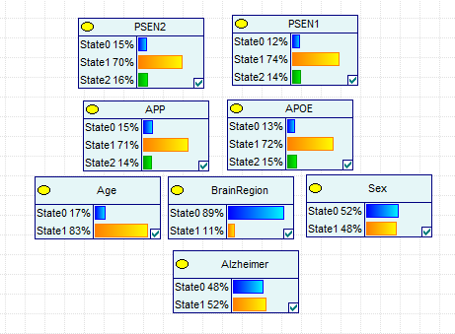

Gene Correlations
The correlations between AD and all genes included in this analysis are found in 8092Genesx2254SamplesCorrelations.xlsx (Path-3>Home>Desktop>Alzheimer>Search Summaries> Summer 2017).
The correlations between APOE, APP, PSEN1, and PSEN2 and AD, Age, Sex, and Brain Region were calculated on GeNIe. The correlation matrix is found below and was derived using z-scores of these genes and the discretized values of AD, Age, Sex, and Brain Region in the file 2254Sx4Gzscores.txt (Path-3>Home>Desktop>Alzheimer>Tools>Genie)
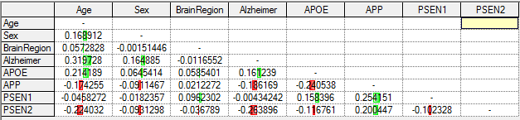

KEGG Alzheimer Pathway Genes
The KEGG Alzheimer's Disease Pathway was used as background knowledge. This pathway includes 171 genes. The dataset used contained 106 of these genes.
List of KEGG genes included & excluded in this analysis:
Total 171 genes
Included (106 genes) | Excluded (65 genes)
ADAM10  APAF1  APBB1  APOE  APP  ATF6  ATP2A1  ATP2A2  ATP2A3  BACE1  BACE2  BAD  BID  CACNA1C  CACNA1D  CACNA1F  CACNA1S  CALM1  CALML3  CALML4  CALML5  CAPN1  CAPN2  CASP3  CASP7  CASP8  CASP9  CDK5  CDK5R1  COX4I1  COX5A  COX5B  COX6A2  COX6B1  COX6C  COX7A1  COX7A2  COX7B  COX8A  CYC1  EIF2AK3  ERN1  FADD  GNAQ  GRIN1  GRIN2A  GRIN2B  GRIN2C  GRIN2D  GSK3B  IDE  IL1B  LPL  LRP1  MAPK1  MAPK3  MAPT  MME  NCSTN  NDUFA10  NDUFA13  NDUFA3  NDUFA5  NDUFA7  NDUFA8  NDUFA9  NDUFAB1  NDUFB1  NDUFB2  NDUFB3  NDUFB5  NDUFB6  NDUFB7  NDUFB8  NDUFC1  NDUFS1  NDUFS2  NDUFS3  NDUFS4  NDUFS6  NDUFS7  NDUFV1  NOS1  PLCB1  PLCB2  PLCB3  PLCB4  PPP3CA  PPP3CB  PPP3CC  PSEN1  PSEN2  RTN3  RTN4  RYR3  SDHA  SDHB  SDHC  SDHD  SNCA  TNF  TNFRSF1A  UQCRB  UQCRC1  UQCRC2  UQCRQ | ADAM17  APH1A  APH1B  ATP5A1  ATP5B  ATP5C1  ATP5D  ATP5E  ATP5F1  ATP5G1  ATP5G2  ATP5G3  ATP5H  ATP5J  ATP5O  ATP6  ATP8  CALM2  CALM3  CALML6  CASP12  COX1  COX2  COX3  COX4I2  COX6A1  COX6B2  COX7A2L  COX7B2  COX7C  COX8C  CYCS  CYTB  FAS  GAPDH  HSD17B10  ITPR1  ITPR2  ITPR3  NAE1  NDUFA1  NDUFA11  NDUFA12  NDUFA2  NDUFA4  NDUFA4L2  NDUFA6  NDUFB10  NDUFB11  NDUFB4  NDUFB9  NDUFC2  NDUFC2-KCTD14  NDUFS5  NDUFS8  NDUFV2  NDUFV3  PPP3R1  PPP3R2  PSENEN  UQCR10  UQCR11  UQCRFS1  UQCRH  UQCRHL

Goal 1) Finding Relationships between APOE, APP, PSEN1, and PSEN2
Bene was used in hopes of obtaining the order of APOE, APP, PSEN1, and PSEN2 with Alzheimer's and the confounding variables Age, Brain Region, and Sex. However, it was found that Bene consistently resulted in a fully connected graph of all these variables whose order was consistent with the order of variables listed in the data file. Though the orders were different, the BDe scores were equal, signifying that the structures were equivalent.
The following structure was created by Bene using the banjo.idt file (for data) and all.vd (for variable names) (Path-3>Desktop>Alzheimer>Tools>bene.git>Summer-Fall2017). The structure's BDe score was determined using BaNJO with the input files 4genes.txt (for data), settingsBene.txt, and BeneStructure.txt (Path-3>Desktop>Link to Tools/banjo.2.2.0>data>release2.0>Summer>input). The output files produced were Benestructure.graph.2017.09.19.09.32.46.png, Benestructure.graph.2017.09.19.09.32.46.txt, and Benestructure.static.report.2017.09.19.09.32.46.txt (Path-3>Desktop>Link to Tools/banjo.2.2.0>data>release2.0>Summer>output>4genes>Fully Connected).
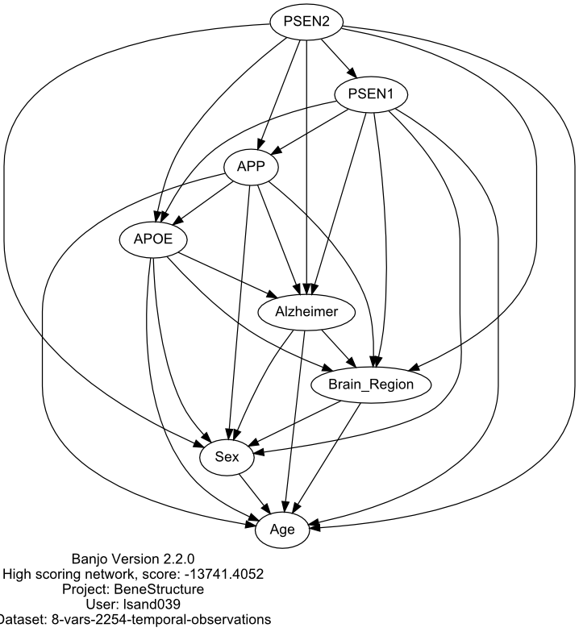
Efrain's ordering code MyOrder.cpp gave this order with a maximum of 7 parents a log likelihood score of –5458.1.
In this structure, the data file 4genes.txt listed the variables in the following order: Alzheimer, Age, Sex, Brain Region, PSEN2, PSEN1, APP, and APOE. This structure was scored using BaNJO with the files settingsBeneStructure.txt and BeneStructureTest.txt (Path-3>Desktop>Link to Tools/banjo.2.2.0>data>release2.0/Summer/input) and produced the files BeneStructureTest.static.report.2017.10.04.11.34.25.txt, BBeneStructureTest.graph.2017.10.04.11.34.25.txt, and BeneStructureTest.graph.2017.10.04.11.34.25.png (Path-3>Desktop>Link to Tools>banjo.2.2.0>data>release2.0>Summer>output>4genes>Fully Connected).
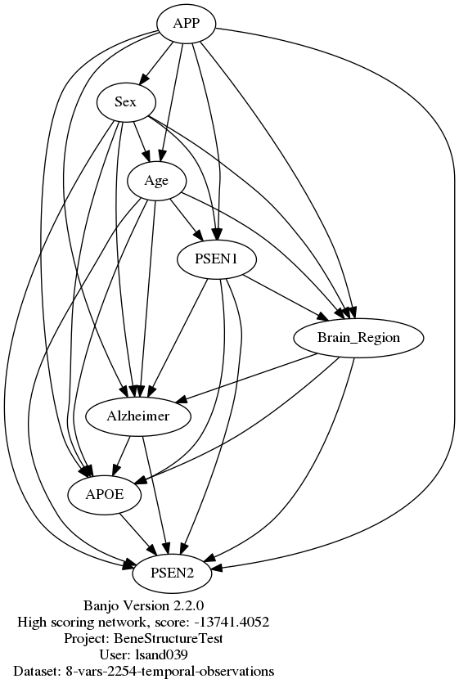
MyOrder.cpp gave this order with a maximum of 7 parents a log likelihood score of –11839.1.
The ROC for both these structures were 0.779903. GeNIe was used to find the ROC. The files containing these structures are Bene4genesx2254samplesP.xdsl and BeneTestStructure.xdsl respectively. The file 2254Sx4G.txt contained the data for these structures (Path-3>Desktop>Alzheimer>Tools>Genie).
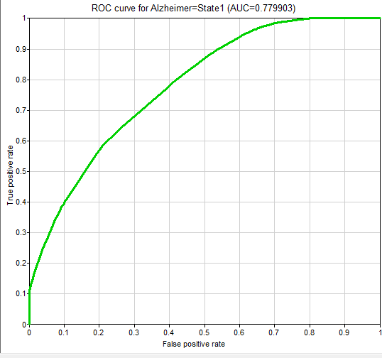
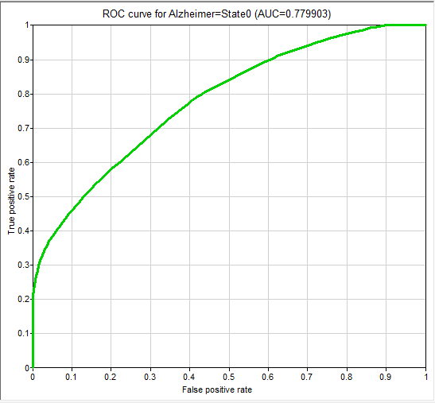
The confounding structure that treats Age, Brain Region, and Sex as confounding variables is shown below. This structure was created on BaNJO using the files settingsCS.txt, CS.txt, and CSmnh.txt (Path-3>Desktop>Link to Tools/banjo.2.2.0>data>release2.0/Summer/output/4genes/Fully Connected) The results files CS.static.report.2017.09.19.09.46.56.txt, CS.graph.2017.09.19.09.46.56, and CS.graph.2017.09.19.09.46.56 may be found in Path-3>Desktop>Link to Tools>banjo.2.2.0>data>release2.0>Summer>output>4genes>Fully Connected.
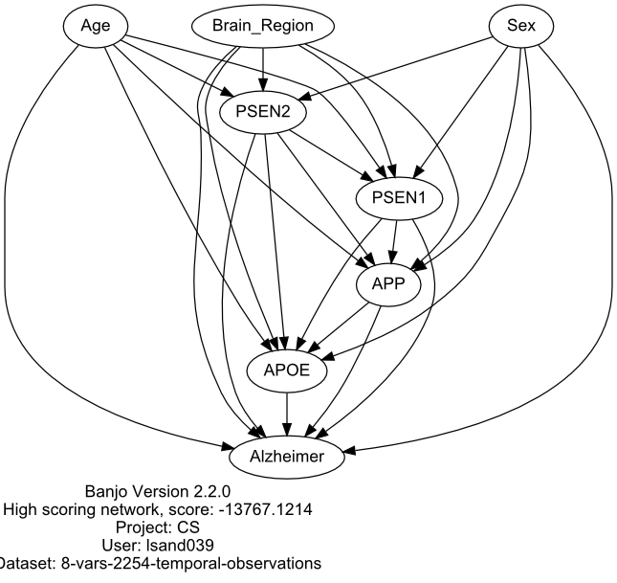
The ROC for this structure was the same as the structures derived from Bene. This structure was created on GeNIe in CS4genesx2254samplesP.xdsl and also used the datafile 2254Sx4G.txt (Path-3>Desktop>Alzheimer>Tools>Genie).
Structure Significance
Bene Structure Score | -13741.4052
Confounding Structure Score | -13767.1214
Min. Significance Value | 2.6049 x 10⁻⁶
Max Significance Value | 1.6140 x 10⁻³

The converging structures that consisted of 95% or more of the best score four each set of 4 variables are identified below. The score comparisons for each set of 4 variables may be found in Best Scores.xlsx under the Normalized Y Structure Scores tab (Path-3>Desktop>Alzheimer>Search Summaries). The images of the top scoring files may be found in Path-3>Desktop>Alzheimer>Search Summaries> Summer 2017>Y-Structure Files>Top Scoring Structures. The settings files used to score each of the structures for each set of 4 variables may be found in Path-3>Desktop>Alzheimer>Search Summaries> Summer 2017>Y-Structure Files.
Goal 2: Finding the order of identified AD genes

BaNJO results:
The individual scores for the structures found on each computer and each time interval may be found in Best Scores.xlsx under the 8092 Genes Score tab (Path-3>Desktop>Alzheimer>Search Summaries). The output files for each of the structures may be found in Path-2>Alzheimer>banjo.2.2.0>data>release2.0>Summer>output>Free Run, Path-3>Desktop>Link to Tools/banjo.2.2.0>data>release2.0>Summer>output>Free Run>All Genes, Path-4>home>lsand039>Alzheimer>banjo2.2.0>data>release2.0>Summer>output>Free Run, and Path-5>Alzheimer>Tools>banjo2.2.0>data>release2.0>Summer>output>All Gene for the structures that did not include the KEGG background knowledge. For the output files of the structures that used the KEGG background knowledge, the files were placed in Path-2>Alzheimer>banjo.2.2.0>data>release2.0>Summer>output>BK: KEGG order>All Genes, Path-3>Desktop>Link to Tools/banjo.2.2.0>data>release2.0>Summer>output>BK: KEGG order>All Genes, and Path-4>home>lsand039>Alzheimer>banjo2.2.0>data>release2.0>Summer>output>BK: KEGG order.
The top scoring structure without background knowledge was found in Path 4 after 48 Hours (T2). It accounted for 100% of the total score when compared to the other structures. The image for this file is Hour48-4KEGG.dot.svg (Path-3>Desktop>Alzheimer>Search Summaries). The Alzheimer node is colored yellow, 1st degree MB genes are colored pink, the 2nd degree MB genes are colored orange, and the KEGG genes are colored teal.
The original image and results files for this structure are Hour48.static.report.2017.07.07.14.21.57.txt, Hour48.graph.2017.07.07.14.21.57.svg, and Hour48.graph.2017.07.07.14.21.57.txt (Path-4>home>lsand039>Alzheimer>banjo2.2.0>data>release2.0>Summer>output>Free Run).
The top scoring structure with background knowledge using the KEGG order was found in Path 2 after 48 Hours. It accounted for 100% of the total score when compared to the other structures. The output files for this structure are Hour48.graph.2017.07.28.17.35.42.svg, Hour48.graph.2017.07.28.17.35.42.txt, and Hour48.static.report.2017.07.28.17.35.42 (Path-2>Alzheimer>banjo.2.2.0>data>release2.0>Summer>output>BK: KEGG order>All Genes).
The MB degrees measure how closely identified AD genes are related to AD. The MB degrees for the KEGG genes included are listed in Gene Notes.xlsx under the 8092 Genes tab (Path-3>Desktop>Alzheimer>Search Summaries) for the top scoring networks derived with and without the KEGG Pathway background knowledge.
The structure without background knowledge placed KEGG AD genes between the 4th and 11th degree MB of AD. The structure without background knowledge placed KEGG AD genes between the 3rd and 13th degree MB of AD.
Same MB degree | MB degree closer to AD  (No Background Knowledge) | MB degree closer to AD  (Background Knowledge)
ADAM10  APP  ATF6  BACE2  BAD  COX6B1  COX6C  COX7A2  GRIN2C  GSK3B  NDUFA8  NDUFS1  NDUFS2  NDUFS3  PLCB2  RTN4  SDHD  UQCRB  UQCRC1 | APOE  ATP2A1  BACE1  CACNA1D  CACNA1F  CACNA1S  CALML3  CALML4  CALML5  CASP3  CASP8  CASP9  COX4I1  COX5A  COX5B  COX6A2  COX7A1  COX7B  EIF2AK3  ERN1  GNAQ  GNAQ  GRIN1  GRIN2A  LRP1  MAPK1  MAPT  NDUFA10  NDUFA13  NDUFA3  NDUFA7  NDUFA9  NDUFB2  NDUFB3  NDUFB5  NDUFB6  NDUFB7  NDUFB8  NDUFC1  NDUFS4  NDUFS6  NDUFS7  NDUFV1  PLCB1  PLCB3  PPP3CA  PPP3CC  PSEN1  PSEN2  RTN3  SDHA  SDHB  TNF  TNFRSF1A  UQCRQ | APAF1  APBB1  ATP2A2  ATP2A3  BID  CACNA1C  CALM1  CAPN2  CASP7  CDK5  CDK5R1  COX8A  CYC1  GRIN2B  GRIN2D  IDE  LPL  MAPK3  NCSTN  NDUFA5  NDUFAB1  NDUFB1  NOS1  PLCB4  PPP3CB  RYR3  SNCA  UQCRC2
There were 19 genes had the same MB degree in both structures. The structure without background knowledge found 55 genes with an earlier MB degree (more closely related to AD, lower MB number) than the structure with background knowledge. The structure with background knowledge only found 28 genes with an earlier MB degree than the structure without background knowledge.
Both structures with and without background knowledge had two genes not connected to their structure. MME and SDHC were not connected to the structure derived without background knowledge. FADD and IL1B were not connected to the structure derived with background knowledge. The MB degree for CAPN1 could not be found using Efrain's code, but manually it was found to have a MB degree of 14.
The paths from each KEGG gene to AD are found in the file KEGG-MBpaths.dot (Path-3>Desktop>Alzheimer>Search Summaries>Summer 2017) for the highest scoring structure derived without background knowledge and the file … for the structure derived with background knowledge.
Goal 3: Finding new potentially causal Alzheimer's Disease genes
Below is a table listing the 1⁰ and 2⁰ MB genes derived from the structures created without the KEGG order background knowledge.
Top Scoring Structure | No Background Knowledge | Background Knowledge
1⁰ MB Genes | GLRX5  TRIP10 | MCL1  YWHAZ
2⁰ MB Genes | CACNB2  CLTA  FGF14  HMG20B  IFT57  MAPK6  OSBPL3  PCSK1  PSME3  SLC25A1  STX12  TIMM8B  UCHL1 | BMP7  CYP4F12  DHRS3  DVL2  GRIA1  LRRN3  MYO1F  NFKB2  SMU1  SRRM2  WSB2

1⁰ MB genes derived without background knowledge:
This is the structure with the 1⁰ MB genes derived without background knowledge:
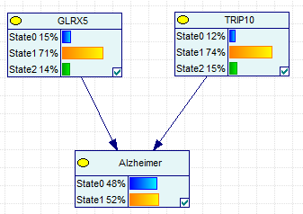
This structure may be found in the file MB1noBK.xdsl using the datafile MB1noBK.txt (Path-3>Desktop>Alzheimer>Tools>Genie) The ROC AUC was 0.670898:
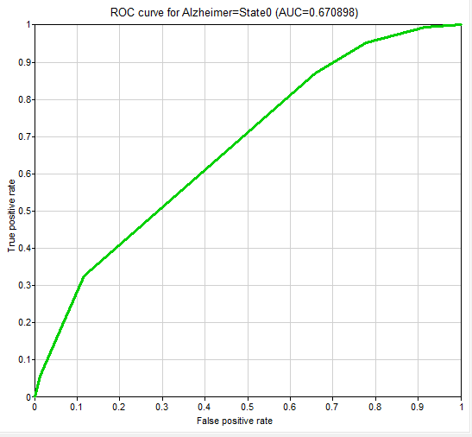
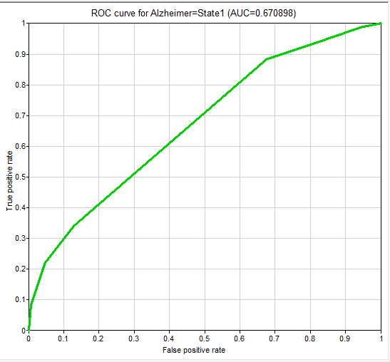
Here the clinical variables Age, Sex, and Brain Region were included in the structure as confounding variables for Alzheimer's:
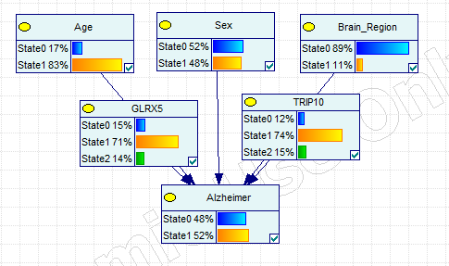
This structure may be found in the file MB1noBK-CS.xdsl using the datafile MB1NoBK-CS.txt (Path-3>Desktop>Alzheimer>Tools>Genie). The ROC AUC was 0.74142, slightly higher than the structure without clinical variables:
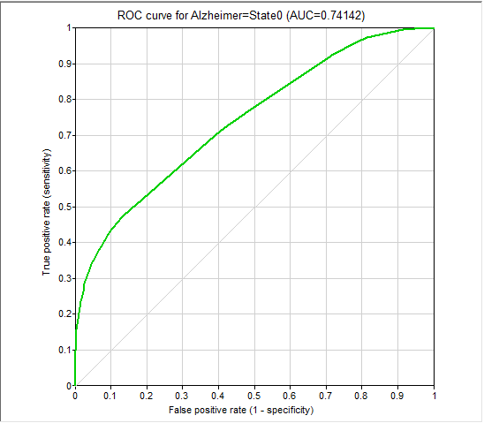
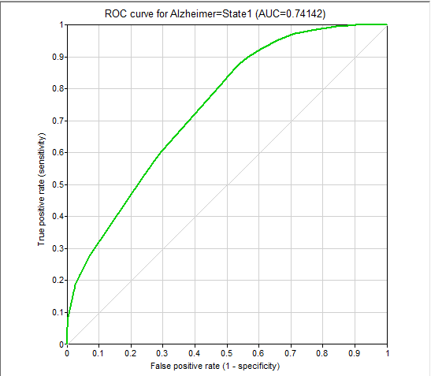

2⁰ MB genes derived without background knowledge:
This is the structure with the 2⁰ MB genes derived without background knowledge:
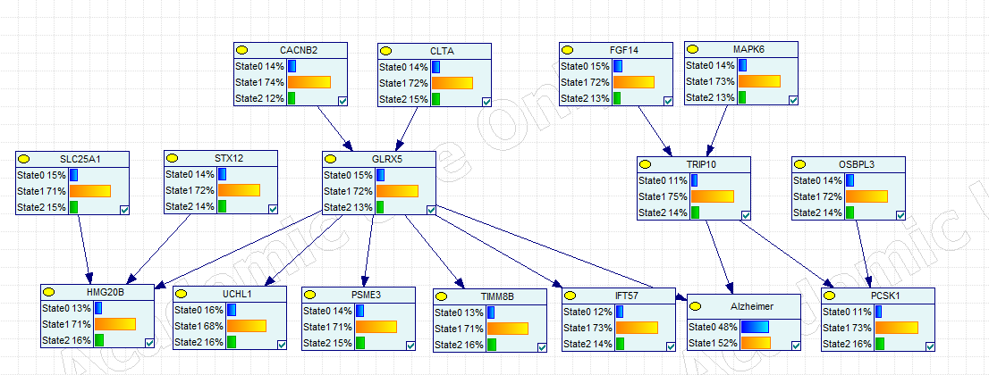
This structure may be found in the file MB2noBK.xdsl using the datafile MBn2oBK.txt (Path-3>Desktop>Alzheimer>Tools>Genie) The ROC AUC was 0.670898:
This is the 2⁰ MB genes derived without background knowledge where the clinical variables Age, Sex, and Brain Region were treated as confounders for Alzheimer's Disease: 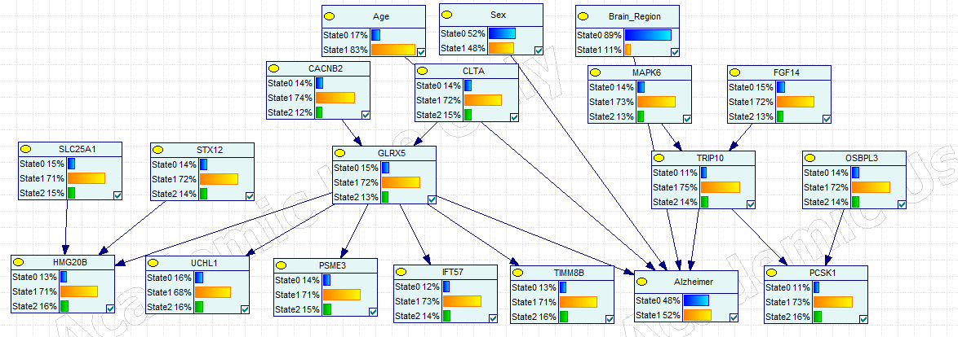
The file for this structure may be found in MB2noBK-CS.xdsl and used the datafile (1)MB1&2NoBK.txt (Path-3>Desktop>Alzheimer>Tools>Genie). The ROC AUC for this structure was 0.741724.
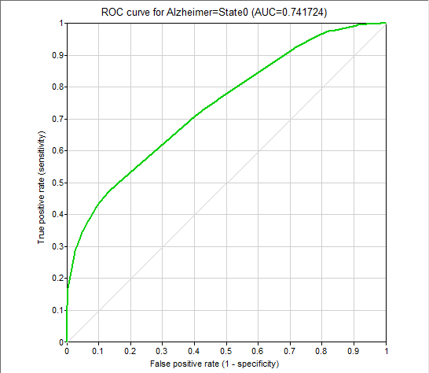
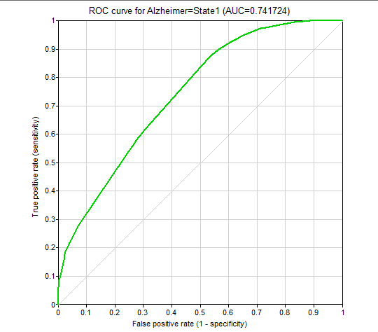

1⁰ MB genes derived with background knowledge:

This is the structure with the 1⁰ MB genes derived without background knowledge:
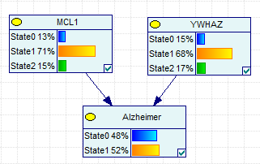
This structure may be found in the file MB1BKKEGG.xdsl using the datafile MB1BKKEGG.txt. (Path-3>Desktop>Alzheimer>Tools>Genie). The ROC AUC was 0.655937:
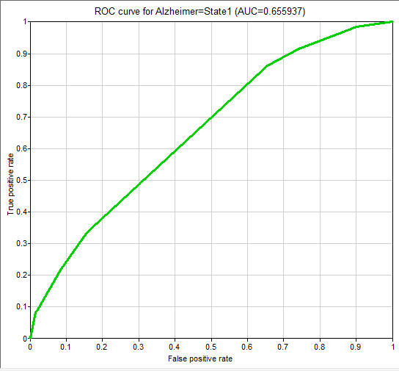
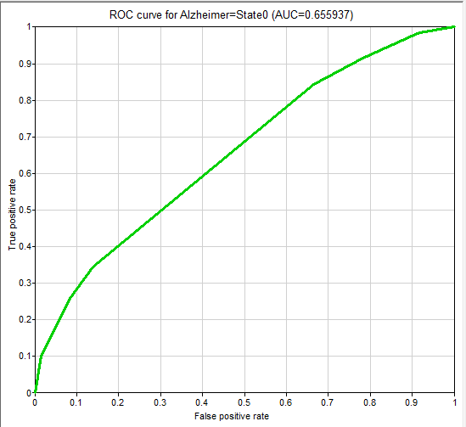
Here the clinical variables Age, Sex, and Brain Region were included in the structure as confounding variables for Alzheimer's:
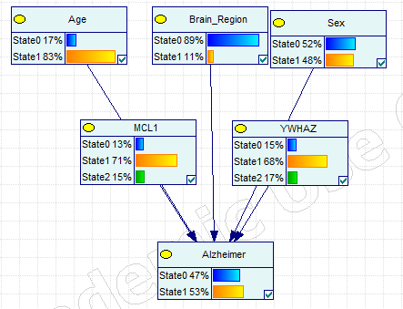
This structure may be found in the file MB1BKKEGG-CS.xdsl using the datafile MB1BKKEGG-CS.txt (Path-3>Desktop>Alzheimer>Tools>Genie). The ROC AUC was 0.726928, slightly higher than the structure without clinical variables:
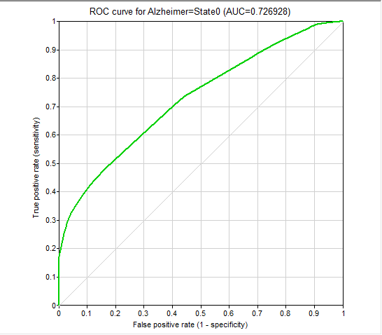
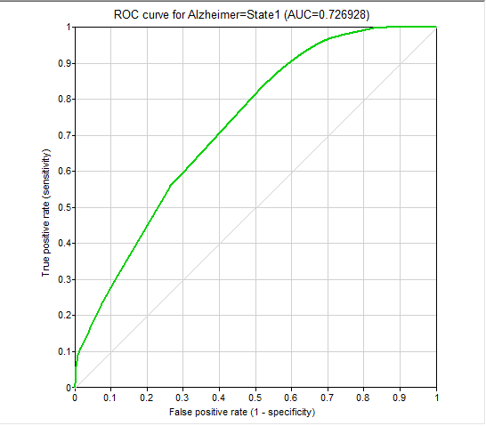

2⁰ MB genes derived with background knowledge:
This is the structure with the 2⁰ MB genes derived with background knowledge: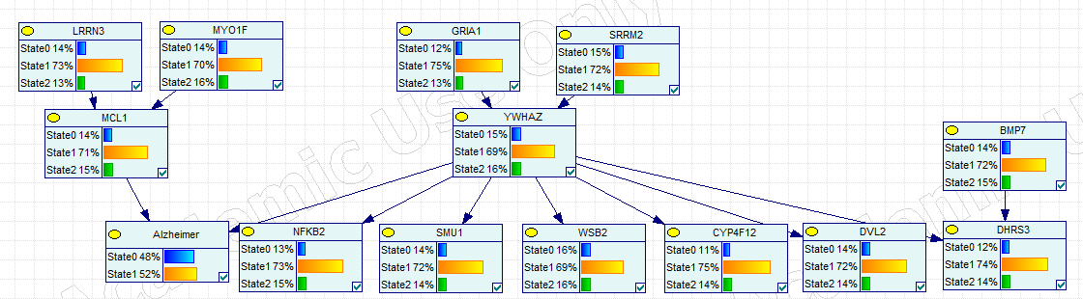
This structure may be found in the file MB2BKKEGG.xdsl using the datafile MB2BKKEGG.txt (Path-3>Desktop>Alzheimer>Tools>Genie). The ROC AUC was 0.655937:
Below is the BN that contains the 1⁰ and 2⁰ MB derived from the structure created with KEGG order background knowledge.
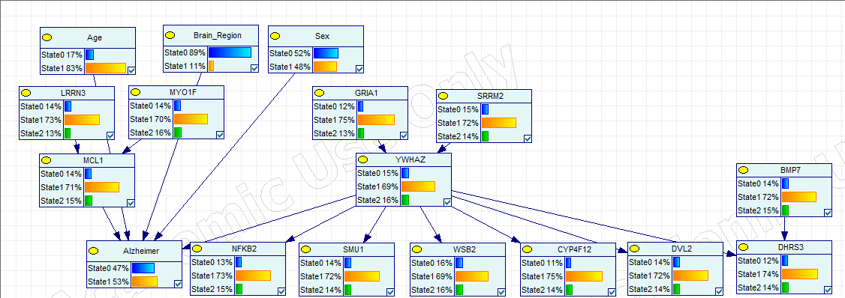
This structure may be found in the file MB2BKKEGG-CS.xdsl using the datafile (2)MB1&2BKKEGG.txt (Path-3>Desktop>Alzheimer>Tools>Genie). The ROC AUC was 0.726928, slightly higher than the structure without clinical variables:

Goal 4: Finding interactions between new potential Alzheimer's Disease genes identified and previously identified AD genes
No Background Knowledge
This is the highest scoring structure from the BaNJO run that only included the 1st and 2nd degree MB genes with the clinical variables:
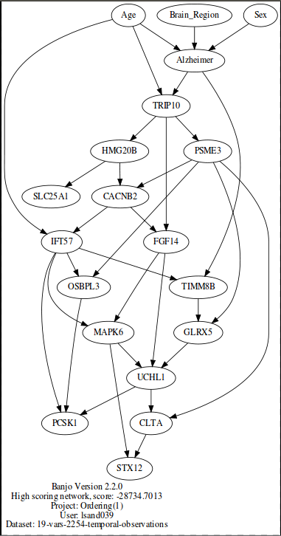
This structure was consistent in paths 2, 3, and 5 in BaNJO searches that ran up to one hour. The input files for these structures can be found in the folder (1): best scoring structure without background knowledge 1st and 2nd degree genes of Alzheimer under Path-2>Alzheimer>banjo.2.2.0>data>release2.0>Summer>input>BK: KEGG order, Path-3>Desktop>Link to Tools/banjo.2.2.0>data>release2.0>Summer>input, and Path-5>Alzheimer>banjo.2.2.0>data>release2.0>Summer>input>BK: KEGG order. Other output files can be found at Path-2>Alzheimer>banjo.2.2.0>data>release2.0>Summer>output>BK: KEGG order, Path-3>Desktop>Link to Tools/banjo.2.2.0>data>release2.0>Summer>output, and Path-5>Alzheimer>banjo.2.2.0>data>release2.0>Summer>output>BK: KEGG order.
This structure was recreated on GeNIe to find the ROC. The files used to create this were (1)MB1&2NoBK.xdsl and (1)MB1&2NoBK.txt (Path-3>Desktop>Alzheimer>Tools>Genie). The ROC AUC was 0.731618:
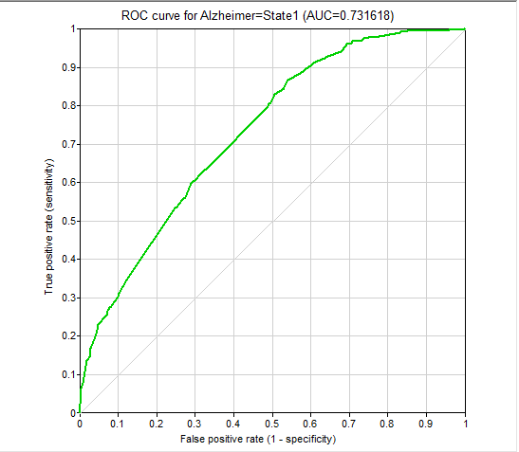
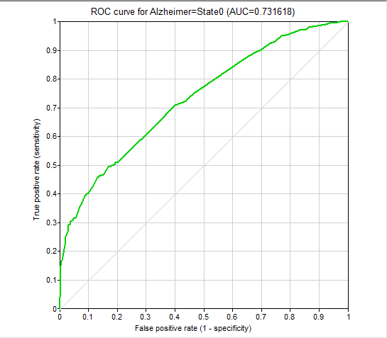
This is the highest scoring structure from the BaNJO run that included the clinical variables, 1st and 2nd degree MB, and the KEGG genes included in the 4th MB:
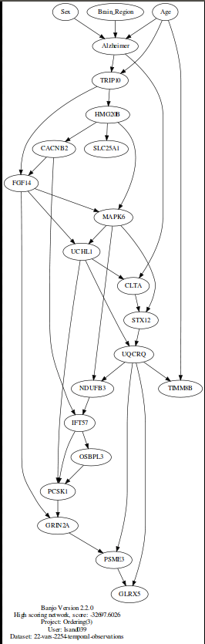
This structure was consistent in paths 2,3, and 5 in BaNJO searches that ran up to one hour. The input files for this structure can be found in the folder (3): best scoring structure without background knowledge 1st and 2nd degree genes of Alzheimer and KEGG genes 4th degree MB with no background knowledge under Path-2>Alzheimer>banjo.2.2.0>data>release2.0>Summer>input>BK: KEGG order, Path-3>Desktop>Link to Tools/banjo.2.2.0>data>release2.0>Summer>input, and Path-5>Alzheimer>banjo.2.2.0>data>release2.0>Summer>input>BK: KEGG order. Other output files can be found at Path-2>Alzheimer>banjo.2.2.0>data>release2.0>Summer>output>BK: KEGG order, Path-3>Desktop>Link to Tools/banjo.2.2.0>data>release2.0>Summer>output, and Path-5>Alzheimer>banjo.2.2.0>data>release2.0>Summer>output>BK: KEGG order.
This structure was recreated on GeNIe to find the ROC. The files used to create this were (3)MB1_2_4NoBK.txt and (3)MB1_2_4NoBK.xdsl (Path-3>Desktop>Alzheimer>Tools>Genie). The ROC AUC was 0.73061:
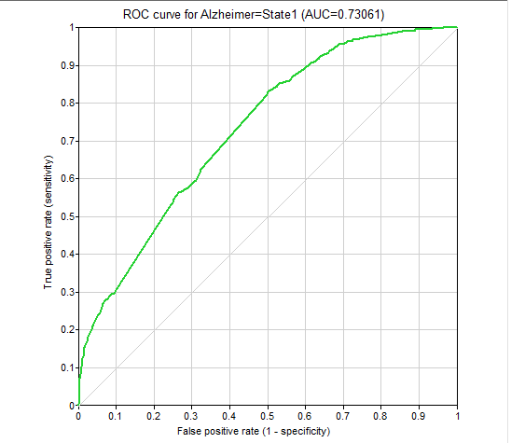
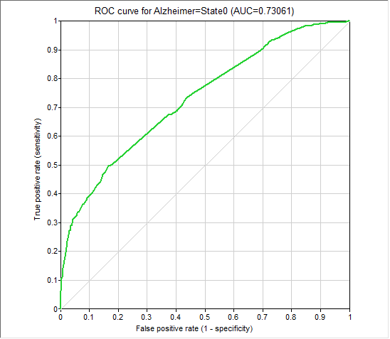
This is the highest scoring structure from the BaNJO run that included the clinical variables, 1st and 2nd degree MB, and the KEGG genes included in the 4th & 5th MB:
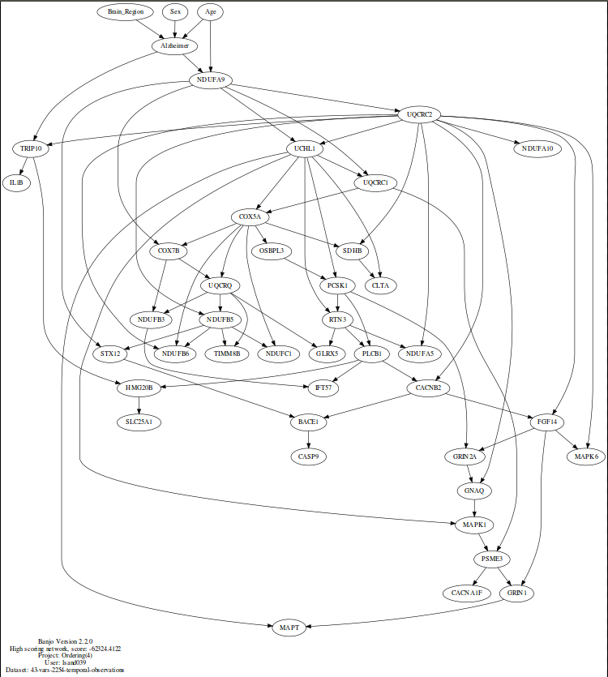
Though this structure was not consistent in paths 2,3, and 5 in BaNJO searches, it consisted of 100% of the total log score. The input files for these structures can be found under the folder (4): best scoring structure without background knowledge 1st and 2nd degree genes of Alzheimer and KEGG genes 4th and 5th degrees MB with no background knowledge in Path-2>Alzheimer>banjo.2.2.0>data>release2.0>Summer>input>BK: KEGG order, Path-3>Desktop>Link to Tools/banjo.2.2.0>data>release2.0>Summer>input, and Path-5>Alzheimer>banjo.2.2.0>data>release2.0>Summer>input>BK: KEGG order. Other output files can be found at Path-2>Alzheimer>banjo.2.2.0>data>release2.0>Summer>output>BK: KEGG order, Path-3>Desktop>Link to Tools/banjo.2.2.0>data>release2.0>Summer>output, and Path-5>Alzheimer>banjo.2.2.0>data>release2.0>Summer>output>BK: KEGG order.

This structure was recreated on GeNIe to find the ROC. The files used to create this were (4)MB1_2_4NoBK.txt and (4)MB1_2_4NoBK.xdsl (Path-3>Desktop>Alzheimer>Tools>Genie). The ROC AUC was 0.741332:
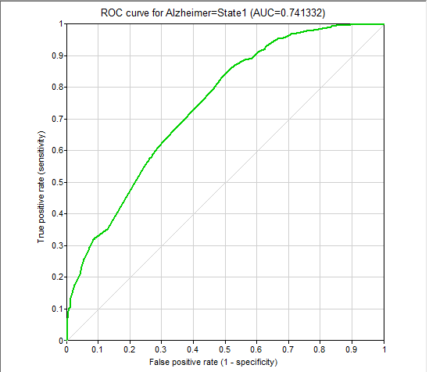
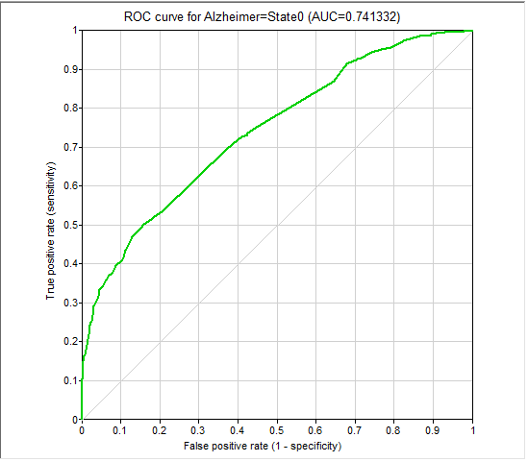
Background Knowledge:
This is the highest scoring structure from the BaNJO run that only included the 1st and 2nd degree MB genes with the clinical variables:
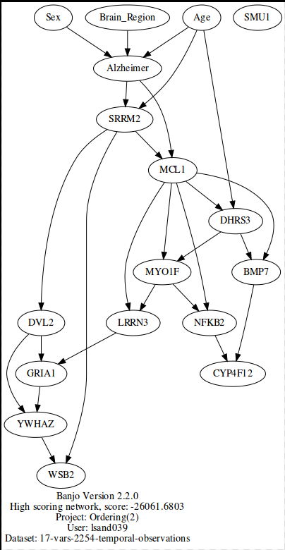
This structure was consistent in paths 2,3, and 5 in BaNJO searches that ran up to one hour. The input files for these structures can be found in the folders named (2): best scoring structure with background knowledge 1st and 2nd degree genes of Alzheimer in Path-2>Alzheimer>banjo.2.2.0>data>release2.0>Summer>input>BK: KEGG order, Path-3>Desktop>Link to Tools/banjo.2.2.0>data>release2.0>Summer>input, and Path-5>Alzheimer>banjo.2.2.0>data>release2.0>Summer>input>BK: KEGG order. Other output files can be found at Path-2>Alzheimer>banjo.2.2.0>data>release2.0>Summer>output>BK: KEGG order, Path-3>Desktop>Link to Tools/banjo.2.2.0>data>release2.0>Summer>output, and Path-5>Alzheimer>banjo.2.2.0>data>release2.0>Summer>output>BK: KEGG order.
This structure was recreated on GeNIe to find the ROC. The files used to create this were (2)MB1&2BKKEGG.xdsl and (2)MB1&2BKKEGG.txt. The ROC AUC was 0.717182:
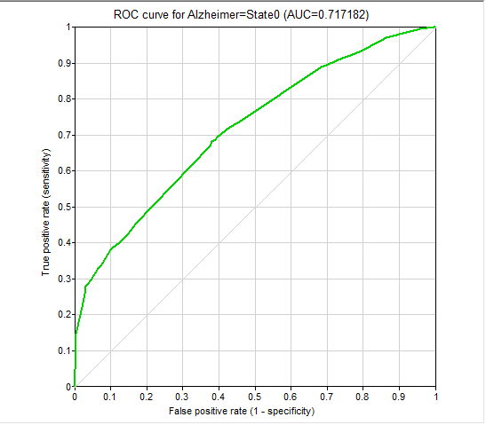
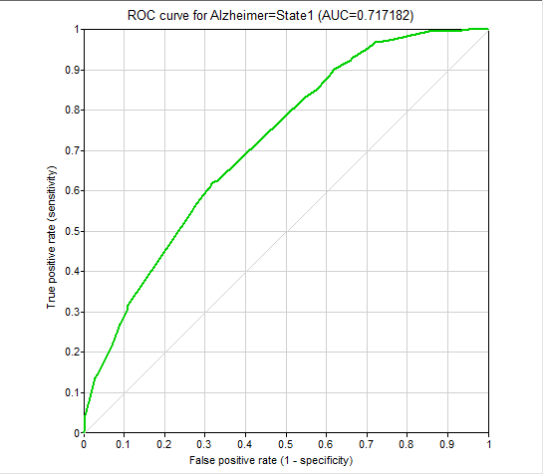
This is the highest scoring structure from the BaNJO run that included the clinical variables, 1st and 2nd degree MB, and the KEGG genes included in the 3rd & 4th MB:
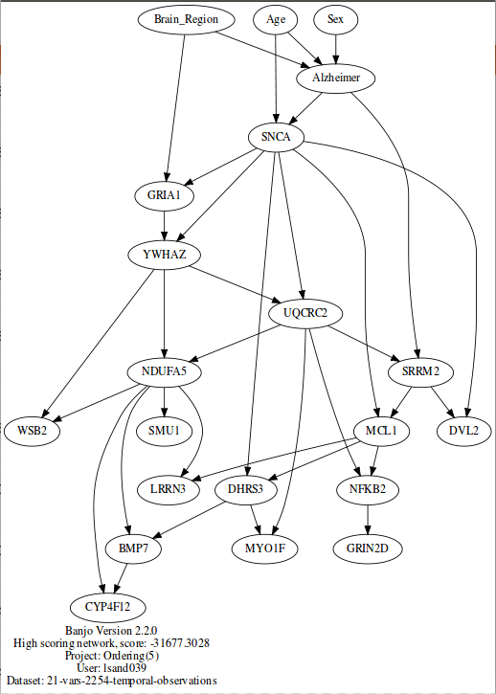
This structure was consistent in paths 2,3, and 5 in BaNJO searches that ran up to one hour. The input files for these structures can be found in Path-2>Alzheimer>banjo.2.2.0>data>release2.0>Summer>input>BK: KEGG order, Path-3>Desktop>Link to Tools/banjo.2.2.0>data>release2.0>Summer>input, and Path-5>Alzheimer>banjo.2.2.0>data>release2.0>Summer>input>BK: KEGG order under the folders named (5): best scoring structure with background knowledge 1st and 2nd degree genes of Alzheimer and KEGG genes 3rd & 4th degree MB with background knowledge. Other output files can be found in the corresponding folders at Path-2>Alzheimer>banjo.2.2.0>data>release2.0>Summer>output>BK: KEGG order, Path-3>Desktop>Link to Tools/banjo.2.2.0>data>release2.0>Summer>output, and Path-5>Alzheimer>banjo.2.2.0>data>release2.0>Summer>output>BK: KEGG order.
This structure was recreated on GeNIe to find the ROC. The files used to create this were (5)MB1_2_3_4BKKEGG.xdsl and (5)MB1_2_3_4BKKEGG.txt The ROC AUC was 0.717238:
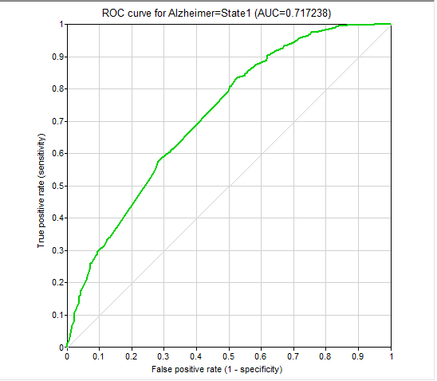
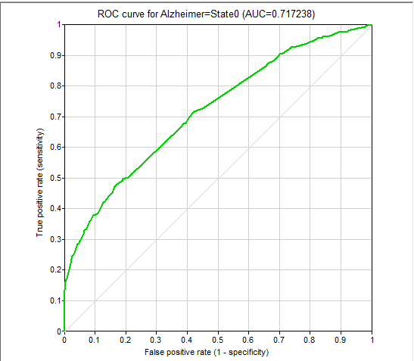
The following 3 structures are the highest scoring structure from the BaNJO run that included the clinical variables, 1st and 2nd degree MB, and the KEGG genes included in the 3rd, 4th, and 5th MB. They accounted for 95% of the log likelihood.
The folders named (6): best scoring structure with background knowledge 1st and 2nd degree genes of Alzheimer andKEGG genes 3rd, 4th and 5th degrees MB with background knowledge in Path-2>Alzheimer>banjo.2.2.0>data>release2.0>Summer>input>BK: KEGG order, Path-3>Desktop>Link to Tools/banjo.2.2.0>data>release2.0>Summer>input, and Path-5>Alzheimer>banjo.2.2.0>data>release2.0>Summer>input>BK: KEGG order contain the input files for each of the structures and in Path-2>Alzheimer>banjo.2.2.0>data>release2.0>Summer>output>BK: KEGG order, Path-3>Desktop>Link to Tools/banjo.2.2.0>data>release2.0>Summer>output, and Path-5>Alzheimer>banjo.2.2.0>data>release2.0>Summer>output>BK: KEGG order for the output structures. These structures were recreated on GeNIe to find the ROC, all using the data file (6)MB1_2_3_4_5BKKEGG.txt.
This structure accounted for 45.89% of total log likelihood score:
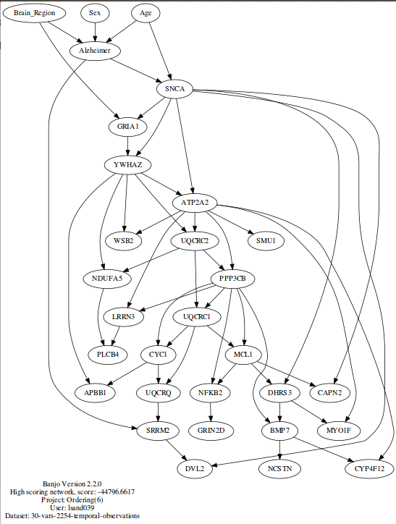
The file used to create this on GeNIe was (6)aMB1_2_3_4_5BKKEGG.xdsl. The ROC AUC was 0.7192:
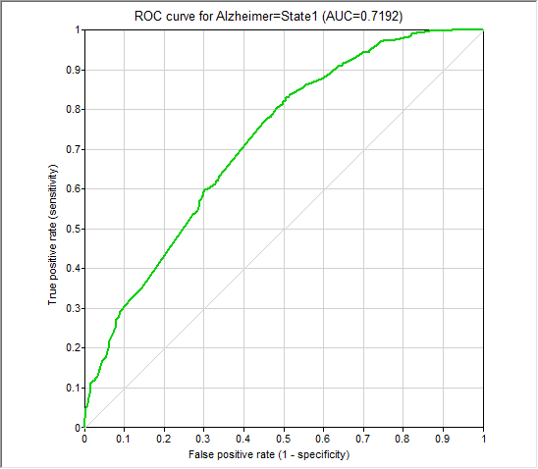
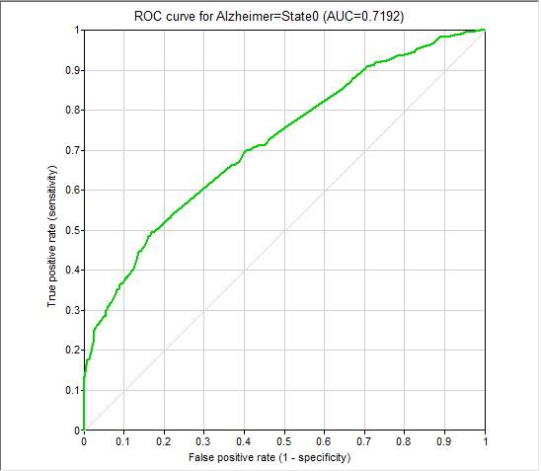
This structure accounted for 36.08% of total log likelihood score:
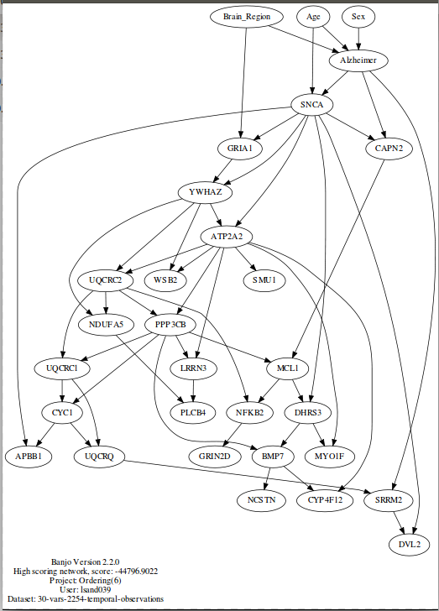
This structure was recreated on GeNIe to find the ROC.with the file (6)bMB1_2_3_4_5BKKEGG.xdsl. The ROC AUC was 0.736538:
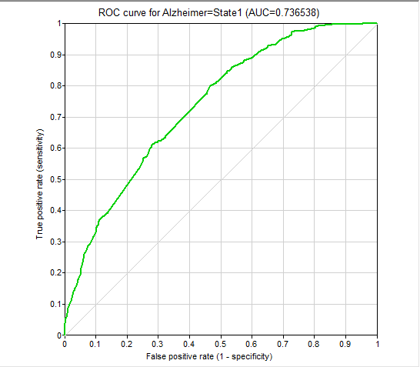
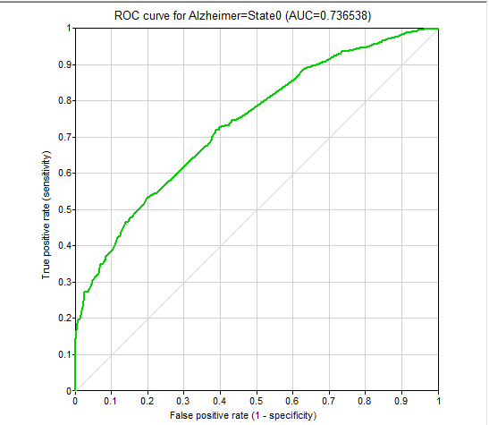
This structure accounted for 9.99% of total log likelihood score.
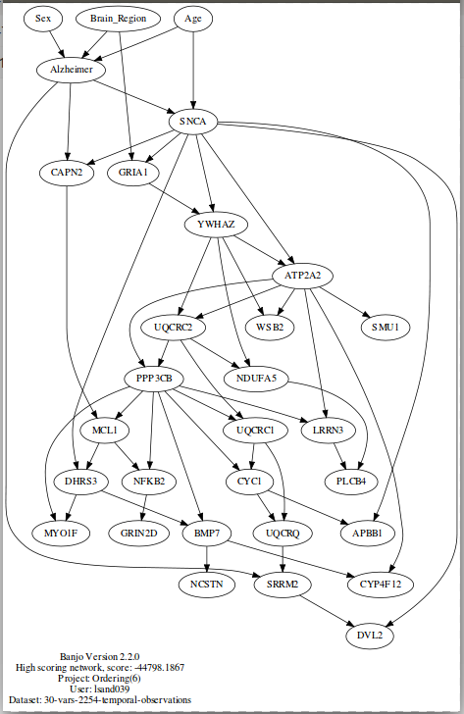
The file used to create this on GeNIe was (6)MB1_2_3_4_5BKKEGG.xdsl. The ROC AUC was 0.736538:


