Figure 1.
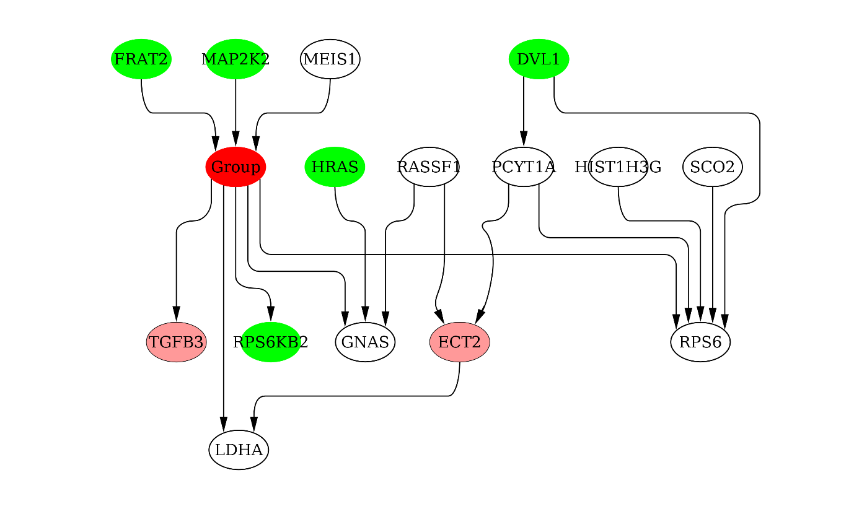

< 1st degree Markov Blanket>
Green colored nodes have the strong correlation with Group. The nodes are the member of upper 10 strong correlated nodes with Group. Purple colored nodes are known as the bone metastasis of breast cancer.

Figure 2. 1st degree MB of Banjo structure is converted into Cytoscape graph with ClueGo and CluePedia apps.
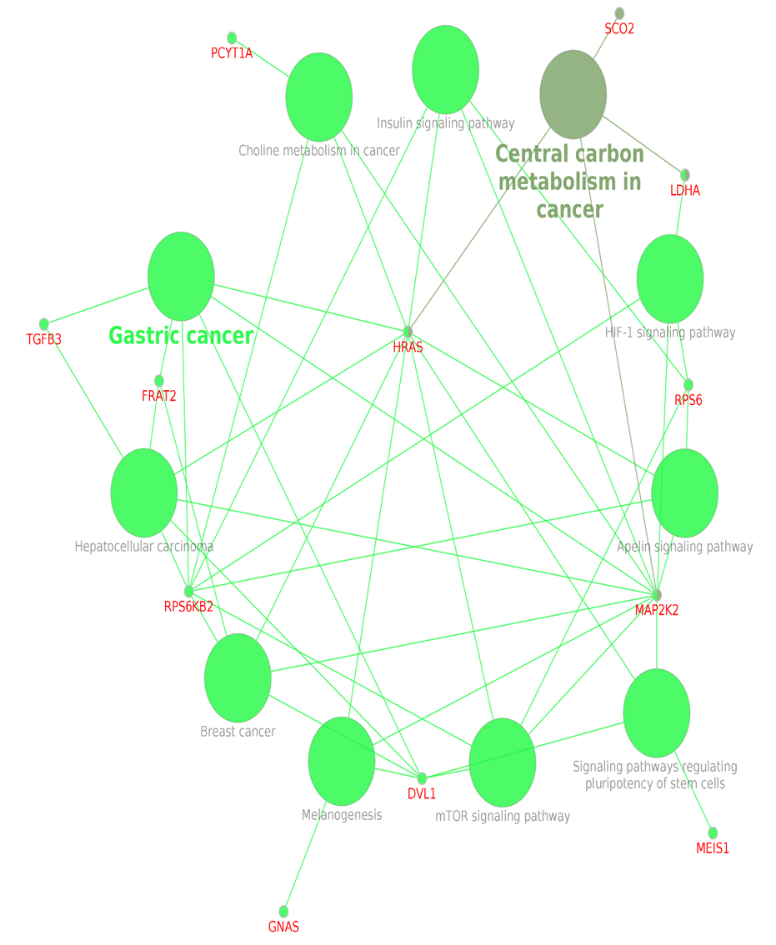
Reference data-bank for genes and pathways is KEGG.

Figure 3. the genes related with mTOR signaling pathways. The genes are selected among the 60 cancer related genes in the present study.


