Causal inference network of genes related with bone metastasis of breast cancer and osteoblasts using causal Bayesian networks

Sung Bae Park, M.D, PhD.¹, Chun Kee Chung. M.D., PhD.², Efrain Gonzalez, M.S.³, Changwon Yoo, PhD.³
1 Department of Neurosurgery, Seoul National University Boramae Medical Center, Seoul, Korea.
2 Department of Neurosurgery, Seoul National University College of Medicine, Seoul, Korea;
Department of Neurosurgery, Seoul National University Hospital, Clinical Research Institute, Seoul, Korea
3. Department of Biostatistics, Robert Stempel College of Public Health and Social Work, Florida International University, Miami, FL, USA.

Corresponding Authors
Changwon Yoo, PhD.
Department of BiostatisticsRobert Stempel College of Public Health and Social Work, Florida International University, Miami, FL 33199, USA. cyoo@fiu.edu.
Chun Kee Chung, M.D., PhD.
Department of Neurosurgery, Seoul National University College of Medicine, Seoul, Korea. chungc@snu.ac.kr
Abstract
Background
Breast cancer is the most common cancer in women. Of those women who receive initial treatment for primary breast cancer, one third develop distant metastases. Among the distant organ of metastases, bone is the most common site in breast cancer. The bone metastasis of breast cancer has a negative effect on the survival and quality of life. Although many studies introduce molecular mechanisms of genes involved in bone metastasis of breast cancer, the causal network among genes commonly expressed in bone metastasis of breast cancer and osteoblasts are not well understood.
Purpose
We provide machine learning methods to obtain plausible causal network of genes commonly expressed in bone metastasis of breast cancer and osteoblasts. The causal network of genes will not only help us better understand the molecular mechanism of how bone metastasis of breast cancer and osteoblasts develops but also provide us with innovative hypotheses for further research questions.

Materials and methods
Gene expression microarray profiles of samples with bone metastasis of breast cancer, breast cancer without metastasis samples, and osteoblasts from seven different studies from Gene Expression Omnibus database. We selected the commonly expressed genes to all 48 subjects (35 bone metastases and 13 osteoblasts). BANJO (Bayesian Network Inference with Java Objects) was used to obtain the Bayesian network with best Bayesian Dirichlet score. The genes, which were registered as breast cancer related genes in Kyoto Encyclopedia of Genes and Genomes, were included as candidate genes in the implementation of BANJO. Then, we got the Bayesian structure that consisted of nodes in the 1st degree Markov Blanket through implementation by using GeNIe. We assessed the prediction rate for bone metastasis, conditional independence among nodes and causality among nodes using Markov chain over Monte Carlo simulation in the final model. In addition, we reported maximum relative risks of combined gene expression of the genes in the model.

Results
From 1,218 common genes of seven different Gene Expression Omnibus studies, machine learning Bayesian analysis and bioinformatics tools in conjunction with the reviewal of published papers, helped us in identifying 70 genes related to bone metastasis of breast cancer. Furthermore, the above mentioned process helped us to identify 33 significantly related and plausiby mechanistically involved genes in the development of bone metastasis as it relates to breast cancer. Some of the notable genes among the 33 genes were: NFKB2, which is known as breast cancer related gene and promotes breast cancer stem cell growth, five genes - SLC10A3, FZD1, BTNL8, KIF11, CACYBP - related with chemotherapy resistance and another five genes - KIF11, MAP2K2, PSAT1, TSPO, ZFP36L2 - known as having a relationship with cancer progression and metastasis. Further model evaluations showed that 16 genes were enough for a model to be statistically significant in terms of maximum likelihood of the causal Bayesian networks (plausible mechanistic gene interactions) and correct predictions of bone metastasis of breast cancer. Maximum relative risks of combined gene expression patterns show that the expression levels of UBIAD1, HEBP1, BTNL8, TSPO, PSAT1 and ZFP36L2 significantly affect whether a subject develops bone metastasis from breast cancer in situ or not.

Conclusions
The Bayesian structure seems to be a reasonable inference network with a high prediction rate of bone metastasis of breast cancer. Several genes including ZFP36L2 may be promising candidates for the diagnosis and treatment of BMBC. Bayesian network analysis may provide us with a more comprehensive understanding of bone metastasis.

Introduction
Bone is a frequent site for primary tumor cells to spread and more than 600,000 people every year suffer from bone metastasis (BM) in the US [1]. Breast, prostate and lung cancers commonly least to BM and more than 70% of patients with breast cancer (BC) and BM are related to high rate of morbidity and mortality [2-4]. Patients with BM may suffer from a variety of skeletal-related complications (SRCs) such as bone pain, pathologic fractures, spinal cord compression, and difficulty to walk [5]. Additionally, once a patient with bone metastasis experiences a first SRC, the likelihood of experiencing a second SRC is greatly increased [5]. Studies regarding normal physiology of bone metabolism, interactions between bone and advanced cancer, and genetics related with bone metastasis have been performed in the laboratory [6-8]. In addition, surgeries, radiation therapy and chemical therapy using target agents are performed in the clinical field [9-10]. However, despite the multidisciplinary approach, a large proportion of BM remains incurable and treatment strategies for BM usually have a palliative effect until now [6]. The decrease in effectiveness is due to fact that the pathophysiology of BM from BC is a multistep and complex process that consists of escapes of tumor cell from primary site, a crosstalk between disseminated BC cells and bone-derived molecules, leading to bone and reconstitution of secondary tumors at the bone [11-12]. Although novel therapies which target the pathways involved in BM are emerging, research which focuses on identifying key upstream regulators related with the molecular signaling pathway of BM remains clinically relevant to the prevention of BM [11]. Using statistical machine learning methods can help us find key upstream regulators from a causal network model inferred from clinical, genomic and environmental data related with BM. In turn, this can improve clinically preventive practices and reduce the adverse effect related with target therapy of BM.
Application of machine learning methods have been widely used to get the statistical relationship and causal networks from large and complicated health data [40,41]. As one of machine learning methods, Causal Bayesian Networks (CBN) have been used to learn causal network inferred from known collected genomic data [13-14]. It has been shown that the gene expression patterns change according to multistep complex processes from primary site, through dissemination, into metastasis [7,15]. Therefore, the relationships of one or two genes or molecules cannot reflect how combination of many genes’ expressions changes according to surrounding environment. We need to seek for the relationships from interactions from network of genes and further search for plausible causal interactions. Studies have presented the gene changes according to bone metastasis of breast cancer (BMBC) [15], however, there has been no research to build an integrated causal network consisting of gene signatures associated to BMBC. The CBN analysis of dataset of the expressed genes in BMBC can provide insight into the causal relationship and upstream regulators governing BMBC. There are three specific niches in homing of tumor cells into bone: the endosteal niche, the haematopoietic stem cell niche and the vascular niche [16]. The endosteal niche related with osteoblast has a key role in the homing and adhesion of circulating tumor cell into bone and the clinically relevant and important network related with BM seem to be in endosteal niche [16,17]. Therefore, we conducted a CBN analysis of microarray data from Gene Expression Omnibus (GEO) [reference of GEO] to get a causal gene expression network consisting of genes related with BMBC and osteoblast for identifying the upstream regulators of BMBC.

Materials and Methods
After
collecting gene expression data from GEO following inclusion criteria, W
e cleaned, normalized, and discretized the gene expression levels. Then, we selected candidate genes that consisted of the commonly expressed genes between BMBC and osteoblast studies except the genes expressed in BC without metastasis studies.
In the next step, we learned Causal Bayesian networks structure by combining the gene expression data with published literature and knowledge. We further learned Causal Bayesian networks parameters (conditional probabilities) and evaluated the final model to see how well it fits the data (maximum likelihood), compared with current knowledge (published literature articles) and predicts future instances (Receiver Operating Curve and Relative Risk).

We further describe each step that we summarized above in more detail:
I. Collecting data from GEO
We have retrieved microarray datasets from GEO database of National Center for Biotechnology Information (NCBI) of National Institute of Health (NIH). Inclusion criteria of datasets were listed as follows: (1) the gene expression data series (GSE) of BMBC, BC without metastasis and osteoblast were collected. (2) The studies should be performed using microarray of Homo sapiens organism. (3) The microarray studies of BMBC and BC without metastasis were performed using human female tissue extracted from metastatic bone and cancer region of breast, respectively. The microarray study of osteoblast was conducted using experimental human cell lines. (3) The BC without metastasis was diagnosed as breast ductal carcinoma without metastasis when the tissues were extracted by biopsy or surgery. As a result, the data set of study consisted of 7 studies (10 GSEs and 48 GSMs) (Table 1).

II. Data mining and Selection of candidate genes
1. Data mining – CANDi (Cleaning, Averaging, Normalization and Discretization)
Because gene symbols in the GSEs are written by gene ID not gene name, we changed gene IDs in GSE into corresponding gene symbol in matched GPL (Cleaning). Then, if single gene had several raw expression values of gene, we transformed the raw values of each gene into a mean value of the raw values (Averaging). For meaningful comparison of gene expression level, the relative data from individual studies should be transformed into normalized data. We normalized the averaging data into z-scores and performed the normalization task on study-by-study basis (Normalization) [18]. Banjo is one of computational modeling tools based on data-driven method and Banjo utilize Bayesian network frameworks to result in directed inference network [19, 20]. Because Banjo implement Baysian Dirichlet equivalence (BDe) scoring metric of data consisting of discrete variables, we transformed the normalized data to discrete values (Discretization). We set the osteoblast and bone metastasis as zero and 1, respectively. In others, z score values less than -1, -1≤ and ≤ 1, and over >1 were discretized as 0, 1 and 2, respectively. We sequentially performed the same process as CANDi per each study.
2. Selection of candidate genes
There were different kinds of expressed genes in GSE files of osteoblast, BMBC and BC without metastasis. Therefore, we selected commonly expressed genes in GSE of osteoblast and BMBC using matching R code. Among the commonly expressed genes, the genes expressed in BC without metastasis were excluded. As a result, ten GSEs (five and five for osteoblast and BM BC, respectively) and 1218 number of genes were selected (Table 1).
3. Checking the data distribution
Because the number of cases of each study was below 30, we checked whether the distributions of normalized values as z scores were similar to normal distribution or skew. We verified whether the irregular distribution of raw averaging data changed into normal distribution pattern in histogram of z scores of genes (Fig. 2).

III. Learning Causal Bayesian Network Structure
The structure of Bayesian network is directed acyclic graph (DAG) consisting of nodes and intervening arrows and the graphs do not include any circle or loop between starting and ending nodes; for example NKEB2 node→ Bone metastasis node → MAP2K2 node → NFKB2 node [41]. The arrows in DAG are interpreted in terms of probabilistic conditional independence between nodes [42]. The terms as parents, child and co-parent nodes are used to define the relationships between nodes. In A and B panels of Fig. 3, NFKB2 is a parent node of Bone metastasis and Bone metastasis is a child node of NFKB2. In addition to, DVL is a co-parent node. In C panel of Fig. 3, the expression of NFKB2 influences the likelihood of the presence of bone metastasis which influences on expressions of MAP2K2 and, or TSO. In parallel, conditional independence between nodes shows as the probability about expression of MAP2K2 or TSO is not influenced by NFKB2 given information of bone metastasis. The Bayesian network is a collection of DAGs with conditional probabilities over all variables of network and we implemented Banjo to obtain the Bayesian network.
After collection all data in 10 GSE, we prepared a data file with observations in row and variables in columns. Observations were name of gene symbol and group (osteoblast or bone metastasis).
In associated setting files to search best static Bayesian network, brief information in the setting file was follows. Dataset was 1219 variables (1218 gene variables and 1 disease variable) and 48 observations. In stopping criteria, although maxRestarts was 30000, we set maxTime as 1hr, 3hrs, 6hrs, 12hrs, 24hrs and 36hrs. In addition, we input nBestNetworks and maxParentCount as 1 and 5, respectively. Then we implemented Banjo three times per six setting times in maxTime. Therefore, we got 18 best BDe scored network and transformed the log BDe score to probability using a perl script. Among 18 probability of Bayesian inference networks, we choose the network with the highest probability. CluePedia and Cytoscpae plugin have been known as a provider for pathways, processes or disease related with gene, miRNA and protein in conjunction with ClueGo [21]. Therefore, we found BCRGs registered KEGG using Cluego and CluePedia Cytoscape plugin. After we made a new data file which comprised the BCRGs and genes within 2nd degree MB of group node, performed again Banjo program with the new data file to get an inference network with genes having more close association to disease and acceptable prior knowledge (BCRGs). The condition of setting files for 2nd Banjo analysis was same as previous condition except the number of variables (from 1219 to 71) and 4 times analyses per 6 setting times.

IV. Learning Causal Bayesian Parameters and Validation
In the 2nd degree Bayesian network, we chose the part of Bayesian network with parent, child and co-parent genes of the group node, group node and arcs. We performed a structural transformation of the part of Bayesian network with preserving the joint probability, conditional independency, and node marginalization using GeNIe (version 2.2.1, BayesFusion, LLC). Learning the parameters of the Bayesian structure was implemented using the exiting data set (42 observations). In addition, we reinforced the inference power of the Bayesian structure by verifying high probability of prediction, node order and conditional independence in the structure. We searched for orders of 16 and 34 variables with best probabilistic score using Markov chain over Monte Carlo (MCMC) simulation and compared the result with the order of nodes in Bayesian structure [22]. The 16 variables were parent, group and child nodes and co-parent nodes were included in 34 variables. The stopping criteria in the order analysis was 1hr working time and 1000 iterations. In the input of same starting order, we got several results with best score given prior information about order or not. Validation test of d-separation among nodes in Bayesian structures was implemented using getting the probabilities of conditional independence. We evaluated the probabilities of all conditional independence given one or two conditions of parent nodes using 16 variables (parent, group and child nodes). Then we investigated whether all conditional independence in the Bayesian structure with 16 nodes had high probability as over 90% or not. After that, we calculate how much we can expect bone metastasis for the observation data of bone metastasis if we got the information of only parent nodes, parent and child nodes or parent, child and co-parent nodes. And, we investigated all joint distribution given BMBC and probabilities of them and evaluated the minimum combination with maximum relative risks of combined gene expression of the genes in the final model and significant genes.

Results
I. 1st Bayesian network, Markov blanket and Breast cancer related genes
Among 18 Bayesian networks, the Bayesian network with 12 hrs implementing time had the best BDe score and probability (-49091.645 and 99.9999 %, respectively). The Bayesian structure with 1219 nodes (1218 gene node and 1 disease group node) seemed to be very complicated (Fig. 4). Among 1219 variables, we selected 59 genes within 2nd degree MB through performance of a program with R language code (Fig. 5). In addition, CluePedia and Cytoscpae plugin revealed 13 BCRGs and pathways and other disease related the BCRGs as a structure of circular layout. (Fig. 6)
II. 2nd Bayesian network and GeNIe structure
The Bayesian network with 36 hrs anlysis had the best BDe score and probability (-2613.829 and 99.9999%, respectively) among 24 candidate Bayesian networks (Fig. 7). Three parent genes (NFKB2, UBIAD1, HEBP1), 12 child (FZD1, MAP2K2, BTNL8, TSPO, HOXB2, FOLH1, KIF11, SLC10A3, PSAT1, CACYBP, S100PBP, ZFP36L2) genes and 20 co-parent (BTNL8, TEP1, L1TD1, TSPO, PSMB8, RPS6KB2, DLL3, TNFRSF11B, MAPK3, FASTKD3, ZNF273, PPP2CA, AGA, IFI30, ZDHHC6, INPP1, YWHAB, EPS8, RANBP6, TATDN2) genes of group were selected from the 2n Bayesian network. We made a Bayesian structure with nodes (the parent, child, and co-parent genes and group node) and arcs and let the parameters Bayesian structure with 34 nodes learn the information of 48 observation (Fig 8). The NFKB2 gene in parent nodes was registered in KEGG as breast cancer related gene and NF-κB proteins was known as transcription factor promoting breast cancer stem cell [23]. Among 12 child genes, SLC10A3, FZD1, BTNL8, KIF11 and CACYBP genes were related with chemotherapy resistance [24-28]. In addition, KIF11, MAP2K2, PSAT1, TSPO and ZFP36L2 genes were known as having relationship with cancer progression and metastasis [29-32]. When the condition of group node change into state 1 (bone metastasis) = 100%, these genes had high probability of state 1 compared to different condition as state 0 (osteoblast) = 100%. Especially, the degree of change in FOLH1 and ZFP36L2 was remarkable (Fig 9).

III. Assessment and Validation of Bayesian structure
The Bayesian structure with 34 nodes achieved 68.3824 % (1116/1632) accuracy in validation test (leave one out cross test) of GeNIe. The accuracy for16 nodes (parent, group and child nodes) was 82.1615 % (631/768). The prediction rates of bone metastasis for the present 35-observation with bone metastasis were almost over 99 %. In addition, even if we provided just 3 parent genes’ information, the prediction rate of bone metastasis were almost over 90% (Table 2).
In analysis of order using MCMC simulation, the 16 nodes-order with best score was NFKB2, HEBP1, Group, FOLH1, ZFP36L2, HOXB2, PSAT1, TSPO, CACYBP, MAP2K2, UBIAD1, BTNL8, KIF11, S100PBP, FZD1. Two parent genes (NFKB2 and HEBP1), which had no ancestor nodes in the 2nd Bayesian network, had the front order to group node. However, the parent UBIAD1 gene, which had ancestors in the 2nd Bayesian network, located at back of the order with best score. The association with ancestor nodes may effect on the order result. The locations of FOLH1 and ZFP36L2 genes, which had the highest change of values according to state of group as state 0 or 1, were just behind the group node in the result of order analysis. Other child nodes located behind the group node. The direction of arcs among 16 nodes in the Bayesian structure may be reasonable based on the result of order analysis with 16 variables. However, the location of parent genes in the order results with 34 variables were apart from the group node. Because the arcs among child and co-parent nodes were complex, the locations of child and co-parent nodes were intermingled. It seems to be difficult to comprehend the order of the Bayesian structure using the result of order analysis with 34 nodes.
The probabilities of conditional independence between parent and group nodes, parent and child nodes and group and child nodes in conditional independence test showed that d- separation and d- connectivity among nodes in the Bayesian structure were reasonable (fig. 10). We found four minimum combinations with maximum relative risks of combined gene expression patterns (Table 3). UBIAD1, HEBP1, BTNL8, TSPO, PSAT1 and ZFP36L2 genes were consistently expressed and altered whether subject got BMBC. The difference of expression levels of ZFP36L2 was especially significant in all combinations compared to other genes.

Discussion
We get a causal inference structure with Bayesian network for microarray data of osteoblast and bone metastasis of breast cancer in GEO database. In addition, biological information as BCRGs registered in KEGG was used as prior knowledge. In other words, to get the causal inference network of genes and disease, we used previous biological information, gene expression data of human specimen, Bayesian network, deep machine learning, and several validation tools.
In a few articles using cell line or animal model of BMBC, IL-6, TGFB and TFF genes were over-expressed [23, 33-36]. The recent article presented that the 15 genes APOPEC3B, ATL2, BBS1, C6orf61, C6orf167, MMS22L, KCNS1, MFAP3L, NIP7, NUP155, PALM2, PH-4, PGD5, SFT2D2 and STEAP3 were associated with the development of bone metastases in breast cancer patients [36]. Among three niches associated with bone metastasis, we considered the endosteal niche related with osteoblast as the critical key [16]. Therefore, we evaluated the causal network with the commonly expressed genes of BMBC and osteoblast, except the genes expressed primary breast cancer. Because of that, most signature genes, which reported in previous studies with BMBC, were not included in our studies. We found three parent genes (NFKB2, UBIAD1, HEBP1) and twelve child genes that had direct connection to BMBC without intervening with other genes. Three parent and 12 child genes may be economic and efficient in expectation or diagnosis of BMBC for patients who have primary breast cancer without bone metastasis. Also, the three parent genes could be powerful candidates for target therapy of BMBC. NFKB2, one of parent genes, encode NF-kappa-B protein that a transcription factor kwon as a regulator of immune system and promote epithelial-to-mesenchymal transition and metastasis of breast cancer [23, 37]. Although the protein encoded by UBIAD1 gene was reported as bladder tumor suppressor protein, there was no report about the role in tumor development or progression of HEBP1 [38]. The UBIAD1 gene had three parents as DVL1, INPP1 and MAPK3 and the DVL1 and INPP1 were registered as BCRGs in KEGG (fig. 5). In addition, UBIAD1 gene was one of the genes that were consistently expressed in minimum combination with maximal relative risk of the present study. Therefore, although the study for the direct effect of HEBP1 gene on BMBC will be needed, we can assume that the UBIAD1 may have an effect on BMBC through influences of other genes as DVL1 and MAPK3.
We mentioned some child genes related with chemotherapy resistance and cancer progression in the Result section. Because the child genes were directly influence by the group node composed of osteoblast and bone metastasis, the Bayesian structure explained why the child genes were reported as genes related with drug resistance, cancer progression and metastasis in previous reports [24-32]. The role of those child genes will be investigated as diagnostic candidates of BMBC in the further study. FOLH1 and ZFP36L2 genes had the great interval between settings of osteoblast and osteoblast as 100% and 100%, respectively in the present study. A study presented that the variants of protein encoded by FOLH1 gene were potential contributors of risk toward breast cancer and prostate cancer [39]. In the Bayesian structure of present study, the expected gene expression of FOLH1 in setting of 100% of BM increased more than other parent, child and co-parent genes. Also, in the setting of 100% of osteoblast, the expected gene expression of FOLH1 decreased more than other genes.
There were several limitation in the present study. Although the Bayesian structure in the present study can provide the meaningful genes for BMBC and showed the causal structure and d-separation between genes through deep machine learning, we got the structure from only 48 human samples. In spite of excellent result of validation test, we should increase the number of human samples to get a point estimate closer to the mean value of the population. The Bayesian structure in the present study was not verified by the animal study or other human studies. Therefore, the structure should need more learning process using analytic results of human sample as RNA-sequencing.
Conclusion
The Bayesian structure composed with 16 nodes (3 parent, disease and 12 child nodes) seems to be reasonable inference network with high prediction rate. The parent and child nodes may be useful candidates for early diagnosis and target therapy of BMBC. Among those nodes, ZFP36L2 may be meaningful candidate for predictor of BMBC. In addition, Bayesian network analysis may provide us with a more comprehensive understanding in biology of bone metastasis.

References
1. Randall RL. A promise to our patients with metastatic bone disease. Ann Surg Oncol 2014;21(13):4049-4050.
2. Lipton A, Theriault RL, Hortobagyi GN, Simeone J, Knight RD, Mellars K, et al. Pamidronate prevents skeletal complications and is effective palliative treatment in women with breast carcinoma and osteolytic bone metastases: long term follow-up of two randomized, placebo-controlled trials. Cancer 2000;88(5):1082–1090.
3. Mundy GR. Metastasis to bone: causes, consequences and therapeutic opportunities. Nat Rev Cancer 2002:(8):584–593.
4. Roodman GD. Mechanisms of bone metastasis. N Engl J Med 2004;350(16):1655–1664.
5. Hernandez RK, Adhia A, -Wade SW, O'Connor E, Arellano J, Francis K, Alvrtsyan H, Million RP, Liede A. Prevalence of bone metastases and bone-targeting agent use among solid tumor patients in the United States. Clin Epidemiol. 2015 Jul 17;7:335-345.
6. Ren G, Esposito M, Kang Y. Bone metastasis and the metastatic niche. J Mol Med (Berl). 2015 Nov;93(11):1203-1212.
7. Fazilaty H, Mehdipour P. Genetics of breast cancer bone metastasis: a sequential multistep pattern. Clin Exp Metastasis. 2014 Jun;31(5):595-612.
8. Suva LJ, Washam C, Nicholas RW, Griffin RJ. Bone metastasis: mechanisms and therapeutic opportunities. Nature reviews Endocrinology. 2011;7:208–218.
9. Sturge J, Caley MP, Waxman J. Bone metastasis in prostate cancer: emerging therapeutic strategies. Nature reviews Clinical oncology. 2011;8:357–368.
10. Coleman RE. Bone cancer in 2011: Prevention and treatment of bone metastases. Nature reviews Clinical oncology. 2012; 9:76–78.
11. Brook N, Brook E, Dharmarajan A, Dass CR, Chan A. Breast cancer bone metastases: pathogenesis and therapeutic targets. Int J Biochem Cell Biol. 2018;96:63-78.
12. Valastyan S, Weinberg RA. Tumor metastasis: molecular insights and evolving paradigms. Cell. 2011;14;147(2):275-92.
13. Nemzek JA, Hodges AP, He Y. Bayesian network analysis of multi-compartmentalized immune responses in a murine model of sepsis and direct lung injury. BMC Res Notes. 2015 Sep 30;8:516
14. Yoo C, Ramirez L, Liuzzi J. Big data analysis using modern statistical and machine learning methods in medicine. Int Neurourol J. 2014; 18(2):50-7.
15. Kang Y, Siegel PM, Shu W, Drobnjak M, Kakonen SM, Cordón-Cardo C, Guise TA, Massagué J. A multigenic program mediating breast cancer metastasis to bone. Cancer Cell. 2003;3(6):537-49.
16. Ottewell PD. The role of osteoblasts in bone metastasis. J Bone Oncol. 2016; 13;5(3):124-127.
17. Haider MT, Holen I, Dear TN, Hunter K, Brown HK. Modifying the osteoblastic niche with zoledronic acid in vivo-potential implications for breast cancer bone metastasis. Bone. 2014;66:240-50.
18. Quackenbush J. Microarray data normalization and transformation. Nat Genet. 2002 Dec;32 Suppl:496-501.
19. Yu J, Smith VA, Wang PP, Hartemink AJ, Jarvis ED. Advances to Bayesian network inference for generating causal networks from observational biological data. Bioinformatics. 2004 Dec 12;20(18):3594-603.
20. Nam S. Databases and tools for constructing signal transduction networks in cancer. BMB Rep. 2017 Jan;50(1):12-19.
21. Bindea, G, Galon J, Mlecnik B. CluePedia Cytoscape plugin: pathway insights using integrated experimental and in silico data. Bioinformatics. 2013 Mar 1; 29(5): 661–663.
22. Agostinho NB, Machado KS, Werhli AV. Inference of regulatory networks with a convergence improved MCMC sampler. BMC Bioinformatics. 2015 Sep 24;16:306.
23. Kendellen MF, Bradford JW, Lawrence CL, Clark KS, Baldwin AS. Canonical and non-canonical NF-κB signaling promotes breast cancer tumor-initiating cells. Oncogene. 2014 Mar 6;33(10):1297-305.
24. Wang Q, Lu F, Lan R. RNA-sequencing dissects the transcriptome of polyploid cancer cells that are resistant to combined treatments of cisplatin with paclitaxel and docetaxel. Mol Biosyst. 2017 Sep 26;13(10):2125-2134.
25. Zhang H, Zhang X, Wu X, Li W, Su P, Cheng H, Xiang L, Gao P, Zhou G. Interference of Frizzled 1 (FZD1) reverses multidrug resistance in breast cancer cells through the Wnt/β-catenin pathway. Cancer Lett. 2012 Oct 1;323(1):106-13.
26. Nakao T, Iwata T, Hotchi M, Yoshikawa K, Higashijima J, Nishi M, Takasu C, Eto S, Teraoku H, Shimada M. Prediction of response to preoperative chemoradiotherapy and establishment of individualized therapy in advanced rectal cancer. Oncol Rep. 2015 Oct;34(4):1961-7
27. Jiang M, Zhuang H, Xia R, Gan L, Wu Y, Ma J, Sun Y, Zhuang Z. Prediction of response to preoperative chemoradiotherapy and establishment of individualized therapy in advanced rectal cancer. Oncotarget. 2017 Sep 8;8(54):92106-92118.
28. Shi Y, Hu W, Yin F, Sun L, Liu C, Lan M, Fan D. Regulation of drug sensitivity of gastric cancer cells by human calcyclin-binding protein (CacyBP). Gastric Cancer. 2004;7(3):160-6.
29. Huth HW, Albarnaz JD, Torres AA, Bonjardim CA, Ropert C. MEK2 controls the activation of MKK3/MKK6-p38 axis involved in the MDA-MB-231 breast cancer cell survival: Correlation with cyclin D1 expression. Cell Signal. 2016 Sep;28(9):1283-91.
30. Song Gao, et al. PSAT1 is regulated by ATF4 and enhances cell proliferation via the GSK3β/β-catenin/cyclin D1 signaling pathway in ER-negative breast cancer. J Exp Clin Cancer Res. 2017 Dec 8;36(1):179.
31. Mukherjee S, Das SK. Translocator protein (TSPO) in breast cancer. Curr Mol Med. 2012 May;12(4):443-57.
32. Yonemori K, et al.ZFP36L2 promotes cancer cell aggressiveness and is regulated by antitumor microRNA-375 in pancreatic ductal adenocarcinoma. Cancer Sci. 2017 Jan;108(1):124-135.
33. Rajski M, Vogel B, Baty F, Rochlitz C, Buess M. Global gene expression analysis of the interaction between cancer cells and osteoblasts to predict bone metastasis in breast cancer. PLoS One. 2012;7(1):e29743.
34. Mourskaia AA, Dong Z, Ng S, Banville M, Zwaagstra JC, O'Connor-McCourt MD, Siegel PM. Transforming growth factor-beta1 is the predominant isoform required for breast cancer cell outgrowth in bone. Oncogene. 2009 Feb 19;28(7):1005-15.
35. Smid M, Wang Y, Zhang Y, Sieuwerts AM, Yu J, Klijn JG, Foekens JA, Martens JW. Subtypes of breast cancer show preferential site of relapse. Cancer Res. 2008 May 1;68(9):3108-14.
36. Savci-Heijink CD, Halfwerk H, Koster J, van de Vijver MJ. A novel gene expression signature for bone metastasis in breast carcinomas. Breast Cancer Res Treat. 2016 Apr;156(2):249-59.
37. Yeo SK, French R, Spada F, Clarkson R. Opposing roles of Nfkb2 gene products p100 and p52 in the regulation of breast cancer stem cells. Breast Cancer Res Treat. 2017 Apr;162(3):465-477.
38. Fredericks WJ, McGarvey T, Wang H, Lal P, Puthiyaveettil R, Tomaszewski J, Sepulveda J, Labelle E, Weiss JS, Nickerson ML, Kruth HS, Brandt W, Wessjohann LA, Malkowicz SB. The bladder tumor suppressor protein TERE1 (UBIAD1) modulates cell cholesterol: implications for tumor progression. DNA Cell Biol. 2011 Nov;30(11):851-64.
39. Naushad SM, Shree Divyya P, Janaki Ramaiah M, Alex Stanley B, Prasanna Lakshmi S, Vishnupriya J, Kutala VK. Clinical utility of genetic variants of glutamate carboxypeptidase II in predicting breast cancer and prostate cancer risk. Cancer Genet. 2015 Nov;208(11):552-8.
40. Deo RC. Machine Learning in Medicine. Circulation. 2015 Nov 17; 132(20): 1920–1930.
41. Deo RC, Nallamothu BK. Learning about Machine Learning: The Promise and Pitfalls of Big Data and the Electronic Health Record. Circ Cardiovasc Qual Outcomes. 2016 Nov; 9(6): 618–620.
41. Mumford JA, Ramsey JD. Bayesian networks for fMRI: a primer. Neuroimage. 2014 Feb 1;86:573-82
42. Bielza C, Larrañaga P. Bayesian networks in neuroscience: a survey. Front Comput Neurosci. 2014 Oct 16;8:131

Table 1. Information of enrolled GSEs and GSMs

Study | GPL | GSE | GSM | PMID*
1 | GPL6848 | GSE 19276 | GSM 481115, 481116, 481117,481118, 481119 | 20551950
2 | GPL13482 | GSE 29033, 29034, 29035 | GSM 719377, 719381, 719372, 719376 , 719384 , 719387 | 22235336
3 | GPL 6244 | GSE 12885 | GSM288005,288006 | 19286668
4 | GPL 570 | GSE 4017 | GSM352100, 352103, 352105, 352109, 352117, 352119, 352123, 352124, 352126, 352131 | 19573813 & 25670079
4 | GPL 96 | GSE 4018 | GSM352144, 352149, 352151, 352154 , 352155, 352159, 352163 , 352167 | 19573813 & 25670079
5 | GPL 6480 | GSE 39494 | GSM970199, 970200, 970201, 970202, 970203 | 23174366
6 | GPL 10379 | GSE 46141 | GSM1124888, 1124890, 1124904, 1124927, 1124953 | 24287398
7 | GPL 570 | GSE 51232 | GSM1240799, 1240800, 1240801, 1240803, 1240804, 1240805, 1240806 | Not available

*, PMID of published article using each study

Table 2. The prediction rates given different conditions

cases of osteoblast and bone metastasis | prediction rates  given 3 parent genes information | prediction rates  given 3 parent and 12 child genes information | prediction rates  given 3 parent , 12 child and 18 co-parent genes information
osteoblast 1 | 0.125 | 6.35E-05 | 8.29929E-08
osteoblast 2 | 0.0555556 | 1.22E-08 | 7.8259E-15
osteoblast 3 | 0.125 | 8.01E-06 | 5.33354E-09
osteoblast 4 | 0.0138889 | 1.45E-06 | 2.1411E-10
osteoblast 5 | 0.34375 | 7.24E-06 | 6.81075E-12
osteoblast 6 | 0.0555556 | 0.00358152 | 1.04724E-06
osteoblast 7 | 0.125 | 0.008867 | 7.54625E-08
osteoblast 8 | 0.0138889 | 0.0104353 | 0.000005475
osteoblast 9 | 0.34375 | 0.00236364 | 1.13218E-05
osteoblast 10 | 0.0138889 | 6.64E-06 | 1.65664E-08
osteoblast 11 | 0.125 | 4.40E-06 | 1.16112E-08
osteoblast 12 | 0.0138889 | 6.50E-08 | 2.09571E-11
osteoblast 13 | 0.0138889 | 2.26E-08 | 2.32857E-10
bone metastasis 1 | 0.98 | 0.998629 | 1
bone metastasis 2 | 0.944444 | 0.998264 | 0.999999
bone metastasis 3 | 0.986111 | 0.999468 | 1
bone metastasis 4 | 0.944444 | 1 | 1
bone metastasis 5 | 0.997778 | 1 | 1
bone metastasis 6 | 0.944444 | 1 | 1
bone metastasis 7 | 0.986111 | 0.999978 | 1
bone metastasis 8 | 0.944444 | 0.999757 | 0.99999
bone metastasis 9 | 0.997778 | 0.99999 | 0.999998
bone metastasis 10 | 0.986111 | 1 | 1
bone metastasis 11 | 0.98 | 0.999998 | 1
bone metastasis 12 | 0.96875 | 1 | 1
bone metastasis 13 | 0.997778 | 1 | 1
bone metastasis 14 | 0.98 | 0.999993 | 1
bone metastasis 15 | 0.997778 | 0.999999 | 1
bone metastasis 16 | 0.997778 | 1 | 1
bone metastasis 17 | 0.986111 | 0.999997 | 1
bone metastasis 18 | 0.98 | 0.999988 | 1
bone metastasis 19 | 0.997778 | 0.999974 | 0.999999
bone metastasis 20 | 0.997778 | 0.999585 | 1
bone metastasis 21 | 0.997778 | 0.999988 | 1
bone metastasis 22 | 0.997778 | 0.99999 | 0.999995
bone metastasis 23 | 0.944444 | 0.999435 | 1
bone metastasis 24 | 0.986111 | 0.999997 | 1
bone metastasis 25 | 0.997778 | 1 | 1
bone metastasis 26 | 0.96875 | 0.994262 | 0.999555
bone metastasis 27 | 0.875 | 0.996313 | 1
bone metastasis 28 | 0.997778 | 1 | 1
bone metastasis 29 | 0.997778 | 1 | 1
bone metastasis 30 | 0.997778 | 0.999959 | 1
bone metastasis 31 | 0.944444 | 0.999987 | 1
bone metastasis 32 | 0.997778 | 0.999993 | 0.999999
bone metastasis 33 | 0.875 | 0.999977 | 1
bone metastasis 34 | 0.34375 | 0.999263 | 0.999964
bone metastasis 35 | 0.96875 | 0.999941 | 1

Table 3. Minimum combinations with maximum relative risks of combined gene expression patterns

Gene expression patterns | probability | Relative risk
BMBC [1] | NFKB2[1], UBIAD1[1], HEBP1[1], FZD1[1], BTNL8[1], MAP2K2[0], TSPO[1], KIF11[1], SLC10A3[1], PSAT1[1], ZFP36L2[0] | 1 | 74014862.8
BMBC [1] | NFKB2[1], UBIAD1[0], HEBP1[2], FZD1[1], BTNL8[2], MAP2K2[0], TSPO[0], KIF11[2], SLC10A3[2], PSAT1[0], ZFP36L2[2] | 1.35108e-10 | 74014862.8
BMBC [1] | NFKB2[1], UBIAD1[1], HEBP1[1], FZD1[1], BTNL8[1], MAP2K2[0], TSPO[1], KIF11[1], PSAT1[1], CACYBP[1], ZFP36L2[0] | 1 | 58169972.66
BMBC [1] | NFKB2[1], UBIAD1[0], HEBP1[2], FZD1[1], BTNL8[2], MAP2K2[0], TSPO[2], KIF11[2], PSAT1[1], CACYBP[2], ZFP36L2[2] | 1.7191e0-8 | 58169972.66
BMBC [1] | NFKB2[1], UBIAD1[1], HEBP1[1], FZD1[1], BTNL8[1], MAP2K2[0], TSPO[1], SLC10A3[1], PSAT1[1], CACYBP[1], ZFP36L2[0] | 1 | 35717729.92
BMBC [1] | NFKB2[1], UBIAD1[0], HEBP1[2], FZD1[1], BTNL8[2], MAP2K2[0], TSPO[0], SLC10A3[2], PSAT1[1], CACYBP[2], ZFP36L2[2] | 2.79973e-08 | 35717729.92
BMBC [1] | NFKB2[1], UBIAD1[1], HEBP1[1], BTNL8 [1], MAP2K2[0], TSPO[1], KIF11[1], SLC10A3[1], PSAT1[1], CACYBP[1], ZFP36L2[0] | 1 | 19295520.54
BMBC [1] | NFKB2[1], UBIAD1[0], HEBP1[2], BTNL8 [2], MAP2K2[0], TSPO[0], KIF11[2], SLC10A3[2], PSAT1[1], CACYBP[2], ZFP36L2[2] | 5.18255e-08 | 19295520.54

Figure 1. Outline of the study

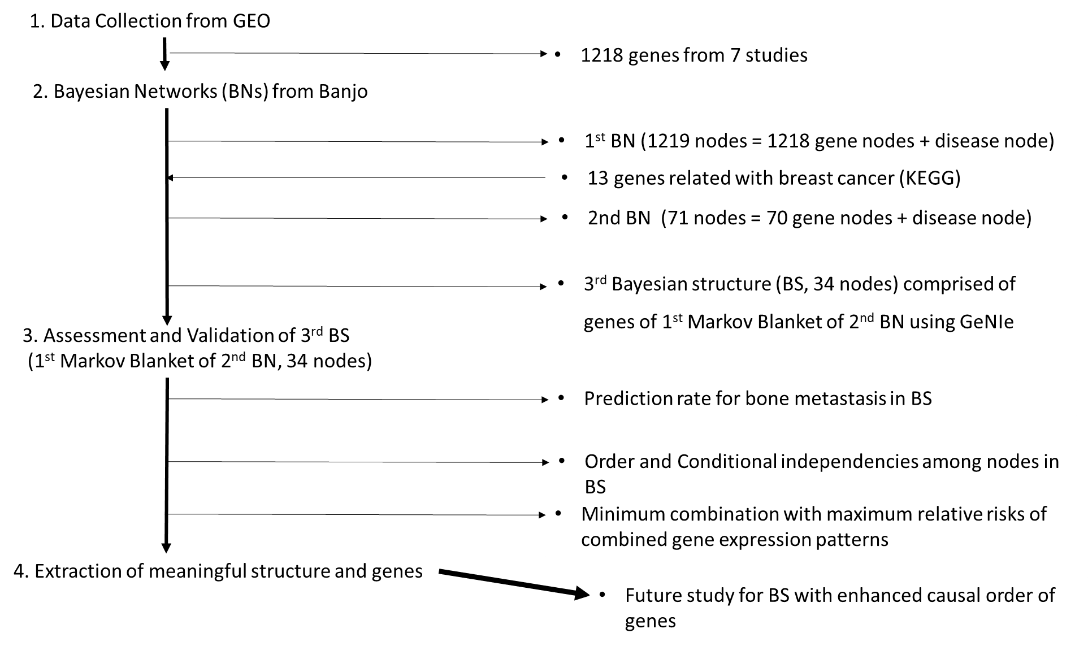

GEO: Gene Expression Omnibus database, KEGG: Kyoto Encyclopedia of Genes and Genomes

Figure 2. Data distribution of averaging value and z scores.

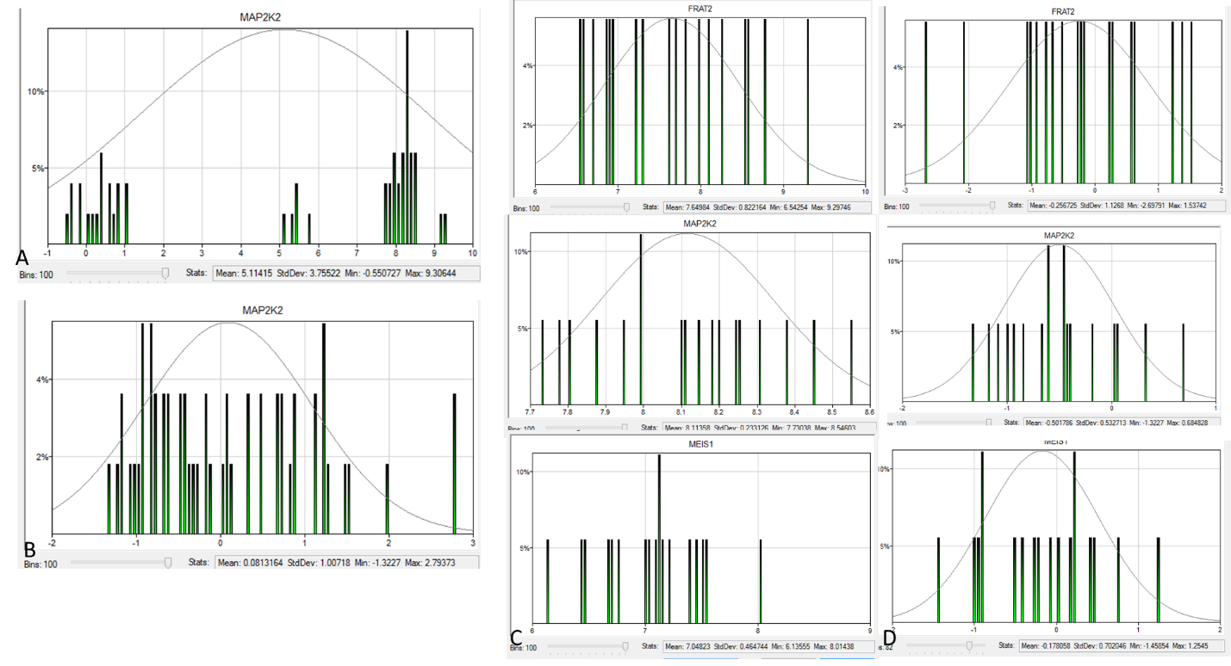
A, Histogram of raw averaging values of MAP2K2 genes. B, Histogram of z scores of MAP2K2 after normalization. C, Histogram of raw averaging values of FRAT2, MAP2K2 and MEIS1 genes in study 4. D, Histogram of z score of FRAT2, MAP2K2 and MEIS1 genes in study 4 after normalization.
A and B figures show that data distribution of MAP2K2 gene has normal distribution after normalization by z score. In study 4, different raw values in different genes were redistributed in z score histogram after normalization (C and D).

Figure 3. Three examples illustrating Bayesian structure

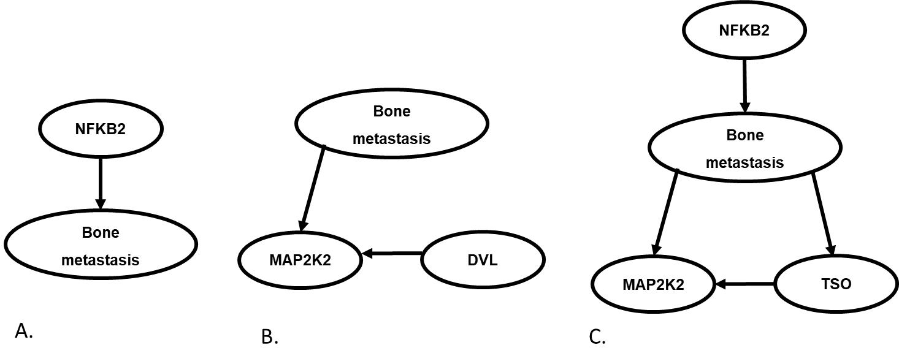
Figure 4. Bayesian structure
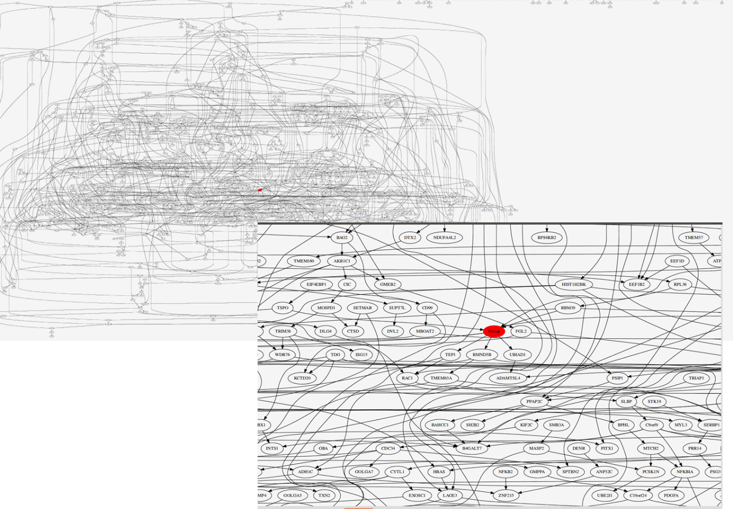

Left figure shows the 1st Bayesian structure with 1219 node and complicated connection between them. Right figure show red colored group node and around connected genes. Group node represented osteoblast or bone metastasis of breast cancer.

Figure 5. Schematic description and genes in 2nd Markov blanket
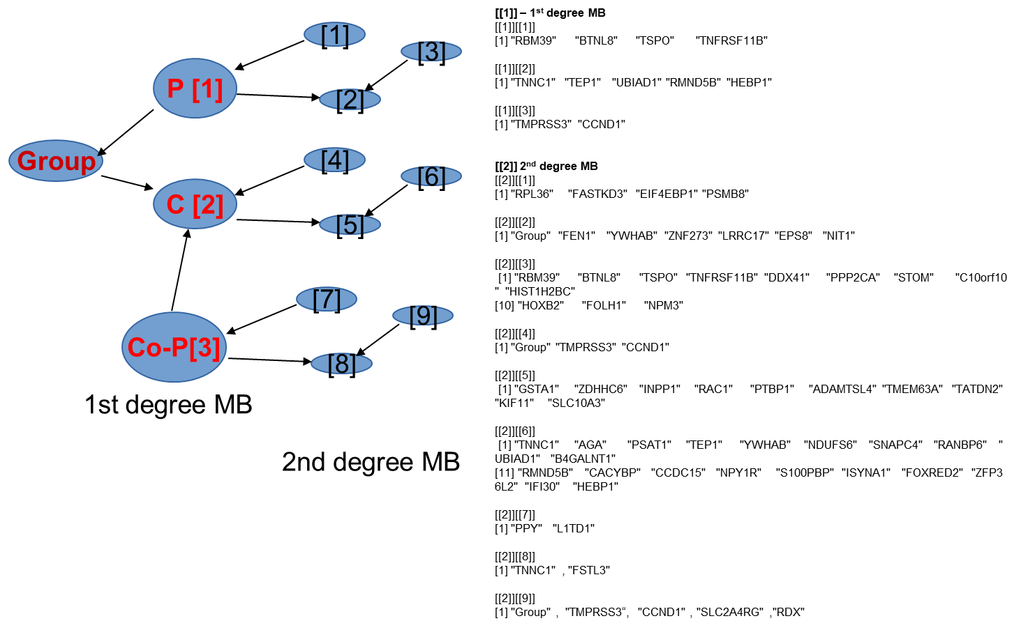

This figure show the schematic description of relationship among group node, parent (P) node, child (C) node and co-parent (Co-P) node (left-side figure) and gene names (right-side figure) within 2nd degree Markov blanket(MB).

Figure 6. Circular layout with breast cancer related genes, pathways, and diseases
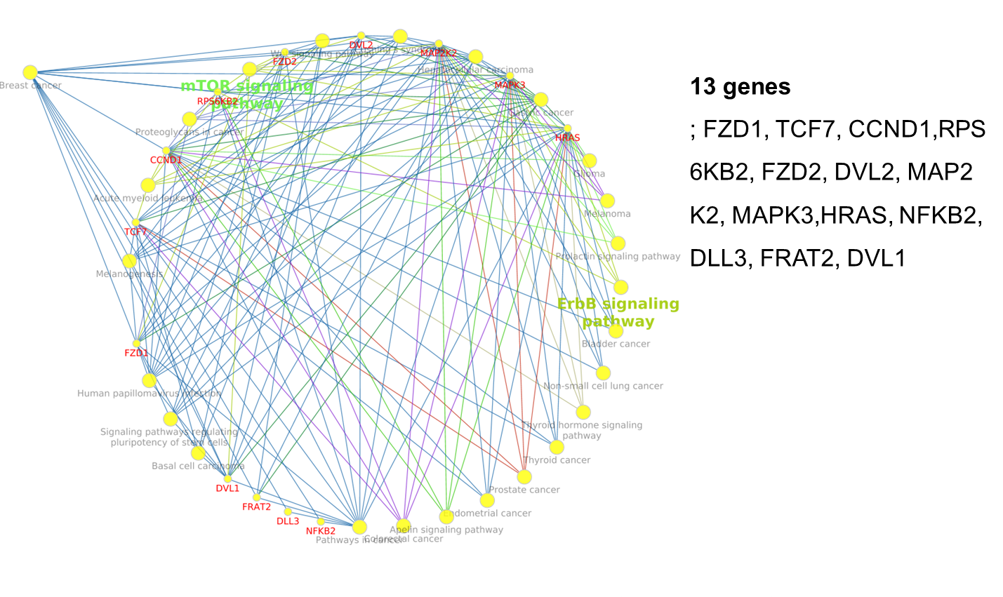
Cytoscape with ClueGo and CluePedia showed us the circular structures with 13 breast cancer related genes, pathways and other diseases as well as connections among them.

Figure 7. 2nd Bayesian network with best BDe score
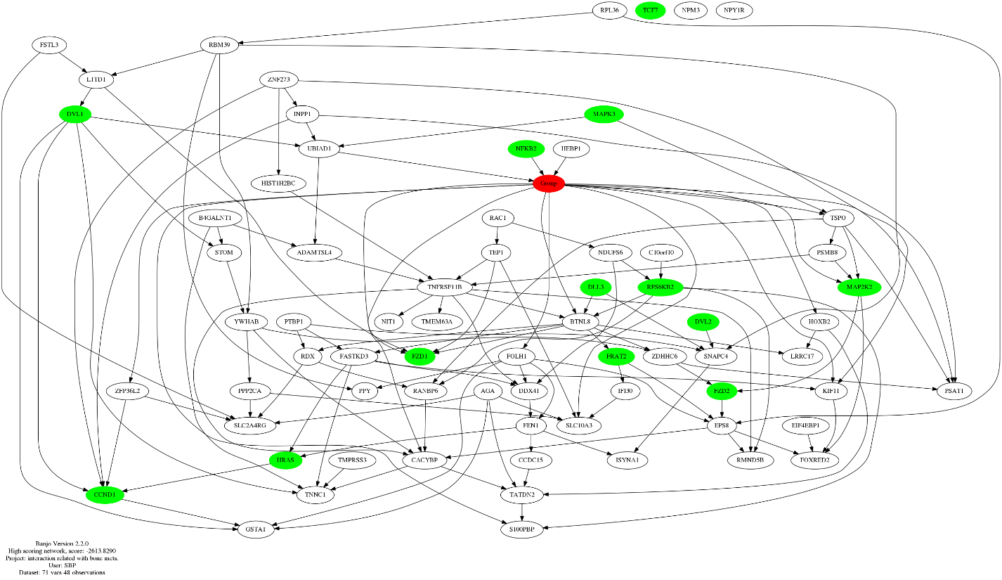
A node filled with red color represented group (osteoblast or bone metastasis) node. 13 nodes filled with green color represented breast cancer related genes.

Figure 8. Bayesian structure using GeNIe
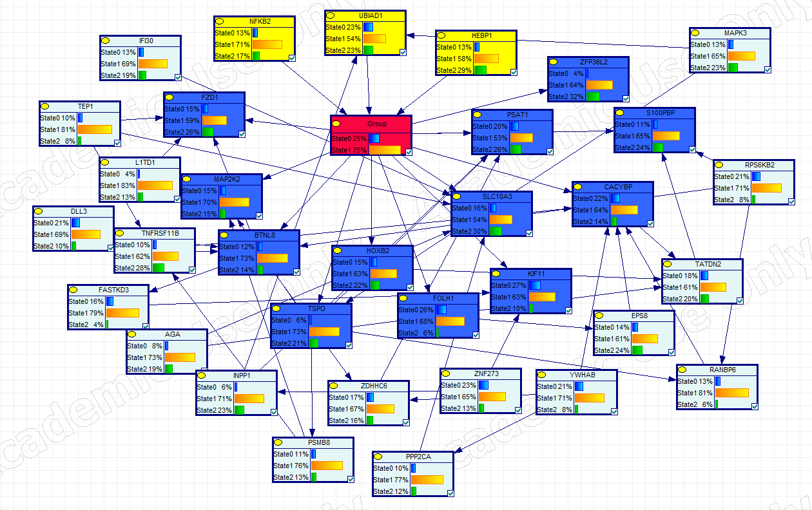
Picture show the Bayesian structure learned with existing data set using GeNIe. The parent, group, child and co-parents nodes filled with yellow, red, blue, and bright blue, respectively. State 0 and 1 in group node represent probability of occurrence of osteoblast and bone metastasis, respectively. Sate 0, 1 and 2 in other nodes represent discretized value 0, 1 and 2, respectively.
Figure 9. Bayesian structures according to different conditions of group node
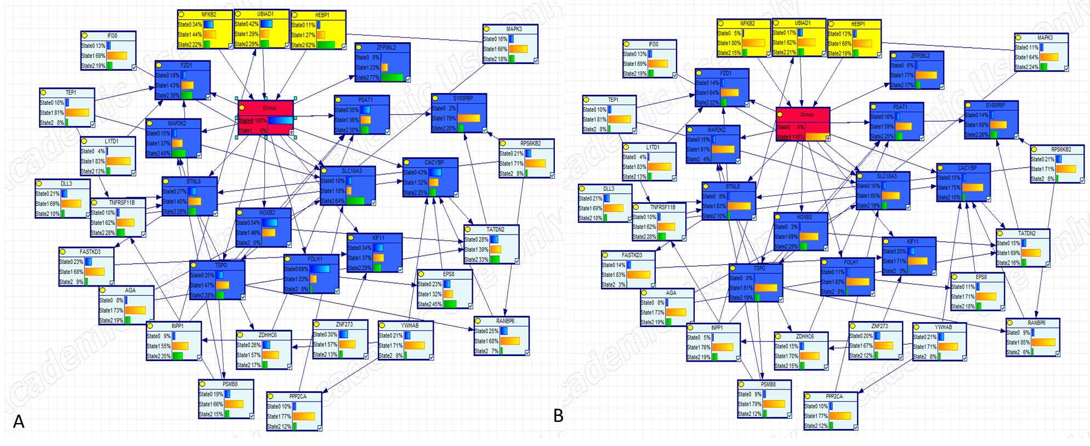

A and B pictures show changes of gene expressions dependent on two conditions as state 0 (probability of osteoblast occurrence) = 100% and state 1 (probability of bone metastasis occurrence) = 100%, respectively.

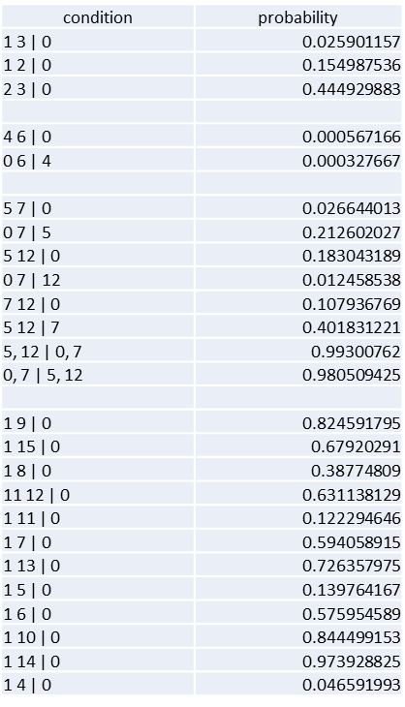
Figure 10. Probability of conditional independence among nodes

1
2
3
0
4
5
6
7
8
10
11
12
14
13
15
16

Left picture show the Bayesian structure with 16 nodes. The parent, group and co-parent nodes were filled with yellow, red and blue colors, respectively. And right table shows the probabilities of conditional independences dependent on different conditions.

