Masters of Science Project Proposal
Data Science Program

Title: Conditional Independencies for the Alarm Monitoring System

Alberto Cruz, MPH
1947558

Abstract
The ALARM network dataset was developed by a physician in order to determine if a response to patient can be determined by certain factors. Using a dataset generated to simulate the ALARM dataset, we determined the accuracy of the predictability of this dataset. We used a Bayesian network (BN) directed acyclic graph (DAG) of the Alarm dataset using the true “sparse” separated variables, and a second “close” variable DAG. We began with the determination of the different combinations of conditional independence with different numbers of parents. Using d-separation algorithms, we then determined the percentage of combinations correctness to the DAG.

Introduction
Patient monitoring systems have been a highly studied topic within the healthcare field. With the goal to improve the signaling to healthcare providers about patients, A Logical Alarm Reduction Mechanism (ALARM) was developed to help with the monitoring of patients. This system included 37 variables, including diagnoses and findings variables (Beinlich et al., 1989). This causal Bayesian Network (BN) has been studied to better understand the predictability of causal relationships.

In order to test the effectiveness of data generation techniques and how it compares to a real-life causal model, we will use generated data from the ALARM monitoring system. We will test the accuracy of the predictive nature of the generated dataset, to the real-life dataset, using different conditions.

Methods
Models
The original ALARM system includes 37 total variables. Previous analyses determined that there are nine significantly correlated variables, which differ per model. Two different models were used in order to more appropriately explore this dataset. A “sparse” dataset takes the nine most significantly correlated variables, regardless of proximity to each other. The directed acyclic graph (DAG) demonstrates the position of each of the variables (Figure 1). These nine variables include: LVFailure, BP, CO, Catechol, HRBP, Intubation, VentAlv, ExpCO2, and VentTube. The remaining variables are purposefully hidden, so as to not be used in the calculations.
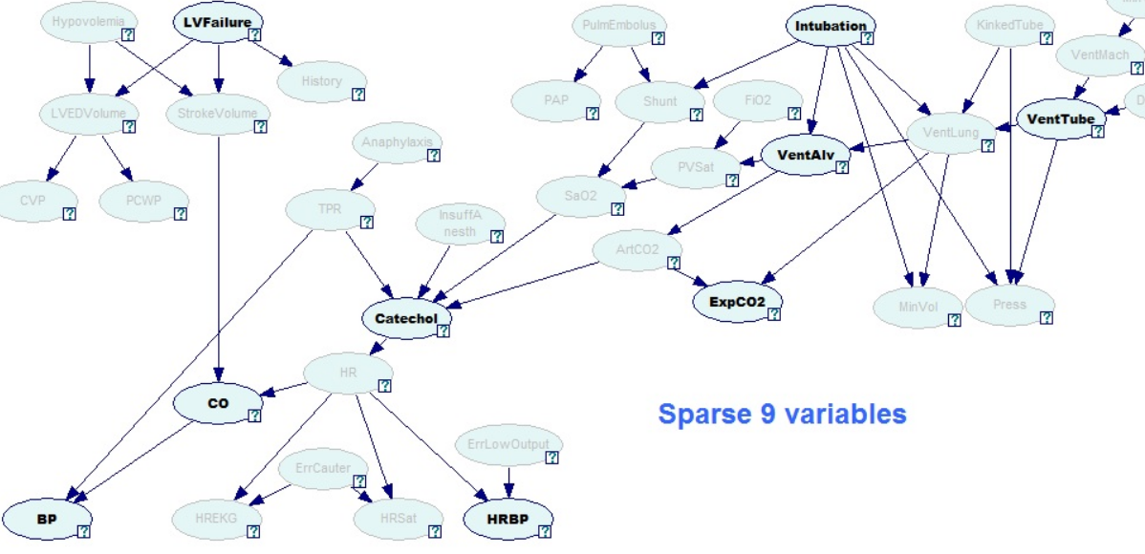
Figure 1: Sparse ALARM DAG highlighting the nine statistically significantly correlated sparse variables (in bold).

A “close” dataset takes the nine most significantly correlated variables that are all within close proximity to each other (Figure 2). These nine variables include: Anaphylaxis, TPR, InsuffAnesth, Catechol, HR, SaO2, ArtCO2, ExpCO2, and VentLung.

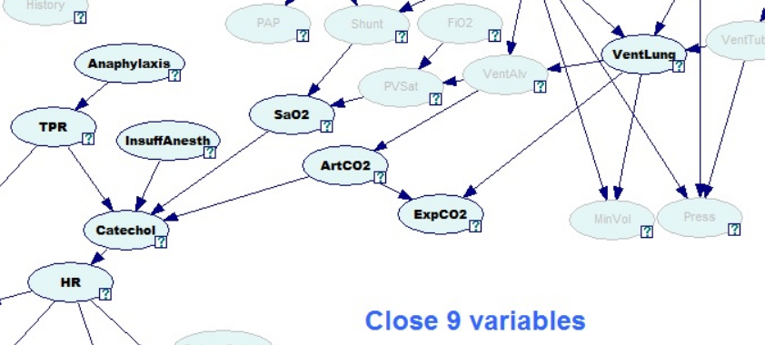
Figure 2: Close ALARM DAG highlighting the nine statistically significantly correlated close variables (in bold).

Datasets
We used Datasets that were generated for the ALARM monitoring system. One dataset used a sample size of 50, and another dataset used a sample size of 1,000. Each sample size dataset was compared to determine if sample size would affect the outcome. Table 1 outlines the dataset names, with a brief description. There is also a dataset for each model, for a total of four datasets.
Table 1: ALARM Dataset Descriptions
Dataset Name | n | Model
D50S9V | 50 | Sparse
D50C9V | 50 | Close
D1KS9V | 1,000 | Sparse
D1KC9V | 1,000 | Close
*9V signifies the 9 significantly correlated variables

Analyses
We tested the conditional independence of each combination of variables, with no parents, one parent, and two parents. There were three methods that were employed for this.
Method I. All pairwise correlations, $c_{ij}=corr\left(X_{i},X_{j}\right)$for all$i,j,i≠j$ were calculated. Then for all $\left(X_{i},X_{j}\right)$, the k highest common correlations were selected, $c_{ih1},c_{ih2},…c_{ih3},$ and using $Pa=\left\{X_{h1},X_{h2},…X_{hk}\right\}$ as candidate parents the conditional distribution was estimated, i.e., $P\left(X_{i}⊥X_{i}∨pa\right)$ for all $pa⊆Pa$.
Method II. All pairwise correlations, $c_{ij}=corr\left(X_{i},X_{j}\right)$ for all $i,j,i≠j$ were calculated. Then for all $\left(X_{i},X_{j}\right)$, the k lowest common correlations were selected, $c_{ih1},c_{ih2},…c_{ih3},$ and using $Pa=\left\{X_{h1},X_{h2},…X_{hk}\right\}$ as candidate parents the conditional distribution was estimated, i.e., $P\left(X_{i}⊥X_{i}∨pa\right)$for all $pa⊆Pa$.
Method III. All pairwise correlations, $c_{ij}=corr\left(X_{i},X_{j}\right)$for all$i,j,i≠j$ were calculated. Then for all $\left(X_{i},X_{j}\right)$, the k/2 lowest common correlations, $c_{ih1},c_{ih2},…c_{{ihk}/2},$ and k/2 lowest common correlations were selected, $c_{il1},c_{il2},…c_{{ihl}/2},$ and using $Pa=\left\{X_{h1},X_{h2},X_{{hk}/2},…X_{l1},X_{l2},X_{{lk}/2}\right\}$ as candidate parents the conditional distribution was estimated, i.e. $P\left(X_{i}⊥X_{i}∨pa\right)$for all $pa⊆Pa$.
Using the “bnlearn” package in R version 3.4.0, we determined the conditional independencies. The output is a list of p-values, generated from a χ² test, to determine the statistical significance of the combination being conditionally independent. The null hypotheses states that the combination pair is independent of each other (in the case of parents, it is also dependent on whether the parent(s) is/are present). Using this output, we then visually followed the nodes of the respective DAG to determine if the result is correct.
We later determined d-separation through the R software, eliminating the visual bias. This required the input of the DAG, while only including the nine significantly correlated variables of each model. This calculation gave an out of “true” or “false” depending if the combinations of variables were d-separated from each other or not. In addition, receiver operating characteristic (ROC) curves were generated to better determine the p-values. The area under the curve (AUC) was also used to determine effectiveness of the predictability.
Using C++, Bayesian Dirichlet likelihood-equivalence (BDe) scores were calculated for each dataset. These BDe scores were used as a comparison tool, to determine most likely parents for each node, using the lowest BDe score per variable.

Results
TBA
Discussion
TBA
References
Beinlich, I. A., Suermondt, H. J., Chavez, R. M., and Cooper. G. F. (1989) The Alarm Monitoring System: A Case Study with two Probabilistic Inference Techniques for Belief Networks. Proceedings of the 2nd European Conference on Artificial Intelligence in Medicine. Springer-Verlag. 247-256.

