Class Project Descriptive Statistics
Survival Gene:
There are 433 subjects: 145 Females, 284 males and 4 missed gender identity. Also, there 638 genes in this category.
Summary for Age, DiseaseGrade, Survival Time and top 5 genes for this category.
 | Mean | SD | 1st Q | Median | 3rd Q | Missing Values
Age | 55.97 | 10.691 | 49.10 | 56.70 | 63.60 | 4
Grade | 0.624 | 0.608 | 0.000 | 1.000 | 1.000 | 16
Overall Survival (OS) Time | 17.82 | 10.574 | 10.18 | 15.66 | 24.31 | 4
Progression-Free Survival (PFS) Time | 9.299 | 6.104 | 4.200 | 8.000 | 12.900 | 84
ABCC9 | 0.963 | 0.615 | 1.000 | 1.000 | 1.000 | 0
ABHD4 | 1.085 | 0.522 | 1.000 | 1.000 | 1.000 | 0
ABHD6 | 1.058 | 0.499 | 1.000 | 1.000 | 1.000 | 0
ACTB | 1.233 | 0.512 | 1.000 | 1.000 | 2.000 | 0
ACTN1 | 1.242 | 0.556 | 1.000 | 1.000 | 2.000 | 0

Standard deviation was calculated after removing the missing values.
Q-Q plots for age, overall survival time and progression free survival time.
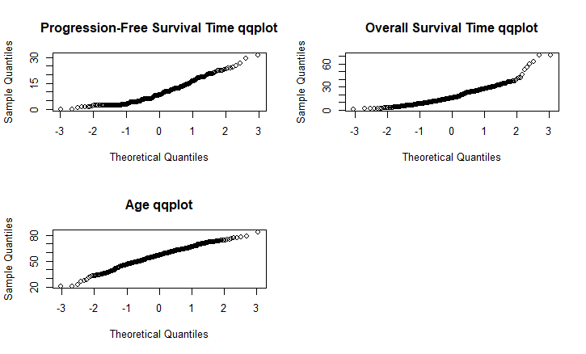
This shows that the dataset follows normal distribution.
Correlation Matrix for top 5 gene in survival category
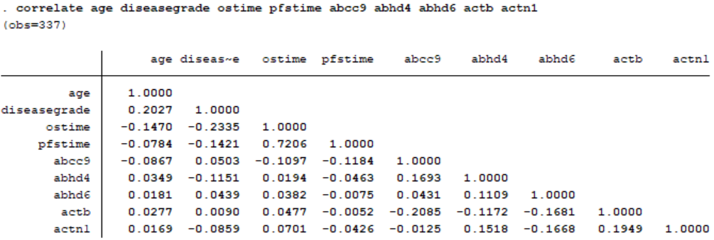
Grade Gene
There are 497 subjects: 184 Females, 305 males and 8 missed gender identity. Also, there 504 genes in this category

Summary for age grade and top 5 genes in grade category

 | Mean | SD | 1st Q | Median | 3rd Q | Missing Values
Age | 56.89 | 11.612 | 51.00 | 58.00 | 65.00 | 8
Grade | 1.614 | 1.656 | 0.000 | 1.000 | 4 | 12
ABCC9 | 1.05 | 0.499 | 1.000 | 1.000 | 1.000 | 0
ABHD4 | 1.078 | 0.512 | 1.000 | 1.000 | 1.000 | 0
ABHD6 | 1.044 | 0.514 | 1.000 | 1.000 | 1.000 | 0
ACTB | 1.282 | 0.525 | 1.000 | 1.000 | 2.000 | 0
ACTN1 | 1.219 | 0.530 | 1.000 | 1.000 | 2.000 | 0

Q-Q Plots for age and grade in grade category
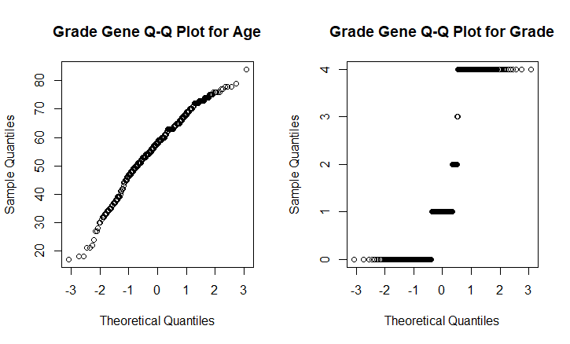
This plot shows a normally distributed age. Grade does seam to be normally distributed. This due to the fact that, grade is a categorical variable, and qqplot cannot be used for it.
Correlation for Grade top 5 genes in grade category.
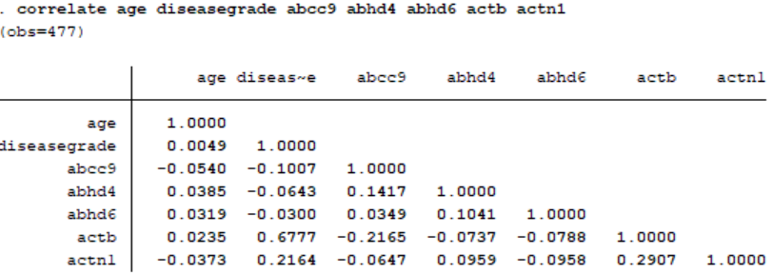

Treatment Genes
Summary: There are 449 subjects: 151 Females, 294 males and 4 missed gender identity. Also, there 571 genes in this category
 | Mean | SD | 1st Q | Median | 3rd Q | Missing Values
Age | 55.95 | 10.694 | 49.00 | 56.20 | 63.80 | 4
Grade | 0.5786 | 0.641 | 0.000 | 0.000 | 4 | 112
ABCC9 | 0.9644 | 0.604 | 1.000 | 1.000 | 1.000 | 0
ABHD4 | 1.094 | 0.522 | 1.000 | 1.000 | 1.000 | 0
ABHD6 | 1.065 | 0.498 | 1.000 | 1.000 | 1.000 | 0
ACTB | 1.243 | 0.514 | 1.000 | 1.000 | 2.000 | 0
ACTN1 | 1.232 | 0.555 | 1.000 | 1.000 | 2.000 | 0

Q-Q Plot for age and grade in treatment category.
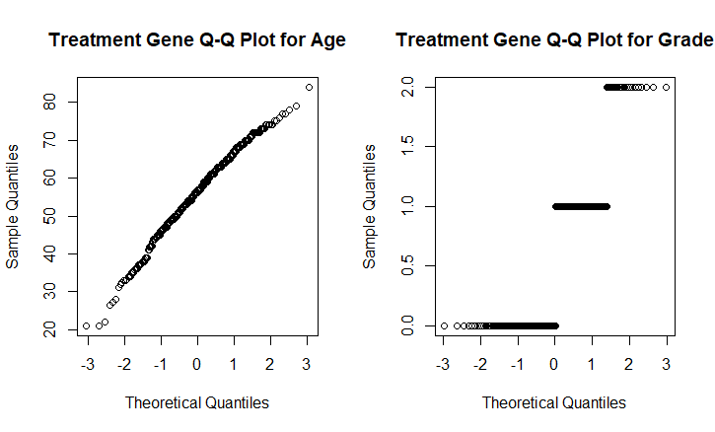
Correlation for the top 5 genes in treatment category


