PHC 6067
Probabilistic Graphical Models
Class Project Proposal

Abstract
Introduction
Methods
Timeline

Abstract
Glioblastoma multiforme (GBM) is the most common primary malignant brain tumor in adults. It has a very poor clinical outcome and median survival time of 15 months, even with aggressive surgical resection, radiotherapy and chemotherapy. It accounts for about 15% of all primary brain tumors. Despite much research it still remains incurable. To appropriately and adequately treat this disease, the causal associations of various genes involve in its pathogenesis and progression need to be better understand, and this knowledge should be factored into developing effective treatment. We also need to know how these genes together with age and gender specifically relate (determine) survival time in people with the tumor.
We aim to learn, using Bayesian network modeling, the association of various overall survival time with various identified genes, gender and age. Do these variables have effects on overall survival time? Since we are going to be concentrating on what affects survival time, i.e. time from diagnosis to death, in people with GBM, it will be worthwhile to use Dynamic Bayesian Network to model our data. This we help us to determine relationship between survival time and genes that affect this relationship. We are setting out to see if some of these genes have any association with patients’ survival time, and how these genes (related to survival) behave across gender differences. Learning these relationships may help in improving survival time, and ensure extended progression free survival. Even though, survival time length perhaps mainly depends on grade at diagnosis, treatment types, patient demographics, genes etc., we are going to be concentrating on patients’ gender, age, and gene types.
Introduction
Glioblastoma multiforme and is the most common and aggressive primary brain tumors. It accounts for about 15% of all primary brain tumors, 45.2% of all malignant primary brain and CNS tumor and 54% of all gliomas. It is commonly located in the supratentorial region of the cranium and rare in cerebellum and spinal cord. Advance in medical diagnosis and treatments notwithstanding, there is no current cure for GBM. The median survival for patient with GBM is about 15 months, despite aggressive surgical, radiotherapy and chemotherapy.
GBM has annual age-adjusted incidence rate of 3.19 per 100,000 population. It is more common in adult with median age diagnosis of 64 years. It is less common in children account only 3% of all brain and CNS tumor among them. However, incidence raises with age. Men have higher incidence compare to women.
Methods
- Describe the data using descriptive statistics such as mean, standard deviation, variance and frequency table. Determine the distribution and normality.
- Determine the correlations between overall survival time (as our outcome), gender, age and genes
- Overall survival time is discretized to binary numbers (0 and 1) based on average overall survival time in our data. The mean overall survival time is 17.83 from over data. We group value less than or equal to 17.83 as 0, and values greater than 17.83 as 1. Likewise, we grouped patients’ age into two categorize using the mean age of 56 year as cutoff. Age 56 and below are assign 0 value while age greater 56 are assign value of 1. We equally represent male as 0 and female as one.
- We will learn the structure and CPTs of relationship between outcome overall survival time and gender, age and genes, and the make estimates and inferences base on this.
- We will apply dynamic Bayesian network to determine how overall survival time relate to gender, age and genes over the time frame giving in our dataset.
Dataset
Datasets for survival information on GBM (GSE7696, GSE84010) was downloaded from NCBI database using Geoparse in python. Then, data was clean and merged as a single data using a python code we created. After cleaning and merging, we have in the data individual specific ID, demographic information, overall survival time, 638 genes for 428 subjects. The data is now ready for analysis.
Preliminary Descriptive Statistics Results
Summary of overall survival time, gender, age and top 5 genes is as follows:
Gender: There are 145 females and 284 males in the data set. Male to female ratio is roughly 2:1.
Age: Age summary is as shown in the table below. The Q-Q plot show age is normally distributed in this data.
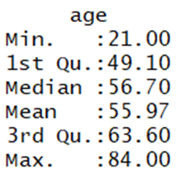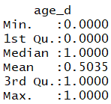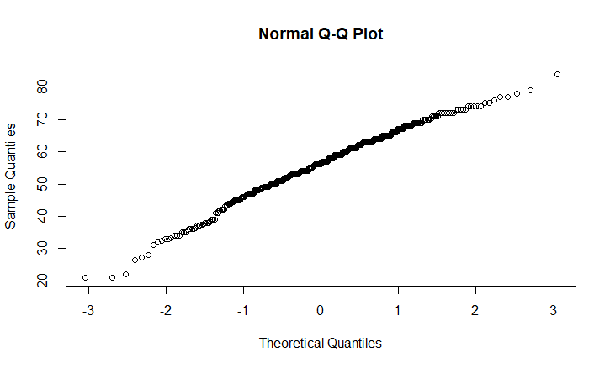
Overall survival time: This also appear normally distributed
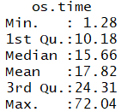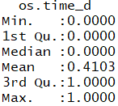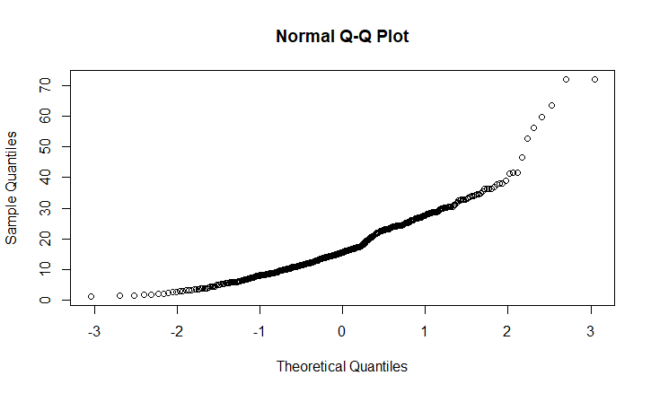
Other summaries include:
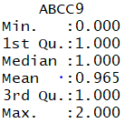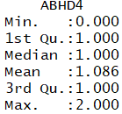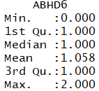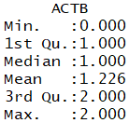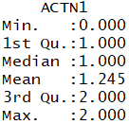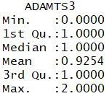
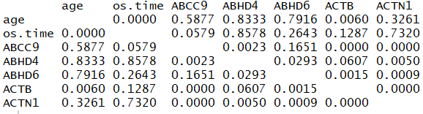
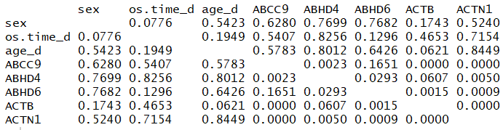
From the correlation matrix, overall survival time appear to be more (positively) correlated with genes ABHD4 (0.83) and ACTN1 (0.72). Correlations between genes are minimal.
Our next step is to use bnlearn package in r to learn this dataset for appropriate parameters estimation and inference, while we continue of literature search for more details
Timeline
S/N | Activity | Date
1 | Study around the dataset for basic understanding | Sept 24 – Oct 1
2 | Write up project proposal/outline | Oct 1 – Oct 8
3 | Clean up data | Oct 1 – Oct 8
4 | Descriptive Analysis of the data | Oct 8 – Oct 22
5 | Write up abstract and introduction | Oct 8 – Oct 22
6 | Apply BN learn to data | Oct 23 – Oct 30
7 | Review results | Oct 30 -Nov 13
8 | Write up result and discussion | Nov 13 – Nov 27
9 | Compile complete project | Nov 27 – Dec 3

