PRIMARY METHODS FOR MICROARRAY RAW DATA ANALYSIS
The proposed methods in this document will describe Aim 2 and its processes, describing and identifying Nuclear respiratory factor 1 (nrf1) molecular signatures. The downstream analysis illustrated in Figure 1, ONLY utilizes samples from adult zebrafish liver tissue. More, the query used to extrapolate the samples are from the Gene Expression Omnibus (NCBI-GEO) and includes: “Environmental stressors”, “Heavy metals”, “Zebrafish”, “Gene Expression”, “Arsenic”, “Cadmium”, “Microarray”, “Mercury”, and “Estradiol”.
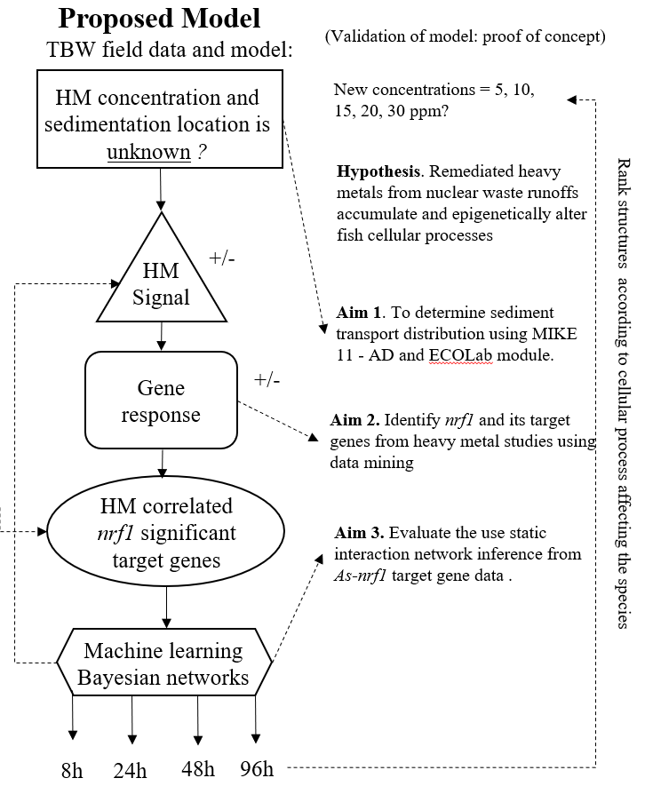
Figure 1. Proposed flowchart of research testing the efficacy of nuclear respiratory factor 1 and its target genes as a surrogate marker for ecosystem recovery and remediation success of environmental stressors in surface waters.
- DOWNLOAD DATA. Obtain raw data from the NCBI Gene Expression Omnibus. First identify the dataset and begin to filter each sample concentration and exposure time conditions including their designated platforms of gene list identifiers.
Identified contaminants: Arsenic, Cadmium, Mercury, and Estradiol
Table 1. Zebrafish transcriptomic data in which a contaminant of exposure (x) is evaluated as a function of time. Data from this table will be used to extrapolate the nrf1 molecular signatures.
CONTAMINANT | CONCENTRATION | EXPOSURE TIME | SEX | SAMPLES | GENE SERIES EXPRESSION | PLATFORM
Arsenic (As) | 15 ug/L | 8, 24, 48 and 96H | M | 24 | GSE3048 | GPL2715
Arsenic (As) | 15 ug/L | 8, 24, 48 and 96H | F | 24 | GSE30062 | GPL2715
Cadmium (Cd) | 30 ug/L | 8, 24, 48 and 96H | F | 22 | GSE41622 | GPL2715
Cadmium (Cd) | 30 ug/L | 8, 24, 48 and 96H | M | 22 | GSE41623 | GPL2715
Estradiol (E2) | 0.5, 5, and 50 ug/L | 24 and 96H | M | 50 | GSE30050 | GPL10182
Mercury (Hg) | 200 ug/L | 8, 24, 48 and 96H | N/A contact author | 24 | GSE18861 | GPL2715

- GENERATE DATA MATRIX TABLE. Illustrated in Figure 2, the data matrix identifies the variables used to incorporate in the downstream analysis. First, identify the treatment and control groups. Second, categorize the replicate groups and insert them into individual groups. Using the GLP platform for the designated dataset, insert the gene list and reference identification number to align all samples with their gene ids.
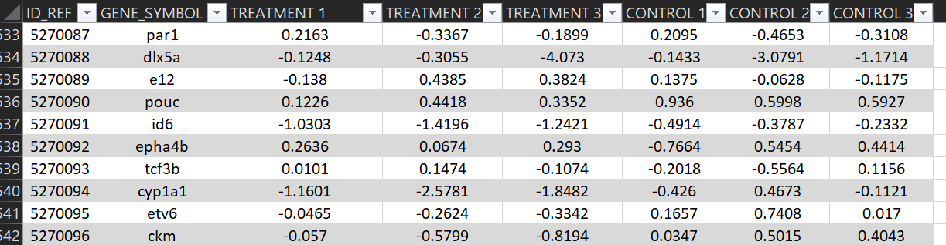
Figure 2. Sample data frame including treatment conditions and control samples with their designated gene symbol and reference identificator.
- REMOVE BLANK GENE SETS. Remove the blank rows in the gene list first. This allows for easy access and will help you identify the initial paraments. First, using the home tab select the editing tool- FIND select and go to SPECIAL. In addition, select BLANKS and click OK. Go to cells, delete cell rows. This will effectively remove all blank rows in the data frame.

- AVERAGE PROBE SETS. Before Using the SUBSTOTAL function tool, SORT the data from A-Z and then go to data, select SUBTOTAL tool and select Gene symbol at gene to change and follow the icon to select the appropriate variables. Copy the new simplified version of the average probe sets to a new sheet and make a data frame using the insert table selection. Figure 3 identifies the averaging of the probe sets which is an important component in the downstream analysis of microarray data.
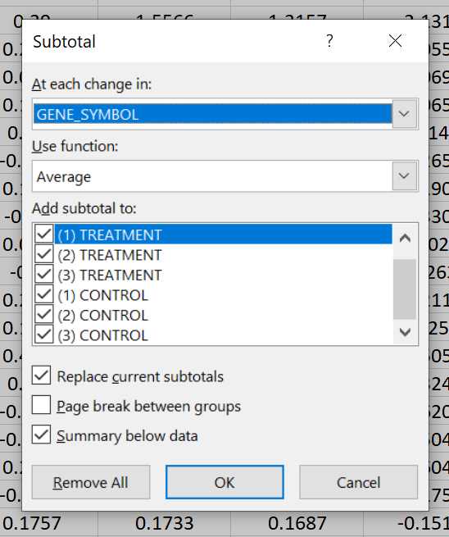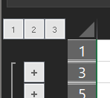
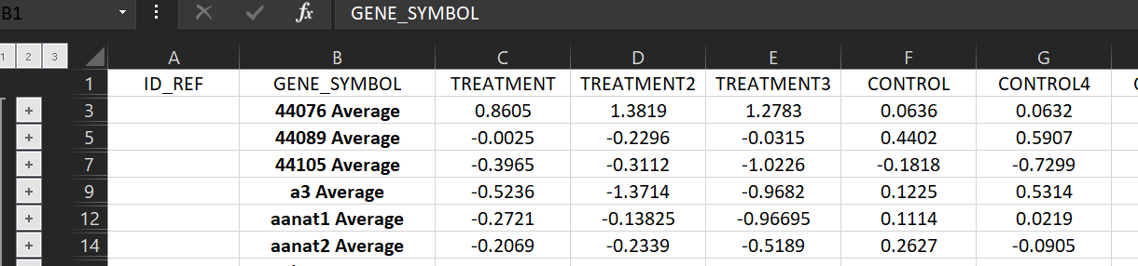
Figure 3. Simplified data frame including average probe sets for treatment and control samples.
- IDENTIFY ONLY AVERAGE PROBESETS USING FILTER OPTION. Go to the filter option in the GENE_SYMBOL icon and write AVERAGE in the search bar. This will allow for the selection of all the probe sets in the average selection. Copy and paste this new list to a new sheet.
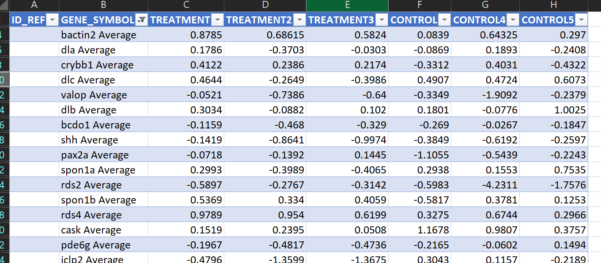
Figure 4. This image represents the original spreadsheet generated in the analysis using the SUBSTOTAL function. All duplicate genes were averaged and simplified into a groupd dataset.
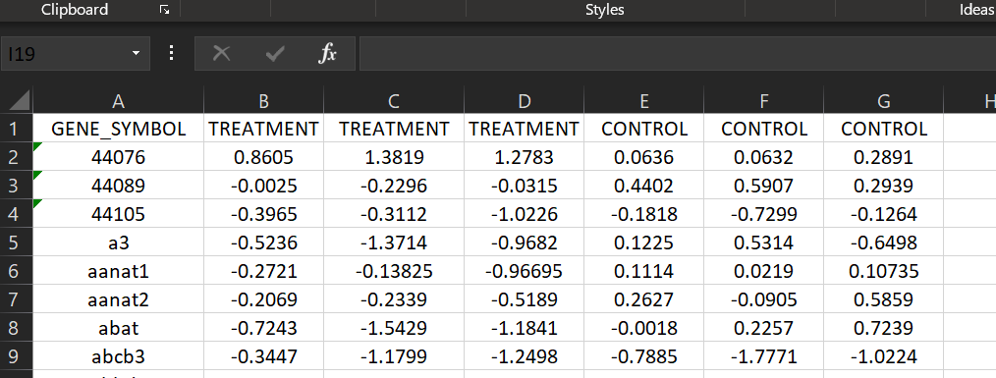
Figure 5. Final version of dataset including the removal of the AVERAGE suffix after the gene name.
- IDENTIFY NEW GENE LIST. Remove all words after the space bar from the selected GENE_SYMBOL. Write this code in the designated cell to remove all text after the space bar.
=LEFT(A1,FIND(" ",A1)-1)

- SELECTION OF NRF1 TARGET GENES. Download NRF1 ChIP-seq dataset and identify how many nrf1 target genes. To identify a comprehensive set of nrf1 molecular signatures, select and copy the 11280 target genes of the NRF1 transcription factor in ChIP-seq dataset from the ENCODE Transcription Factor Targets dataset. Data used will be from the binding site motifs from the ChIP-seq datesets from the ENCODE TF datasets: https://amp.pharm.mssm.edu/Harmonizome/gene_set/NRF1/ENCODE+Transcription+Factor+Targets.
- IDENTIFY NRF1 TARGET GENES. Copy the NRF1 signature genes into column a of the data matrix. Using the conditional formatting tool in excel -> highlight the duplicate values icon and select OK. Copy and paste the new list of NRF1 target genes to a new sheet.
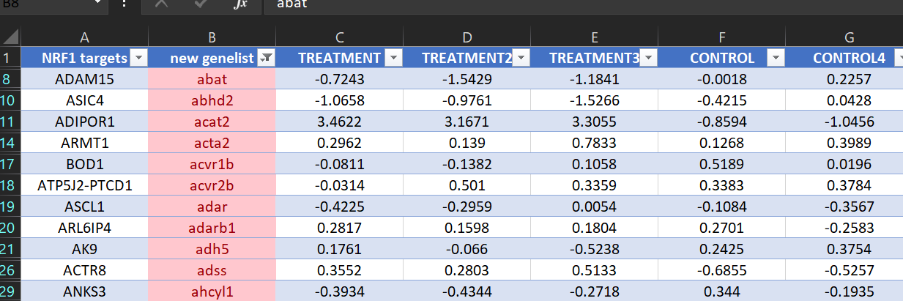
Figure 6. Using the conditional formatting tool, a new list of genes was extracted filtering out only the nrf1 targets and were selected in red. This process allows for the identification and aligned grouped sample changes.
- IDENTIFY SIGNIFICANT NRF1 TARGETS. First, run R studio and using the Linear Models for Microarray Data (limma) package from Bioconductor, compare the Treatment vs Control genes using a Student t-test to identify which genes are differentially expressed. The output will be a summary comparative data frame shown in Figure 4 which includes a the downstream analysis (Gene ID, Adjusted p value, P value, t test, B test Log FC, Gene Symbol and gene title). The criteria of selection for our proposal is (p value <0.05, logFC > ± 1). During this step, the source code incorporates a visualization application to test the median-centered distribution across all samples as shown in Figure 5. If the data is uniformly distributed, you may continue in using the dataset for downstream analysis.
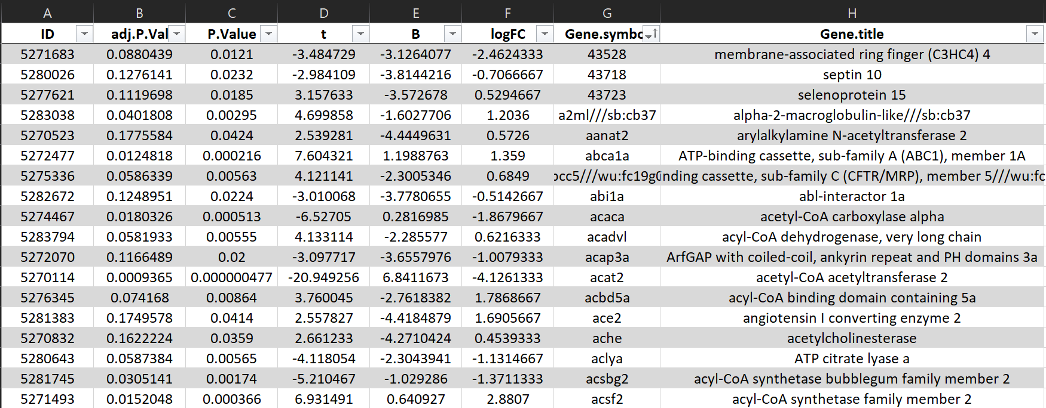
Figure 7. Summary table that includes a comparative analysis using a student t-test to identify the differentially expressed genes found across the grouped dataset.
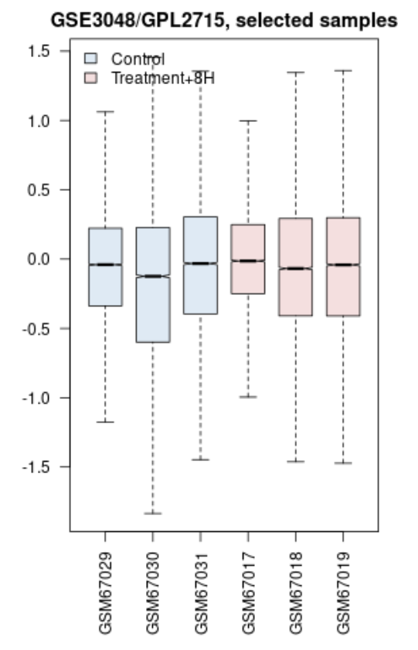
Figure 8. Treatment and control samples comparison of data distribution across sample data. This test is to confirm whether the data is uniformly distributed and ready for downstream analysis.
For our proposal, we will utilize a two-phase criterion (p value < 0.05 and LogFC > ± 1). To identify, first copy and paste the new gene list into a new spreadsheet and remove duplicates rows using the remove duplicates function found in the Data tools. Use this new set list to compare with the nrf1 targets.
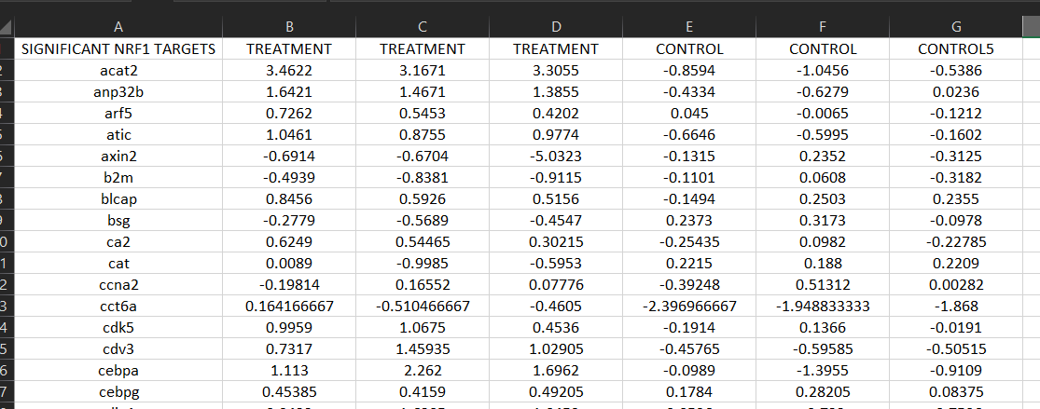
Figure 9. Representative gene list with grouped treatment and control group set of gene expression.
ZSCORE TRANSFORMATION. Copy the gene list from the significant nrf1 targets to a new spreadsheet. Begin by calculating the average and standard deviation on each sample group using the AVERAGE and STDEV.S function. Second, use source code in Figure 10 to process the ZSCORE transformation.
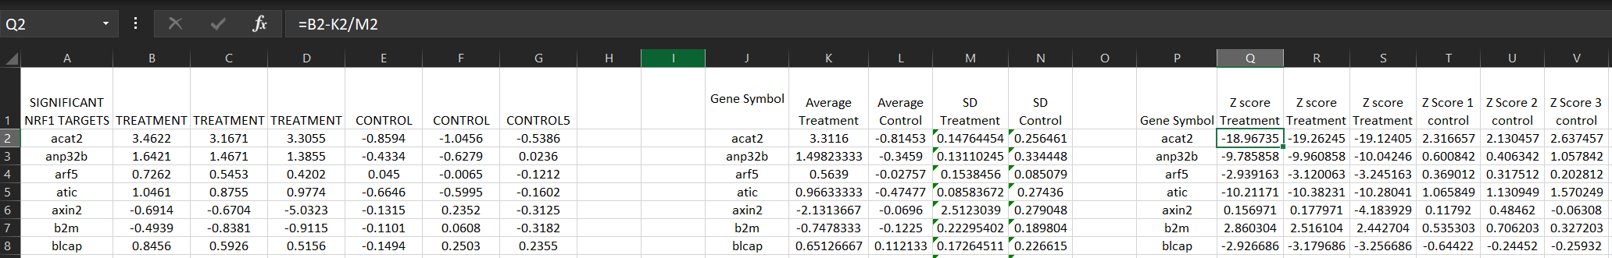
Figure 10. Analysis and workflow utilizing source code to calculate the Z score for each individual sample group.
HIERARCHICAL CORRELATION ANALYSIS. Begin a new spreadsheet(tab) and copy the entire nrf1 target gene list. Calculate the average of each row across treatment and control group. Use the AVERAGE function and account for the 3 replicate samples in each row (treatment and control) -> =AVERAGE(number 1, number 2). Calculate the rank average using the = RANK.AVG(K2,K$2:K$110,0) function source code. This will rank each individual row and rank according from the largest to smallest, include treatment and control groups.
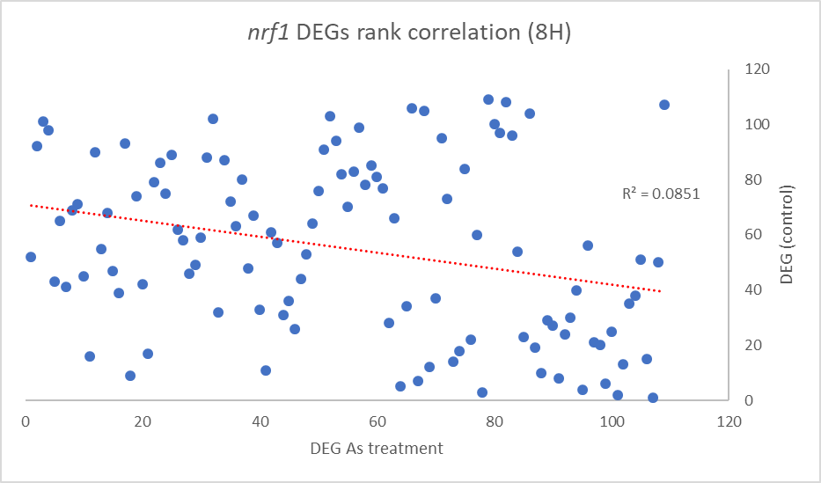
Figure 11. Pearson correlation analysis identifying nrf1 targets correlated genes in response to arsenic (8H)
Calculate the difference and difference squared using the =(M2-N2), and =(O2^2) functions. Plot the data and run a trendline across.
Using the difference analysis, plot the genes and rank according to smallest to largest to identify which gene is highest correlated to arsenic treatment.
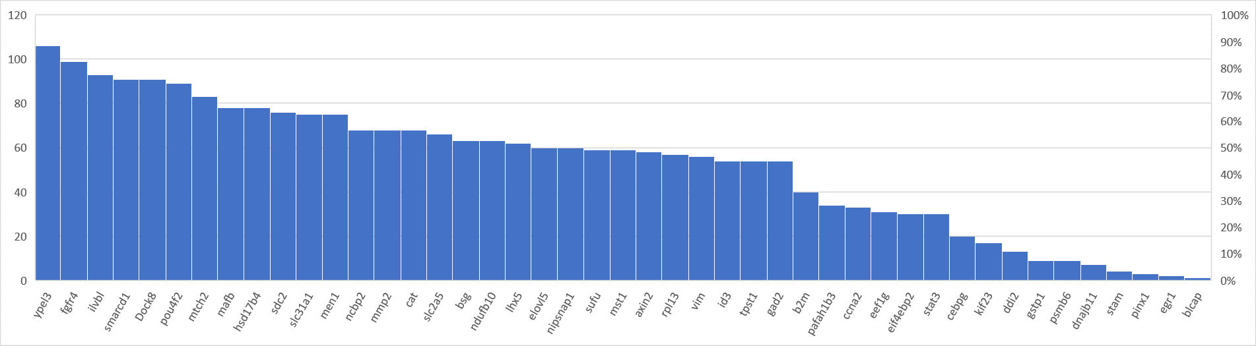
DISCRETE VARIABLES- BANJO PREPROCESSING. Copy and paste the gene list from Figure 10 and follow source code to discretize each sample group with its representative gene ID. Use this list to begin BANJO and include the condition including time of exposure.
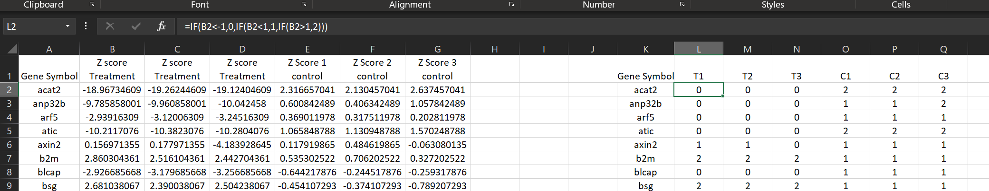
Figure 12. Z score transformed groups to a discrete preprocessing for BANJO.
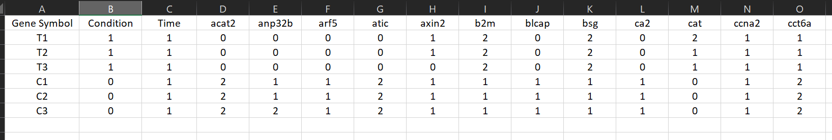
Figure 13. Banjo input file including the time, exposure condition, treated and control genes
Research plan. Clearly outline my criteria and nodes.
What are the nrf1 targets to select. Are
Remove Time. Look at the individual times
Gender include once finished. As exposure vs gender.
Look A the research question before running Banjo
What are the variable I my question. Gender, nrf1 targets, treatment
Extrapolate genes that are relevant to As exposure and are nrf1 targets in fish model. (llok at panther, cdt toxicogenomic database.) Biological implications.!
Review Dr. Parks and Dr. Yoos Paper on bones metastasis

