Insights into the Interplay Among Zinc, Biological Aging, Energy Intake, and Inflammation: A Cross-Sectional Analysis Using 2015-2018 NHANES Participants
Keywords: Zinc, Dietary Intake, Fasting, Inflammation, Biological Aging
Word Count: Abstract 295; Text 3,782
Author Contact Information: Rebecca Lake, MS, RD^{a,1}, Juan Liuzzi, PhD^{a,2} and Changwon Yoo, PhD.^{b,3 a}Department of Dietetics and Nutrition, ^{b}Department of Biostatistics, Robert Stempel College of Public Health & Social Work, Florida International University, 11200 SW 8th Street, AHC5, Miami, FL 33199. Phone: 305-348-4903. Email: rpazo001@fiu.edu¹; ORICD: 0000-0002-9011-6802¹; jliuzzi@fiu.edu² ; ORCID: ²;cyoo@fiu.edu³;ORCID: ³; Position: PhD Candidate¹, Associate Professor in the Department of Dietetics and Nutrition², Associate Professor in the Department of Biostatisitics³
Author Contributions: Dr. Liuzzi and Dr. Yoo were instrumental in the conceptualization, investigation , formal analysis, methodology, validation and reviewing and editing the manuscript. Mrs. Lake also participated in the conceptualization, investigation, methodology, validation, formal analysis as well as data curation, programming and data visualization and writing the original draft.

Corresponding Author & Reprint Contact:

Rebecca Pazos, MS, RD. PhD Candidate. Department of Dietetics and Nutrition, Robert Stempel College of Public Health & Social Work, Florida International University, 11200 SW 8th Street, AHC5, Miami, FL 33199. Phone: 515-200-6025. Email: rpazo001@fiu.edu .

Competing Financial Interest: The study was funded in part by internal funds of Florida International University. The funder was not involved in the study design; in the collection, analysis, and interpretation of data; in the writing of the report; and the decision to submit the article for publication.
Conflict of Interest: None to Report.
Acknowledgements:

Research Snapshot
Research Question: Is there a three-way interaction effect among age, dietary zinc intake, and energy intake that may be associated with circulating levels of HS-CRP?

Key Findings: This is a survey-weighted, cross-sectional study using 4,415 adult participants from 2015-2018 NHANES cycles. A three-way interaction effect was identified among those who consumed at least 8 mg of Zn (“Adequate Intake”), those who “Fasted” and “Age”; this was significantly associated with increased levels of HS-CRP. Additionally, another three-way interaction effect was identified among Adequate Intake, “Moderate Calorie Diet” and Age; this was significantly associated with lowering HS-CRP.

Abstract
Background: Although it is documented that zinc plays an essential role in immune function, little is known about its relationship to factors that influence biological aging.
Objectives: The primary objective of this study is to investigate how fasting status, total energy intake, and carbohydrate intake interfaces with dietary zinc, aging and acute inflammation status via HS-CRP.
Design: This is a survey weighted, cross-sectional analysis.
Participants / setting: The data derives from 4,415 adult participants from the 2015-2018 NHANES cycles with a BMI of 17-34.9. The data from the first dietary recall, questionnaire, examination, and bloodwork was collected at the MEC. The data from the second dietary recall was collected via telephone three - ten days later.
Main outcomes measures: Circulating levels of HS-CRP were associated with Fasted, Age, and Adequate Zn Intake while adjusting for WBC count, Copper Intake, Choline Intake, Folate Intake and Gender. Circulating levels of HS-CRP were also associated with a Moderate Calorie Diet, Age, and Adequate Zn Intake while adjusting for WBC count, Copper Intake, Choline Intake, Folate Intake and Gender.
Statistical analyses performed: Survey weighted generalized linear models and the Likelihood-Ratio-Test were implemented via the survey package in R.
Results: A three-way interaction effect was found among Fasted, Adequate Zn Intake, Aging (exp β = 1.02 ,P= 0.036, 95% CI 1.00, 1.04; Working 2logLR = 16.567, P= 0.035 ) and was associated with higher levels of HS-CRP. Adequate Zn Intake, Moderate Calorie Diet, and Aging (exp β= 0.98, P= 0.031, 95% CI 0.96, 1.00; Working 2logLR = 19.026, P= 0.028) were associated with lower HS-CRP.
Conclusion: In the short term, fasting while have adequate zinc intake and increase age may raise HS-CRP. In the long term, a moderate caloric intake, adequate zinc intake and decreasing age may lower HS-CRP.

Introduction
Biological aging can be roughly defined as the overall resemblance an individual has to the average age associated changes in their chronological age group.¹ Biological aging varies from chronological aging because it suggests that aging can be accelerated or decelerated based upon environmental, genetic, and lifestyle factors.¹ To date, one of the most potent modulators of biological aging in mammalian and nonmammalian species is caloric restriction (CR).²⁻⁴ Although the mechanism of CR is not fully elucidated, it is believed that CR may inhibit mTOR complex 1, which is believed to increase lifespan. ⁵⁻⁶ Additionally, the micronutrient zinc, may impact the same pathway as it has been shown to, in part, inhibit AMPK/ mTOR pathway by inducing Beclin 1 and promoting autophagy; the latter is a mechanism where dysfunctional or excessive cell components are removed or recycled.⁶⁻⁹
In practice, data collected from humans on energy intake as well as macronutrient intake in relation to biological aging and mortality has been mixed, particularly in short duration caloric restriction.^{5,11-13} However, some studies such as the longitudinal, randomized trial called CALERIE, have found that normal weight participants between the ages of 21-50 who practiced modest CR did see improvement on markers used to classify biological aging.⁵ Further, data gathered from the Caloric Restriction Society (CRON), suggests that men and women who consumed roughly 30% less energy than their peers, but still had optimal nutrient intake had ideal levels of biomarkers related biological aging.¹¹ Turning to carbohydrates, a metanalysis found that those who consumed a diet of 50-55 % carbohydrate have a lower risk of mortality.¹² However, more recent data from an 37,233 person NHANES study suggests that healthy, low-carbohydrate and low-fat diets were not associated with increase mortality rates.¹³Finally, there are studies that proport lower protein diets with a higher carbohydrate intake decreases the risk of mortality.^{11,14}
One marker that is used as a clinical biomarker associated with biological aging CRP or HS-CRP.^{10-11,15}CRP belongs to the pentraxin family of proteins and is released in the blood during times of stress, trauma or acute infection via IL-6.¹⁶⁻¹⁷ It is mainly synthesized by the liver and is consider an acute phase reactant.¹⁸ More recently, high-sensitivity or HS-CRP has been used to measure CRP levels as it is a more precise way to measure the biomarker.¹⁸ Mechanistically, CRP is suspected to play a role in autophagy and longevity by blocking Beclin 1’s release from Beclin-2 complex, thereby inhibiting autophagy when circulating levels of CRP are elevated.^{9,17} Current research suggest that zinc intake via diet or supplementation can lower circulating levels of HS-CRP and improve mortality outcomes.¹⁹⁻²⁰ Finally, zinc may act as a catalyst for the degradation of cellular component in the autolysosome, which may help reduce long-term inflammation.²¹
The primary objective of this study is to investigate how total energy intake, carbohydrate intake and fasting status may interface with dietary zinc intake, aging and acute inflammation status via HS-CRP. To our knowledge, there has yet to be a study investigating this three-way interaction effect among these variables or how they can possibly relate to biological aging. Overall, the study looks to provide insight on how zinc may interface with these variables using epidemiological data gathered from 2015-2018 NHANES participants.

Methods
Study Design and Study Population
Study participants derived from the National Health and Nutrition Examination Survey (NHANES). NHANES is an ongoing program that is affiliated with the Centers for Disease Control and Prevention (CDC) and is tasked with evaluating the health and nutritional status of Americans.²² The main aim of NHANES is to generate high quality data that may be analyzed by various professionals that can help inform public health policy.
This study is a survey weighted, cross-sectional, secondary analysis that uses publicly available data collected from the 2015-2016 and 2017-2018 NHANES cycles. The initial sample size of the 2015-2016 cycle is 9,971 participants and 2017-2018 cycle was 8,366, totaling 18,337 participants. A complete case analysis (CCA) was conducted for all variables, which were the following: Dietary Zinc Intake, Fasting, Age, Energy Intake (Kcals), Carbohydrate Intake, HS-CRP, Dietary Folate, Dietary Copper, Dietary Choline, WBC Count, BMI, Gender, and Race and or Ethnicity. Then, participants who were younger than 19 years old were excluded reducing the sample size to 6,276. Following, the recommended bridge equation for HS-CRP was implemented and negative values as well as values greater than 100 were excluded (n= 232) and dietary zinc values greater than 40 mg were also removed from analysis (n=15).²³ Finally, participants with a BMI less than 17 and greater than 34.9 were excluded from the analysis leaving the final sample to be 4,415. The above exclusion criteria were implemented to reduce bias and improve the quality of the data. Lastly, according to the Florida International University’s Institutional Review Board, this study is exempt as it falls under current regulation (§46.104).²⁴

Dietary Data
All NHANES participants were eligible for the dietary assessment. For adults, the dietary assessment began with an in-person interview, which was conducted in the Mobile Examination Center (MEC).²⁵⁻²⁶ Participants were interviewed by a trained professional and were given a set of measuring guides as references for food and beverages they consumed in the previous 24-hours. The interview was designed to use the Automated Multiple Pass Method, which is a computerized recall that collects data by following a five-step probing method.²⁵⁻²⁶ The first step was to have the participant recall all foods and beverages consumed in the past 24-hours, then the participant was probed about commonly forgotten foods. Following, the participant was queried about the time and eating occasion and asked to give an in-depth description of each food item. Finally, one last probe was performed to make sure all foods were accounted. Once this was completed, participants were given a set of measuring guides to use for their second 24-hour recall that took place three to ten days later via telephone.²⁵⁻²⁶ The dietary interview is known as What We Eat in America.²⁵⁻²⁶ For the study presented, the data for the variables Energy Intake (Kcals), Copper, Folate (DFE), Total Choline, Carbohydrate Intake and Zinc derive from this section. Specifically, the average of the two dietary recalls was calculated unless the participant only submitted one recall. Finally, supplement data were not included in the analysis.
Questionnaire Data
For the 2015-2016 and 2017-2018 cycles, a fasting questionnaire was administered. Between one-half to one-third of all participants who were randomly selected to fast.²⁷ The fasting participants donated their blood samples in the morning session during their MEC examination. The phlebotomist administered the fasting questionnaire to the participants, and their results were directly recorded into a computerized database.²⁸⁻²⁹ For this study, the variable fasting is determined by the participants total length of fast in hours. Specifically, the questionnaire asked, “The time (in hours) between when the examinee last ate or drank anything other than water and the time of the venipuncture”.²⁸⁻²⁹ NHANES protocol defines a participant to be fasted if they have not consumed food or any caloric beverages for at least nine hours.²⁷⁻²⁹
Examination Data
The next variable of interest in relation to this study is BMI. All NHANES participants had access to a trained technician that measured their BMI. When a participant entered the MEC for examination, a participant’s standing height and weight was recorded via a stadiometer and digital weighted scale.³⁰⁻³² If a person was in a wheelchair, the technician may have used discretion. Pregnancy status was also noted during body composition measurements. This data extracted was used to calculate BMI in the participants, which follows CDC standards.³⁰⁻³²
Demographic Data
The data for the variables Age, Gender, and Ethnicity and or Race were obtained from the demographic data. The demographic data was gathered by a trained interviewer in the home of the participant.³³⁻³⁴ The data was collected with the assistance of a Computer-Assisted Personal Interview system (CAPI), which helped the interviewer gather key points.³³⁻³⁴ The participant had the option to have a translator and needed to be 16 years old or emancipated to complete this section on their own. After the data was collected in the field, NHANES staff reviewed it for completeness and accuracy.³³⁻³⁴

Laboratory Data
All bloodwork that the participants submitted was extracted by a phlebotomist at the MEC.³⁵ A subsample of participants submitted bloodwork when fasted.^{28-29,35} Blood samples were processed, stored and shipped to the appropriate facilities for analysis.³⁵ The outcome variable’s samples, HS-CRP, were shipped to the Collaborative Laboratory Services in Iowa, where they were analyzed using the Beckman Coulter UniCel DxC 660i Synchron Access Clinical System and Beckman UniCel® DxC 660i Synchron Access Clinical System for the 2015-2016 cycle and the Cobas 6000 for the 2017-2018 cycle.^{23,36} Due to differences in instrumentation, method validation studies were conducted to bridge the differences in variability between the measuring procedures and the equations were implemented in this current analysis.²³ The samples for WBC count were analyzed on site at the MEC using the quantitative analyzer, UniCel DxH 800 Analyzer.³⁷⁻³⁸ QC/QA measures were in place at both the MEC and at the laboratory to maintain the integrity of the process and all values reported a LOD. ^{23,34-38} For further information on these processes, refer to the laboratory manuals or the FAQ.^{35,39-40}
Models, Variables and Potential Cofounders
The following models were constructed:
1. HSCRP ~ Zinc * Fasting * Age + Copper + Choline + WBC + Gender+ Folate
2. HSCRP ~ Zinc * Kcal (energy intake) * Age + Copper + Choline + WBC + Gender+ Folate
3. HSCRP ~ Zinc * Carbohydrate (intake) * Age + Copper + Choline + WBC + Gender+ Folate
For all the models, HS-CRP was the outcome variable, which was continuous and measured in mg/L. Dietary Zinc, Fasting, Kcal (Energy Intake), Carbohydrate Intake and Age were the exposure variables. Dietary Zinc, Fasting, Kcal (Energy Intake), and Carbohydrate Intake were reported as a continuous variable but were transformed into categorical variables in this analysis. For Dietary Zinc Intake, the categories “Inadequate and Adequate Intake” were created and defined as consuming less than 8 mg of zinc per day or consuming more than or equal to 8 mg of zinc per day.⁴¹ The variable Fasting was also defined in a dichotomous manner with those who fasted for 9 or more hours as “Fasted” and then the remainder defined as “Not Fasted”.²⁷⁻²⁹ Kcal was categorized into three categories based upon energy intake. Participants who consumed less than or equal to 1500 kcals per day were defined as “Low Calorie Diet”, 1500.1-2100 kcals per day as “Moderate Calorie Diet” and greater than 2100 kcals per day as “High Calorie Diet”^{.42-43} Carbohydrate Intake was defined as less than or equal to 150 grams per day as “Low Intake”, 150.001-200 grams per day as “Moderate Intake” and greater than 200 grams per day as “High Intake”.⁴⁴ Age was left as a continuous variable and measured in years.
To adjust for potential cofounders, the variables Dietary Copper, Total Choline, WBC Count , Dietary Folate, and Gender were included in the PO’s analysis, and all are continuous except for gender. Copper was a potential cofounder as high levels of copper consumption may impair zinc absorption, as zinc and copper compete for similar transporters.⁴⁵ Choline may be a cofounder as it is poorly recycled in many individuals, and it is a necessary component for CRP to bind and initiate the classical complement pathway, which eventually reduces circulating CRP. ^{46,47} Elevated WBC count is a known marker of inflammation affiliated with acute and chronic infection and is an independent risk factor for mortality as chronic, elevated levels are associated with roughly doubling total mortality risk.⁴⁸ Folate intake may be used as indicator to correct for fruit and vegetables consumption, which are known to reduce inflammation and have numerous beneficial health effects.⁴⁹ Gender was categorized as male and female and is a potential cofounder as men throughout the life cycle have a greater risk of mortality.⁵⁰ BMI was continuous and used as an exclusion criteria for the study. Finally, Ethnicity and Race were categorized as Mexican American, Other Hispanic, Black, White, Asian and Other Race.
Data Management and Statistical Analysis
All relevant data files were downloaded from the NHANES website and transferred to Excel. In Excel, variables were recoded and underwent CCA. Sample weights for combined survey cycles were calculated based off the NHANES protocol.²⁷ Additionally, the recommended bridge equations designated for combined survey cycles for the variable HS-CRP were applied.²³ The datasets were then uploaded and analyzed in R using the package survey, which is designed to analyzed complex survey data.⁵¹ The package gtsummary was used to display the results in the tables.⁵² Descriptive statistics for continuous variables were reported in mean and standard deviation and for categorical variables were recorded as frequency and percent. Due to the distribution of HS-CRP, survey-weighted generalized linear models (GLMs) using a gaussian distribution and link function set to log were constructed.^{53,54} Exponential beta, confidence intervals of 95% and p-values <0.05 were reported. Following, Likelihood-Ratio-Test with corresponding p-value <0.05 were also generated to determine the validity of each model. Finally, to prevent overfitting, 10-fold cross-validation was conducted using the caret package comparing the root mean square error of the trained data with the root mean square error (RMSE) generated from the models.^{55,56} Data will be made publicly available upon the release of the manuscript at GitHub, https://github.com/LittleBlueHeron/Insights-into-the-Interplay-Among-Zinc-Biological-Aging-Energy-Intake-and-Inflammation.

Results:
Exploratory Statistics
As part of the exploratory statistics, the concentrations of HS-CRP were grouped by mg consumption of Dietary Zinc Intake ( prior to categorization) and a simple survey-weighted GLM was performed yielding (exp β= 0.95, P= 0.033, 95% CI 0.92, 1.00). In Figure two, Age was grouped by Dietary Zinc Intake. Adults in their late 70s and early 80s appear to be consuming more zinc than other age groups, although it is not statistically significant metric (exp β= 1.01, P= 0.7, 95% CI 0.98, 1.03). Other exploratory figures can be seen in the supplementary file.

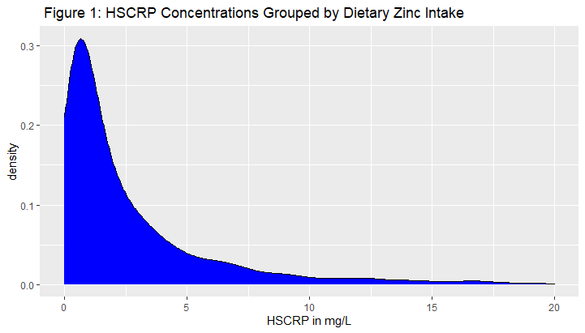

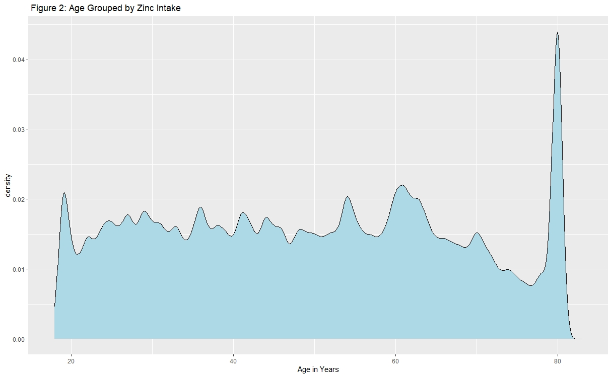
Visual Displays of the Data
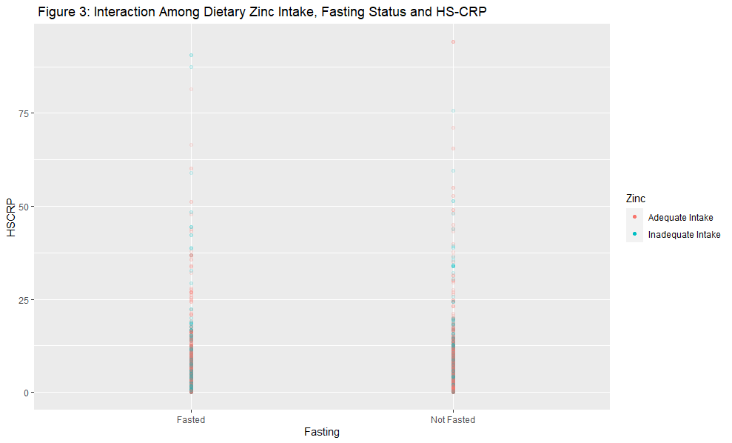
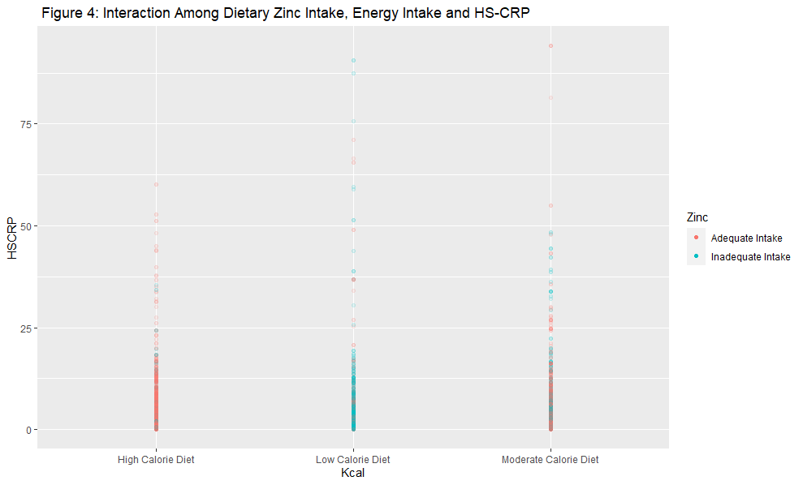
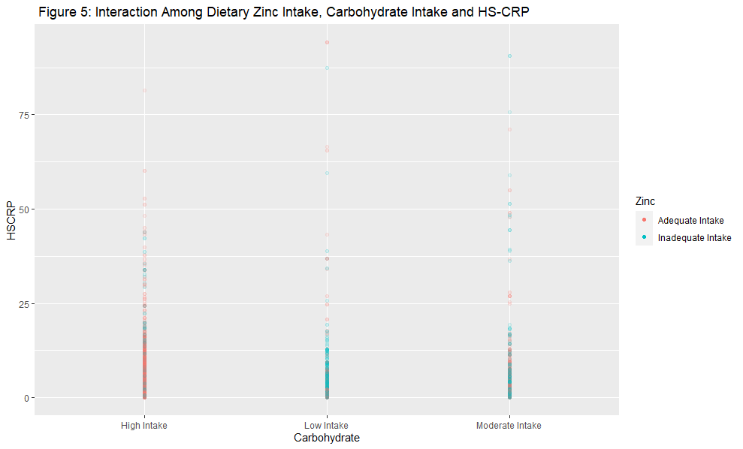
Survey Adjusted Demographics and Other Characteristics of the Participants
In the sample of 4,415 adult participants surveyed, demographics and other pertinent characteristics were stratified by sex. In term of zinc intake, 31.2 % of males and 33.8 % of females had inadequate dietary consumption of zinc as defined by the standards in this study. The mean circulating levels of HS-CRP for both male and female participants were at 3.2 and 3.5 mg/L, which is considered high risk for CVD.¹⁶ In terms of calorie consumption, 39.5 % of male participants and 40.5% of females consumed greater than 2100 kcals per day and 61 % of males and 64.2 % of females consumed more than 200 grams of carbohydrate per day. The mean for folate and copper consumption fells under adequate intake; however, mean choline consumption was inadequate compared to the RDA.⁵⁷⁻⁵⁹ The mean for WBC count fell within the normal range, but the mean for BMI fell within the classification of overweight.⁶⁰⁻⁶¹Fianlly, 43.3 % of males and 45.4% of females fasted for nine or more hours.

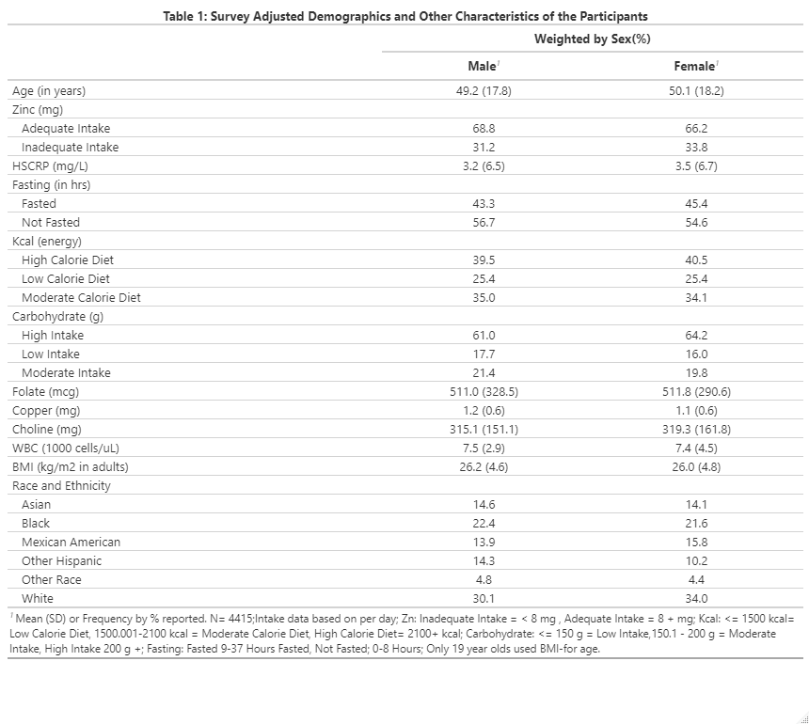Analysis of the Models
For model one, a three-way interaction effect was identified among Fasted, Adequate Intake, and Aging (exp β = 1.02 , P= 0.036, 95% CI 1.00, 1.04) and was associated with higher levels of HS-CRP. Additionally, Fasted (exp β = 3.39 , P= 0.02, 95% CI 1.63, 7.02), WBC Count (exp β = 1.01 , P= 0.001, 95% CI 1.00, 1.01) and Choline ( exp β = 1.00,P= 0.032, 95% CI 1.00, 1.00) were associated with increased levels of circulating HS-CRP. For the two-way interactions, Adequate Intake and Fasted ( exp β = 0.34, P= 0.028, 95% CI 0.13, 0.87) and Fasted and Age ( exp β = 0.98, P= 0.013, 95% CI 0.97, 1.00) were associated with lower levels of HS-CRP. The LRT (Rao-Scott) for the model was Working 2logLR = 16.567 and P= 0.035 . Using 10-fold cross- validation, the RMSE were compared. The RMSE of the trained data vs. the data generated from model one suggests the model was not overfitted ( RMSE of trained data = 6.581 vs. model data = 1.956).
In model two, Adequate Intake, Moderate Caloric Diet, and Aging (exp β= 0.98, P= 0.031, 95% CI 0.96, 1.00) were associated with lower levels of HS-CRP. Further, Adequate Intake ( exp β = 0.24, P= 0.016, 95% CI 0.08, 0.73) and Aged ( exp β = 0.97, P= 0.016, 95% CI 0.97, 1.00) were associated with lower levels of HSCRP , but WBC count (exp β = 1.01 , P= 0.002, 95% CI 1.00, 1.01) and Choline ( exp β = 1.00, P= 0.006, 95% CI 1.00, 1.00) were associated with higher levels of HS-CRP. In terms of two-way interaction effects, Adequate Intake and Moderate Calorie Diet were associated with increased levels of HS-CRP ( exp β = 3.13, P= 0.045, 95% CI 1.03, 9.52). The LRT for model two was Working 2logLR = 19.026 and P= 0.028. The RMSE of the trained data was 6.559 and the RMSE of the model data was 2.054.
The third model for the study found that Adequate Intake (Zn), Moderate Intake ( Carbohydrate), and Aging were not statistically significant as the LRT was Working 2logLR = 12.874 and P= 0.08. The RMSE of the trained data was 6.563 and the model data was 1.937, indicating the model was not overfitted. Finally, although some of the betas in each model may appear small, each one represents the increase in predicted HS-CRP for each unit increase in relation to the three-way interaction effect.
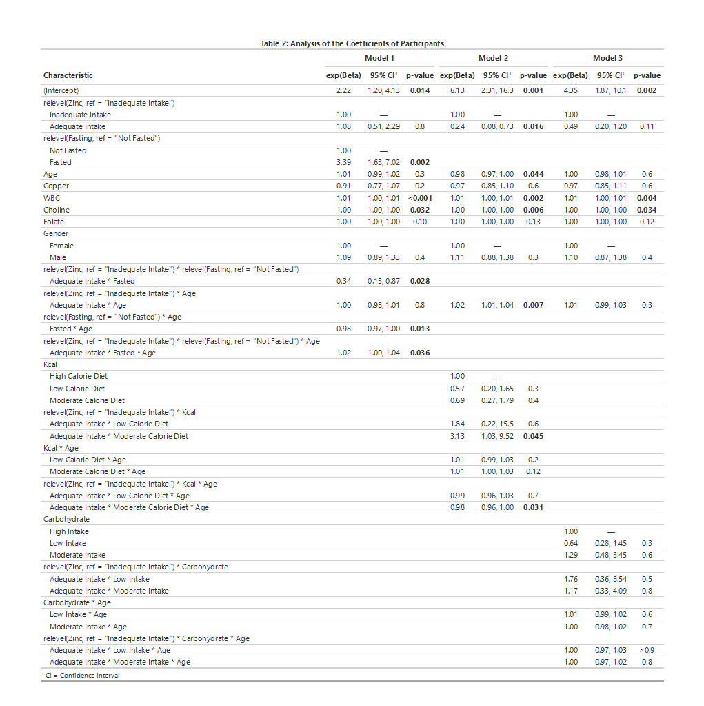

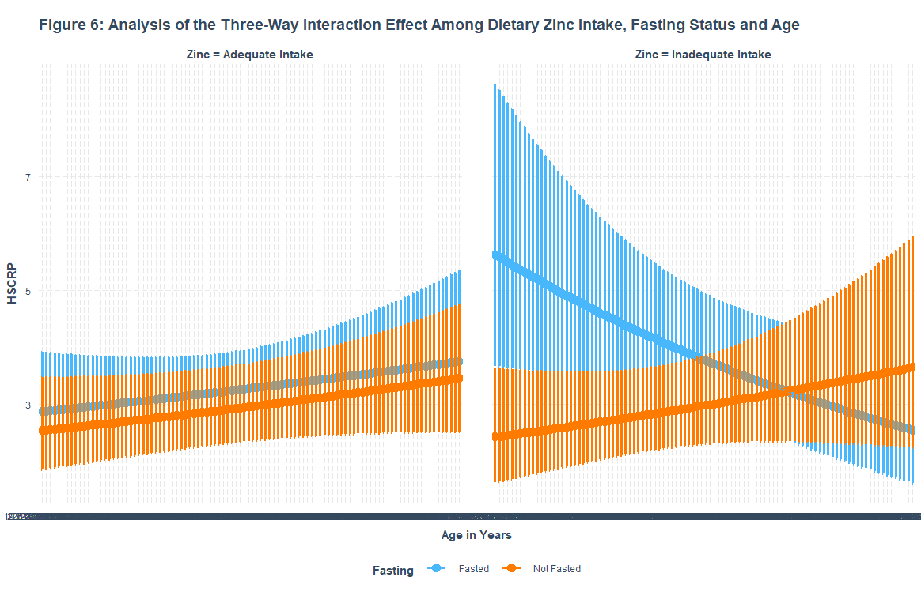
Investigating the three-way interaction effect further, as a participant’s age increased, a participant is fasted for nine or more hours and consumed more than 8 mg of dietary zinc per day, their circulating levels of HS-CRP increased. Additionally, further analysis of suggests that those who consumed less than 8 mg of dietary zinc, fasted for nine or more hours, and were older had lower circulating levels of HS-CRP (exp β= 0.98, P= 0.036, 95% CI 0.96, 1.00).
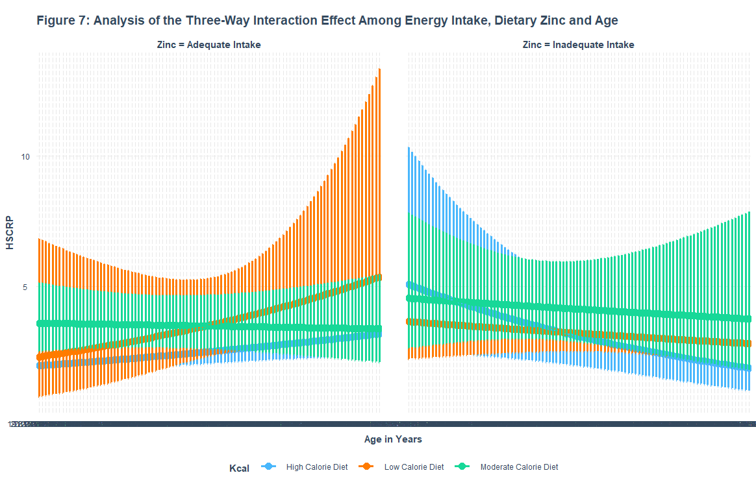
The results for model two suggest those who consumed greater than 1500 but less than or equal to 2100 kcals per day (“Moderate Calorie Diet”), consumed more than 8 mg of zinc per day and were decreasing in age have lower levels of circulating HS-CRP compared to those who consume 1500 kcals per day or less. Participants who consumed an Inadequate Intake, a Moderate Caloric Diet and were increasing in Age were associated with greater levels of HS-CRP ((exp β= 1.02, P= 0.031, 95% CI 1.00, 1.04).
Discussion:
The purpose of this study was to conduct an in-depth analysis among variables that may influence biological aging. Specifically, the main aim was to investigate how total energy intake, carbohydrate intake and fasting status may interface with dietary zinc intake, aging and acute inflammation status via HS-CRP. In a nationally representative sample, the results suggested that when adult participants consumed at least 8 mg of dietary zinc, fasted for nine hours or more and were increasing in age, circulating levels of HS-CRP increased. Further, when participants consumed less than 8 mg of dietary zinc, fasted, and were increasing in age, circulating levels of HS-CRP decreased. Turning to energy intake, the study suggests that those who consumed greater than 1500 but less than or equal to 2100 kcals per day, consumed at least 8 mg of dietary zinc and decreasing in age were associated with lower levels of HS-CRP, but if they consumed less than 8 mg of dietary zinc, then HS-CRP increased. Further, a carbohydrate intake of greater than 150 but less than or equal to 200 grams, dietary zinc intake of at least 8 mg, and age had no statistically significant relationship with HS-CRP.
To our knowledge, no studies have investigated the three-way interaction effects presented; however, there have been numerous studies conducted on fasting, caloric intake and HS-CRP. ⁶³⁻⁶⁵ For example, in a 10-day zero calorie fast conducted in adults who were 22-40 years old, HS-CRP was significantly elevated for the first three days of the fast.⁶³ Further, in a longer term intermittent fasting study conducted in normal weight young adults ages 20-39, fasting for roughly 12 hours a day for a month was found to significantly lower levels of HS-CRP.⁶⁴ In addition, long-term moderate caloric restriction was found to significantly lower HS-CRP in a two year randomized, clinical trial.⁶⁵ Comparing our results to the literature, several insights may be explored. First, those who had an adequate consumption of dietary zinc followed the traditional, short-term inflammatory response that was expected to occur in adults. However, those who did not consume an adequate amount of zinc did not trigger this response as HS-CRP levels decreased, suggesting these participants may not be having an appropriate response to inflammation. Second, moderate caloric consumption with adequate zinc intake may be a useful intervention to help reduce HS-CRP. Finally, the three-way interaction effect that included moderate carbohydrate intake had no significant relationship with HS-CRP.
As with all epidemiological studies, this study has some limitations and as such results should be interpreted accordingly. Firstly, due to the cross-sectional design of the study, causality may not be inferred. Further, there is no recommended range of dietary zinc intake; rather, the RDA for men is 11 mg/day and for women 8 mg/day, which is assumed to cover 97-98% of the population.⁴¹ This study suggested that a beneficial range that included both men and women was at least 8 mg/day, which is lower than the RDA for men. Finally, due to differences in instrumentation, a bridge equation was implemented to correct for variation between the two cycles.
In terms of strengths, this study has several worthy of note. Firstly, to the authors’ knowledge, this was the first time these three-way interaction effects had been investigated. The data followed the NHANES protocol for statistical weighting and data analysis was conducted using survey weighted GLMs via the survey package, which was designed to analyze complex survey data. Although the study did exclude those with a BMI of 35 or greater, it did include participants who were overweight and class I obesity as well as participants of various age. Lastly, the data was derived from a nationally representative sample, which makes the study more generalizable.
Conclusion:
Consumption of at least 8 mg of zinc per day may help an individual have an appropriate response to inflammation during a short-term fast or long-term if s/he consumes a moderate calorie diet. This may, in turn, impact an individual’s response to biological aging. Further research is needed to understand the mechanisms behind this relationship and the possible health impacts on the general population.

Programming Note:
In addition to the packages survey, gtsummary and caret, the following packages were used for the graphing and coding of this manuscript : tidyverse, dbplyr. ggplot2, jtools, interactions and VIM.⁶⁶⁻⁷¹

References:
- Fedintsev A, Kashtanova D, Tkacheva O, et al. Markers of arterial health could serve as accurate non-invasive predictors of human biological and chronological age. Aging (Albany NY). 2017;9(4):1280-1292. doi:10.18632/aging.101227 .
- Pignolo RJ. Exceptional Human Longevity. Mayo Clinic Proceedings. 2019;94(1):110-124. doi:10.1016/j.mayocp.2018.10.005
- Belsky DW, Huffman KM, Pieper CF, Shalev I, Kraus WE. Change in the Rate of Biological Aging in Response to Caloric Restriction: CALERIE Biobank Analysis. The Journals of Gerontology: Series A. 2017;73(1):4-10. doi:10.1093/gerona/glx096
- Belsky DW, Caspi A, Arseneault L, et al. Quantification of the pace of biological aging in humans through a blood test, the DunedinPoAm DNA methylation algorithm. Elife. 2020;9:e54870. Published 2020 May 5. doi:10.7554/eLife.54870
- Tulsian R, Velingkaar N, Kondratov R. Caloric restriction effects on liver mTOR signaling are time-of-day dependent. Aging (Albany NY). 2018;10(7):1640-1648. doi:10.18632/aging.101498
- López-Otín, Carlos, Maria A. Blasco, Linda Partridge, Manuel Serrano, and Guido Kroemer. “The Hallmarks of Aging.” Cell 153, no. 6 (2013): 1194–1217. https://doi.org/10.1016/j.cell.2013.05.039
- Lin S, Tian H, Lin J, et al. Zinc promotes autophagy and inhibits apoptosis through AMPK/mTOR signaling pathway after spinal cord injury. Neuroscience Letters. 2020;736:135263. doi:10.1016/j.neulet.2020.135263
- Ding B, Zhong Q. Zinc deficiency: An unexpected trigger for autophagy. J Biol Chem. 2017;292(20):8531-8532. doi:10.1074/jbc.H116.762948
- Bian A, Shi M, Flores B, Gillings N, Li P, Yan SX, Levine B, Xing C, Hu MC. Downregulation of autophagy is associated with severe ischemia-reperfusion-induced acute kidney injury in overexpressing C-reactive protein mice. PLoS One. 2017 Sep 8;12(9):e0181848. doi: 10.1371/journal.pone.0181848. PMID: 28886014; PMCID: PMC5590740
- Belsky DW, Huffman KM, Pieper CF, Shalev I, Kraus WE. Change in the Rate of Biological Aging in Response to Caloric Restriction: CALERIE Biobank Analysis. The Journals of Gerontology: Series A. 2017;73(1):4-10. doi:10.1093/gerona/glx096
- Most J, Tosti V, Redman LM, Fontana L. Calorie restriction in humans: An update. Ageing Res Rev. 2017;39:36-45. doi:10.1016/j.arr.2016.08.005
- Seidelmann SB, Claggett B, Cheng S, et al. Dietary carbohydrate intake and mortality: A prospective cohort study and meta-analysis. The Lancet Public Health. 2018;3(9). doi:10.1016/s2468-2667(18)30135-x
- Shan Z, Guo Y, Hu FB, Liu L, Qi Q. Association of low-carbohydrate and low-fat diets with mortality among US adults. JAMA Internal Medicine. 2020;180(4):513. doi:10.1001/jamainternmed.2019.6980
- Kitada M, Ogura Y, Monno I, Koya D. The impact of dietary protein intake on longevity and Metabolic Health. EBioMedicine. 2019;43:632-640. doi:10.1016/j.ebiom.2019.04.005
- Beekman M, Uh HW, van Heemst D, Wuhrer M, Ruhaak LR, Gonzalez-Covarrubias V, Hankemeier T, Houwing-Duistermaat JJ, Slagboom PE. Classification for Longevity Potential: The Use of Novel Biomarkers. Front Public Health. 2016 Oct 28;4:233. doi: 10.3389/fpubh.2016.00233. PMID: 27840811; PMCID: PMC5083840.
- Kamath DY, Xavier D, Sigamani A, Pais P. High sensitivity C-reactive protein (hsCRP) & cardiovascular disease: An Indian perspective. Indian J Med Res. 2015;142(3):261-268. doi:10.4103/0971-5916.166582
- Bello-Perez M, Pereiro P, Coll J, Novoa B, Perez L, Falco A. Zebrafish C-reactive protein isoforms inhibit SVCV replication by blocking autophagy through interactions with cell membrane cholesterol. Scientific Reports. 2020;10(1). doi:10.1038/s41598-020-57501-0
- Mayo Clinic. Test ID: HSCRP C-Reactive Protein, High Sensitivity, Serum. Mayo Clinic Laboratories. https://www.mayocliniclabs.com/test-catalog/Clinical+and+Interpretive/82047. Accessed June 10, 2021.
- Bao B, Prasad AS, Beck FW, et al. Zinc decreases C-reactive protein, lipid peroxidation, and inflammatory cytokines in elderly subjects: a potential implication of zinc as an atheroprotective agent. Am J Clin Nutr. 2010;91(6):1634-1641. doi:10.3945/ajcn.2009.28836
- Clemons TE, Kurinij N, Sperduto RD; AREDS Research Group. Associations of mortality with ocular disorders and an intervention of high-dose antioxidants and zinc in the Age-Related Eye Disease Study: AREDS Report No. 13. Arch Ophthalmol. 2004;122(5):716-726. doi:10.1001/archopht.122.5.716
- Liuzzi JP, Guo L, Yoo C, Stewart TS. Zinc and autophagy. BioMetals. 2014;27(6):1087-1096. doi:10.1007/s10534-014-9773-0
- National Center for Health Statistics. 2021.
https://www.cdc.gov/nchs/nhanes/about_nhanes.htm
- HSCRP_J. Centers for Disease Control and Prevention. https://wwwn.cdc.gov/Nchs/Nhanes/2017-2018/HSCRP_I.htm. Accessed November 9, 2021.
- Office for Human Research Protections. 45 CFR 46. HHS.gov.
2021. https://www.hhs.gov/ohrp/regulations-and-policy/regulations/45-cfr- 46/index.html
- Dietary Interview - Total Nutrient Intakes, First Day. Centers for Disease Control and Prevention.https://wwwn.cdc.gov/Nchs/Nhanes/2015-2016/DR1TOT_I.htm.Accessed November 9, 2021.
- Dietary Interview - Total Nutrient Intakes, First Day. Centers for Disease Control and Prevention.https://wwwn.cdc.gov/Nchs/Nhanes/2017-2018/DR1TOT_I.htm.Accessed November 9, 2021.
- Module 3: Weighting. Continuous NHANES Tutorials. Centers for Disease Control and Prevention. https://wwwn.cdc.gov/nchs/nhanes/tutorials/module3.aspx. Accessed November 9, 2021.
- NHANES 2015-2016: Fasting Questionnaire Data Documentation, codebook, and frequencies. Centers for Disease Control and Prevention. https://wwwn.cdc.gov/Nchs/Nhanes/2015-2016/FASTQX_I.htm. Accessed November 9, 2021.
- NHANES 2017-2018: Fasting Questionnaire Data Documentation, codebook, and frequencies. Centers for Disease Control and Prevention. https://wwwn.cdc.gov/Nchs/Nhanes/2017-2018/FASTQX_I.htm. Accessed November 9, 2021.
- BMX_I. Centers for Disease Control and Prevention. https://wwwn.cdc.gov/Nchs/Nhanes/2015-2016/BMX_I.htm. Accessed November 9, 2021.
- BMX_J. Centers for Disease Control and Prevention. https://wwwn.cdc.gov/Nchs/Nhanes/2017-2018/BMX_J.htm. Accessed November 9, 2021.
- National Health and Nutrition Examination Survey (NHANES): Anthropometry Procedures Manuel. NHANES. https://wwwn.cdc.gov/nchs/data/nhanes/2015-2016/manuals/2016_Anthropometry_Procedures_Manual.pdf. Accessed November 9, 2021.
- DEMO_I. Centers for Disease Control and Prevention. https://wwwn.cdc.gov/Nchs/Nhanes/2015-2016/DEMO_I.htm. Accessed November 9, 2021.
- DEMO_J. Centers for Disease Control and Prevention. https://wwwn.cdc.gov/Nchs/Nhanes/2017-2018/DEMO_J.htm. Accessed November 9, 2021.
- NHANES 2015-2016 laboratory data overview. Centers for Disease Control and Prevention. https://wwwn.cdc.gov/nchs/nhanes/continuousnhanes/overviewlab.aspx?BeginYear=2015. Accessed November 9, 2021.
- HSCRP_I. Centers for Disease Control and Prevention. https://wwwn.cdc.gov/Nchs/Nhanes/2015-2016/HSCRP_I.htm. Accessed November 9, 2021.
- CBC_I. Centers for Disease Control and Prevention. https://wwwn.cdc.gov/Nchs/Nhanes/2015-2016/CBC_I.htm. Accessed November 9, 2021.
- CBC_J. Centers for Disease Control and Prevention. https://wwwn.cdc.gov/Nchs/Nhanes/2017-2018/CBC_J.htm. Accessed November 9, 2021.
- Nhanes frequently asked questions (faqs). Centers for Disease Control and Prevention. https://wwwn.cdc.gov/nchs/nhanes/continuousnhanes/faq.aspx. Accessed November 18, 2021.
- NHANES 2017-2018 laboratory data overview. Centers for Disease Control and Prevention. https://wwwn.cdc.gov/nchs/nhanes/continuousnhanes/overviewlab.aspx?BeginYear=2017. Accessed November 9, 2021.
- Office of dietary supplements - zinc. NIH Office of Dietary Supplements. https://ods.od.nih.gov/factsheets/Zinc-HealthProfessional/. Accessed November 10, 2021.

- Kim JY. Optimal Diet Strategies for Weight Loss and Weight Loss Maintenance. J Obes Metab Syndr. 2021;30(1):20-31. doi:10.7570/jomes20065
- Osilla EV, Safadi AO, Sharma S. Calories. [Updated 2021 Sep 15]. In: StatPearls [Internet]. Treasure Island (FL): StatPearls Publishing; 2021 Jan-. Available from: https://www.ncbi.nlm.nih.gov/books/NBK499909/
- Oh, R Gilani B, Uppaluri, KR. Low Carbohydrate Diet.[Updated 2021 Jul 12]. In
StatPearls [Internet]. Treasure Island (FL): StatPearls Publishing; 2021 Jan-. Available from: https://www.ncbi.nlm.nih.gov/books/NBK537084/
- Holt RR, Uriu-Adams JY, Keen CL. Zinc. In: Erdman Jr JW, Macdonald IA, Zeisel SH, eds. Present Knowledge in Nutrition. 10th ed. Washington D.C.: ILSI Press; 2012:521-539.
- Zeisel SH, da Costa KA. Choline: an essential nutrient for public health. Nutr Rev. 2009;67(11):615-623. doi:10.1111/j.1753-4887.2009.00246.x
- Sproston NR, Ashworth JJ. Role of C-reactive protein at sites of inflammation and infection. Frontiers in Immunology. 2018;9. doi:10.3389/fimmu.2018.00754
- Kabat GC, Kim MY, Manson JE, et al. White Blood Cell Count and Total and Cause-Specific Mortality in the Women's Health Initiative. Am J Epidemiol. 2017;186(1):63-72. doi:10.1093/aje/kww226
- Duthie SJ, Duthie GG, Russell WR, et al. Effect of increasing fruit and vegetable intake by dietary intervention on nutritional biomarkers and attitudes to dietary change: A randomised trial. European Journal of Nutrition. https://link.springer.com/article/10.1007/s00394-017-1469-0. Published May 30, 2017. Accessed November 18, 2021.
- Crimmins EM, Shim H, Zhang YS, Kim JK. Differences between Men and Women in Mortality and the Health Dimensions of the Morbidity Process. Clin Chem. 2019;65(1):135-145. doi:10.1373/clinchem.2018.288332
- Lumley T (2020). “Survey: analysis of complex survey samples.” R package version 4.0.
- Sjoberg DD, Whiting K, Curry M, Lavery JA, Larmarange J. Reproducible summary tables with the gtsummary package. The R Journal 2021;13:570–80. https://doi.org/10.32614/RJ-2021-053.
- 6.1 - Introduction to Generalized Linear Models. STAT 504. https://online.stat.psu.edu/stat504/lesson/6/6.1. Accessed November 11, 2021.
- Exploring links for the gaussian distribution. Cran.r-project.org. https://cran.r-project.org/web/packages/GlmSimulatoR/vignettes/exploring_links_for_the_gaussian_distribution.html. Accessed November 11, 2021.
- Arnholt A. Machine learning with caret in R - github pages. Machine Learning with caret in R. https://stat-ata-asu.github.io/MachineLearningToolbox/. Accessed November 11, 2021.
- Kuhn,M. Caret: Classification and Regression Training. https://github.com/topepo/caret/. Accessed November 11, 2021.
- Office of dietary supplements - Folate. NIH Office of Dietary Supplements. https://ods.od.nih.gov/factsheets/Folate-HealthProfessional/?mod=article_inline. Accessed November 18, 2021.
- Office of dietary supplements - Copper. NIH Office of Dietary Supplements. https://ods.od.nih.gov/factsheets/Copper-HealthProfessional/#:~:text=Copper%20Intakes%20and%20Status,-Typical%20diets%20in&text=In%20adults%20aged%2020%20and,adults%20aged%2020%20and%20over. Accessed November 18, 2021.
- Office of dietary supplements - Choline. NIH Office of Dietary Supplements. https://ods.od.nih.gov/factsheets/Choline-HealthProfessional/. Accessed November 18, 2021.
- WBC count. ucsfhealth.org. https://www.ucsfhealth.org/medical-tests/wbc-count#:~:text=The%20normal%20number%20of%20WBCs,%C3%97%20109%2FL). Published October 6, 2020. Accessed November 18, 2021.
- Defining adult overweight & obesity. Centers for Disease Control and Prevention. https://www.cdc.gov/obesity/adult/defining.html. Published June 7, 2021. Accessed November 18, 2021.
- Maxfield L, Shukla S, Crane JS. Zinc Deficiency. [Updated 2021 Aug 13]. In: StatPearls [Internet]. Treasure Island (FL): StatPearls Publishing; 2021 Jan-. Available from: https://www.ncbi.nlm.nih.gov/books/NBK493231/
- Fazeli PK, Zhang Y, O'Keefe J, et al. Prolonged fasting drives a program of metabolic inflammation in human adipose tissue. Molecular Metabolism. 2020;42:101082. doi:10.1016/j.molmet.2020.101082
- Aksungar FB, Topkaya AE, Akyildiz M. Interleukin-6, C-reactive protein and biochemical parameters during prolonged intermittent fasting. Annals of Nutrition and Metabolism. 2007;51(1):88-95. doi:10.1159/000100954
- Meydani SN, Das SK, Pieper CF, et al. Long-term moderate calorie restriction inhibits inflammation without impairing cell-mediated immunity: a randomized controlled trial in non-obese humans. Aging (Albany NY). 2016;8(7):1416-1431. doi:10.18632/aging.100994
- Wickham H, Averick M, Bryan J, Chang W, McGowan LD, François R, Grolemund G, Hayes A, Henry L, Hester J, Kuhn M, Pedersen TL, Miller E, Bache SM, Müller K, Ooms J, Robinson D, Seidel DP, Spinu V, Takahashi K, Vaughan D, Wilke C, Woo K, Yutani H (2019). “Welcome to the tidyverse.” Journal of Open Source Software, 4(43), 1686. doi: 10.21105/joss.01686.
- Hadley Wickham, Romain François, Lionel Henry and Kirill Müller (2018). dplyr: A Grammar of Data Manipulation. R package version 0.7.6. https://CRAN.R-project.org/package=dplyr
- Wickham H (2016). ggplot2: Elegant Graphics for Data Analysis. Springer-Verlag New York. ISBN 978-3-319-24277-4, https://ggplot2.tidyverse.org.
- Long JA (2020). jtools: Analysis and Presentation of Social Scientific Data. R package version 2.1.0, https://cran.r-project.org/package=jtools.
- Long JA (2019). interactions: Comprehensive, User-Friendly Toolkit for Probing Interactions. R package version 1.1.0, https://cran.r-project.org/package=interactions.
- Kowarik A, Templ M (2016). “Imputation with the R Package VIM.” Journal of Statistical Software, 74(7), 1–16. doi: 10.18637/jss.v074.i07.

