Rebecca Lake
Dr. Yoo
PHC 6067
11/30/2021
Class Project Paper
Abstract: Biological aging can be roughly defined as the overall resemblance an individual has to the average age associated changes in their chronological age group. Biological aging varies from chronological aging because it suggests that aging can be accelerated or decelerated based upon environmental, genetic, and lifestyle factors.¹ As it currently stands, little is known on how biological aging is modulated by the micronutrient zinc and the possible the implications that may arise from this relationship as it relates to longevity. The goal of this project is to investigate how zinc status impacts markers of biological aging and autophagy via dataset GSE31430. The results of this study suggest that the gene Pik3ca is upregulated in zinc deficient rats independent of caloric restriction. Further BN analysis suggests that Pik3ca is upregulated given that Dzip3 ( a zinc finger, protein coding gene) is also upregulated, implying a causal relationship.
Introduction & Background :
Research Question: Does zinc interface with mechanisms that regulate biological aging and longevity?
Objective: To construct a Bayesian Network among zinc transporters, metallothioneins and differentially expressed genes (DEGS) related to longevity, biological aging and autophagy in the dataset GSE 31430.
Key Points from the Literature: As it is currently understood, there are nine hallmarks affiliated with the aging process. These hallmarks are altered intercellular communication, genomic instability, telomere attrition, epigenetic alteration, loss of proteostasis, deregulated nutrient-sensing, mitochondrial dysfunction, stem cell exhaustion, and cellular senescence.² Zinc may modulate biological aging via the following pathways. Firstly, zinc may in part inhibit the AMPK/mTOR pathway by inducing Beclin 1; inhibition this pathway has been shown to extend lifespan across various species.²⁻⁵ It is important to note that the medication Rapamycin, one of the most potent initiators/analogs of this mTOR pathway, works to release Beclin 1 from the Beclin 2 complex to induce autophagy.⁵ Caloric restriction also engages in this pathway and extends lifespan in a variety of species.² A second pathway that may inhibited without zinc is the termination of the autolysosomes.⁶ Without this pathway running until completion, proteins, lipids and other cellular contents would buildup in the cell causing damage, contributing to the aging process. Finally, as humans age, the immune response becomes compromised for various reasons, and the number of senescent cells increases (another hallmark of aging); this decreases metallothionein (a protein that sequesters and releases zinc) expression and lowers the amount of available intracellular zinc needed to repair damaged DNA.⁷
Methods:
The dataset: The dataset contains tissue samples of the diencephalon from 16 male rats. Both initial groups were calorically restricted; however, one group was also given a limited amount of zinc ( to make them deficient). ⁸ This first phase on the experiment went on for 10 days. On the 11th day, both groups were given adequate calories and the zinc deficient groups was given an adequate amount of zinc to recover.⁸ Researchers wanted to understand how feeding behaviors were impacted by being calorically restricted vs fed and zinc status.
Part 1: Analysis of the DEGs
The data was downloaded from NCBI in Geo profiles into R using Geoquery. Then the expression set data was processed via the Robust Multiarray Averaging Method in Limma. Cel files and corresponding data were matched with PhenoData and normalization and gene expression level calculations were performed. Additionally, the average Euclidean distance of each sample is calculated , so that the hierarchical clustering could have been visualized. From here, the design matrix and contrast groups were constructed. The contrast groups were PF (control group), ZD_10_days (zinc deficient for ten days), ZR( recovery group of rats who were zinc deficient for 10 days) and ZR_PF (recovery group of the control). The Empirical Bayes Statistics for DEGS and Multiple Testing Across Gene Contrast was performed. The minimum log2 was set to 2 -fold changes and the Benjamini- Hochberg adjusted p-value of less than 0.05 was utilized. The summary statistics generated DEGS between ZRvsZD_10 days and ZF_PF vs PF via the package Tabletop. The top 15 genes that were different from the two groups were identified ( with ZF_PF vs PF set to not significant) and used in the Bayesian Network analysis. This design would allow the study to see the unique contribution zinc deficiency plays in caloric restricted rats. This is an important point as caloric restriction on its own is a potent modulator of longevity, biological aging and autophagy.

Part 2: Construction of the Bayesian Network
The genes were exported into Excel and the top 15 were kept (as mentioned in part 1). If the gene was identified, its gene name was used and if not then its number from Affymetrix was used. Genes were contrasted as not significant, up or down. Once genes were reimported into R, a Naïve Bayesian Model was constructed using Bnlearn. The parent node was designated based upon the gene that most closely relates to the mTOR pathway. Additionally, a call equation was generated for the network ( one for each method MLE and Bayes). Further, the ESS will be set based upon the background knowledge of the gene of interest. The Naïve Bayesian Model was then evaluated using by their BIC score and arc strength and approximate and exact interference was extracted.
Results:
Part 1: Analysis of the DEGs
A density plot of gene expression data was generated prior to normalization. As suggested by the literature, probes were normalized, and the background was corrected (i.e background set to TRUE). The Euclidean distance of each cluster was inspected for errors, as large distances between the clades suggest there may be issues with the data.
Figure 1: Density Plot of Gene Expression Data Prior to Normalization
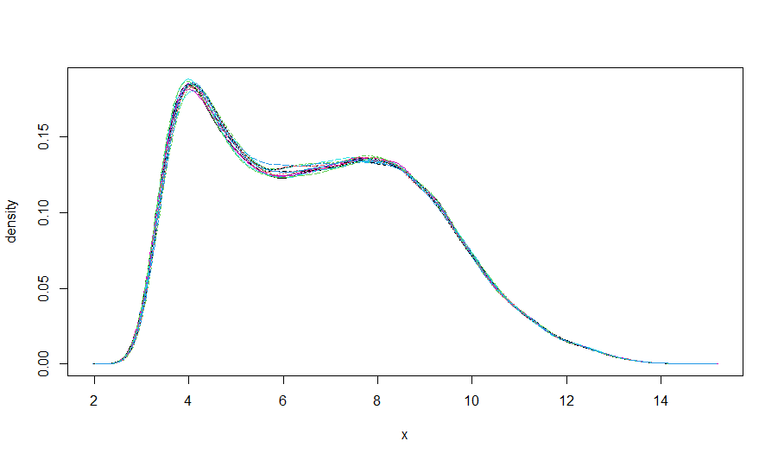

Figure 2: Arrays’ Normalized
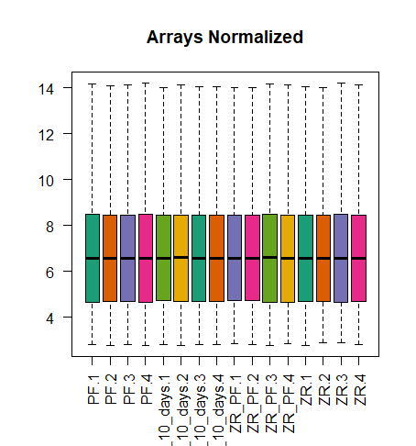
Figure 3: Comparison of the Biological Replicates
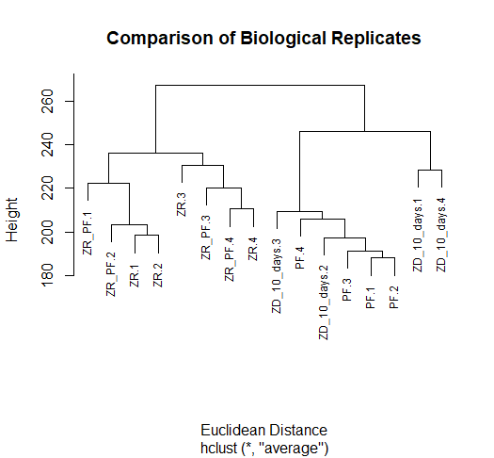:

Table 1: Summary of the DEGs
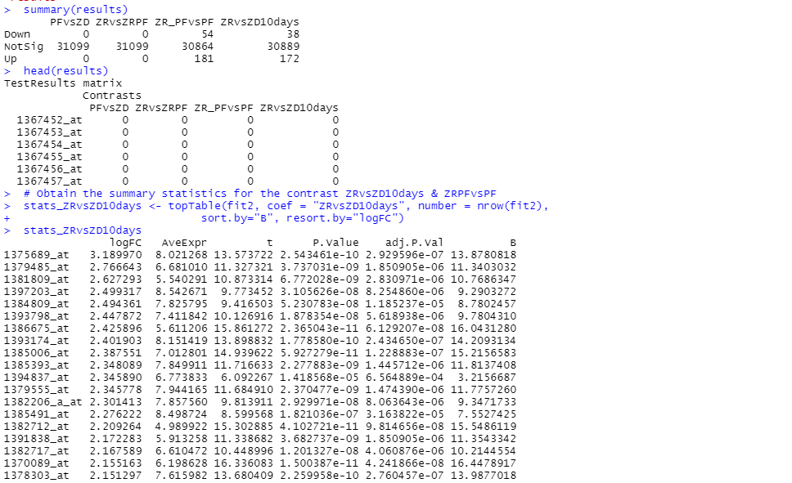
* See text document for full summary
logFC AveExpr t p.value adj. P.Val B
** Gene of interest 1374232_at 1.319079 7.501750 12.280881 1.137290e-09 8.421094e-07 12.4737569
Table 2: Top DEGs for BN Analysis
Afftmetrix ID | ZR_PFvsPF | ZRvsZD10days | Gene ID(rat genome)
1367847_at | 0 | -1 | Nupr1|1
1367984_at | 0 | 1 | Scaf1
1368701_at | 0 | 1 | Atp1a3
1369083_at | 0 | -1 | Cirbp
1373386_at | 0 | -1 | Gjb2
1374232_at | 0 | 1 | Pik3ca
1376534_at | 0 | -1 | unknown
1378107_at | 0 | 1 | unknown
1379132_at | 0 | 1 | unknown
1379200_at | 0 | 1 | Dzip3
1380027_at | 0 | -1 | unknown
1380503_at | 0 | 1 | Fam193a
1381099_at | 0 | 1 | unknown
1382809_at | 0 | -1 | Arid3a
1382938_at | 0 | 1 | Map1a
*Full Results are listed on the Excel Sheet in terms of contrast
Analysis from the data suggest that 54 genes from ZR_PF vs PF are downregulated and 181 are upregulated. In terms of ZRvs ZD10days 38 genes are downregulated, and 172 genes are upregulated. Generating the summary statistic comparing the two the above Affymetrix gene names were found to be the most significant. All genes were downloaded into Excel , then not significant genes of ZRvs ZD10days days were removed, leaving the top 15 contrasted genes to be used in the Bayesian Network. One gene of interest that was found to be significantly upregulated was Pik3ca ( Affymetrix ID 1374232_at). Pik3ca is a catalytic subunit of the PI3K pathway, which when activated, phosphorylates AKT and then activates mTOR.⁹⁻¹¹ Based upon the research in this study, it is found to be upregulated in zinc deficient rats independent of caloric restriction.
Figure 4: mTOR Pathway
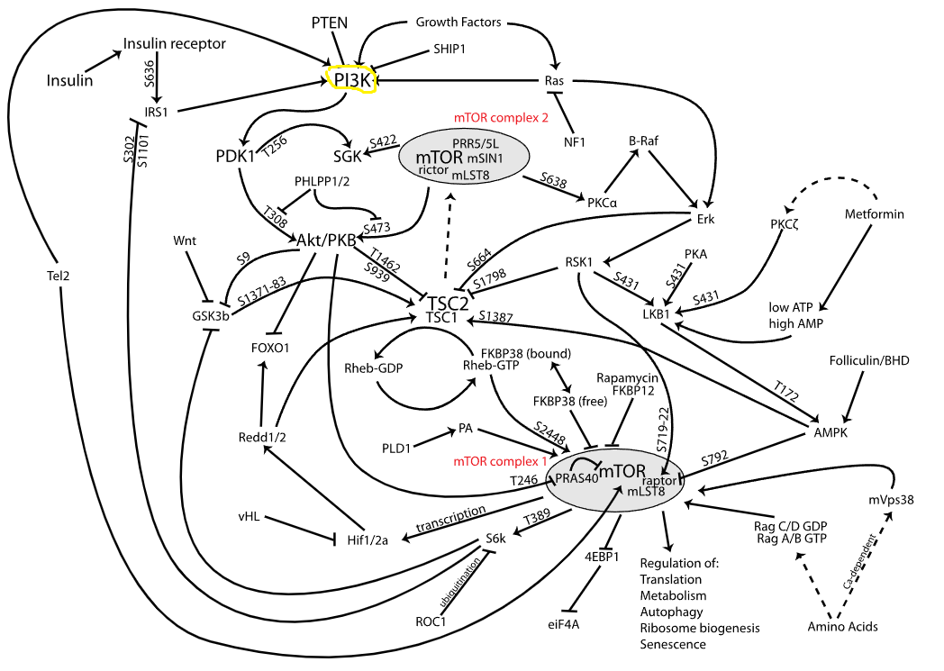
Figure reprinted from Wikipedia, PI3K/AKT/MTOR pathway

Part 2: Construction of BN
The top 15 contrasted genes were used in the analysis and a Naïve Bayesian Models was constructed in Bnlearn.¹² The model was designed with using Pik3ca as the parent node, since it is integral in the mTOR pathway. The arc strength and network score using the bic criteria were evaluated and reported below. Due to the genes and model selected, arc strengths were identical.
Table 3: Arc Strength and Network Score
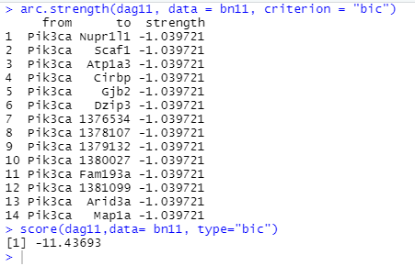
Figure 6: Naïve Bayesian Model 1
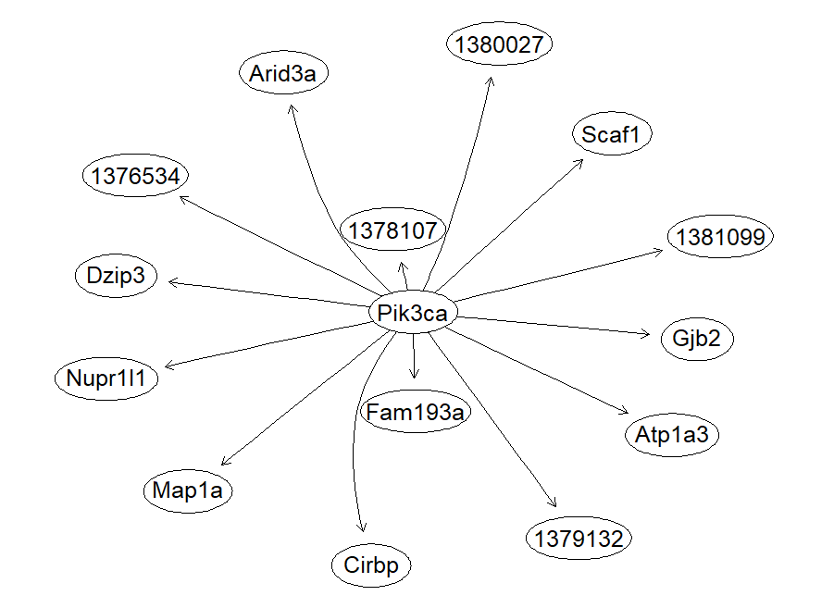

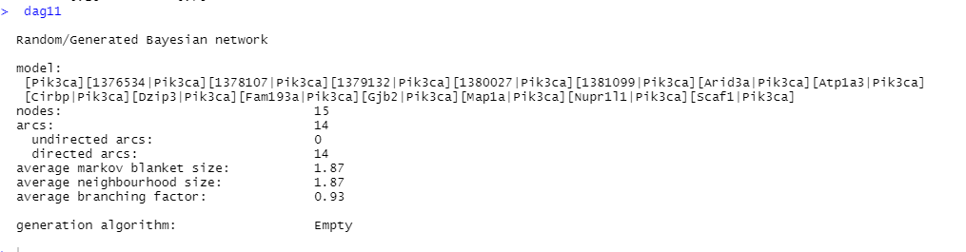
Next, the call equation was created so that conditional probabilities tables can be generated. The method was set to Bayes and ESS to 2., as there is some background knowledge associated with this pathway, but none in the context of zinc. Due to the design structure of the Bayesian network , all the CPTs were the same ( as only the contrast of the two groups were compared).CPTs using the Mle method were also generated and attached as a supplementary file.
Table 4: CPT’s of the BN
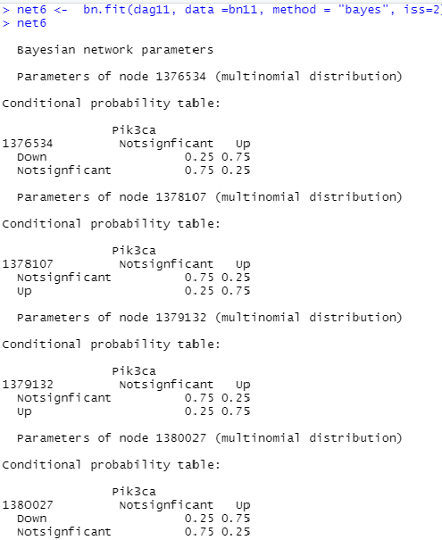
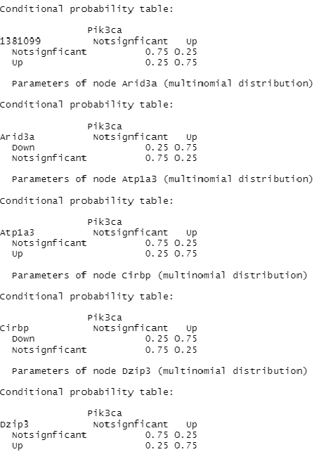
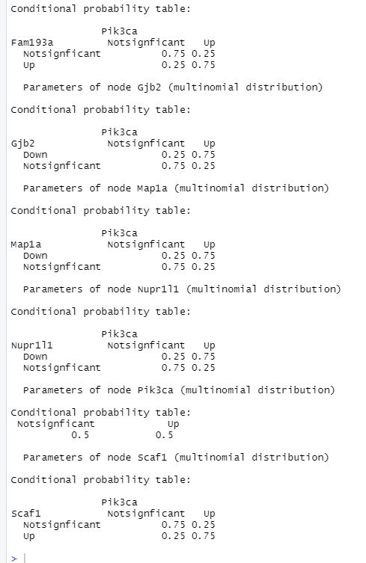
Approximate and Exact Inference
Upon further review the relationship among Pik3ca and Dzip3 ( a zinc finger, protein coding gene) was further evaluated. Approximate inference among these two nodes was determined using forward and Gibbs/ likelihood weighting sampling.
Table 5: Approximate Inference
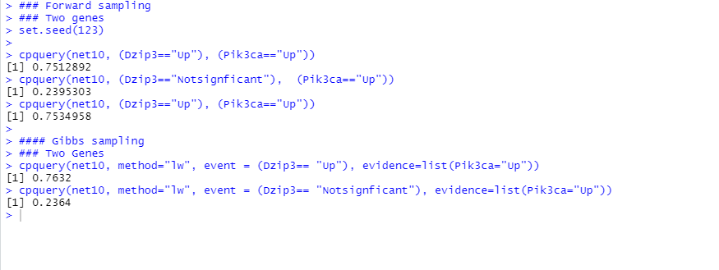
For both queries if Pik3ca is upregulated (the parent node), Dzip3 may also be upregulated by a probability of 0.7512892 using forward sampling and 0.7632 using Gibbs. Extracting the values using exact inferance, we find the values to be roughly the same.
Table 6: Exact Inference
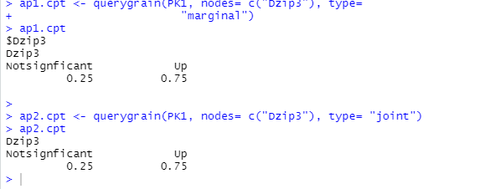
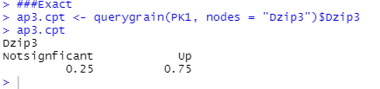
Discussion and Conclusion
The purpose of this paper was to determine if any genes related to biological aging and longevity were associated with zinc transporter or metallothioneins. In the first part of the paper, Limma was used to determine what genes were differentially expressed between the ZR vs. ZD10days and the control group. From here, the not significant genes from ZRvs ZD10days days were removed, so that a contrast remained between ZR vs. ZD10days and the control group. The top 15 DEGs of interest were used in the Bayesian Network Analysis. The main gene of interest, Pik3ca plays a pivotal role in the mTOR pathway, as it is the catalytic subunit of PI3K. The data of this study suggest that the gene Pik3ca is upregulated in zinc deficient rats independent of caloric restriction. This would be evidence of zinc’s influence on the biological aging and consequently Pik3ca was designated as the parent node in the Naïve Bayesian Model. Further evaluation of this model suggests that it may share a causal relationship with Dzip3, a protein encoding gene that utilizes zinc and functions as a ligase. Exact and Approximate Inference were calculated to determine this relationship and the queries found the probability to be roughly 0.75. This suggests a causal relationship among the two genes. Although promising, further research using the full network of genes needs to be conducted to validate the results.

References:
- Fedintsev A, Kashtanova D, Tkacheva O, et al. Markers of arterial health could serve as accurate non-invasive predictors of human biological and chronological age. Aging (Albany NY). 2017;9(4):1280-1292. doi:10.18632/aging.101227 .
- López-Otín, Carlos, Maria A. Blasco, Linda Partridge, Manuel Serrano, and Guido Kroemer. “The Hallmarks of Aging.” Cell 153, no. 6 (2013): 1194–1217. https://doi.org/10.1016/j.cell.2013.05.039
- Lin S, Tian H, Lin J, et al. Zinc promotes autophagy and inhibits apoptosis through AMPK/mTOR signaling pathway after spinal cord injury. Neuroscience Letters. 2020;736:135263. doi:10.1016/j.neulet.2020.135263
- Ding B, Zhong Q. Zinc deficiency: An unexpected trigger for autophagy. J Biol Chem. 2017;292(20):8531-8532. doi:10.1074/jbc.H116.762948
- Bian A, Shi M, Flores B, Gillings N, Li P, Yan SX, Levine B, Xing C, Hu MC. Downregulation of autophagy is associated with severe ischemia-reperfusion-induced acute kidney injury in overexpressing C-reactive protein mice. PLoS One. 2017 Sep 8;12(9):e0181848. doi: 10.1371/journal.pone.0181848. PMID: 28886014; PMCID: PMC5590740.
- Liuzzi JP, Guo L, Yoo C, Stewart TS. Zinc and autophagy. BioMetals. 2014;27(6):1087-1096. doi:10.1007/s10534-014-9773-0
- Cabrera ÁJ. Zinc, aging, and immunosenescence: an overview. Pathobiol Aging Age Relat Dis. 2015;5:25592. Published 2015 Feb 5. doi:10.3402/pba.v5.25592
- Okada S, Abuyama M, Yamamoto R, Kondo T, Narukawa M, Misaka T. Dietary zinc status reversibly alters both the feeding behaviors of the rats and gene expression patterns in diencephalon. BioFactors. 2012;38(3):203-218. doi:10.1002/biof.1007
- PIK3CA Gene - Phosphatidylinositol-4,5-Bisphosphate 3-Kinase Catalytic. Genecards.org. https://www.genecards.org/cgi-bin/carddisp.pl?gene=PIK3CA. Accessed December 1, 2021.
- Xie S, Ni J, Guo H, et al. The role of the PIK3CA gene in the development and aging of the brain. Scientific Reports. 2021;11(1). doi:10.1038/s41598-020-79416-6
- PIK3CA gene: Medlineplus genetics. MedlinePlus. https://medlineplus.gov/genetics/gene/pik3ca/. Published February 2, 2021. Accessed December 1, 2021.
- Scutari M, Denis J-B. Bayesian Networks: With Examples in R. Boca Raton: CRC Press; 2021.

