Abstract
This project will conduct analysis on ALARM dataset already created. I proposed three methods to reproduce the optimal score of the network structure and compare the result with already calculated Bayesian Dirichlet likelihood-equivalence (BDe) scores for each dataset.
Introduction
Patient monitoring systems have been a highly studied topic within the healthcare field. A Logical Alarm Reduction Mechanism (ALARM) was designed to assist with patient monitoring with the purpose of improving signaling to healthcare practitioners concerning patients. There are 37 variables in the system, including diagnostic and discovery variables (Beinlich et al., 1989). This causal Bayesian Network (BN) has been studied in order to improve our understanding of the predictability of causal linkages.
I will use the simulated data created from the ALARM monitoring system to examine the effectiveness of data generation techniques and how they compare to a real-life causal model. I will propose 3 methods to reproduce the optimal score of the network structure and compare the result with already calculated Bayesian Dirichlet likelihood-equivalence (BDe) scores for each dataset.
Methods
Models
The original ALARM system includes 37 total variables. Previous analyses determined that there are nine significantly correlated variables, which differ per model. Two different models were used in order to more appropriately explore this dataset. A “sparse” dataset takes the nine most significantly correlated variables, regardless of proximity to each other. The directed acyclic graph (DAG) demonstrates the position of each of the variables (Figure 1). These nine variables include: LVFailure, BP, CO, Catechol, HRBP, Intubation, VentAlv, ExpCO2, and VentTube. The remaining variables are purposefully hidden, so as to not be used in the calculations.
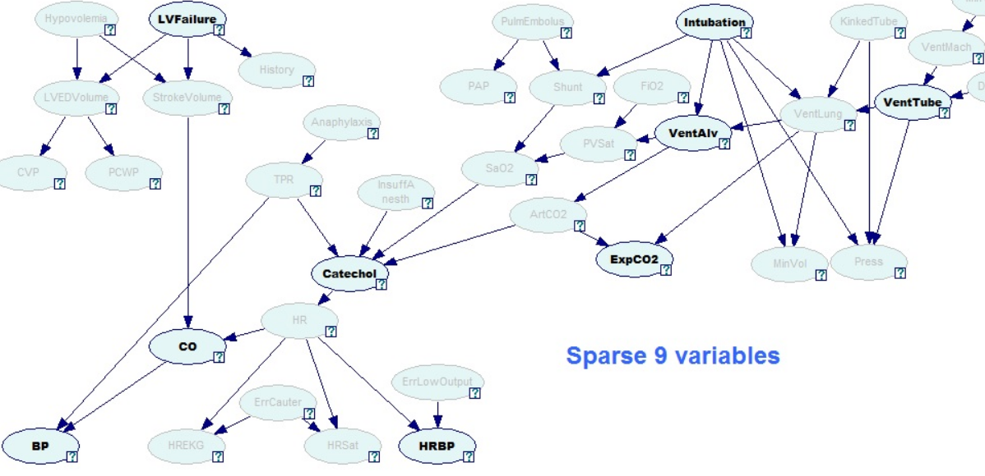
Figure 1: Sparse ALARM DAG highlighting the nine statistically significantly correlated sparse variables (in bold).
A “close” dataset takes the nine most significantly correlated variables that are all within close proximity to each other (Figure 2). These nine variables include: Anaphylaxis, TPR, InsuffAnesth, Catechol, HR, SaO2, ArtCO2, ExpCO2, and VentLung.
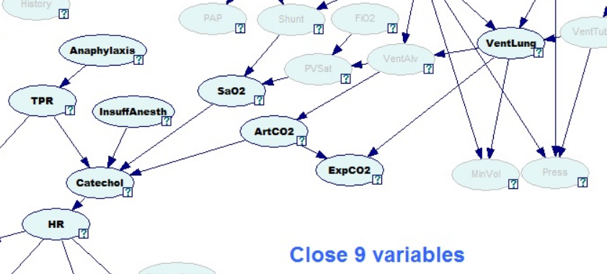
Figure 2: Close ALARM DAG highlighting the nine statistically significantly correlated close variables (in bold).

Datasets
We used Datasets that were generated for the ALARM monitoring system. One dataset used a sample size of 50, and another dataset used a sample size of 1,000. Each sample size dataset was compared to determine if sample size would affect the outcome. Table 1 outlines the dataset names, with a brief description. There is also a dataset for each model, for a total of four datasets.
Table 1: ALARM Dataset Descriptions
Dataset Name | n | Model
D50S9V | 50 | Sparse
D50C9V | 50 | Close
D1KS9V | 1,000 | Sparse
D1KC9V | 1,000 | Close

Analyses
To compare with the optimum structure, I will use three methods:
First Method:
In this method, I first choose a variable from a set of n (n = 9) variables. Then I will identify up to k (k = 2, 3 or 4) potential variables set from the rest of the (n-1) variables that are associated with the selected variable. Here, for a chosen variable I will randomly assign numbers to the remaining (n-1) potential variables, and then I will select up to k possible variables set using a cut of value.
Second Method:
In this method, first, I will calculate all pairwise correlations, $r_{ij}=corr\left[X_{i},X_{j}\right]; i≠j$. Then for all X_{i} select up to k (k = 2,3 or 4) correlations $r_{ij}$, where the p-value is less than 0.15.
Third Method:
In this approach, I will use conditional independence to select at most k (k = 2,3 or 4) possible variables set that are highly correlated. I will test the conditional independence of each combination of variables, with no parents, one parent, and two parents.
I will follow following steps:
i) Calculate p(X_{i,} X_{j}); $i≠j$
ii) Calculate p(X_{i,} X_{j} | X_{k}); $i≠j≠k$
iii) Calculate p(X_{i,} X_{j}| X_{k}, X_{m}); $i≠j≠k≠m$
Then for each combination I will average the p-value and then select at most k- variables where, the p-value is greater than 0.85.

Fourth Method:
In this approach, I will use I-Map to select at most k (k = 2,3 or 4) possible variables set that are highly correlated. I will find the I-Map of each combination of variables using conditional probabilities, with no parent, one parent and two parents.
I will follow following steps:
i) Calculate P(X_{i,} X_{j}); $i≠j$
ii) Calculate P(X_{i,} X_{j} | X_{k}); $i≠j≠k$
iii) Calculate P(X_{i,} X_{j}| X_{k}, X_{m}); $i≠j≠k≠m$
Then I will arrange these conditional probabilities and for each variable I will select at most k conditional probabilities to create my I-Map structure.

Evaluation:
I will calculate Bayesian Dirichlet likelihood-equivalence (BDe) scores for all the structures found using the four methods. These BDe scores will be used as a comparison tool to find the most likely parent node for each node using the variable with the lowest BDe score.

Timeline
October 24: By this date, I plan to have finalized my proposal based on feedback from Dr. Yoo and the class.
November 01: Bu this date, I plan to finish calculating BDe score for first three methods.
November 08: By this date, I plan to prepare the R-code for the fourth method.
November 15: By this date, I plan to finish my analysis.
November 22: By this date, I plan to present the first draft of my project paper.
November 29: By this date, I plan to have my second draft of the project paper.
December 09: By this date, I plan to submit the final project paper.

References
Beinlich, I. A., Suermondt, H. J., Chavez, R. M., and Cooper. G. F. (1989) The Alarm Monitoring
System: A Case Study with two Probabilistic Inference Techniques for Belief Networks.
Proceedings of the 2nd European Conference on Artificial Intelligence in Medicine. Springer
Verlag. 247-256.
Scutari M (2010). “Learning Bayesian Networks with the bnlearn R Package.” Journal of Statistical Software, 35(3), 1–22. doi:10.18637/jss.v035.i03.

