Aaliyah Vincent
PHC 6067
17. October 2025
Class Project Proposal (Updated)
Abstract
I will compare a Naive Bayes Bayesian Network (BN) with data-driven (learned) Bayesian networks for classifying lung tumor vs. matched normal samples from GEO GSE19804. All variables will be discretized (genes into Low/High or Low/Med/High; Stage). I will (i) estimate tabular CPDs, (ii) score and compare three structure hypotheses using log-likelihood/BIC, and (iii) evaluate predictive accuracy through a stratified, patient-wise 5-fold CV. I will also answer inference queries about likely gene-activity patterns and risk, linking conclusions to d-separation.
Introduction/Background
Lung cancer remains a leading cause of mortality in the United States. Essentially, gene-expression profiles can distinguish tumors from normal tissue. GSE19804 provides paired tumor/adjacent-normal microarray samples from non-smoking female patients, offering clear labels and balanced classes.
Question
- Can a simple Naive Bayes model perform as well as, or be outperformed by, a BN learned from the data for tumor/normal classification; Which conditional independencies are most supported by the data?
Significance
- Interpretable Bayesian Networks expose dependencies among clinical and molecular variables and provide probabilistic predictions.
Dataset
- GEO GSE19804: paired lung tumor and adjacent normal samples from non-smoking female patients (balanced labels and clear pairing).
Variables
- Y: Class (Tumor/Normal)
- Stage: Cancer Stage (I-IV)
- X_g: Discretized expression for 20-30 top variance genes
Goals/Hypotheses
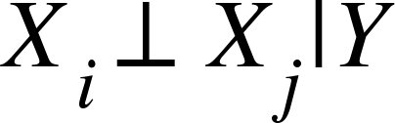
- H1 (Naive Bayes): encodes
- H2 (Lightly Structured): adds sparse gene-gene/Stage-Y edges
- H3 (Learned BN): Obtained by score-based search under sparsity constraints
We hypothesize that H3 will achieve a higher BIC than H1 if the data support residual dependencies beyond Naive Bayes
Methods (Data Analysis)
Data Prep
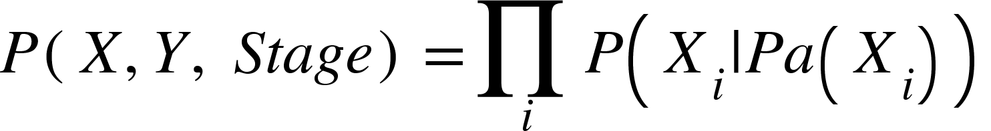
- Build a patient-ID index (to keep pairs together). Within each training split: select top-variance genes, discretize by quantiles (2-3 bins), and apply the learned cutpoints to the test split. Model class. Discrete Bayesian Networks with tabular CPDs. The joint factorizes as:

Structure Hypotheses
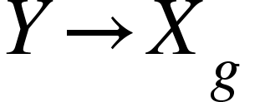
- H1 (Naive Bayes): for all g; independence
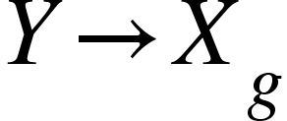
- H2 (Lightly Structure): plus 1 peer parent per gene, including 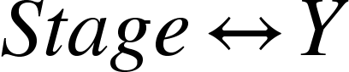(direction chosen by score)
- H3 (Learned BN): Greedy hill climb with BIC, max in-degree 2, and a restricted candidate edge set. Parameter learning. Maximum-likelihood (counts) with Laplace smoothing.

- Log-likelihood:
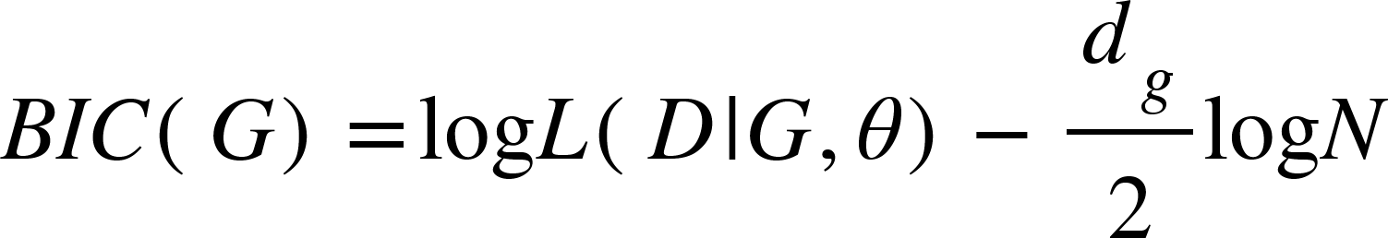
- BIC: (penalizes complexity)

- Model Comparison: Choose the hypothesis with highest BIC & report LL
Inferences (Queries)
- P(Y = Tumor | Stage, gene pattern)

- Most likely gene-activity combination for a subset S:
- Use d-separation to explain when genes become independent once conditioning on Y (Naive Bayes) versus learned structures.
Evaluation
- Protocol: Stratified 5-fold cross-validation with patient-wise grouping (keeping each patient’s tumor+normal in the same fold).
- Predictive metrics: Accuracy (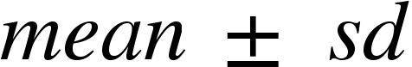), a pooled confusion matrix, & compare to a majority-class baseline
- Model comparison metrics: Report BIC and log-likelihood for H1-H3
- Baselines & sensitivity: Majority-class baseline, sensitivity to #genes (20 vs 30) and binning (2 vs 3 bins)

Timeline (dated weekly outcomes)
Week 1 (10/13-10/19) - Data & framing
- Download/inspect GSE 19804, build metadata (patient IDs, tumor/normal, stages).
- QC snapshot and normalization check, finalize variable list, and edge constraints.
Week 2 (10/20-10/26) - Feature pipeline set
- Implement fold-wise top variance selection (target 20-30 genes)
- Implement fold-wise discretization (2-3 bins) and lock the binning scheme.
Week 3 (10/27-11/2) - H1 Naive Bayes
- Train H1 (Naive Bayes) with Laplace smoothing
- Run stratified patient-wise 5 fold CV, record accuracy, and pooled confusion matrix
- Verify BN diagram, factorization, I-map, & parameter count
Week 4 (11/03-11/09) - H2 Light Structure
- Implement constrained search (TAN-style cap: 1 peer parent per gene, )
- Compute log-likelihood and BIC for H1 vs H2 & CV comparison
Week 5 (11/10-11/16) - H3 learned BN
- Greedy hill climb with BIC (max in-degree2, restricted edge set)
- Record LL/BIC & run CV accuracy
Week 6 (11/17-11/23) - Model comparison & inference
- Summarize H1-H3: LL, BIC, CV metrics
- Draft inference examples: P(Y = Tumor | Stage, gene pattern)
- Note d-separation insights (what becomes independent under each structure)
Week 7 (11/24-11/30) - Thanksgiving Buffer/Clean Up
- Light week: fix any data/metrics issues & finalize which model is “best” by BIC
- Start figures: structure diagrams, accuracy table, confusion matrix, LL/BIC table
Week 8 (12/01-12/07) - Writing Sprint
- Draft abstract, introduction/background, and methods for paper
- Insert all figures/tables, write results (H1-H3 comparison) and discussion
Week 9 (12/08-12/11) - Polish Checks
- Proofread, verify equations, & cross-check numbers
- Finalize references
Final Submission (12/12)
- Submit the class project paper and upload code/notebook as required
References
Koller, D., & Friedman, N. (2012). Probabilistic graphical models principles and techniques Daphne Koller; Nir Friedman. MIT Press.
T, L., L, L., & EY, C. (n.d.). Genome-wide screening of transcriptional modulation in non-smoking female lung cancer in Taiwan. National Center for Biotechnology Information. https://www.ncbi.nlm.nih.gov/geo/query/acc.cgi?acc=GSE19804

