Abstract:
The gene interactions that lead to the onset of Alzheimer's Disease (AD) are not well understood, though many genetic risk factors have been identified. We are interested in understanding how identified AD risk factors interact and relate to each other using Bayesian Networks (BN). We have done previous tests relating APOE, APP, PSEN1 and PSEN2 with Age and Sex and have attempted to reconcile the literature understanding of these relationships with the Global Maximum Likelihood structure obtained from our data. A Local Maximum Likelihood structure was derived from the Global Maximum Likelihood Structure and suggested that Age was independent of or did not influence the onset of AD given the patient's Sex. Additionally the model suggested that given APOE gene expression, APP and PSEN2 expression were independent of each other or did not influence each other. We aim to determine whether this model still stands given more samples, include Brain Region of the sample as its own variable, and utilize Bayesian information criterion (BIC) scoring instead of Maximum Likelihood scoring to evaluate structures.
Intro:
Alzheimer's Disease is a devastating neurological disorder that is characterized by slowly diminishing memory, reasoning skills, and language ability. AD has been shown to greatly affect the hippocampus (Miller et al, 2013; Kong et al, 2015). There is currently no known cure. Increased Age has been considered a risk factor for developing AD (Calero 2015; Fowler et al 2015), and females are more likely to develop it, possibly due to estrogen's protective effect on oxidative stress (Fowler et al 2015). It is believed that AD has a genetic component, and a variety of risk factor genes have been proposed. APOE (Apolipoprotein E) has consistently been considered the greatest genetic risk factor for developing Alzheimer's disease (Bertram et al, 2008). The E4 allele variant has been associated with a greater likelihood of developing AD, while the E2 allele has been considered protective in developing AD (Calero et al, 2015). APP (Amyloid Precursor Protein) is an integral membrane protein that, when cleaved by y-secretase which is encoded by PSEN1 and PSEN2 (Presenilin 1 and 2), contributes to the formation of beta amyloid plaques characteristic of AD (Bertram et al, 2008; Soler-López et at, 2011). Mutations in APP, PSEN1, and PSEN2 have been found to contribute to AD pathogenesis (Miller et al 2013; Calero, et al, 2015). PSEN1 mutations have been specifically linked to Early Onset Alzheimer’s Disease (EOAD) and have been identified as a significantly differentially expressed gene in AD (Chandrasekaran and Bonchev, 2016). A link between APP and APOE has been found in a study by Kong et al (2015).
Hypothesis:
The Global Maximum Likelihood and the Local Maximum Likelihood structure derived from pruning the Global Maximum Likelihood graph will provide different relationships among the variables when Brain Region is included as a variable.
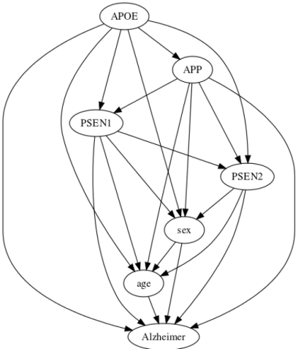
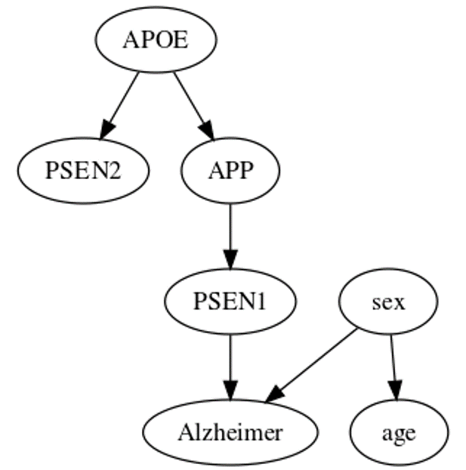
Initial Global Maximum Likelihood structure Initial Local Maximum Likelihood structure

Objective:
Develop a more accurate structure relating APOE, APP, PSEN1, PSEN2, Age, and Sex with AD.
Methods:
Data:
We currently have 377 samples from four datasets obtained from National Center for Biotechnology Information (NCBI) Gene Expression Omnibus (GEO). These samples are from datasts GSE 1297, 28146, 29378, and 48350.

Dataset | Published |  | Description of Samples |  | Aim/Results of study
GSE 1297 | 2004 |  | 31 total hippocampal samples analyzed with microarray |  | Used microarray data to find variety of genes involved in the transcriptional response that may be detected in early signs of AD
GSE 28146 | 2011 |  | 30 CA1 hippocampal grey matter samples removed from white matter |  | Found the down-regulation of genes involved in the ryanodine receptor Ca2+ release and up-regulation of gene involved vascular development. Distinguished from previous study that transcription factors and epigenetic factors up-regulated in AD are localized in the white matter.
GSE 29378 | 2013 |  | 63 samples from CA1 and CA3 |  | Aimed to find which cellular pathway is most relevant to AD onset. Found that CA3 samples are less vulnerable to AD effects. Several genes found that may affect vulnerability and protection against AD.
GSE 48350 | 2014 |  | Microarray data from AD and control individuals from 4 different brain regions |  | Analyzed changes in gene expression for genes related to synaptic & immune functions, age and brain region.
 |  | Males |  | Females |  | Total
Alzheimer |  | 59 |  | 95 |  | 154
Control |  | 127 |  | 96 |  | 223
Total |  | 186 |  | 191 |  | 377

We discretized the gene expression levels as high, low and normal expression by finding the z-scores of expression levels in each dataset. Z-scores greater than 1 were categorized as high expression, and Z-scores less than –1 were categorized as low expression. Females were encoded as 1 where males were encoded as 0.
We will be obtaining an additional 893 amount of samples from 5 additional datasets: GSE 16759, 44768, 44770, 44771, 84890. Three of the datasets, GSE 44768, 44770, and 44771, were subsets of a larger dataset.

Dataset | Published | Description of Samples | Aim of study
GSE 16759 | 2010 | 4 AD and 4 age-matched control samples from the parietal lobe | Compared the expressions of mRNA and miRNA for miRNA's role in AD and their relationship to their target mRNA.
GSE 44768 | 2013 | LOAD patient and control samples from the cerebellum | Constructed gene regulatory networks using Bayesian inference to highlight the importance of immune and microglial functions in LOAD pathology.
GSE 44770 | 2013 | LOAD patient and control samples from the Prefrontal cortex | Constructed gene regulatory networks using Bayesian inference to highlight the importance of immune and microglial functions in LOAD pathology.
GSE 44771 | 2013 | LOAD patient and control samples from the visual cortex | Constructed gene regulatory networks using Bayesian inference to highlight the importance of immune and microglial functions in LOAD pathology
GSE 84890 | 2016 | 97 middle temporal gyrus samples of AD patients and 98 control samples matched for age & sex. | Found genes involved AD pathways: DNA methylation, Synaptic Vesicle Trafficking and GABA expression. Female AD patients found to have an enriched “L1CAM interactions”.

Together with the previously gather data, there will be a total of 1270 samples available for analysis from 9 different brain regions.
Hippocampus: 190
Entorhinal Cortex: 54
Superior Frontal Cortex: 65
Post-Central Gyrus: 68
Middle temporal gyrus: 195
Parietal lobe: 8
Visual Cortex: 230
Cerebellum: 230
Prefrontal Cortex: 230
Bayesian Network Modeling:
Bayesian Networks are a system-based approach in analyzing gene expression data. Results are in the form of directed acyclic graphs where the nodes represent variables of interest, and the variables hold different states. In this case, genes were discretized into high, low, and normal gene expression levels. The relationships between the nodes are represented by arcs, and probabilities that further describe these relationships are assigned to these nodes based off the joint distributions of the nodes' parents. The connections of these nodes allow us to deduce relationships between nodes that are not directly connected to each other. There are three basic connections between these nodes:
- Serial connections show the chain of variables that lead to a certain state. Given no evidence, all these nodes influence each other. However, when the state of a middle node is known, the nodes above and below that node are now independent of each other.
- Diverging connections show how one node influences the effect two or more other nodes. Given evidence on the affected nodes or no evidence on the node where the diversion occurs, the children nodes influence and are connected to each other. However, given information on the node where the diversion occurs, the children of those nodes are independent of each other. This relationship is useful in distinguishing the difference between the causes of one node's state from other nodes that are also a result of a shared cause.
- Converging connections demonstrate how several nodes cause or influence a common node. Without information on the common node, these nodes are independent from each other (Charniak, 1991).
There are multiple ways to analyze BNs. One way is through Likelihood scoring, the probability of observing the data given the structure. Because the probability values of observing the data given the structure are so low, the values are usually expressed in as a log of the probability.
Bene is software that searches for the Global Maximum Likelihood Structure. The output graph is the structure that provides the highest likelihood of observing the data that was put in. It provides us with an order of how the variables relate to each other. One disadvantage of using Likelihood scoring is that the Global Maximum Likelihood structure is usually a fully connected network since the input data rarely demonstrates true independent variables. This fully connected graph tends to over fit the data.
The Bayesian score attempts to prevent this over fitting of the data by penalizing over complicated structures. The Bayesian Information Criterion (BIC) score tries to balance out the tradeoff between the fit of the data and the simplicity of the structure. The BIC score is consistent with the perfect structure that maps out the data where the perfect structure has the maximum BIC score, and any structure that demonstrates different dependencies from that structure will have a lower score (Koller and Friedman, 2009).
With the added data and brain region variable, we plan to run the data through Bene to find the Global Maximum Likelihood structure and compare it with the previous Global Maximum Likelihood structure we found using only the 4 datasets. From this new Global Maximum Likelihood structure, a simpler structure that demonstrates the variables' interactions and compared using both Maximum Likelihood Scoring and BIC scoring.
Timeline:
Week | Posted on the Forum
8 | Clean up new data, post demographics of full dataset.
9 | Bene graph
10 | Simplified bene graphs
11 | Likelihood and BIC Scores of graphs
12 | Discussion of differences & implication of graphs
13 | Draft final paper
14 | Revised final paper
15 | Final paper submission

References:
Bertram, L., & Tanzi, R. E. (2008). Thirty years of Alzheimer's disease genetics: the implications of systematic meta-analyses. Nature Reviews Neuroscience, 9(10), 768-778.
Blalock, E. M., Geddes, J. W., Chen, K. C., Porter, N. M., Markesbery, W. R., & Landfield, P. W. (2004). Incipient Alzheimer’s disease: Microarray correlation analyses reveal major transcriptional and tumor suppressor responses. Proceedings of the National Academy of Sciences of the United States of America, 101(7), 2173–2178. http://doi.org/10.1073/pnas.0308512100
Calero, M., Gómez-Ramos, A., Calero, O., Soriano, E., Avila, J., & Medina, M. (2015). Additional mechanisms conferring genetic susceptibility to Alzheimer’s disease. Frontiers in Cellular Neuroscience, 9, 138. http://doi.org/10.3389/fncel.2015.00138
Chandrasekaran, S., & Bonchev, D. (2016). Network Topology Analysis of Post-Mortem Brain Microarrays Identifies More Alzheimer’s Related Genes and MicroRNAs and Points to Novel Routes for Fighting with the Disease. PLoS ONE, 11(1), e0144052. http://doi.org/10.1371/journal.pone.0144052
Charniak, E. (1991). Bayesian networks without tears. AI magazine, 12(4), 50.
Fowler KD, Funt JM, Artyomov MN, Zeskind B, Kolitz SE, Towfic F. Leveraging existing data sets to generate new insights into Alzheimer’s disease biology in specific patient subsets. Scientific Reports. 2015;5:14324. doi:10.1038/srep14324
Koller, D., & Friedman, N. (2009). Probabilistic graphical models: principles and techniques. MIT press
Kong, W., Mou, X., Zhang, N., Zeng, W., Li, S., & Yang, Y. (2015). The Construction of Common and Specific Significance Subnetworks of Alzheimer’s Disease from Multiple Brain Regions. BioMed Research International, 2015, 394260. http://doi.org/10.1155/2015/394260
Miller, J. A., Woltjer, R. L., Goodenbour, J. M., Horvath, S., & Geschwind, D. H. (2013). Genes and pathways underlying regional and cell type changes in Alzheimer’s disease. Genome Medicine, 5(5), 48. http://doi.org/10.1186/gm452
Soler-López, M., Zanzoni, A., Lluís, R., Stelzl, U., & Aloy, P. (2011). Interactome mapping suggests new mechanistic details underlying Alzheimer’s disease. Genome Research, 21(3), 364–376. http://doi.org/10.1101/gr.114280.110

