Isabel Griffin
Class Project

Social-Networking Smartphone Applications, Risky Behaviors, and Sexually Transmitted Diseases among HIV-positive individuals in Florida

Abstract
Each year in the United States, 19 million people are diagnosed with an STD, costing the U.S. healthcare system 16 billion dollars. Since the late 1990s, online chat rooms have facilitated opportunities to meet individuals looking to have sexual encounters. In 2009, social networking applications were introduced which not only facilitated the meeting of two risky individuals, but also increased the circumference of a user’s sexual network via their smartphone. The impact of this introduction on the transmission of STDs has yet to be examined in the context of mathematical models. This project will aim to examine the relationship between the known factors contributing to syphilis transmission and the risks associated with meeting a sexual partner with these dating applications.
Background
Each year in the United States, 19 million people are diagnosed with a sexually transmitted disease (STD), costing the U.S. healthcare system 16 billion dollars [1]. The total number of infectious syphilis, chlamydia, and gonorrhea cases in Florida has increased from 359.8 per 100,000 persons in 2005 to 588.7 per 100,000 persons in 2015. Over the past several decades, Miami-Dade County has seen spikes in primary and secondary cases of Syphilis [2]. Transmission of the bacteria causing syphilis occurs only about 20% of the time. However, while a person is only infectious to others during the primary and secondary stage of syphilis, it is possible for an individual to be infected but not infectious and cannot be re-infected themselves during that time. Resulting in “saturation” among members in the community. However, treating infected persons, which renders individuals no longer infected, reverts them back to a susceptible state.

STDs and the Internet
Since the late 1990s, online chat rooms have facilitated opportunities to meet individuals looking to have sexual encounters. Members would solicit encounters, providing age, weight, and preferred sexual act preferences in chat rooms geared towards particular audiences. What resulted were STD outbreaks—most notably an outbreak of syphilis in 1999 that was traced back to a single chat room in San Francisco, California [3].

The Introduction of Dating Apps
In 2009, the Social Networking Smartphone Application (SNSA) Grindr was introduced, an app geared towards a gay, bisexual, and bi-curious male audience. Now with the swipe of their finger, users were able to connect with a complete stranger aided by geospatial mapping software that showed their exact distance (in feet). In 2015, two SNSAs Hzone and Positive Singles were released on the market. For the first time in history, users were able to match with partners using SNSAs based on their STD status, a practice commonly referred to as serosorting. This web-based technology not only facilitates the meeting of two risky individuals, but also increases the circumference of a user’s sexual network via their smartphone. The purpose of this project is to determine the influence of dating apps among these cases. The impact of this introduction on the transmission of STDs has yet to be examined in the context of mathematical models.

Most adults weigh the cost and benefit of safe sex practices, the fact that HIV is no longer a death sentence and the common belief that STDs are treatable. However, our ability to treat these infections is changing as these viruses and bacteria are becoming resistant to antibiotics, our first line of treatment. The potential public health impact associated with SNSAs and serosorting behaviors not only affect the health of all sexually active adults in Florida, but may also increase the spread of resistant STDs throughout the state via the technology in our pockets.

Methods

Bayesian causal network are a type of statistical modeling that allows researchers to obtain a graphical network of variables and outcomes using empirical data. These models are useful when evaluating a phenomenon for which complete data may not be available. For this project, GENIE will be used to model a causal network examining the relationship between known risk factors and Syphilis. Figure 1 depicts the proposed directed acyclic graph (DAG) of relevant nodes and structural dependencies among them. This DAG examines the relevant nodes (sexual orientation, type of sexual act, gender, condom usage, viral load, HIV-status, race/ethnicity, socioeconomic status, sex with multiple partners, drinking, and Age). In addition to these known variables associated with syphilis infection, app usage and owning a smartphone are nodes of interest.

Figure 1: DAG examining syphilis risk factors

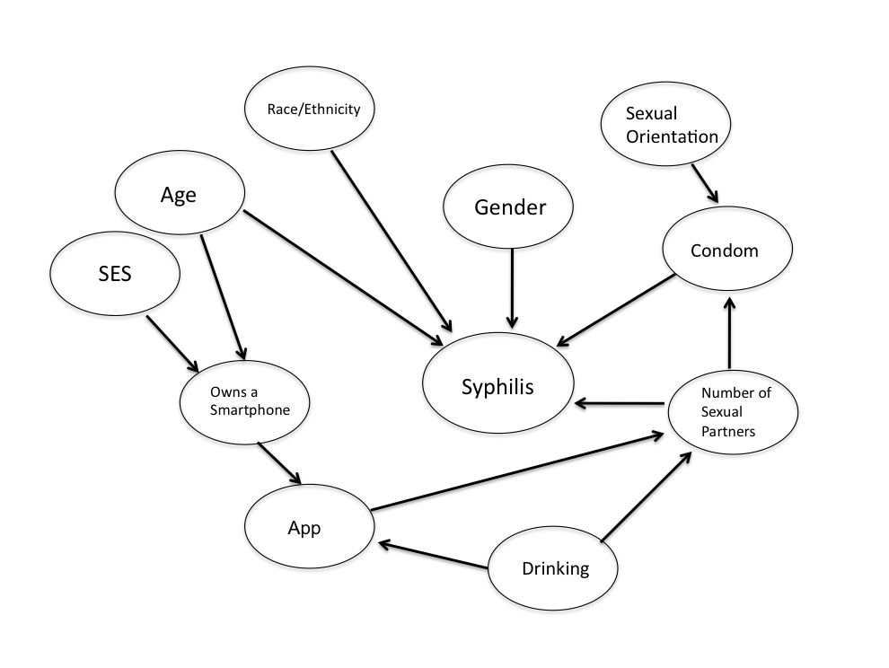
For each node in the DAG, there needs to be a conditional probability distribution. Meaning, a list of each probability of that the child node takes for each combination values of its parents. For some of the nodes, the conditional probability distribution may not be available, and thus must be derived from data (conditional frequencies). To evaluate the network, sensitivity analysis will also be performed. At this point in time, it hasn’t been determined whether this sensitivity analysis should be one-way deterministic (varying one parameter at a time over a specified range), or as a probabilistic sensitivity analysis (varying all parameters of the network at once over a specified probability distribution). The Genie package will also be used to conduct sensitivity analysis.

To examine the strength of the model, I will use cross-validation tests in which the dataset will be divided into k equally sized sets, and then in each iteration holding as test data one partition and testing all the remaining instances. To ensure that the model is strong, I will use cross-validation to select an algorithm and ensure that it works well, and then train the model on the entire data set, making use of the maximum amount of available data to learn a single model. In addition to cross-validation, goodness-of-fit tests will also be performed to determine whether the data behave as though they were sampled from the distribution. A comparison of both the training data set to properties of the simulated data sets of the same size that was generated previously. If the training data behaves differently from what was observed in the majority of simulations, then the data may not have been generated from the learned distribution.

Aim of Analysis
The goal of the proposed study is to examine the role that dating applications play in acquiring a syphilis infection among HIV positive individuals.
Data Source
Database where these variables have already been studied. Estimated sample size. Data has already been collected. Currently the data source is to be determined. I am currently working with Dr. Ibanez on trying to obtain access to the University of Florida’s Florida Cohort Study dataset. Sample size is approximately 798 participants. Acquisition of this dataset may not occur in time to run simulations required for this project by the end of the semester.

Timeline
Week 10: Create network in GENIE
Week 11: Identify appropriate database (UF Florida Cohort Study Data or FDOH).
Week 12: Input probabilities in GENIE
Week 13: Run the simulations and consults with probabilistic expert (Dr. Yoo)
Week 14: Complete final draft of project
Week 15: Revised and submit final draft of project

References
- Centers for Disease Control. Division of STD Prevention, National Center for HIV/AIDS, Viral Hepatitis, STD, and TB Prevention. Sexually Transmitted Diseases - Reported Cases and Rates of Reported Cases per 100,000 Population, United States, 1941-2013 Retrieved from: http://www.cdc.gov/std/stats13/tables/1.htm
- Florida Department of Health. Florida CHARTS Reportable and Infectious Diseases. Retrieved from http://www.floridacharts.com/charts/CommunicableDiseases/default.aspx
- Dworkin, Mark. "16/Tracking a Syphilis Outbreak Through Cyberspace." Cases in Field Epidemiology: A Global Perspective. By Jeffrey D. Klausner. Sudbury, MA: Jones & Bartlett Learning, 2011. 163-71. Print.

