2338 samples:
Age>65=1
Hippocampus=1
Female=1
AD=1
Training group:
1465 age>65 samples
181 hippocampi samples
820 female samples
926 AD case samples
Test group= 584/2338
309 AD cases
61 Hippocampi samples
480 age>65 samples
255 female samples
GMLS
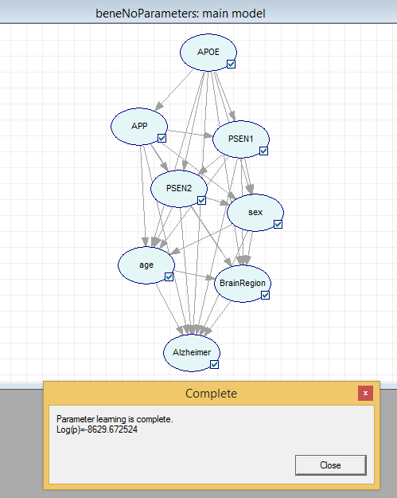

LMLS
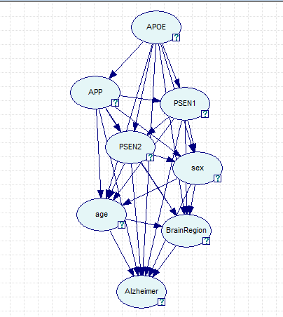
GLL -8629.67 82.38%
LLL -8631.21 17.62%
min 0.462499 Times better: 467.50
max 0.680073



