Brain Tumors
Tharaa Aljifri

PID#4891082

PHC 6907

Independent Study, Public Health, Quant II

Instructor: Dr. Changwon Yoo

Florida International University

Robert Stempel Collage of Public Health & Social Work

Abstract
According to the American Cancer Society's publication, (2014) it is estimated that 23,380 adults in US will be diagnosed with primary cancerous tumors of the brain and spinal cord, and 14,320 adults will die from this disease this year. Surveillance, Epidemiology, and End Results Program (SEER) database had reported cancer cases, including brain tumors, from 1973 to 2011 in US. The purpose of this project is to analyze different variables with Linear and Logistic regressions on SPSS to test the association between these variables of brain tumors patients.

Introduction:
The brain is a soft, spongy mass of tissue protected by fluid, thin tissue and skull bone. Within the brain and spinal cord, glial cells surround nerve cells and hold them in place (NCI, 2009). Brain tumor is referred to an abnormal mass of tissue in which some cells (glial or non-glial) grow and multiply uncontrollably (Price, et.al, 2007). According to the American Cancer Society's publication, (2014) it is estimated that 23,380 adults (12,820 men and 10,560 women) in the United States will be diagnosed with primary cancerous tumors of the brain and spinal cord, and 14,320 adults (8,090 men and 6,230 women) will die from this disease this year. Brain tumors are categorized as primary or metastatic. The primary brain tumors start in the brain, they include glioma, primary cerebral nervous system lymphoma (PCNSL), meningioma, choroid plexus papilloma, and haemangioblastoma (Henry, 2009). Metastatic brain tumors start somewhere else in the body and move to the brain. Lung and breast carcinoma make up the majority of metastatic tumors, largely because of the fact of their increased prevalence in the population compared with other tumors (Ryan T, 2012). A tumor damages the brain by increasing its pressure, by shifting the brain or pushing against the skull, and by invading and damaging nerves and healthy brain tissue (Price, et.al, 2007). The symptoms of a brain tumor depend on tumor size, type, and location. However, common symptoms include headaches, nausea and vomiting, complications in speech, vision, or hearing, problems in balancing or walking, change in mood, personality, concentrating ability, problems with memory, and numbness or tingling in arms or legs (NCI, 2009). Neuroimaging such as magnetic resonance imaging (MRI) and computed tomography (CT) are the first diagnostic tools for brain tumors. CT serves as a quick screening modality, where MRI can predict the type of tumor, but not the pathology. Recently, MRI has largely replaced CT to evaluate brain tumors (Ryan T, 2012). Tissue biopsy is the only definite way to diagnose a brain tumor, confirm the pathology, know the grade, and plan treatment (NCI, 2009). There are several options to treat brain tumors, and again, the treatment choice depends on tumor size, type, grade and location. The options are surgery, chemotherapy, and external or internal radiation therapy. In addition, supportive care is needed such as physical, speech, and occupational therapies to reduce the tumor complication (NCI, 2009). A major challenge to treating brain tumor is to find drugs that cross the blood–brain barrier (BBB). Many chemotherapy drugs used to treat systemic tumors are too large or hydrophilic to cross the BBB (Ryan T, 2012). There are no known causes for brain tumors, but few risk factors are recognized. For example, family history, exposure to ionizing radiation, age, race, and many other factors are linked for brain tumors. Moreover, human immunodeficiency virus infection is a well-known risk factor for PCNSL. There are studies discuss concerns of using cell phone, but there is no certain evidence to be a risk factor for brain tumor (Ryan T, 2012).

Proposed Method:
Analyze different variables (age, sex, race, cancer type, and survival months) from public database to predict the outcomes of brain tumors and test their significant using Statistical Package for the Social Sciences (SPSS) software. Data are downloaded from Surveillance, Epidemiology, and End Results Program (SEER) database; it includes 8,208,917 reported cases from 1973 to 2011 in US. The data are coded and saved in a text file format, detailed information about incidence and population data includes all variables and their codes are provided in a pdf. file. In order to analyze the data, the text file should be transferred into excel file and decode variables of interest.
Steps of transferring:
- Open new excel file and go to data, get external data, then import text file.
- After choosing the text file, a text import wizard window will show up.
- On original data type choose fixed width (as it is explained in the pdf. file).
- Next, in preview section, create, move or remove a break line according the position and digits length of each variable as explained in the pdf. file.
- Next, in column data format section, click on the column and choose the format for each one. You can choose skip for columns of unwanted variables.
- Finish importing and the data will show up without naming variables.
- Add a row above the first row and name each variable.

Using SPSS, open the excel file to analyze the decoded data with linear regression and logistic regression. For Linear Regression, the assumptions are as follows,
- For any given value of x, the corresponding value of y has an average value α+βx, which is a linear of x.
- For any given value of x, the corresponding value of y is normally distributed about α+βx with the same variance for any x.
- For any two data points (x1,y1), (x2,y2), the error terms e1, e2 are independent of each other.
For Logistic Regression, the assumptions are as follows,
- Assumes a linear relationship between the logit of the independent variables and dependent variables. However, does not assume a liner relationship between the actual dependent and independent variables.
- The sample is ‘large’- reliability of estimation declines when there are only a few cases.
- Independent variables are not linear functions of each other.
- Normal distribution is not necessary or assumed for the dependent variable.
Linear regression is used to establish a relationship between two variables.
Usually it used if we want to predict the value of a dependent variable based on the value of independent variable and when we have one dependent variable. If we have more than one independent variable, multiple regression had been suggested for this analysis.

Results and Discussion:
SPSS had been used to apply Linear and Logistic Regressions for brain tumor cases of all SEER 1973-2011 data. For linear regression, survival months was used as dependent variable, age, sex and race were used as independent variables. See appendix A for linear regression result’s tables.
The Interpretation of Linear Regression Results:
- From Model Summary Table: The coefficient of determination (R² = 0.002): it is the proportion of variation accounted for by the regression model above and beyond the mean model. The independent variables explain 0.2% of the variability of survival months.
- From Coefficients Table: The unstandardized coefficient (B): indicate how much the survival months vary with an independent variable, when all other independent variables are held constant. For example, for each 1 year increase in age, there is an increase in the survival months by 2.647
- The equation to predict (survival months) = 105.289 + (2.647 x age) – (11.584 x sex) – (1.129 x race)
For linear regression, survival months was used as dependent variable, age, sex and race were used as independent variables. See appendix B for linear regression result’s tables.
The Interpretation of Logistic Regression Results:
- From Model Summary Table: The Cox & Snell R² and Nagelkerke R² values are sometimes called (pseudo R²) values, and explain the variation of survival months.
- According to Model Summary Table: The variation ranges from 11.2% to 17.1%.
- From Classification Table: The cut value = 0.5 that means if the case probability above 0.5 then it is above survival months mean (1), and if the case probability below 0.5 then it is below survival months mean (0).
- Percentage accuracy in classification (PAC)= 77.7%
- Sensitivity= 19.9% ~ 20%
- Specificity= 94.6%
- The positive predictive value= 51.7%
- The negative predictive value= 80.2%
- From Variables in The Equation Table: The sig. column shows the significance of each variable. For example, race/ethnicity do not add significance to the model as (P= 0.060).
- From Variables in the Equation table: The Exp(B) column shows the odds ratio. For example, the increases in age reduce the likelihood of long survival months.

Surveillance, Epidemiology, and End Results Program
Turning Cancer Data Into Discovery

References:
Henry Marsh, 2009. “Brain Tumors”. Surgery (Oxford), Vol. 27, Is. 3, P. 135-138
National cancer institute (NCI), 2009. “What You Need to Know About Brain Cancer”. U.S. Department of Health and Human Services. http://www.cancer.gov/cancertopics/wyntk/brain.pdf
Price, T. R. P., Goetz, K. L., & Lovell, M. R. (2007). Neuropsychiatric aspects of brain tumors. In S. C. Yudofsky & R. E. Hales (Eds.), The American psychiatric publishing textbook of neuropsychiatry and behavioral neurosciences (5th ed., pp. 735–764). Washington, DC: American Psychiatric Association.
Ryan T. Merrell, MD, 2012. “Brain Tumors”. Disease-a-Month, Vol. 58, Is.12, P. 678-689
The American Cancer Society's publication. Cancer Facts Figures 2014, American Brain Tumor Association and the National Cancer Institute.

Appendix A
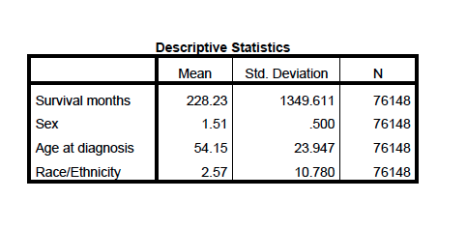
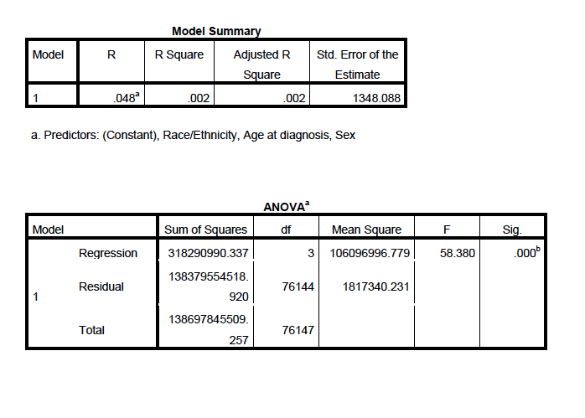

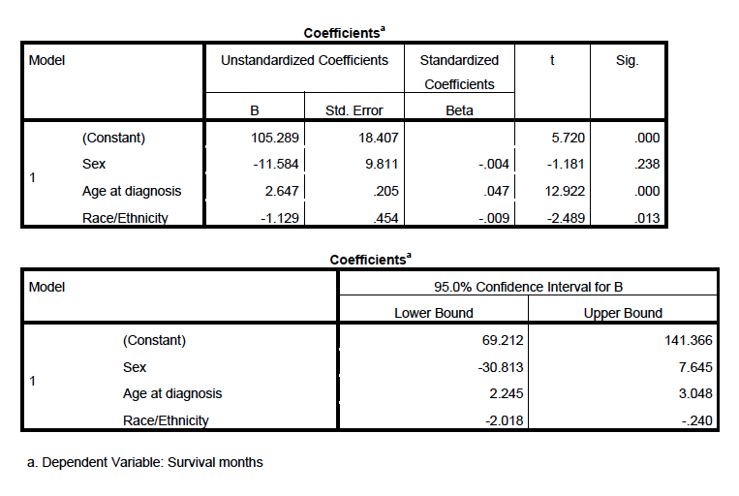

Appendix B


