Results
Data Selection
2403 GEO Datasets resulted from a search with the search term “Alzheimer”. There were 253 Series within these results, 181 studies on expression profiling by (micro)array, with 83 of those were from humans. Series that used cell lines to obtain data or did not have a published paper cited with the data were not included.
Figure 1: Dataset Search

13 series were used in this study with 2337 samples were included in our dataset (Table 1). Among these samples, 1235 (53%) were AD cases and 1102(47%) were Non-AD cases. Samples labeled as "Possible AD" or "Probable AD" were not included. Samples using platforms that were missing gene expression data for APOE, APP, PSEN1 or PSEN2 were excluded. There were 1132 Females (46%) and 1205 (54%) Males in our dataset.

Table 1: Description of GEO Datasets Included
Author | Year | GEO accession number | Total Samples (Alzheimers/Control) | Brain Regions | Platform
Blalock EM, Geddes JW, Chen KC, Porter NM et al. | 2004 | GSE1297 | 31 (22/9) | Hippocampus | GPL96
Liang WS, Dunckley T, Beach TG, Grover A et al. | 2006 | GSE5281 | 161 (87/74) | Entorhinal Cortex  Hippocampus  Medial Temporal gyrus  Posterior Cingulate  Superior Frontal Gyrus  Primary Visual Cortex | GPL570
Webster JA, Gibbs JR, Clarke J, Ray M et al. | 2009 | GSE15222 | 363 (176/187) | Temporal Cortex | GPL2700
Nunez-Iglesias J, Liu CC, Morgan TE, Finch CE et al. | 2010 | GSE16759 | 8 (4/4) | Parietal Lobe | GPL570
Durrenberger PF, Fernando FS, Magliozzi R, Kashefi SN et al. | 2011 | GSE26927 | 18 (11/7)* | Entorhinal Cortex | GPL6255
Blalock EM, Buechel HM, Popovic J, Geddes JW et al. | 2011 | GSE28146 | 30 (22/8) | Hippocampus | GPL570
Tan MG, Chua WT, Esiri MM, Smith AD et al. | 2012 | GSE37263 | 16 (8/8) | Neocortex | GPL5175
Hokama M, Oka S, Leon J, Ninomiya T et al. | 2013 | GSE36980 | 79 (32/47) | Hippocampus  Temporal cortex  Frontal cortex | GPL6244
Zhang B, Gaiteri C, Bodea LG, Wang Z et al. | 2013 | GSE44768 | 690 (387/303) | Visual Cortex  Prefrontal Cortex  Cerebellum | GPL4372
Miller JA, Woltjer RL, Goodenbour JM, Horvath S et al. | 2013 | GSE29378 | 63 (31/32) | Hippocampus | GPL6947
Berchtold NC, Cribbs DH, Coleman PD, Rogers J et al. | 2014 | GSE48350 | 253 (80/173) | Entorhinal Cortex  Hippocampus  Superior Frontal Cortex  Post Central Gyrus | GPL570
Antonell A, Lladó A, Altirriba J, Botta-Orfila T et al. | 2015 | GSE39420 | 21 (14/7) | Posterior Cingulate | GPL11532
Wang M, Roussos P, McKenzie A, Zhou X et al. | 2016 | GSE84422 | 604 (362/242)** | Frontal Pole  Occipital Visual Cortex  Inferior Temporal Gyrus  Medial Temporal Gyrus  Superior Temporal Gyrus  Posterior Cingulate Cortex  Anterior Cingulate  Parahippocampal Gyrus  Temporal Pole  Precentral Gyrus  Inferior Frontal Gyrus  Dorsolateral Prefrontal Cortex  Superior Parietal Lobule  Prefrontal Cortex  Caudate Nucleus  Hippocampus  Putamen  Amygdala  Nucleus Accumbens | GPL96  GPL 570
* Only the Alzheimer's disease and control for Alzheimer's disease cases were added to our dataset
** Only Definite Alzheimer cases and Normal cases included. Data from GPL 97 were excluded because genes of interest were not included in this microarray platform. Possible and Probable AD cases were also excluded.
The gene expression for our data was obtained from 31 different brain regions. 242 (10%) samples were from the Hippocampus, and the remaining 2095 (90%) samples were categorized as Non-Hippocampus.
The mean age of the samples was 78.0±14.5 years. Ages of the samples were categorized as age 65 and younger (Age≤65) and those older than 65 (Age>65). A majority of the data, 1945 samples (83%) were Age>65. Descriptive statistics and can be found in Table 2.
Table 2: Breakdown of Total Samples
 | Alzheimer’s | Non-Alzheimer’s
Females  Males  Age>65  Age≤65  Hippocampus  Non-Hippocampus | 46%  54%  83%  17%  10%  90% | 46%  54%  83%  17%  10%  90%
Developing the Training Group & Test group
These samples were randomized and split into a training group and a test group. The training group was used to find the best Bayesian Network structure that models the relationships between the variables of interest and its parameters. The test group was used to determine the accuracy of the structure for predicting Alzheimer’s disease cases from sample’s Age, Sex, Brain Region, and gene expression levels of APOE, APP, PSEN1, and PSEN2.
The training group comprised of 1754 samples, or 75% of the dataset compiled. Among this group, there were 926 (53%) AD cases and 827 (47%) Non-AD cases, 820 (46%) Females and 933 (54%) Males, 181 (10%) from the Hippocampus, and 1572 (90%) categorized as Non Hippocampus, and 1465 (84%) Age>65 and 288 (16%) Age≤65. Further descriptive statistics and can be found in Table 3.
Table 3: Breakdown of Training Group Samples
 | Alzheimer’s | Non-Alzheimer’s
Females  Males  Age>65  Age≤65  Hippocampus  Non-Hippocampus | 55%  45%  84%  16%  10%  90% | 55%  45%  84%  16%  10%  90%

The test group comprised of 538 samples, or 25% of the dataset compiled. Among this group, there were 309 (53%) AD cases and 275 (47%) Non-AD cases, 820 Females (46%) and 933 (54%) Males, 61 (10%) from the Hippocampus and 93 (90%) categorized as Non-Hippocampus, and 480 (82%) Age>65 and 104 (18%) Age≤65. Further descriptive statistics and can be found in Table 4.
Table 4: Breakdown of Test Group
 | Alzheimer’s | Non-Alzheimer’s
Females  Males  Age>65  Age≤65  Hippocampus  Non-Hippocampus | 44%  56%  82%  18%  11%  89% | 44%  56%  82%  18%  11%  89%
Global Maximum Likelihood Structure and Analysis
Bene finds the Global Maximum Likelihood Structure (GMLS), or the structure that gives the highest probability of observing our data with the given variables (Figure 2). The training data was used to find the parameters of this structure. Figure 3 demonstrates the distributions of the variables states within the structure.
GeNIe was used to manipulate the different states of the variables to determine patterns among them. Relationships analyzed involved pairwise comparisons of AD, Brain Region, Age, and Sex. Analysis of AD, Brain Region, Age, and Sex individually were done by controlling for the other three variables. Additionally, relationships among the genetic variables were determined by gene expression level patterns in Low, Normal, and High expression of APOE, APP, PSEN1, and PSEN2 individually
Figure 2: Global Maximum Likelihood Structure (GLMS)
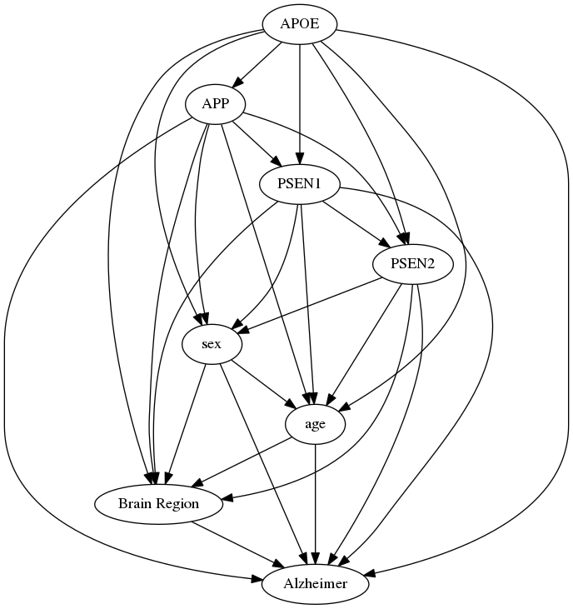
Figure 3: GMLS Distributions
Log (p): -8629.67
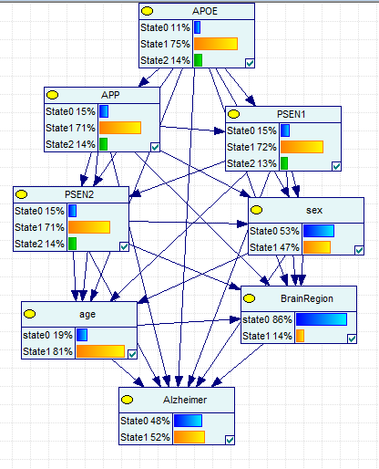

Brain Region: The Hippocampus samples consistently had greater dysregulation of gene expression compared to the Non- Hippocampus samples regardless of AD status, Age, and Sex. Higher expressions of APOE were consistently observed within the Hippocampus (Appendix B, Appendix H).
Age: Those Age>65 consistently showed that there was less dysreguation of gene expression compared to those Age≤65 regardless of AD status, Brain Region & Sex (Appendix A).
Sex: Females show a general pattern of greater dysregulation of gene expression.
APOE: Increased APOE expression seems to increase AD risk. Increased APOE expression showed a decreased APP and an increased PSEN1 expression, and dysregulated expression of APOE seems to increase PSEN2 expression. Overexpression of APOE seems to have a greater effect on PSEN1 and dysregulating its expression (Appendix G). Within the Hippocampus, increased APOE expression was linked to decreased AD risk. (Appendix H). Females tend to have higher proportions of overexpression and higher expressions of APOE overall.
APP: Increased APP expression shows a decrease in AD risk. Females and those Age>65 had lower expression. APOE expression was decreased and PSEN2 expression increased as APP expression increased. The relationship between APP and PSEN1 is less clear; dysregulation of APP expression also shows greater dysregulation with PSEN1 expression. It appears that under expression of APP has a greater effect on PSEN1 underexpression. PSEN2 expression seems to increase as APP expression increases (Appendix G).
Within the Hippocampus, the relationship between APP expression and AD risk was less clear. Increased APP dysregulation increased AD risk (Appendix H), but over expression seemed to have a greater effect on increasing AD risk. The same relationships between APOE, PSEN1, and PSEN2 seem to hold regardless of brain region (Appendix H).
PSEN1: Dysregulation of PSEN1 expression was shown to increase AD risk. Females were found to have greater dysregulated PSEN1 expression. Those Age>65 had greater PSEN1 expression than those Age≤65. PSEN1 expression increases with APOE expression. The relationships between PSEN1 with APP and PSEN2 were less clear (Appendix G). Within the Hippocampus, it was observed that females have lower PSEN1 expression. The same relationships between PSEN1 with APOE, APP, and PSEN2 also found within the hippocampus.
PSEN2: AD risk decreased as PSEN2 expression increased (Appendix G). There was a greater under expression of PSEN2 in females and those Age>65. Overexpression of PSEN2 found a decrease in APOE expression, and increased expression of APP was found with increasing PSEN2 expression levels (Appendix G).
Various validation methods of this structure were done using the test data. Results are found in Table 5.
Table 5: Validation Tests for GMLS
Test | GMLN | ROC AUC: Healthy | ROC AUC: Alzheimer
Test | Alzheimer = 0.648973 (379/584)  AD = 0.574545 (158/275)  Non-AD = 0.71521 (221/309) | 0.703054 | 0.703089
Leave One Out | Alzheimer = 0.585616 (342/584)  AD = 0.690909 (190/275)  Non-AD = 0.491909 (152/309) | 0.628997 | 0.628997
4-fold cross validation | Alzheimer = 0.59589 (348/584)  AD = 0.716364 (197/275)  Non-AD = 0.488673 (151/309) | 0.661353 | 0.661353
Confounding Structure and Analysis:
The confounding structure maintained the connectivity of the genetic variables with AD and treated Age, Sex, and Brain Region as confounding variables (Figure 4). The training data was used to find the parameters of this structure. Figure 5 demonstrates the distributions of the variables states within the structure.
Figure 4: Confounding Structure
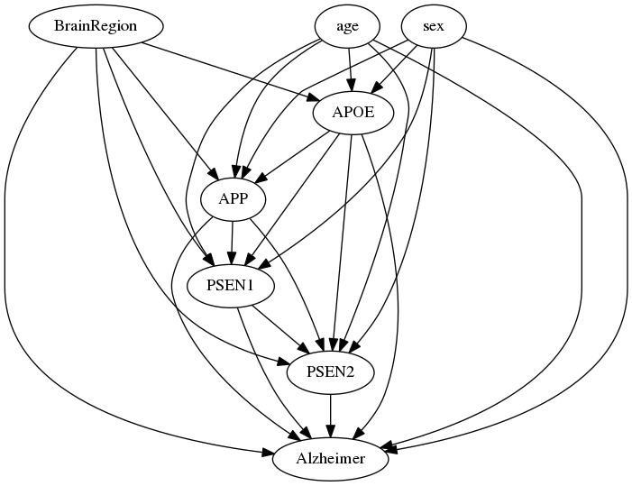
Figure 5: Confounding Structure Distributions
Log (p):
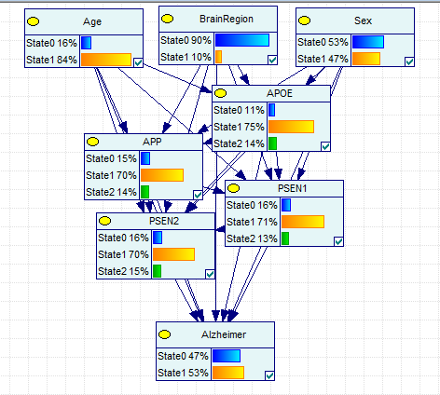
The relationships and patterns demonstrated in the Confounding Structure slightly differed than the relationships found in the GMLS among the variables.
Brain Region: The Hippocampus samples consistently had greater dysregulation of gene expression compared to the Non- Hippocampus samples, though there were some exceptions. APOE expression in AD and Non-AD samples had a higher proportion of normal expression than Non- Hippocampus samples (Appendix B).
Age: Those Age>65 consistently showed that there was less dysreguation of gene expression compared to those Age≤65 regardless of AD status, Brain Region & Sex (Appendix A).
Sex: Females show a general pattern of greater dysregulation and lower expression of APOE, APP, PSEN1, and PSEN2 when compared to Males, but there are a few exceptions. AD and Non-AD females had less dysregulation and higher expression of APOE than males (Appendix C).
APOE: Increased APOE expression seems to increase AD risk (Appendix G). Increased APOE expression showed decreased APP expression and an increased PSEN1 expression. Dysregulated expression of APOE seems to increase PSEN2 expression, but underexpressed APOE has a larger effect on increased PSEN2 expression. Females had higher expressions of APOE overall (Appendix C); however, AD Females had less APOE over expression compared to AD Males (Appendix F). There was also less dysregulation and higher expression observed in Female Non-Hippocampi samples. Underexpression of APOE seems to have a greater effect on increasing APP and PSEN2 overexpression. Overexpression of APOE seems to have a greater effect on dysregulating PSEN1 expression (Appendix G).
Within the Hippocampus, increased AD expression was also linked to decreased AD risk. Dysregulated expression of APOE increased with when comparing those Age>65 and Age≤65 (Appendix H).
APP: Increased APP expression shows a decrease in AD risk. APP expression was decreased for those Age>65 compared to those Age≤65. APOE expression decreased and PSEN2 expression increased as APP expression increased. Dysregulation of APP expression also shows greater dysregulation with PSEN1 expression, but appears that under expression of APP has a greater effect on PSEN1 underexpression (Appendix G).
Within the Hippocampus, APP had greater dysregulation and greater expression than Non-Hippocampus samples (Appendix B). Though Females tended to have lower expressions of APP than males(Appendix G), APP expression within the hippocampus was higher in females than it was in males. The relationship between increased expression of APP and increased AD risk was less clear. Increased APP dysregulation increased AD risk, but over expression seemed to have a greater effect on increasing AD risk. Decreased expression of APP was observed as APOE expression increased (Appendix H)
PSEN1: Dysregulation of PSEN1 expression was shown to increase AD risk (Appendix G). Females were found to have greater dysregulated PSEN1 expression. The proportion of those Age>65 increased with higher PSEN1 expression (Appendix G). Those Age>65 had less PSEN1 dysregulation than those Age≤65 (Appendix A). PSEN1 expression increases with APOE expression. The relationships between PSEN1 with APP and PSEN2 were less clear; dyregulated APP and PSEN2 expression was observed with dysregulated PSEN1 (Appendix G).
There was greater dysregulation of PSEN1 within the Hippocampus (Appendix B). Dysregulated APOE, APP, PSEN2 expressions were seen with PSEN1 dysregulation (Appendix H).
PSEN2: AD risk increased as PSEN2 expression decreased (Appendix G). Overall, those Age>65 had less PSEN2 dysregulation than those Age≤65 (Appendix A). Overexpression of PSEN2 found a decrease in APOE expression, and increased expression of APP was found with increasing PSEN2 expression levels. Dysregulations in PSEN2 expressions were also linked with PSEN1 dysregulation (Appendix G).
AD risk increased when PSEN2 was dysregulated within the hippocampus (Appendix H). The Hippocampus had greater dysregulated PSEN2 expression when compared to Non- Hippocampus samples (Appendix B). PSEN2 overexpression in this region was shown with increased APOE dysregulation. Dysregulated APP expression was also linked with dysregulated PSEN2 expression. Though Females tended to have lower PSEN2 expressions than Males (Appendix G), this relationship was not shown within the Hippocampus (Appendix H).
This structure had better log likelihood value and is significantly better than the GMLN. Results from the validation tests are found in Table 6.
Table 6: Validation Tests for Confounding Structure
Test | CSN | ROC AUC: Healthy | ROC AUC: Alzheimer
Test | Alzheimer = 0.648973 (379/584)  Non-AD = 0.574545 (158/275)  AD = 0.71521 (221/309) | 0.703089 | 0.703071
Leave One Out | Alzheimer = 0.585616 (342/584)  Non-AD = 0.690909 (190/275)  AD = 0.491909 (152/309) | 0.628997 | 0.628997
4-fold cross validation | Alzheimer = 0.561644 (328/584)  Non-AD = 0.661818 (182/275)  AD = 0.472492 (146/309) | 0.661353 | 0.661353

