Datasets:
Table 1
Author | Year | GEO accession number | Total Samples (Alzheimer's /Control) | Brain Regions | Platform
Blalock EM, Geddes JW, Chen KC, Porter NM et al. | 2004 | GSE1297 | 31 (22/9) | Hippocampus | GPL96
Liang WS, Dunckley T, Beach TG, Grover A et al. | 2006 | GSE5281 | 161 (87/74) | Entorhinal Cortex  Hippocampus  Medial Temporal gyrus  Posterior Cingulate  Superior Frontal Gyrus  Primary Visual Cortex | GPL570
Webster JA, Gibbs JR, Clarke J, Ray M et al. | 2009 | GSE15222 | 363 (176/187) | Temporal Cortex | GPL2700
Nunez-Iglesias J, Liu CC, Morgan TE, Finch CE et al. | 2010 | GSE16759 | 8 (4/4) | Parietal Lobe | GPL570
Durrenberger PF, Fernando FS, Magliozzi R, Kashefi SN et al. | 2011 | GSE26927 | 18 (11/7)* | Entorhinal Cortex | GPL6255
Blalock EM, Buechel HM, Popovic J, Geddes JW et al. | 2011 | GSE28146 | 30 (22/8) | Hippocampus | GPL570
Tan MG, Chua WT, Esiri MM, Smith AD et al. | 2012 | GSE37263 | 16 (8/8) | Neocortex | GPL5175
Hokama M, Oka S, Leon J, Ninomiya T et al. | 2013 | GSE36980 | 79 (32/47) | Hippocampus  Temporal cortex  Frontal cortex | GPL6244
Zhang B, Gaiteri C, Bodea LG, Wang Z et al. | 2013 | GSE44768 | 690 (387/303) | Visual Cortex  Prefrontal Cortex  Cerebellum | GPL4372
Miller JA, Woltjer RL, Goodenbour JM, Horvath S et al. | 2013 | GSE29378 | 63 (31/32) | Hippocampus | GPL6947
Berchtold NC, Cribbs DH, Coleman PD, Rogers J et al. | 2014 | GSE48350 | 253 (80/173) | Entorhinal Cortex  Hippocampus  Superior Frontal Cortex  Postcentral Gyrus | GPL570
Antonell A, Lladó A, Altirriba J, Botta-Orfila T et al. | 2015 | GSE39420 | 21 (14/7) | Posterior Cingulate | GPL11532
Wang M, Roussos P, McKenzie A, Zhou X et al. | 2016 | GSE84422 | 604 (362/242)** | Frontal Pole  Occipital Visual Cortex  Inferior Temporal Gyrus  Medial Temporal Gyrus  Superior Temporal Gyrus  Posterior Cingulate Cortex  Anterior Cingulate  Parahippocampal Gyrus  Temporal Pole  Precentral Gyrus  Inferior Frontal Gyrus  Dorsolateral Prefrontal Cortex  Superior Parietal Lobule  Prefrontal Cortex  Caudate Nucleus  Hippocampus  Putamen  Amygdala  Nucleus Accumbens | GPL96  GPL 570
* Only the Alzheimer's disease and control for Alzheimer's disease cases were added to our dataset
** Only Definite Alzheimer cases and Normal cases included. Data from GPL 97 were excluded because genes of interest were not included in this microarray. Possible and Probable AD cases were also excluded.

* Only the Alzheimer's disease and control for Alzheimer's disease cases were added to our dataset
** Only Definite Alzheimer cases and Normal cases included. Data from GPL 97 were excluded because genes of interest were not included in this microarray. Possible and Probable AD cases were also excluded.
Descritization
In total there were 2337 samples.
- 1235 (53%)AD cases/ 1102(47%) non-AD cases
- 1132 Females (46%)/ 1205 (54%)Males
- 78.0±14.5 years
Gene expression values were categorized as high, low, and normal gene expression
The hippocampus is frequently cited as the first and most severely affected brain region in AD. The brain regions for the samples were categorized as hippocampal & non-hippocampal brain samples.
- 242 (10%)Hippocampus
- 2095 (90%) Non Hippocampus
Ages of the samples were categorized as age 65 and younger and those older than 65. A majority of the data were age>65
- 1945 (83%)Age>65
- 392 (17%) Age≤65
Further breakdown (Table 2)
- AD / non AD cases
  - AD: 46% females/ 54% males
    - Age Females: 83% Age>65
    - Age Females: 17% Age≤65
    - Age Males: 83% Age>65
    - Age Males: 17% Age≤65
    - Brain Region Females: 10%Hippocampus
      - 83% Age>65
      - 17% Age≤65
    - Brain Region Females: 90%Non-Hippocampus
      - 83% Age>65
      - 17% Age≤65
    - Brain Region Males: 10%Hippocampus
      - 83% Age>65
      - 17% Age≤65
    - Brain Region Males: 90%Non-Hippocampus
      - 83% Age>65
      - 17% Age≤65
  - Non AD: 46% females/ 54% males
    - Age Females: 83% Age>65
    - Age Females: 17% Age≤65
    - Age Males: 83% Age>65
    - Age Males: 17% Age≤65
      - Brain Region Females: 10%Hippocampus
      - 83% Age>65
      - 17% Age≤65
    - Brain Region Females: 90%Non-Hippocampus
      - 83% Age>65
      - 17% Age≤65
    - Brain Region Males: 10%Hippocampus
      - 83% Age>65
      - 17% Age≤65
    - Brain Region Males: 90%Non-Hippocampus
      - 83% Age>65
      - 17% Age≤65
Developing the Training Group & Test group
These samples were randomized using randomizer.org and split into a training group to find the best Bayesian Network and test this structure in accuracy for predicting Alzheimer’s disease cases from sample’s age, sex, brain region, and gene expression levels of APOE, APP, PSEN1, PSEN2.

Training Group
The training group comprised of 1754 samples, or 75% of the dataset compiled.
A majority of the data had normal gene expression were not from the hippocampus, and were age>65. There was a fairly even split between males & females and AD & non AD cases.
- 926 (53%) AD cases/ 827 (47%) Non AD cases
- 820 Females (46%)/ 933 (54%)Males
- 1465 (84%) Age>65/ 288 (16%) Age≤65
- 181 (10%) Hippocampus/ 1572 (90%) Non Hippocampus
Table 3
- AD / non AD cases
  - AD: 55% females/ 45% males
    - Age Females: 84% Age>65
    - Age Females: 16% Age≤65
    - Age Males: 84% Age>65
    - Age Males: 16% Age≤65
    - Brain Region Females: 10%Hippocampus
      - 84% Age>65
      - 16% Age≤65
    - Brain Region Females: 90%Non-Hippocampus
      - 84% Age>65
      - 16% Age≤65
    - Brain Region Males: 10%Hippocampus
      - 84% Age>65
      - 16% Age≤65
    - Brain Region Males: 90%Non-Hippocampus
      - 84% Age>65
      - 16% Age≤65
  - Non AD: 37% females/ 63% males
    - Age Females: 84% Age>65
    - Age Females: 16% Age≤65
    - Age Males: 84% Age>65
    - Age Males: 16% Age≤65
    - Brain Region Females: 10%Hippocampus
      - 84% Age>65
      - 16% Age≤65
    - Brain Region Females: 90%Non-Hippocampus
      - 84% Age>65
      - 16% Age≤65
    - Brain Region Males: 10%Hippocampus
      - 84% Age>65
      - 16% Age≤65
    - Brain Region Males: 90%Non-Hippocampus
      - 84% Age>65
      - 16% Age≤65
- There was a nearly even split for males & females, AD & non AD cases.
- Majority of the samples were age>65
Test Group
The test group comprised of 538 samples, or 25% of the dataset compiled.
- 309 (53%) AD cases/ 275 (47%) Non AD cases
- 820 Females (46%)/ 933 (54%)Males
- 480 (82%) Age>65/ 104 (18%) Age≤65
- 61 (10%) Hippocampus/ 93 (90%) Non Hippocampus
Table 4
- AD / non AD cases
  - AD: 44% females/ 56% males
    - Age Females: 82% Age>65
    - Age Females: 18% Age≤65
    - Age Males: 82% Age>65
    - Age Males: 18% Age≤65
    - Brain Region Females: 11%Hippocampus
      - 82% Age>65
      - 18% Age≤65
    - Brain Region Females: 89%Non-Hippocampus
      - 82% Age>65
      - 18% Age≤65
    - Brain Region Males: 11%Hippocampus
      - 82% Age>65
      - 18% Age≤65
    - Brain Region Males: 89%Non-Hippocampus
      - 82% Age>65
      - 18% Age≤65
  - Non AD: 44% females/ 56% males
    - Age Females: 82% Age>65
    - Age Females: 18% Age≤65
    - Age Males: 82% Age>65
    - Age Males: 18% Age≤65
    - Brain Region Females: 11%Hippocampus
      - 82% Age>65
      - 18% Age≤65
    - Brain Region Females: 89%Non-Hippocampus
      - 82% Age>65
      - 18% Age≤65
    - Brain Region Males: 11%Hippocampus
      - 82% Age>65
      - 18% Age≤65
    - Brain Region Males: 89%Non-Hippocampus
      - 82% Age>65
      - 18% Age≤65
- A majority of the data had normal gene expression were not from the hippocampus, and were age>65.
- There was a fairly even split between males & females and AD & non AD cases.
Global Maximum Likelihood Structure
Figure 2
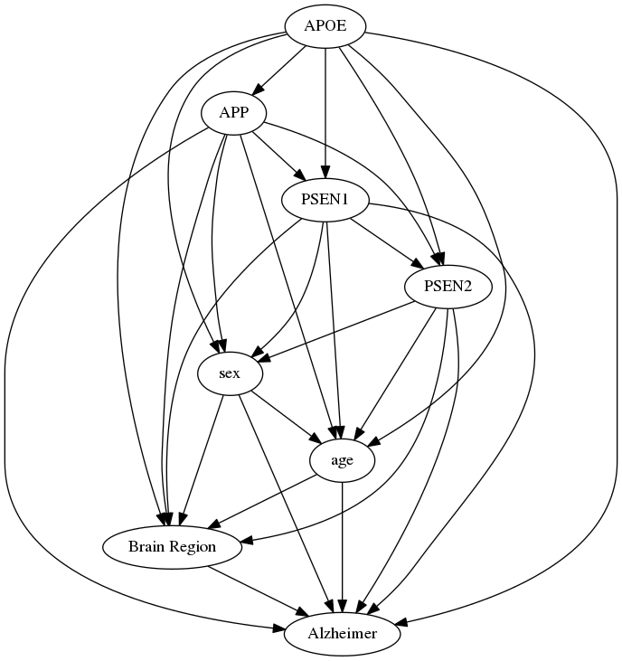
Figure 3
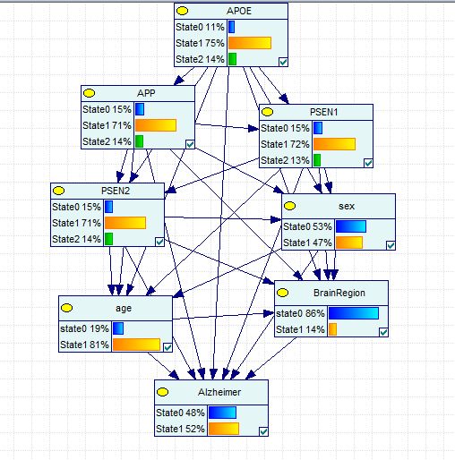
- Log (p)= -8629.672524
- Validation Tests: Table 5
Test | GMLN | ROC AUC: Healthy | ROC AUC: Alzheimer
Test | Alzheimer = 0.648973 (379/584)  Present = 0.574545 (158/275)  Not Present = 0.71521 (221/309) | 0.703054 | 0.703089
Leave One Out | Alzheimer = 0.585616 (342/584)  Present = 0.690909 (190/275)  Not Present = 0.491909 (152/309) | 0.628997 | 0.628997
4-fold cross validation | Alzheimer = 0.59589 (348/584)  Present = 0.716364 (197/275)  Not Present = 0.488673 (151/309) | 0.661353 | 0.661353

Confounding Structure
TBD
- Log (p): TBD
- Comparison Between GMLS & LMLS
  - Brain Region & Age arc removed
  - % comparisons in log scores: TBD% (GMLS) vs TBD% (LMLS)
  - Significance:
    - Max: TBD
    - Min: TBD
  - Times better: TBD
- Test of accuracy:
Test | GMLN | ROC AUC: Healthy | ROC AUC: Alzheimer
Test | Alzheimer = 0.648973 (379/584)  Present = 0.574545 (158/275)  Not Present = 0.71521 (221/309) | 0.703054 | 0.703089
Leave One Out | Alzheimer = 0.585616 (342/584)  Present = 0.690909 (190/275)  Not Present = 0.491909 (152/309) | 0.628997 | 0.628997
4-fold cross validation | Alzheimer = 0.59589 (348/584)  Present = 0.716364 (197/275)  Not Present = 0.488673 (151/309) | 0.661353 | 0.661353

Information obtained from GMLS
- Brain Region & AD:
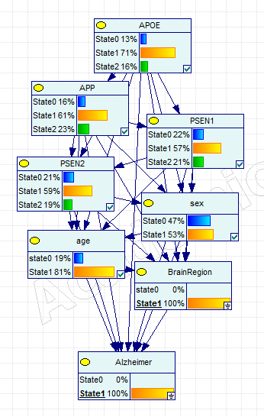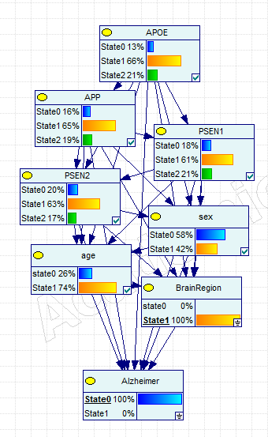
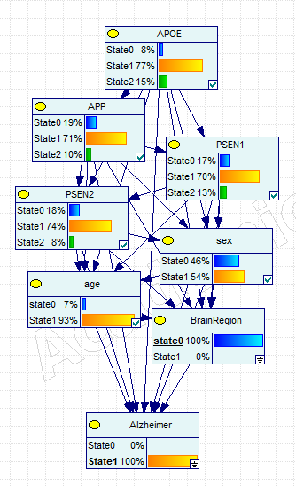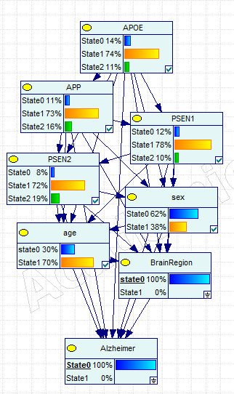
  - Hippocampus AD vs Non AD:
    - APOE: More AD cases had normal expression
    - APP: AD cases had greater over expression
    - PSEN1: AD had a slightly greater under expression
    - PSEN2 AD had slightly more dysregulation
    - Sex: more females than males had AD
    - Age: greater proportion of those age>65 in AD
  - Non hippocampus: mostly the same patterns as Hippocampus
    - APOE: Same as Hippocampus
    - APP: Same as Hippocampus
    - PSEN1: Same as Hippocampus
    - PSEN2: not very clear relationship, AD has more normal expression
    - Sex: Same as Hippocampus
    - Age: Same as Hippocampus
  - AD Hippocampus vs Non Hippocampus
    - APOE: Hippocampus has greater dysregulated expression
    - APP: Hippocampus has greater dysregulated expression, higher expression
    - PSEN1: Hippocampus has greater dysregulated expression
    - PSEN2: Hippocampus has greater dysregulated expression, lower expression
    - Sex: Hippocampus has less females, more females in total AD
    - Age: Hippocampus has less age>65
  - Non AD Hippocampus vs Non Hippocampus
    - APOE: Hippocampus has greater dysregulated expression, higher expression
    - APP: Hippocampus has greater dysregulated expression
    - PSEN1: Hippocampus has greater dysregulated expression, higher expression
    - PSEN2: Hippocampus has greater dysregulated expression, lower expression
    - Sex: Hippocampus has less females, more males in total non AD
    - Age: Hippocampus has more age>65
- Age & AD
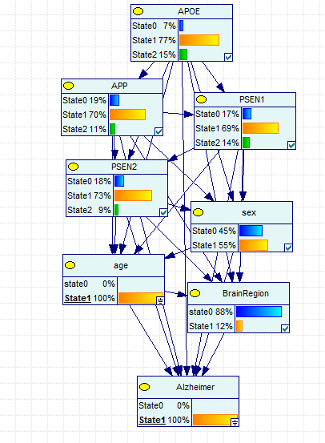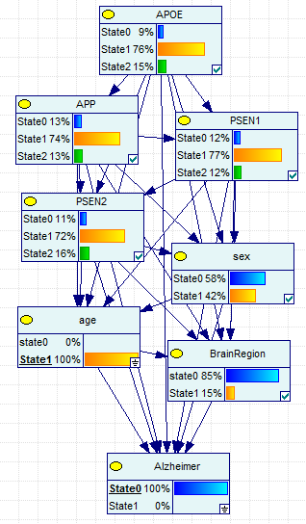
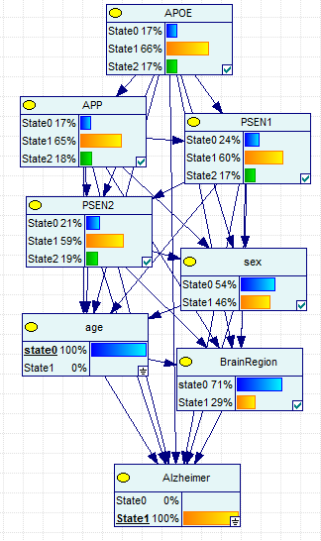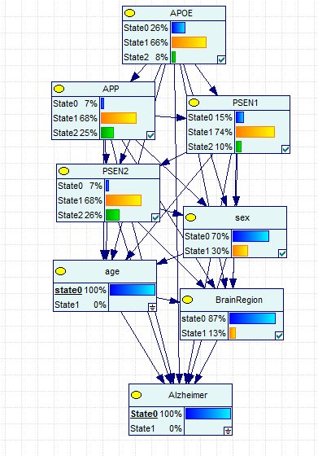
  - Age>65
    - APOE: More AD cases had normal expression
    - APP: AD cases had less expression
    - PSEN1: AD had more dysregulation
    - PSEN2: unclear relationship; AD has less dysregulation but greater under expression
    - Sex: more females than males had AD
    - Brain Region: Less hippocampal samples in AD cases
  - Age≤65
    - APOE: More AD cases had normal expression; greater over expression in AD cases
    - APP: AD cases had less expression
    - PSEN1: AD had more dysregulation
    - PSEN2: AD had less expression
    - Sex: more females than males had AD; more males overall
    - Brain Region: more hippocampal samples in AD cases
  - AD Age >65 vs Age≤65
    - APOE: Age>65 had less dysregulation
    - APP: Age>65 had less expression
    - PSEN1: Age>65 had less dysregulation
    - PSEN2: Age>65 had less dysregulation
    - Sex: Age>65 had more females
    - Brain Region: Age>65 had less hippocampus samples
  - Non AD Age >65 vs Age≤65
    - APOE: Age>65 had higher expression
    - APP: Age>65 had less expression
    - PSEN1: Age>65 had less dysregulation
    - PSEN2: Age>65 had less expression
    - Sex: Age>65 had less females; more male samples in total
    - Brain Region: Age>65 had more hippocampus samples
- Sex & AD
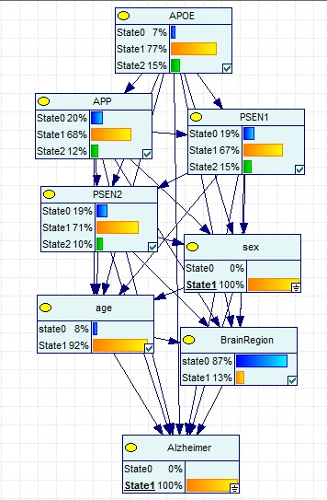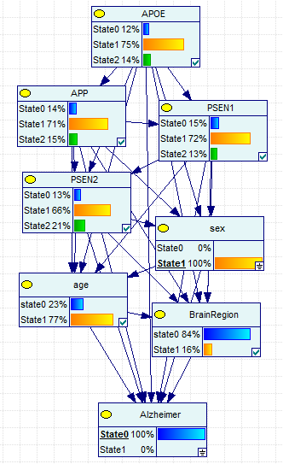
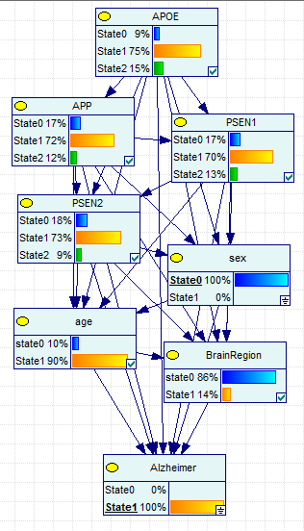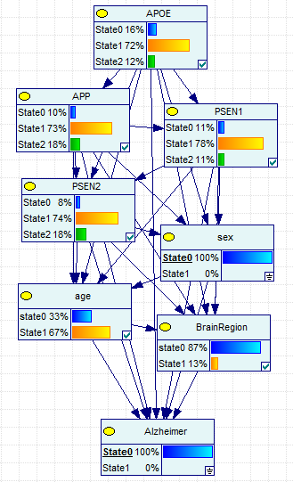
  - Females
    - APOE: AD has higher expression
    - APP: AD has lower expression
    - PSEN1: AD has more dysregulated expression
    - PSEN2: AD has lower expression
    - Age: AD has much more age>65
    - Brain Region: AD has fewer hippocampi samples
  - Males
    - APOE: AD has lower expression
    - APP: AD has lower expression
    - PSEN1: AD has lower expression
    - PSEN2: AD has lower expression
    - Age: AD has much more age>65
    - Brain Region: AD has more hippocampi samples
  - AD Females vs Males
    - APOE: Females had greater expression
    - APP: Females had lower expression
    - PSEN1: Females had more dysregulation
    - PSEN2: Females had more dysregulation
    - Age: Females had more age>65
    - Brain Region: Females had less hippocampi samples
  - Non AD Females vs Males
    - APOE: Females had higher expression
    - APP: Females had lower expression
    - PSEN1: Females had more dysregulated expression, lower expression
    - PSEN2: Females had more dysregulated expression
    - Age: Females had more age>65
    - Brain Region: Females had more hippocampi samples
- Age & Brain Region
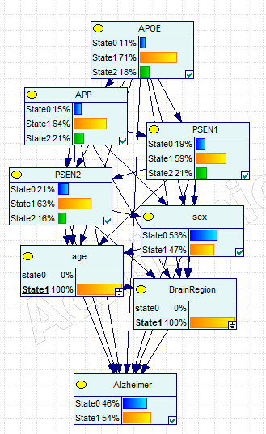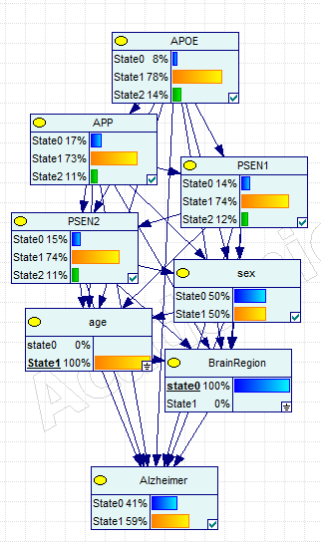
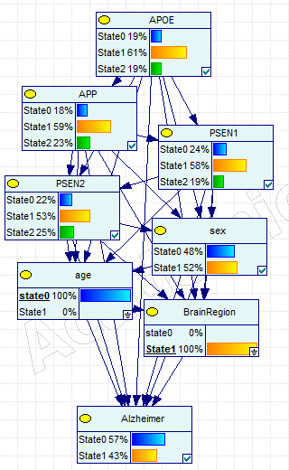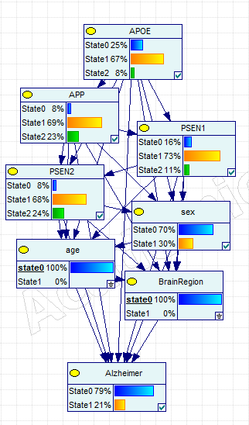
  - Age >65
    - APOE: Hippocampus has greater dysregulation
    - APP: Hippocampus has greater dysregulation, higher expression
    - PSEN1: Hippocampus has greater dysregulation
    - PSEN2: Hippocampus has greater dysregulation
    - Sex: Hippocampus has less Females
    - AD: Hippocampus has less AD cases
  - Age≤65
    - APOE: Hippocampus has higher expression
    - APP: Hippocampus has greater dysregulation, lower expression
    - PSEN1: Hippocampus has greater dysregulation
    - PSEN2: Hippocampus has greater dysregulation
    - Sex: Hippocampus has more Females
    - AD: Hippocampus has much moreAD cases; much more non AD cases
  - Hippocampus Age>65 vs Age≤65
    - APOE: Age>65 has less dysregulation
    - APP: Age>65 has less dysregulation
    - PSEN1: Age>65 has greater expression
    - PSEN2: Age>65 has less dysregulation, lower expression
    - Sex: Age>65 had more females
    - AD: Age>65 had more AD cases
  - Non Hippocampus Age≤65 vs Age>65
    - APOE: Age>65 has less dysregulation, higher expression
    - APP: Age>65 has less dysregulation, lower expression
    - PSEN1: Age>65 has less dysregulation, greater expression
    - PSEN2: Age>65 has less dysregulation, lower expression
    - Sex: Age>65 had much more females
    - AD: Age>65 had much more AD cases
- Age & Sex
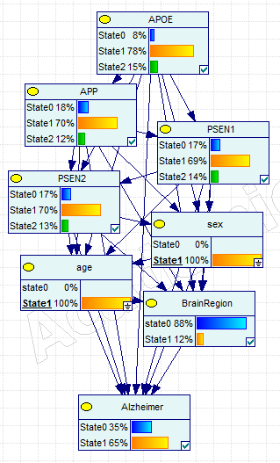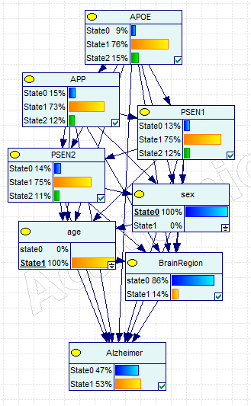
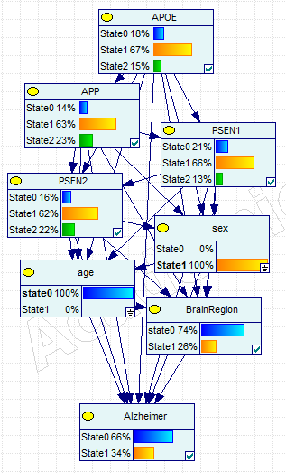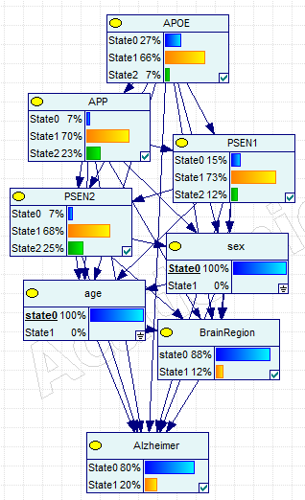
  - Age >65
    - APOE: Females have slightly higher expression
    - APP: Females have lower expression
    - PSEN1: Females have greater dysregulation
    - PSEN2: Females have greater dysregulation, lower expression
    - Brain Region: Females have less hippocampi samples
    - AD: Females have more AD cases
  - Age≤65
    - APOE: Females have slightly higher expression
    - APP: Females have lower expression
    - PSEN1: Females have greater dysregulation
    - PSEN2: Females have greater dysregulation, lower expression
    - Brain Region: Females have less hippocampi samples
    - AD: Females have more AD cases
  - Females Age>65 vs Age≤65
    - APOE: Age>65 has less dysregulation, greater expression
    - APP: Age>65 has lower expression
    - PSEN1: Age>65 has less dysregulation, higher expression
    - PSEN2: Age>65 has lower expression
    - Brain Region: Age>65 has less hippocampi samples
    - AD: Age>65 has more AD cases
  - Males Age>65 vs Age≤65
    - APOE: Age>65 has less dysregulation, greater expression
    - APP: Age>65 has less dysregulation, lower expression
    - PSEN1: Age>65 has less dysregulation, higher expression
    - PSEN2: Age>65 has less dysregulation, lower expression
    - Brain Region: Age>65 has less hippocampi samples
    - AD: Age>65 has much more AD cases
- Brain Region & Sex
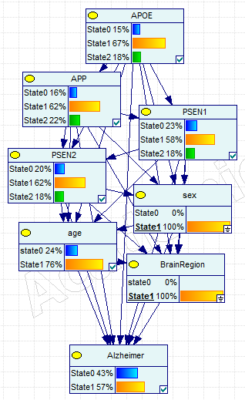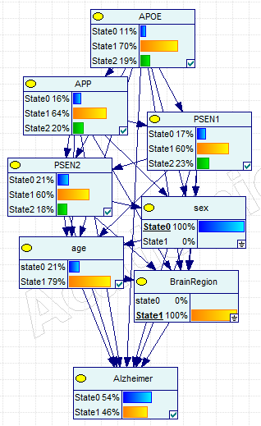
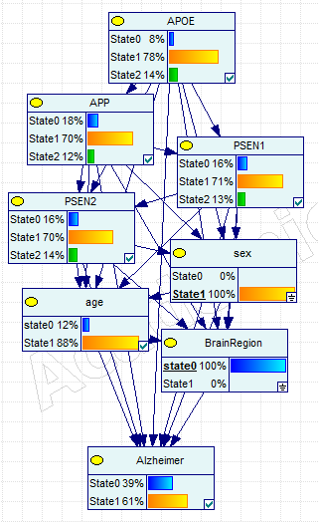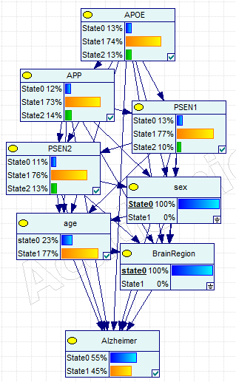
  - Hippocampus
    - APOE: Females have greater dysregulated expression, lower expression
    - APP: Females have greater dysregulated expression, higher expression
    - PSEN1: Females have greater dysregulated expression, lower expression
    - PSEN2: Females have less dysregulated expression, higher expression
    - Age: Females have less age>65
    - AD: Females have greater AD cases
  - Non Hippocampus
    - APOE: Females have less dysregulated expression, higher expression
    - APP: Females have greater dysregulated expression, lower expression
    - PSEN1: Females have greater dysregulated expression, lower expression
    - PSEN2: Females have greater dysregulated expression, lower expression
    - Age: Females have more age>65
    - AD: Females have greater AD cases
  - Female Hippocampus vs Non Hippocampus
    - APOE: Hippocampus has greater dysregulation
    - APP: Hippocampus has greater dysregulation, higher expression
    - PSEN1: Hippocampus has greater dysregulation, lower expression
    - PSEN2: Hippocampus has greater dysregulation, lower expression
    - Age: Hippocampus has less age>65
    - AD: Hippocampus has less AD cases
  - Male Hippocampus vs Non Hippocampus
    - APOE: Hippocampus has greater dysregulation, higher expression
    - APP: Hippocampus has greater dysregulation, higher expression
    - PSEN1: Hippocampus has greater dysregulation, lower expression
    - PSEN2: Hippocampus has greater dysregulation, lower expression
    - Age: Hippocampus has more age>65
    - AD: Hippocampus has more AD cases
- Sex & Brain Region & AD
  - Within Hippocampus
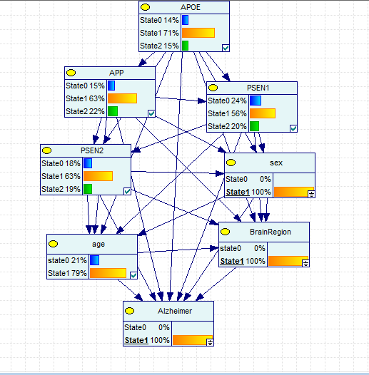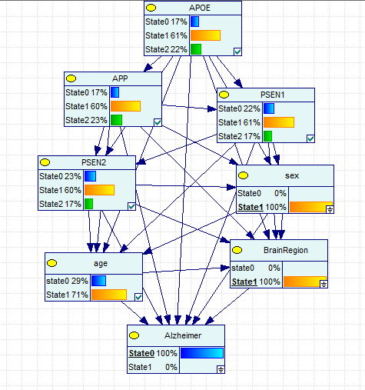
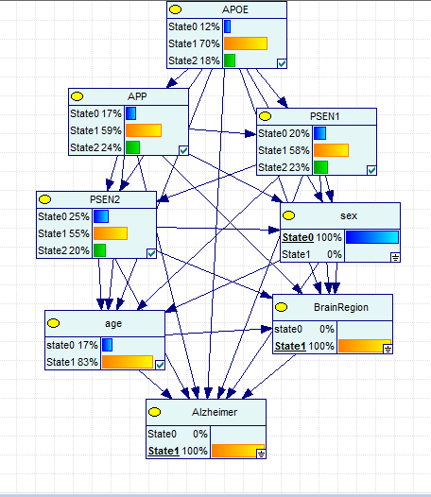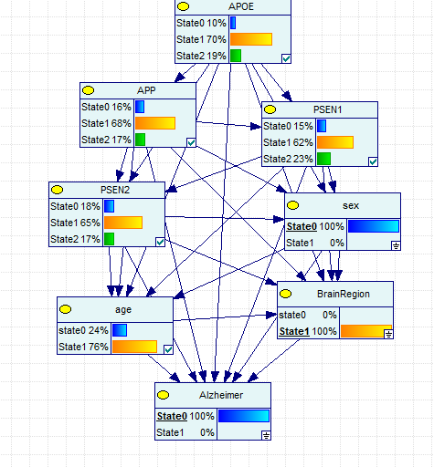

- Females:
  - APOE: AD has less dysregulated expression
  - APP: AD has less dysregulated expression
  - PSEN1: AD has more dysregulated expression
  - PSEN2: AD has higher expression
  - Age: AD has greater proportion of those age>65
- Males:
  - APOE: AD had less dysregulated expression
  - APP: AD had more dysregulated expression
  - PSEN1: AD had more dysregulated expression
  - PSEN2: AD had more dysregulated expression
  - Age: AD has greater proportion of those age>65
- AD Males v Females:
  - APOE: Females had less dysregulated expression
  - APP: Females had less dysregulated expression
  - PSEN1: Females had more dysregulated expression
  - PSEN2: Females had less dysregulated expression
  - Age: Females had lower proportion of those age>65
- Non AD Males v Females:
  - APOE: Females had more dysregulated expression
  - APP: Females had more dysregulated expression
  - PSEN1: Females have more under expression, males have more over expression
  - PSEN2: Females had more underexpression
  - Age: Females had less age >65
  - Non Hippocampus
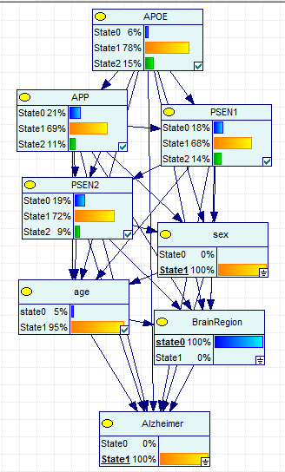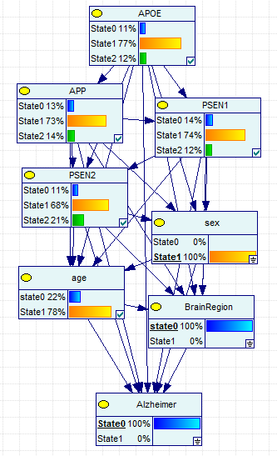
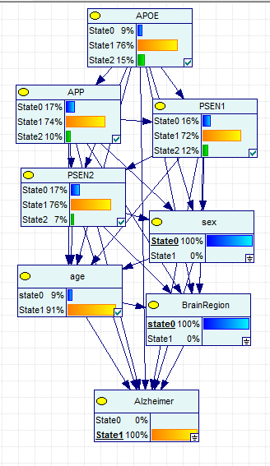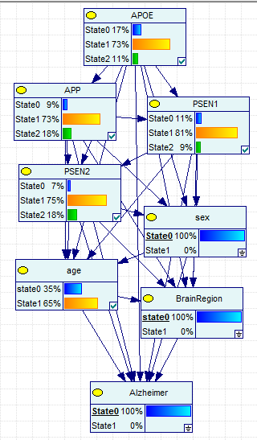
    - Females:
      - APOE: AD has higher expression
      - APP: AD has lower expression
      - PSEN1: AD has more dysregulated expression
      - PSEN2: AD has lower expression
      - Age: AD has greater proportion of those age>65
      - Males:
      - APOE: AD had higher expression
      - APP: AD had lower expression
      - PSEN1: AD had more dysregulated expression
      - PSEN2: AD had lower expression
      - Age: AD has greater proportion of those age>65
      - AD Males v Females:
      - APOE: Females had less under expression
      - APP: Females had more dysregulated expression
      - PSEN1: Females had more dysregulated expression
      - PSEN2: Females had more dysregulated expression
      - Age: Females had lower proportion of those age>65
      - Non AD Males v Females:
      - APOE: Females had more expression
      - APP: Females had more under expression
      - PSEN1: Females have more dysregulated expression
      - PSEN2: Females had more overexpression
      - Age: Females had more age >65
- Sex & Age & AD
  - Age >65
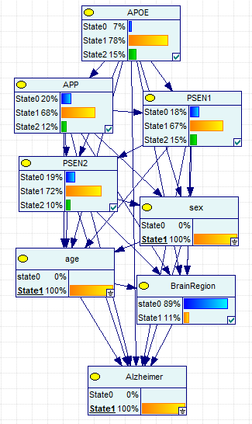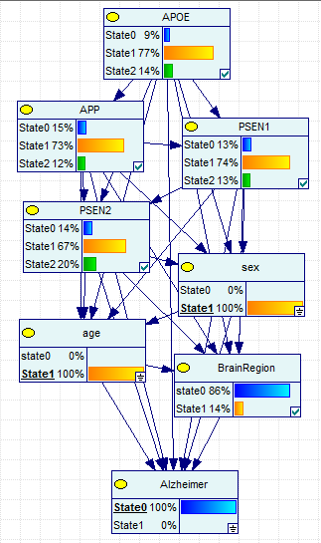
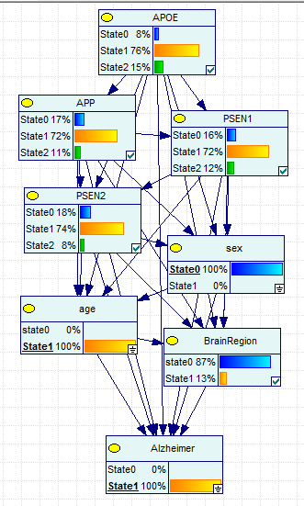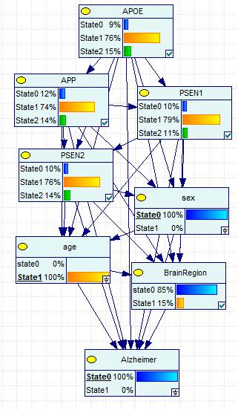
    - Females
      - APOE: AD has higher expression
      - APP: AD has lower expression
      - PSEN1: AD has greater dysregulated expression
      - PSEN2: AD has lower expression
      - Brain Region: AD has less hippocampal samples
    - Males
      - APOE: AD virtually the same; AD has higher expression
      - APP: AD has lower expression
      - PSEN1: AD has greater dysregulated expression
      - PSEN2: AD has lower expression
      - Brain Region: AD has less hippocampal samples
    - AD Males v Females
      - APOE: AD virtually the same; females have higher expression
      - APP: Females have lower expression
      - PSEN1: Females have greater dysregulated expression
      - PSEN2: Females have greater dysregulated expression
      - Brain Region: Females have less hippocampal samples
    - Non AD Males v Females
      - APOE: AD virtually the same; females have lower expression
      - APP: Females have lower expression
      - PSEN1: Females have greater dysregulated expression
      - PSEN2: Females have greater dysregulated expression
      - Brain Region: Females have less hippocampal samples
  - Age ≤65
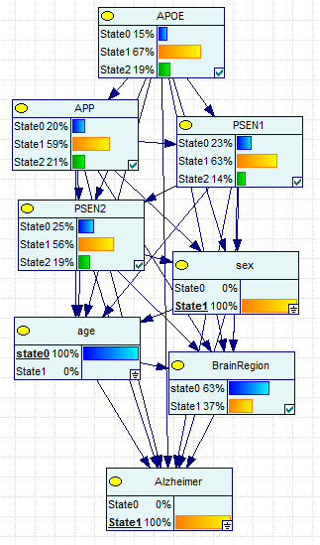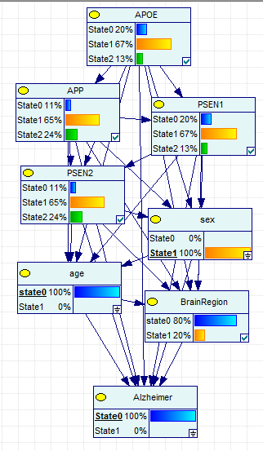
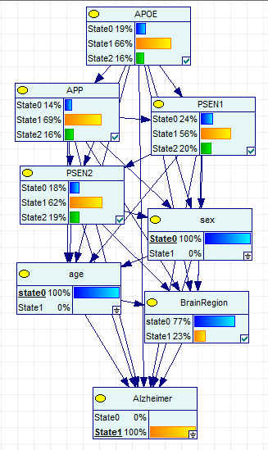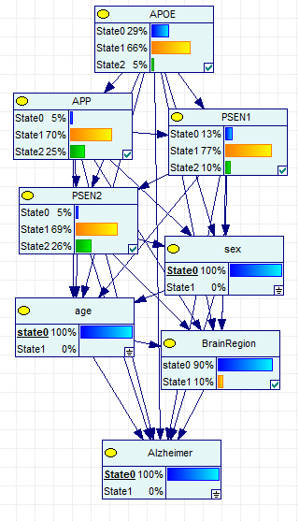
    - Females
      - APOE: AD has higher expression
      - APP: AD has lower expression
      - PSEN1: AD has greater dysregulated expression
      - PSEN2: AD has lower expression
      - Brain Region: AD has more hippocampal samples
    - Males
      - APOE: AD has higher expression
      - APP: AD has lower expression
      - PSEN1: AD has greater dysregulated expression
      - PSEN2: AD has lower expression
      - Brain Region: AD has more hippocampal samples
    - AD Males v Females
      - APOE: females have higher expression
      - APP: Females have lower expression
      - PSEN1: Females have less expression
      - PSEN2: Females have lower expression
      - Brain Region: Females have more hippocampal samples
    - Non AD Males v Females
      - APOE: females have higher expression
      - APP: Females have greater dysregulated expression, less expression
      - PSEN1: Females have greater dysregulated expression
      - PSEN2: Females have greater dysregulated expression, less expression
      - Brain Region: Females have more hippocampal samples
- Brain Region & Age & AD
  - Age >65
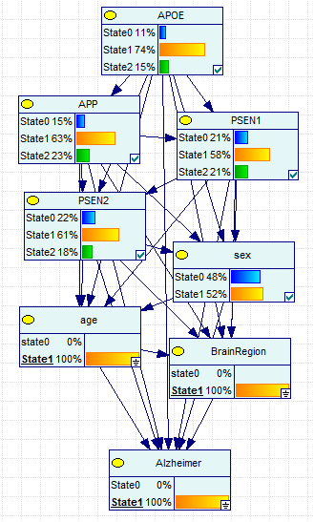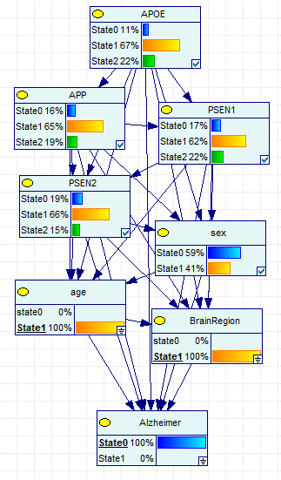
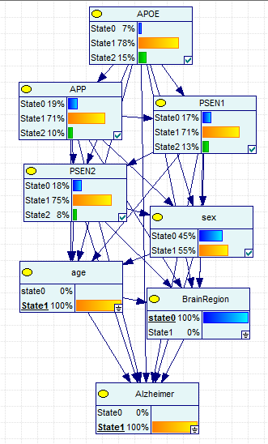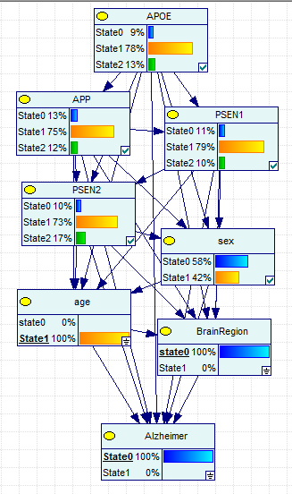
    - Hippocampus
      - APOE: AD has decreased expression
      - APP: AD has increased expression
      - PSEN1: AD has greater dysregulated expression, decreased expression
      - PSEN2: AD has dysregulated expression
      - Sex: AD had more females
    - Non Hippocampus
      - APOE: AD has greater expression
      - APP: AD has decreased expression
      - PSEN1: AD has greater dysregulated expression
      - PSEN2: AD has lower expression
      - Sex: AD had more females
    - AD Hippocampus vs Non Hippocampus
      - APOE: Hippocampus has lower expression
      - APP: Hippocampus has higher expression
      - PSEN1: Hippocampus has greater dysregulated expression
      - PSEN2: Hippocampus has greater dysregulated expression
      - Sex: Hippocampus has less females
    - Non AD Hippocampus vs Non Hippocampus
      - APOE: Hippocampus has greater dysregulated expression
      - APP: Hippocampus has greater dysregulated expression
      - PSEN1: Hippocampus has greater dysregulated expression
      - PSEN2: Hippocampus has lower expression
      - Sex: Hippocampus has less females
  - Age ≤65
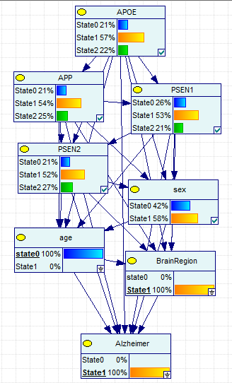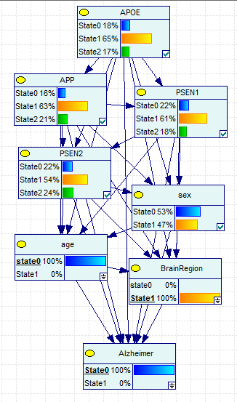
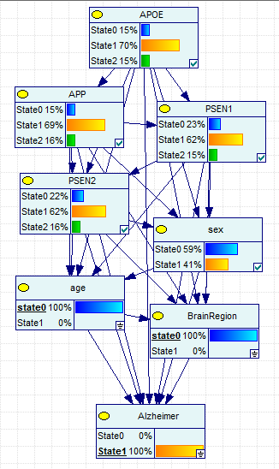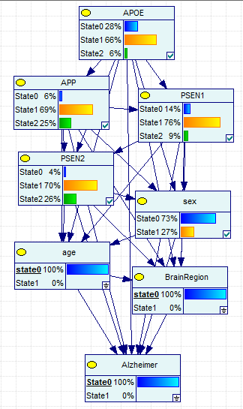
    - Hippocampus
      - APOE: AD has greater dysregulated expression
      - APP: AD has greater dysregulated expression
      - PSEN1: AD has greater dysregulated expression, decreased expression
      - PSEN2: AD has greater expression
      - Sex: AD had more females
    - Non Hippocampus
      - APOE: AD has greater expression
      - APP: AD has decreased expression
      - PSEN1: AD has greater dysregulated expression
      - PSEN2: AD has lower expression
      - Sex: AD had more females
    - AD Hippocampus vs Non Hippocampus
      - APOE: Hippocampus has greater dysregulated expression
      - APP: Hippocampus has greater dysregulated expression
      - PSEN1: Hippocampus has greater dysregulated expression
      - PSEN2: Hippocampus has greater dysregulated expression, lower expression
      - Sex: Hippocampus has more females
    - Non AD Hippocampus vs Non Hippocampus
      - APOE: Hippocampus has greater dysregulated expression, higher expression
      - APP: Hippocampus has lower expression
      - PSEN1: Hippocampus has greater dysregulated expression, lower expression
      - PSEN2: Hippocampus has greater dysregulated expression, lower expression
      - Sex: Hippocampus has more females, more males total
- Sex & Brain Region & Age
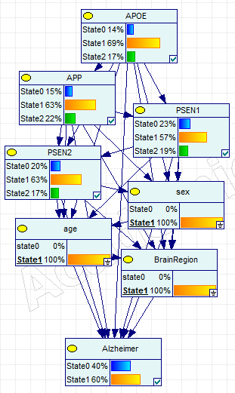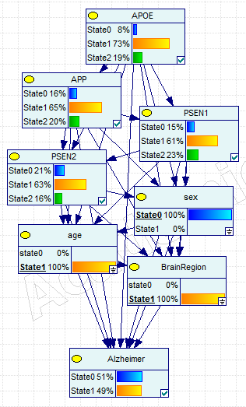
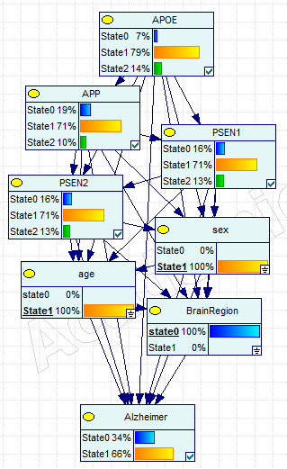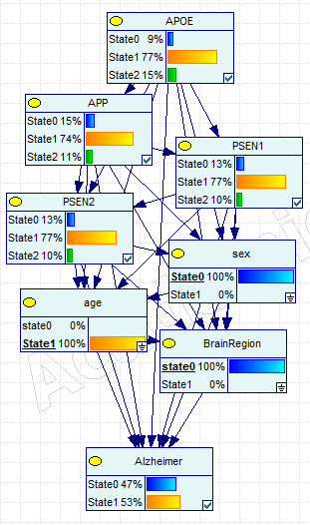
  - Age>65
    - Hippocampus
      - APOE: females have greater dysregulation, lower expression
      - APP: females have greater dysregulation, higher expression
      - PSEN1: females have greater dysregulation, lower expression
      - PSEN2: females have greater expression
      - AD: females have more AD cases
    - Non Hippocampus
      - APOE: females have less dysregulation, lower expression
      - APP: females have greater dysregulation, lower expression
      - PSEN1: females have greater dysregulation
      - PSEN2: females have greater expression
      - AD: females have more AD cases
    - Female Hippocampus vs Non Hippocampus
      - APOE: Hippocampus has greater dysregulation, lower expression
      - APP: Hippocampus has greater dysregulation, higher expression
      - PSEN1: Hippocampus has greater dysregulation, lower expression
      - PSEN2: Hippocampus has greater dysregulation, lower expression
      - AD: Hippocampus has less AD cases
    - Male Hippocampus vs Non Hippocampus
      - APOE: Hippocampus has greater dysregulation, higher expression
      - APP: Hippocampus has greater dysregulation
      - PSEN1: Hippocampus has greater dysregulation, higher expression
      - PSEN2: Hippocampus has greater dysregulation, lower expression
      - AD: Hippocampus has less AD cases

  - Age>65
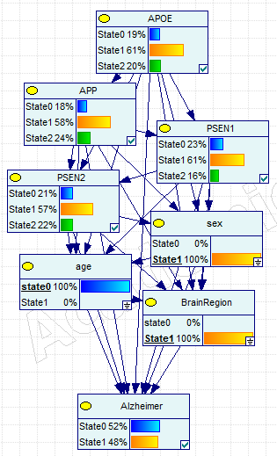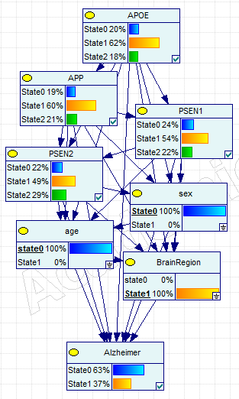
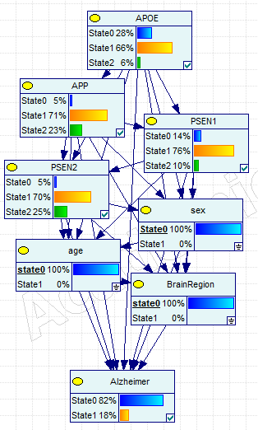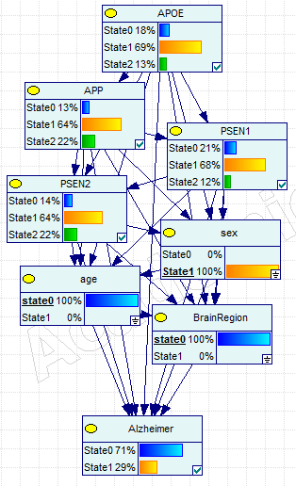
    - Hippocampus
      - APOE: females have greater dysregulation, higher expression
      - APP: females have greater dysregulation, higher expression
      - PSEN1: females have greater dysregulation, lower expression
      - PSEN2: females have less dysregulation, lower expression
      - AD: females have more AD cases
    - Non Hippocampus
      - APOE: females have greater dysregulation, lower expression
      - APP: females have less dysregulation, higher expression
      - PSEN1: females have less dysregulation, higher expression
      - PSEN2: females have less dysregulation, greater expression
      - AD: females have less AD cases
    - Female Hippocampus vs Non Hippocampus
      - APOE: Hippocampus has greater dysregulation
      - APP: Hippocampus has greater dysregulation
      - PSEN1: Hippocampus has less dysregulation, lower expression
      - PSEN2: Hippocampus has greater dysregulation, lower expression
      - AD: Hippocampus has much more AD cases
    - Male Hippocampus vs Non Hippocampus
      - APOE: Hippocampus has greater dysregulation, higher expression
      - APP: Hippocampus has greater dysregulation
      - PSEN1: Hippocampus has greater dysregulation, higher expression
      - PSEN2: Hippocampus has greater dysregulation, lower expression
      - AD: Hippocampus has less AD cases
- Gene expression profile patterns
  - APOE
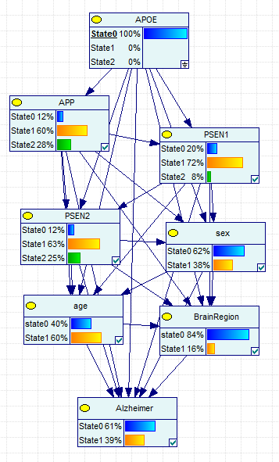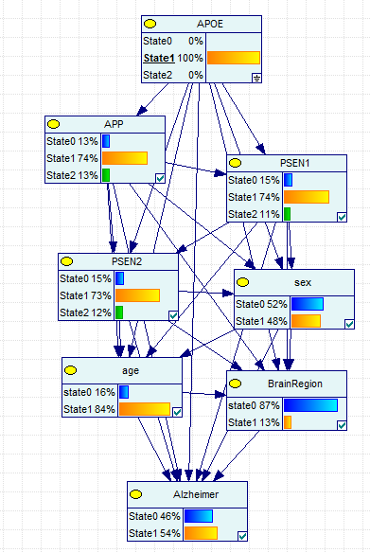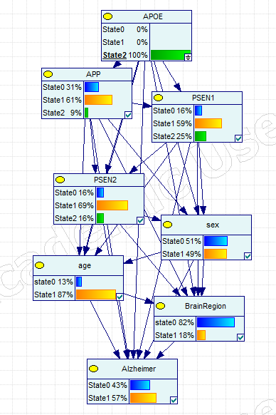
    - General patterns
      - AD risk: Risk increased as APOE expression increased
        - Under expression: lower AD risk (39% vs 54% for normal expression)
        - Over Expression: higher AD risk (57% vs 54% for normal expression)
      - Sex:
        - More males than females in data
        - Under expression found less prevalent in females (38% vs 48% & 49%)
      - Age: APOE expression increases with age
        - under expression: 60% age>65
        - normal expression: 84% age>65
        - over expression: 87% age>65
      - APP: decreased expression as APOE expression increases
        - under expression: 12% APP under expression; 28% over expression
        - normal expression: 13% APP under expression; 13% over expression
        - over expression: 31% APP under expression; 9% over expression
      - PSEN1: dysregulation of APOE dysregulates PSEN1 expression
        - APOE over expression has greater affect on PSEN1 expression
        - under expression: 8% PSEN1 over expression; 20% under expression
        - normal expression: 11% PSEN1 over expression; 15% under expression
        - over expression: 25% PSEN1 over expression; 16% under expression
      - PSEN2: dysregulation of APOE dysregulates PSEN2 expression
        - Slight difference in under expressions
        - under expression: 12% PSEN2 under expression; 25% over expression
        - normal expression: 15% PSEN2 under expression; 12% over expression
        - over expression: 16% PSEN2 under expression; 16% over expression
    - Brain Region: Hippocampus
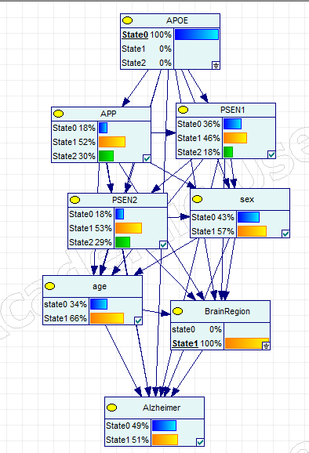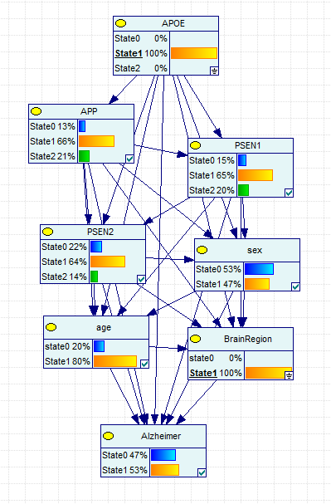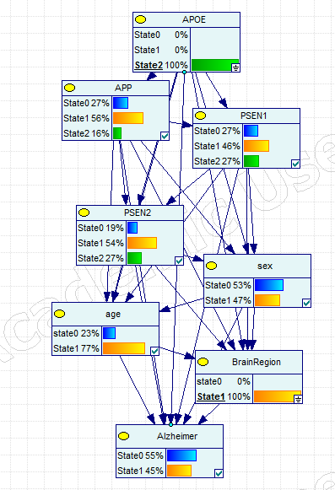
      - AD risk: increasing APOE expression decreases AD risk
        - Under expression: increased AD risk (51% vs 53% for normal expression)
        - Over Expression: lower AD risk (57% vs 45% for normal expression)
      - Sex:
        - More females than males in data only in APOE under expression
        - Under expression found more prevalent in females (57% vs 47% & 47%)
      - Age: less APOE dysregulation in those age>65
        - under expression: 66% age>65
        - normal expression: 80% age>65
        - over expression: 77% age>65
      - APP: decreased over expression as APOE expression increases
        - under expression: 30% APP over expression; 36% under expression
        - normal expression: 21% APP under expression; 15% under expression
        - over expression: 16% APP under expression; 27% under expression
      - PSEN1: increased APOE expression increases PSEN1 expression
        - under expression: 18% PSEN1 over expression; 36% under expression
        - normal expression: 20% PSEN1 over expression; 15% under expression
        - over expression: 27% PSEN1 over expression; 27% under expression
      - PSEN2: dysregulation of APOE dysregulates PSEN2 expression
        - under expression: 18% PSEN2 under expression; 29% over expression
        - normal expression: 22% PSEN2 under expression; 14% over expression
        - over expression: 19% PSEN2 under expression; 27% over expression
      - Sex & Age
      - Sex, Brain Region & Age
  - APP
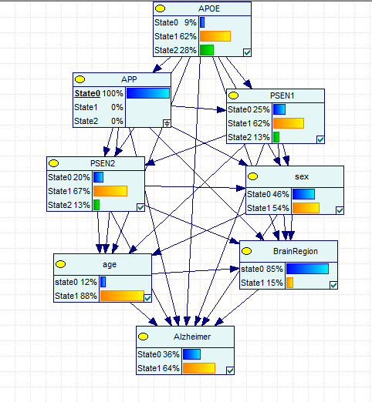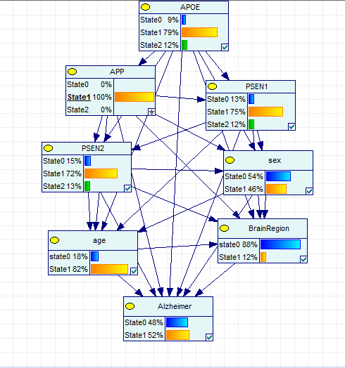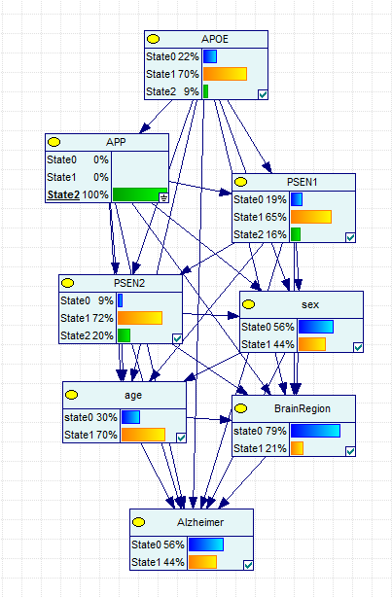
- General APP patterns
      - AD risk: Risk decreased as APP expression increased
        - Under expression: higher AD risk (64% vs 52% for normal expression)
        - Over Expression: lower AD risk (44% vs 52% for normal expression)
      - Sex:
        - Under expression is more prevalent in females
        - Higher expression found less prevalent in females (54% vs 48% & 44%)
      - Age: APP expression decreases with age
        - under expression: 88% age>65
        - normal expression: 82% age>65
        - over expression: 70% age>65
      - APOE: APP decreased expression as APOE expression increases
        - under expression: 28% APOE over expression; 9% under expression
        - normal expression: 12% APOE over expression; 9% under expression
        - over expression: 9% APOE over expression; 22% under expression
      - PSEN1: dysregulation of APP dysregulates PSEN1 expression
        - under expression: 13% PSEN1 over expression; 25% under expression
        - normal expression: 12% PSEN1 over expression; 13% under expression
        - over expression: 16% PSEN1 over expression; 19% under expression
      - PSEN2: expression increases as APP increases
        - under expression: 20% PSEN2 under expression; 13% over expression
        - normal expression: 15% PSEN2 under expression; 13% over expression
        - over expression: 9% PSEN2 under expression; 20% over expression
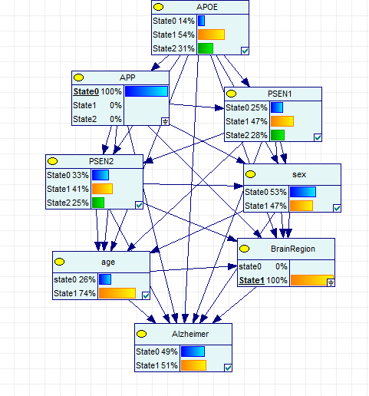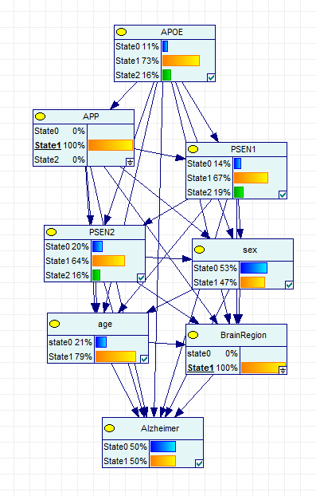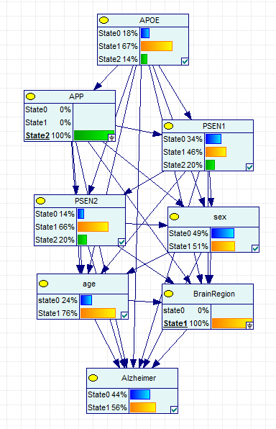
- Brain Region: APP patterns within hippocampus
      - AD risk: Risk increased as APP expression dysregulated
        - Over expression seems to have a greater effect on increasing AD risk
        - Under expression: higher AD risk (51% vs 50% for normal expression)
        - Over Expression: lower AD risk (56% vs 50% for normal expression)
      - Sex:
        - Over expression is more prevalent in females (47% vs 47% & 51%)
        - Fairly even split of males & females
      - Age: APP expression unclear relationships
        - under expression: 74% age>65
        - normal expression: 79% age>65
        - over expression: 76% age>65
      - APOE: APP decreased expression as APOE expression increases
        - under expression: 31% APOE over expression; 14% under expression
        - normal expression: 18% APOE over expression; 11% under expression
        - over expression: 14% APOE over expression; 18% under expression
      - PSEN1: dysregulation of APP dysregulates PSEN1 expression
        - under expression: 28% PSEN1 over expression; 25% under expression
        - normal expression: 19% PSEN1 over expression; 14% under expression
        - over expression: 20% PSEN1 over expression; 34% under expression
      - PSEN2: expression increases as APP increases
        - under expression: 33% PSEN2 under expression; 25% over expression
        - normal expression: 20% PSEN2 under expression; 16% over expression
        - over expression: 14% PSEN2 under expression; 20% over expression
  - PSEN1
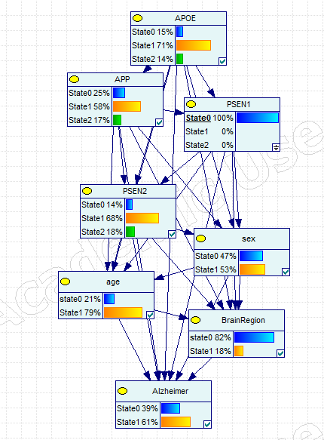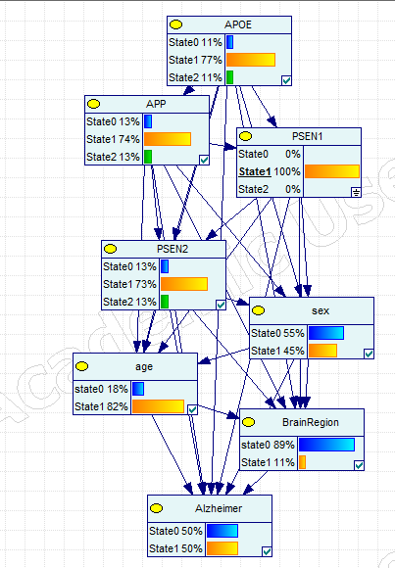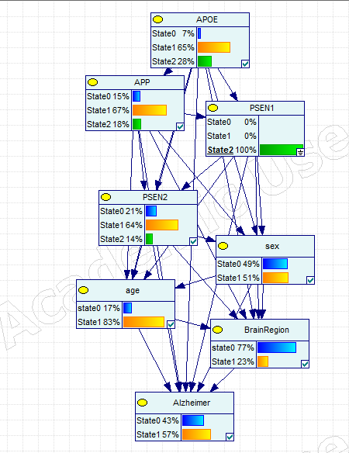
- General PSEN1 patterns
  - AD risk: Risk increased as PSEN1 expression dysregulated
    - Under expression: higher AD risk (61% vs 50% for normal expression)
    - Over Expression: lower AD risk (57% vs 50% for normal expression)
  - Sex:
    - Greater dysregulation in females (53% vs 45% & 51%)
    - Females have less normal expression of PSEN1 (45%)
  - Age: PSEN1 expression increases with age
    - under expression: 79% age>65
    - normal expression: 82% age>65
    - over expression: 83% age>65
  - APOE: PSEN1 increased expression as APOE expression increases
    - under expression: 28% APOE over expression; 9% under expression
    - normal expression: 12% APOE over expression; 9% under expression
    - over expression: 9% APOE over expression; 22% under expression
    - Relationships not as clear
  - APP: dysregulation of APP dysregulates PSEN1 expression
    - under expression: 25% APP over expression; 17% under expression
    - normal expression: 13% APP over expression; 13% under expression
    - over expression: 15% APP over expression; 18% under expression
    - Relationship not as clear
  - PSEN2: dysregulation of PSEN1 dysregulates PSEN2
    - under expression: 20% PSEN2 under expression; 13% over expression
    - normal expression: 15% PSEN2 under expression; 13% over expression
    - over expression: 9% PSEN2 under expression; 20% over expression
    - Relationship is not as clear
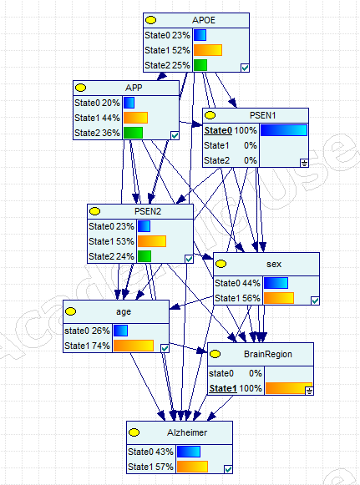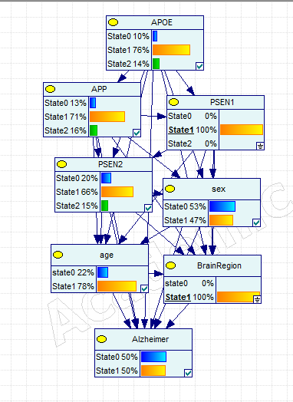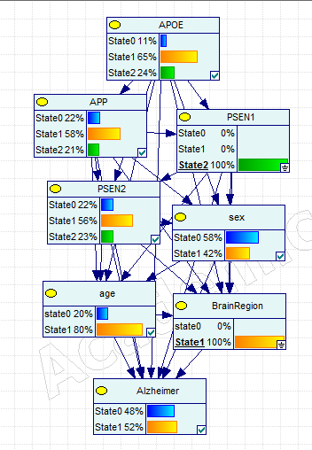
- PSEN1 patterns within hippocampus
  - AD risk: dysregulation increases AD risk
    - Under expression: higher AD risk (57% vs 50% for normal expression)
    - Over Expression: lower AD risk (52% vs 50% for normal expression)
    - Under expression seems to have a greater effect on AD risk
  - Sex:
    - Females tend to have lower expression of PSEN1 (56% vs 47% & 42%)
    - Females have less normal expression of PSEN1 (47%)
  - Age: PSEN1 expression increases with age
    - under expression: 74% age>65
    - normal expression: 78% age>65
    - over expression: 80% age>65
  - APOE: dysregulation of APOE dysregulates PSEN1 expression
    - under expression: 23% APOE under expression; 25% under expression
    - normal expression: 10% APOE over expression; 14% under expression
    - over expression: 11% APOE over expression; 24% under expression
    - Relationships not as clear
  - APP: dysregulation of APP dysregulates PSEN1 expression
    - under expression: 36% APP over expression; 20% under expression
    - normal expression: 16% APP over expression; 13% under expression
    - over expression: 21% APP over expression; 22% under expression
    - Relationship not as clear
    - Decreased PSEN1 expression shows much more dysregulated APP expression
  - PSEN2: dysregulation of PSEN1 dysregulates PSEN2
    - under expression: 23% PSEN2 under expression; 24% over expression
    - normal expression: 20% PSEN2 under expression; 15% over expression
    - over expression: 22% PSEN2 under expression; 23% over expression
    - Relationship is not as clear
  - PSEN2
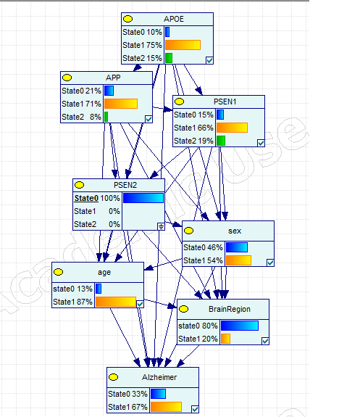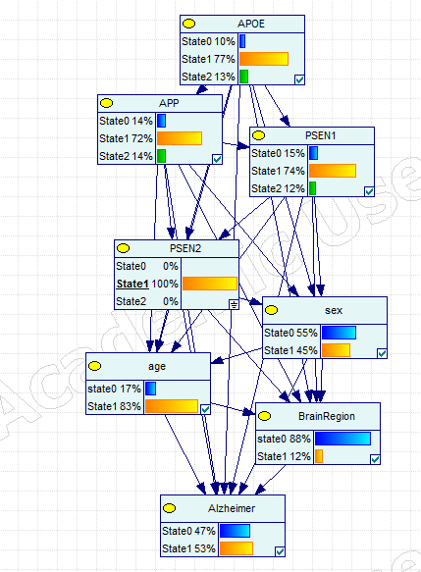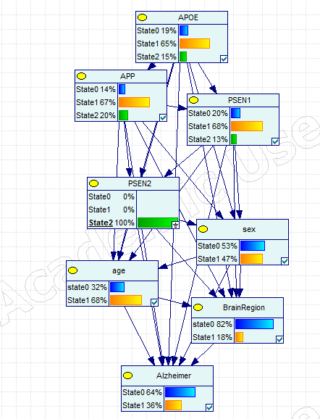
- General PSEN2 patterns
  - AD risk: Risk decreased as PSEN2 expression increased
    - Under expression: higher AD risk (67% vs 53% for normal expression)
    - Over Expression: lower AD risk (36% vs 53% for normal expression)
  - Sex:
    - Greater under expression in females (54% vs 45% & 47%)
  - Age: PSEN2 expression decreases with age
    - under expression: 67% age>65
    - normal expression: 53% age>65
    - over expression: 36% age>65
  - APOE: PSEN2 over expression suggests decreased APOE expression
    - under expression: 15% APOE over expression; 10% under expression
    - normal expression: 13% APOE over expression; 10% under expression
    - over expression: 15% APOE over expression; 19% under expression
    - Relationships not clear
  - APP: increasing expression of APP increases PSEN2 expression
    - under expression: 8% APP over expression; 21% under expression
    - normal expression: 14% APP over expression; 14% under expression
    - over expression: 20% APP over expression; 14% under expression
  - PSEN1: dysregulation of PSEN1 dysregulates PSEN2
    - under expression: 15% PSEN1 under expression; 19% over expression
    - normal expression: 15% PSEN1 under expression; 12% over expression
    - over expression: 20% PSEN1 under expression; 13% over expression
    - Relationship is not as clear
- PSEN2 patterns within the hippocampus
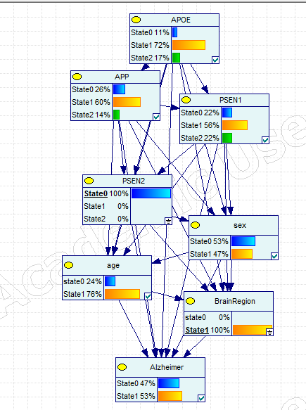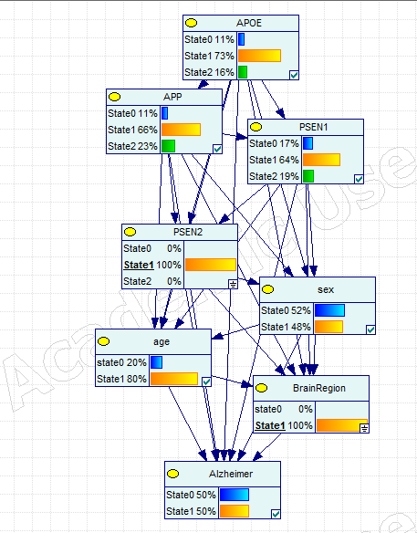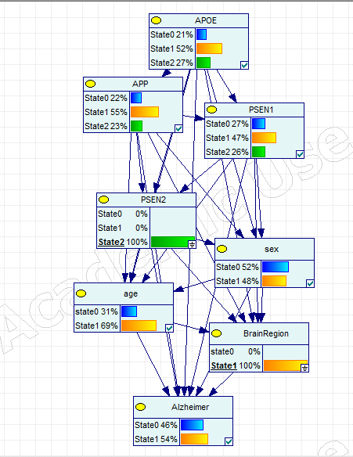
  - AD risk: Risk increases with PSEN2 dysregrulation
    - Under expression: higher AD risk (53% vs 50% for normal expression)
    - Over Expression: slightly higher AD risk (54% vs 50% for normal expression)
  - Sex: More males in the dataset
  - Age: PSEN1 expression decreases with age
    - under expression: 67% age>65
    - normal expression: 53% age>65
    - over expression: 36% age>65
  - APOE: PSEN2 over expression shows more APOE dysregulation
    - under expression: 15% APOE over expression; 10% under expression
    - normal expression: 13% APOE over expression; 10% under expression
    - over expression: 15% APOE over expression; 19% under expression
    - Possible relationship that increasing PSEN2 is related to greater APOE expression
  - APP: dysregulation of APP linked with dysregulated PSEN2 expression
    - PSEN2 over expression linked to greater APOE dysregulation, particularly APOE over expression
    - under expression: 17% APP over expression; 11% under expression
    - normal expression: 16% APP over expression; 11% under expression
    - over expression: 27% APP over expression; 21% under expression
  - PSEN1: dysregulation of PSEN1 dysregulates PSEN2
    - under expression: 22% PSEN1 under expression; 22% over expression
    - normal expression: 17% PSEN1 under expression; 19% over expression
    - over expression: 27% PSEN1 under expression; 26% over expression
    - Relationship is not as clear
    - Possible relationship suggesting that PSEN2 over expression has greater PSEN1 dysregulation
Information obtained from Confounding Structure
Brain Region & AD
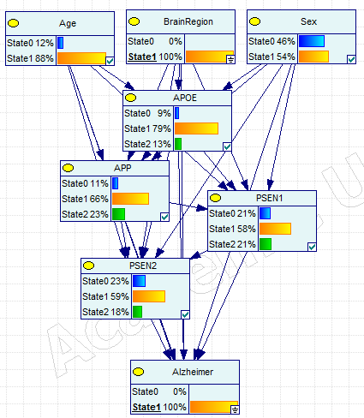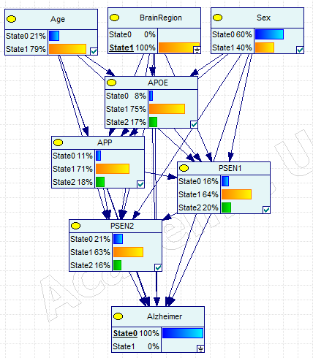
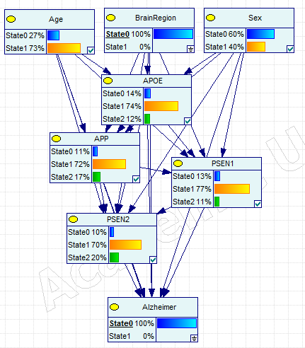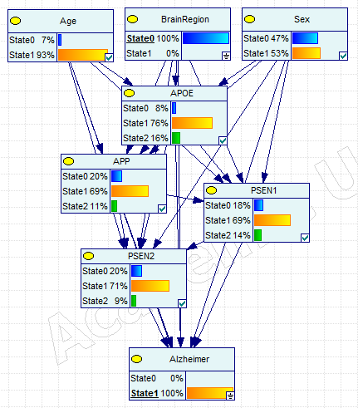
- Hippocampus
  - APOE: More AD cases had normal expression, higher expression
  - APP: AD cases had greater over expression
  - PSEN1: AD had a lower expression
  - PSEN2: AD had lower expression
  - Sex: more females than males had AD
  - Age: greater proportion of those age>65 in AD
- Non hippocampus: mostly the same patterns as Hippocampus
  - APOE: AD had lower expression
  - APP: AD had higher expression
  - PSEN1: AD had lower expression
  - PSEN2: AD had higher expression
  - Sex: AD had less females
  - Age: AD has less Age>65
- AD Hippocampus vs Non Hippocampus
  - APOE: Hippocampus has less dysregulated expression, higher expression
  - APP: Hippocampus has greater dysregulated expression, higher expression
  - PSEN1: Hippocampus has greater dysregulated expression
  - PSEN2: Hippocampus has greater dysregulated expression, lower expression
  - Sex: Hippocampus has more females
  - Age: Hippocampus has more age>65
- Non AD Hippocampus vs Non Hippocampus
  - APOE: Hippocampus has greater dysregulated expression, higher expression
  - APP: Hippocampus has less dysregulated expression, higher expression
  - PSEN1: Hippocampus has greater dysregulated expression, higher expression
  - PSEN2: Hippocampus has greater dysregulated expression, higher expression
  - Sex: Hippocampus has less females, more males in total non AD
  - Age: Hippocampus less more age>65
Age & AD
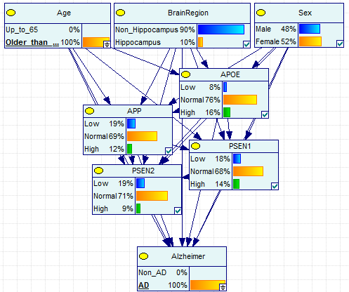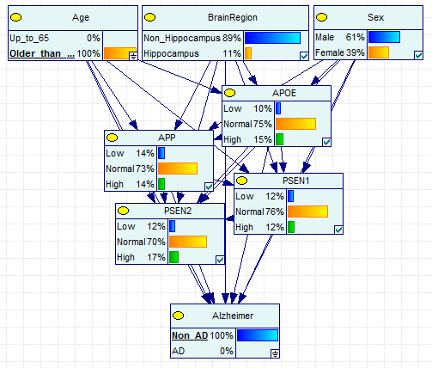
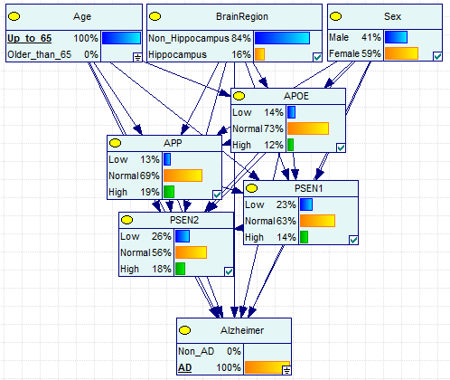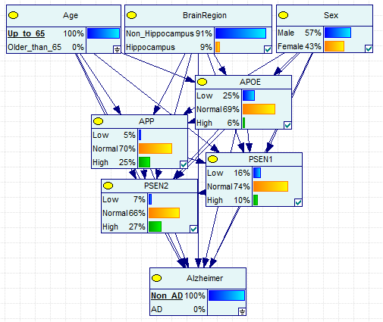
- Age>65
  - APOE: AD had higher expression
  - APP: AD cases had less expression
  - PSEN1: AD had more dysregulation, lower expression
  - PSEN2: AD has less dysregulation but lower expression
  - Sex: AD had more females
  - Brain Region: Less hippocampal samples in AD cases
- Age≤65
  - APOE: AD had less dysregulation, higher expression
  - APP: AD cases had more dysregulation, less expression
  - PSEN1: AD had more dysregulation
  - PSEN2: AD had less expression
  - Sex: AD had more females
  - Brain Region: AD had more hippocampus
- AD Age >65 vs Age≤65
  - APOE: Age>65 had less dysregulation, higher expression
  - APP: Age>65 had less expression
  - PSEN1: Age>65 had less dysregulation
  - PSEN2: Age>65 had less dysregulation
  - Sex: Age>65 had less females
  - Brain Region: Age>65 had less hippocampus samples
- Non AD Age >65 vs Age≤65
  - APOE: Age>65 had higher expression
  - APP: Age>65 had less expression
  - PSEN1: Age>65 had less dysregulation, higher expression
  - PSEN2: Age>65 had less expression
  - Sex: Age>65 had less females; more male samples in total
  - Brain Region: Age>65 had more hippocampus samples
Sex & AD
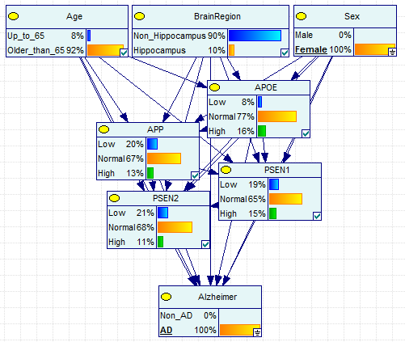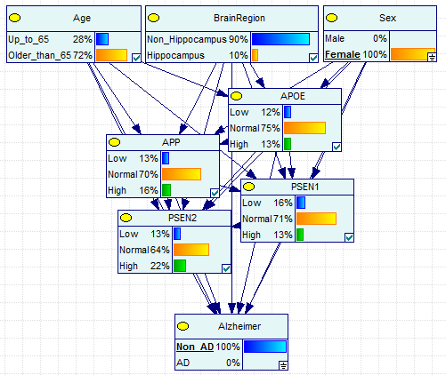
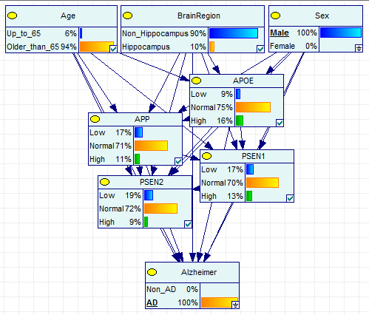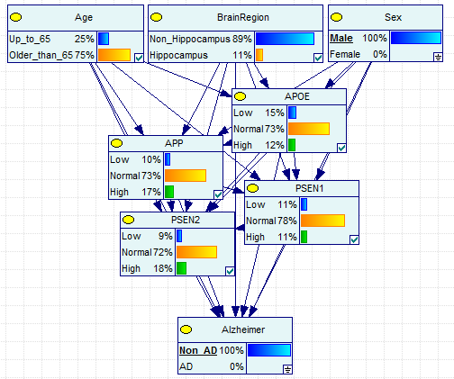
- Females
  - APOE: AD has higher expression
  - APP: AD has lower expression
  - PSEN1: AD has lower expression
  - PSEN2: AD has lower expression
  - Age: AD has much more age>65
  - Brain Region: same breakdown
- Males
  - APOE: AD has higher expression
  - APP: AD has lower expression
  - PSEN1: AD has lower expression
  - PSEN2: AD has lower expression
  - Age: AD has much more age>65
  - Brain Region: AD has less hippocampi samples
- AD Females vs Males
  - APOE: Females had less expression
  - APP: Females had lower expression
  - PSEN1: Females had more dysregulation
  - PSEN2: Females had more dysregulation, lower expression
  - Age: Females had less age>65
  - Brain Region: Females had less hippocampi samples
- Non AD Females vs Males
  - APOE: Females had less dysregulation, higher expression
  - APP: Females had lower expression
  - PSEN1: Females had more dysregulated expression, lower expression
  - PSEN2: Females had more dysregulated expression, higher expression
  - Age: Females had less age>65
  - Brain Region: Females had less hippocampi samples
Age & Brain Region
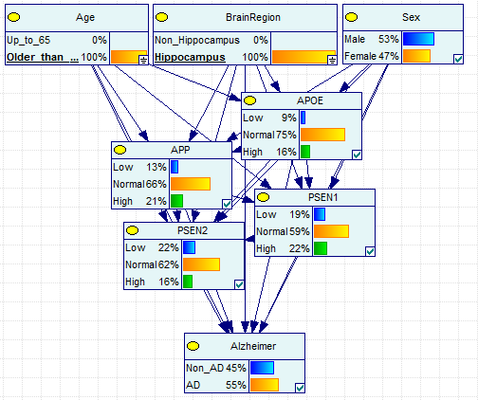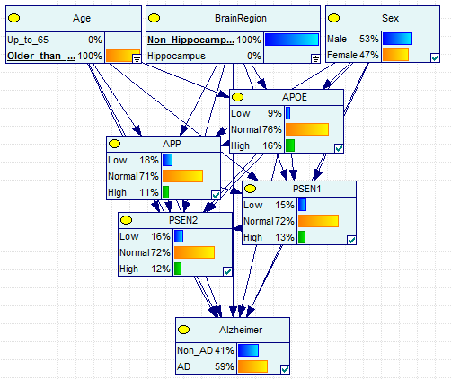
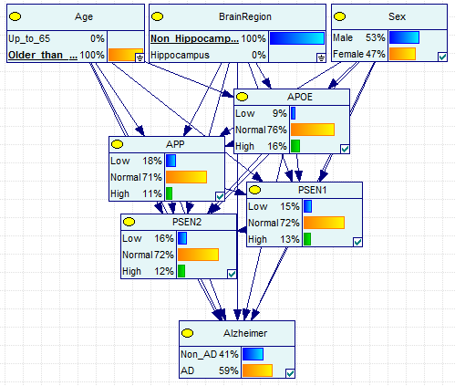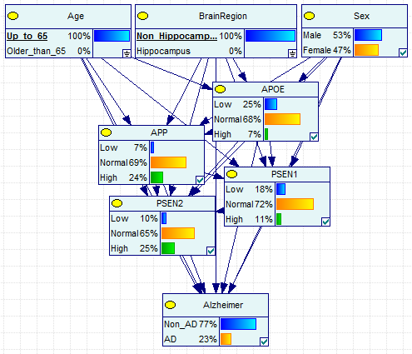
- Age >65
  - APOE: Hippocampus has about the same expression
  - APP: Hippocampus has greater dysregulation, higher expression
  - PSEN1: Hippocampus has greater dysregulation, higher expression
  - PSEN2: Hippocampus has greater dysregulation, lower expression
  - Sex: Hippocampus has same Females
  - AD: Hippocampus has less AD cases
- Age≤65
  - APOE: Hippocampus has higher expression
  - APP: Hippocampus has greater dysregulation, lower expression
  - PSEN1: Hippocampus has greater dysregulation, higher expression
  - PSEN2: Hippocampus has greater dysregulation, lower expression
  - Sex: Hippocampus has same Females
  - AD: Hippocampus has much more AD cases
- Hippocampus Age>65 vs Age≤65
  - APOE: Age>65 has same expression
  - APP: Age>65 has less expression
  - PSEN1: Age>65 has greater expression
  - PSEN2: Age>65 has less dysregulation, higher expression
  - Sex: Age>65 had same females
  - AD: Age≤65 had more AD cases
- Non Hippocampus Age≤65 vs Age>65
  - APOE: Age>65 has less dysregulation, higher expression
  - APP: Age>65 has less dysregulation, lower expression
  - PSEN1: Age>65 has less dysregulation, higher expression
  - PSEN2: Age>65 has less dysregulation, lower expression
  - Sex: Age>65 had same females
  - AD: Age>65 had much more AD cases
Age & Sex
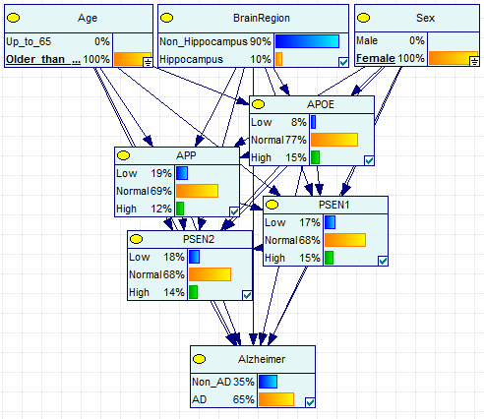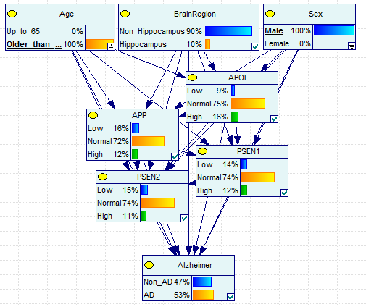
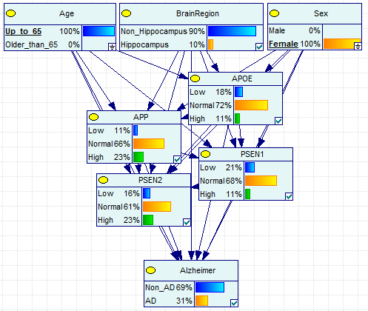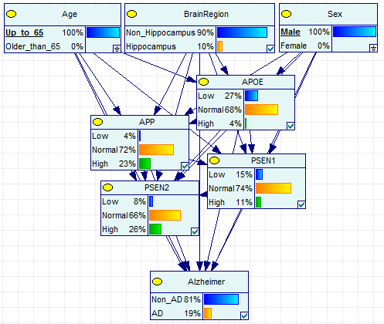
  - Age >65
    - APOE: Females have slightly higher expression
    - APP: Females have lower expression
    - PSEN1: Females have greater dysregulation
    - PSEN2: Females have greater dysregulation
    - Brain Region: Same
    - AD: Females have more AD cases
  - Age≤65
    - APOE: Females have higher expression
    - APP: Females have lower expression
    - PSEN1: Females have lower expression
    - PSEN2: Females have greater dysregulation, lower expression
    - Brain Region: Same
    - AD: Females have more AD cases
  - Females Age>65 vs Age≤65
    - APOE: Age>65 has less dysregulation, greater expression
    - APP: Age>65 has less dysregulation, lower expression
    - PSEN1: Age>65 has less dysregulation, higher expression
    - PSEN2: Age>65 has less dysregulation, lower expression
    - Brain Region: Same
    - AD: Age>65 has more AD cases
  - Males Age>65 vs Age≤65
    - APOE: Age>65 has less dysregulation, greater expression
    - APP: Age>65 has lower expression
    - PSEN1: Age>65 has less expression
    - PSEN2: Age>65 has less dysregulation, lower expression
    - Brain Region: Same
    - AD: Age>65 has much more AD cases
Brain Region & Sex
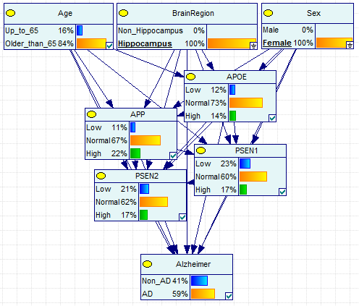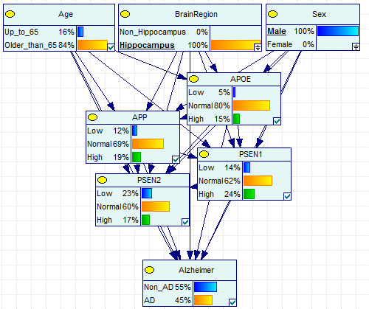
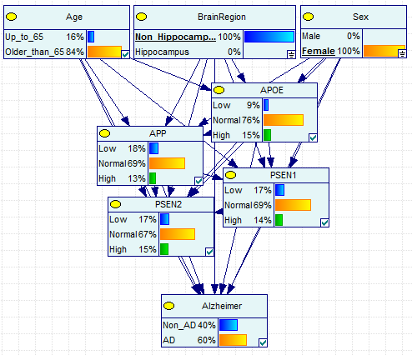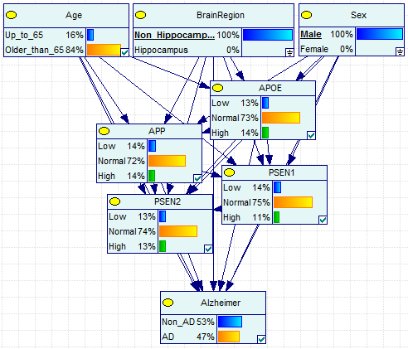
  - Hippocampus
    - APOE: Females have greater dysregulated expression, lower expression
    - APP: Females have greater dysregulated expression, higher expression
    - PSEN1: Females have greater dysregulated expression, lower expression
    - PSEN2: Females have less dysregulated expression, higher expression
    - Age: Same
    - AD: Females have greater AD cases
  - Non Hippocampus
    - APOE: Females have less dysregulated expression, higher expression
    - APP: Females have greater dysregulated expression, lower expression
    - PSEN1: Females have greater dysregulated expression, lower expression
    - PSEN2: Females have greater dysregulated expression, lower expression
    - Age: Same
    - AD: Females have greater AD cases
  - Female Hippocampus vs Non Hippocampus
    - APOE: Hippocampus has greater dysregulation, lower expression
    - APP: Hippocampus has greater dysregulation, higher expression
    - PSEN1: Hippocampus has less dysregulation, lower expression
    - PSEN2: Hippocampus has greater dysregulation, lower expression
    - Age: Same
    - AD: Hippocampus has less AD cases
  - Male Hippocampus vs Non Hippocampus
    - APOE: Hippocampus has greater dysregulation, higher expression
    - APP: Hippocampus has greater dysregulation, higher expression
    - PSEN1: Hippocampus has greater dysregulation, higher expression
    - PSEN2: Hippocampus has greater dysregulation, lower expression
    - Age: Hippocampus has more age>65
    - AD: Hippocampus has less AD cases
Sex & Brain Region & AD
  - Within Hippocampus
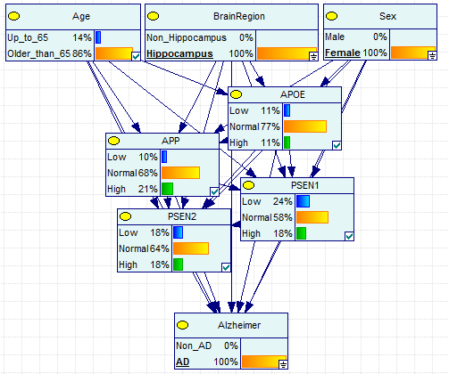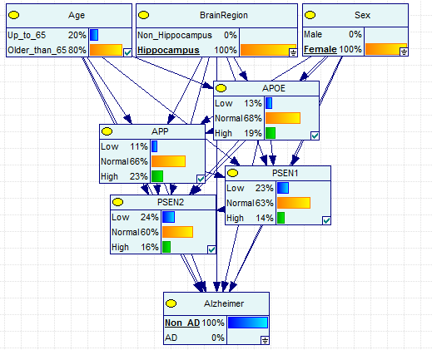
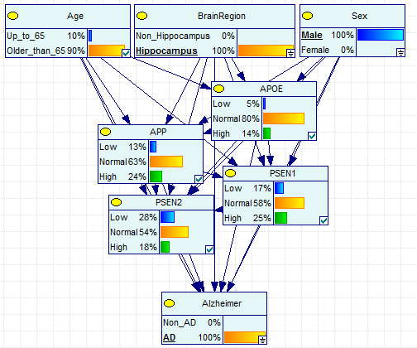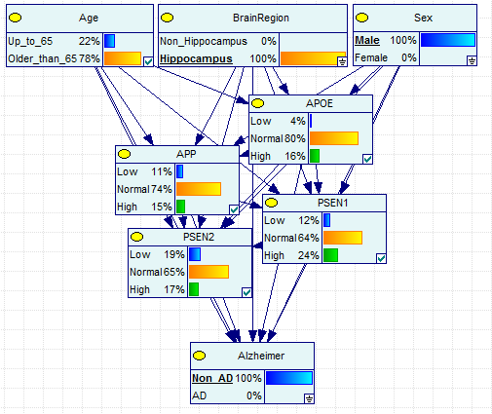
- Females:
  - APOE: AD has less dysregulated expression
  - APP: AD has less dysregulated expression
  - PSEN1: AD has more dysregulated expression
  - PSEN2: AD has higher expression
  - Age: AD has greater proportion of those age>65
- Males:
  - APOE: AD had lower expression
  - APP: AD had more dysregulated expression, higher expression
  - PSEN1: AD had more dysregulated expression, lower expression
  - PSEN2: AD had more dysregulated expression, lower expression
  - Age: AD has greater proportion of those age>65
- AD Males v Females:
  - APOE: Females had more dysregulated expression
  - APP: Females had less dysregulated expression
  - PSEN1: Females had less expression
  - PSEN2: Females had less dysregulated expression, higher expression
  - Age: Females had lower proportion of those age>65
- Non AD Males v Females:
  - APOE: Females had more dysregulated expression
  - APP: Females had more dysregulated expression, higher expression
  - PSEN1: Females have more under expression, lower expression
  - PSEN2: Females had more dysregulation, lower expression
  - Age: Females had more age >65
  - Non Hippocampus
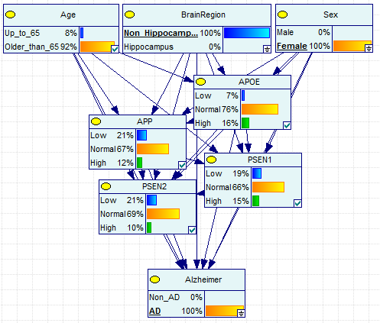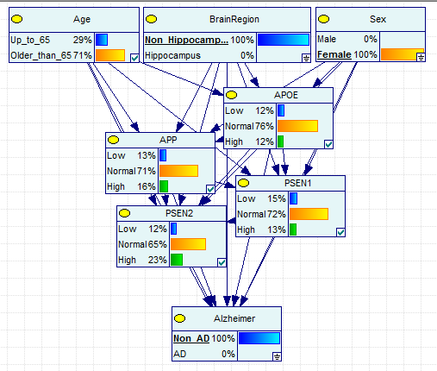
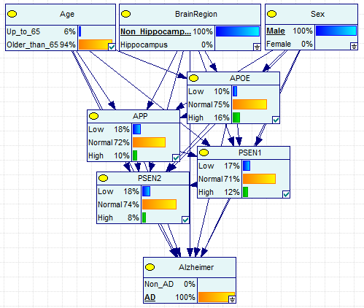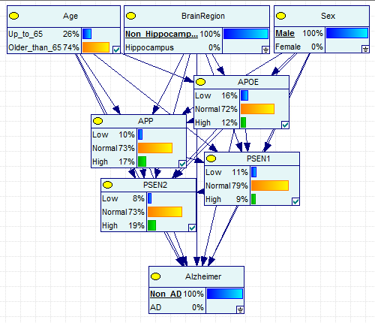
    - Females:
      - APOE: AD has higher expression
      - APP: AD has lower expression
      - PSEN1: AD has more dysregulated expression, lower expression
      - PSEN2: AD has lower expression
      - Age: AD has greater proportion of those age>65
      - Males:
      - APOE: AD had higher expression
      - APP: AD had lower expression
      - PSEN1: AD had more dysregulated expression, lower expression
      - PSEN2: AD had lower expression
      - Age: AD has greater proportion of those age>65
      - AD Males v Females:
      - APOE: Females had less under expression
      - APP: Females had more dysregulated expression
      - PSEN1: Females had more dysregulated expression
      - PSEN2: Females had more dysregulation
      - Age: Females had lower proportion of those age>65
      - Non AD Males v Females:
      - APOE: Females had higher expression
      - APP: Females had more under expression
      - PSEN1: Females have more dysregulated expression
      - PSEN2: Females had more dysregulation
      - Age: Females had less age >65

Sex & Age & AD
- Age >65
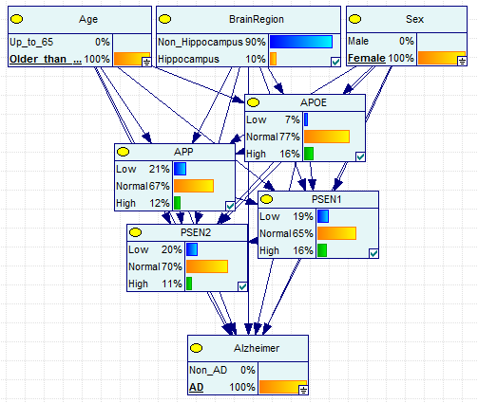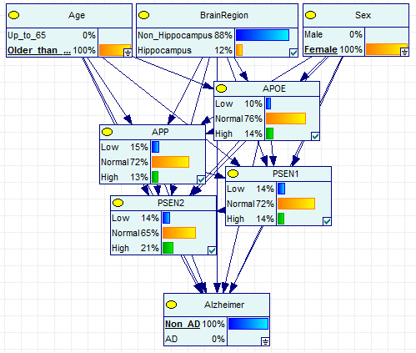
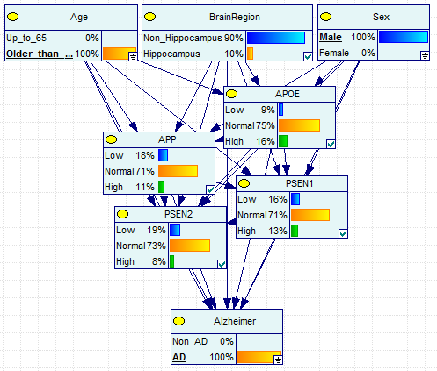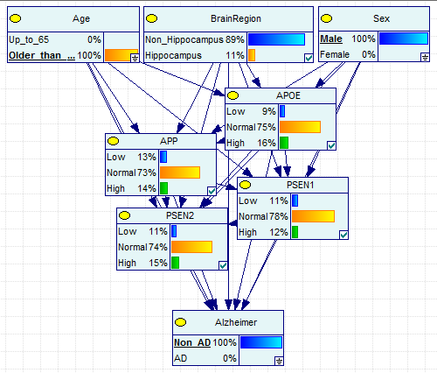
  - Females
    - APOE: AD has higher expression
    - APP: AD has lower expression
    - PSEN1: AD has greater dysregulation, lower expression
    - PSEN2: AD has greater dysregulation
    - Brain Region: Same
  - Males
    - APOE: same
    - APP: AD has lower expression
    - PSEN1: AD has greater dysregulated expression, lower expression
    - PSEN2: AD has lower expression
    - Brain Region: AD has less hippocampal samples
  - AD Males v Females
    - APOE: females have higher expression
    - APP: Females have lower expression
    - PSEN1: Females have greater dysregulated expression
    - PSEN2: Females have greater dysregulated expression, lower expression
    - Brain Region: Females have more hippocampal samples
  - Non AD Males v Females
    - APOE: females have higher expression
    - APP: Females have lower expression
    - PSEN1: Females have greater dysregulated expression, lower expression
    - PSEN2: Females have greater dysregulated expression, lower expression
    - Brain Region: Females have less hippocampal samples
- Age ≤65
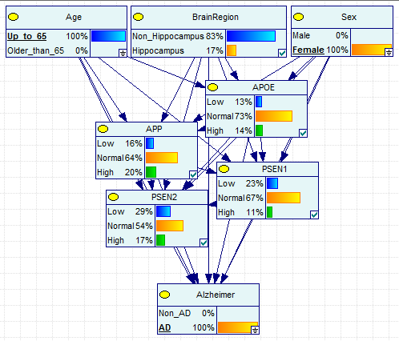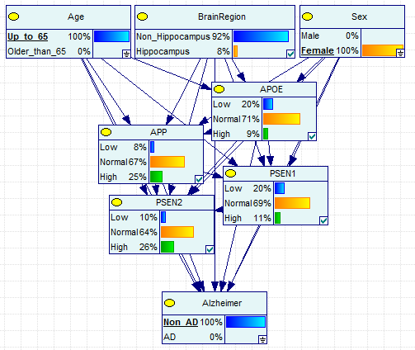
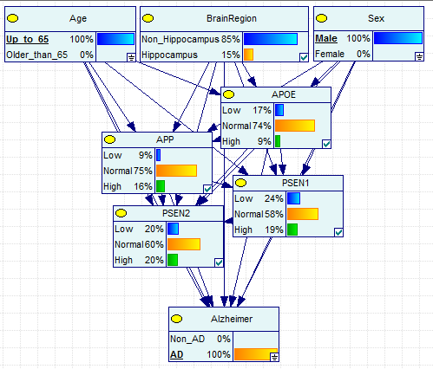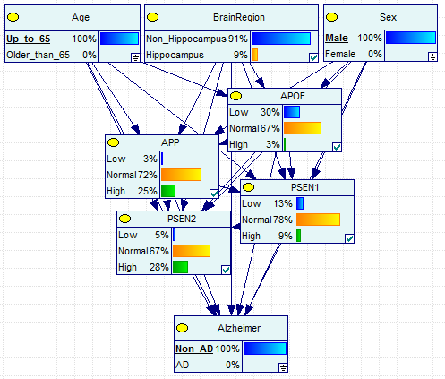
  - Females
    - APOE: AD has higher expression
    - APP: AD has lower expression
    - PSEN1: AD has lower expression
    - PSEN2: AD has lower expression
    - Brain Region: AD has more hippocampal samples
  - Males
    - APOE: AD has higher expression
    - APP: AD has lower expression
    - PSEN1: AD has greater dysregulated expression
    - PSEN2: AD has lower expression
    - Brain Region: AD has less hippocampal samples
  - AD Males v Females
    - APOE: females have higher expression
    - APP: Females have lower expression
    - PSEN1: Females have greater dysregulated expression
    - PSEN2: Females have greater dysregulated expression, lower expression
    - Brain Region: Females have more hippocampal samples
  - Non AD Males v Females
    - APOE: females have lower expression
    - APP: Females have higher expression
    - PSEN1: Females have greater dysregulated expression
    - PSEN2: Females have greater dysregulated expression, higher expression
    - Brain Region: Females have less hippocampal samples
Brain Region & Age & AD
- Age >65
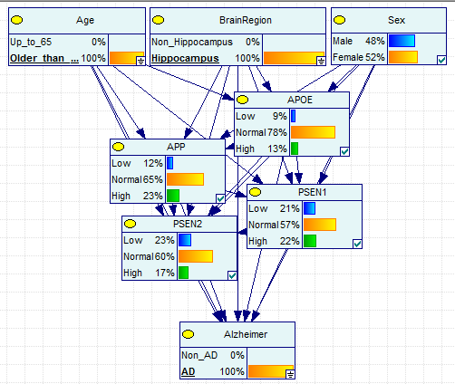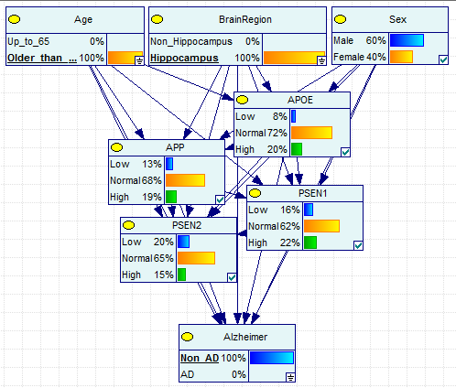
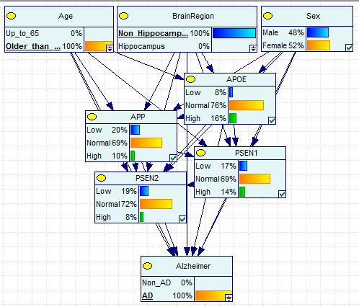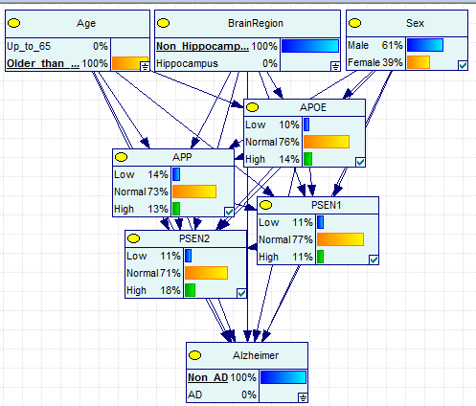
  - Hippocampus
    - APOE: AD has decreased expression
    - APP: AD has increased expression
    - PSEN1: AD has greater dysregulated expression, decreased expression
    - PSEN2: AD has dysregulated expression
    - Sex: AD had more females
  - Non Hippocampus
    - APOE: AD has greater expression
    - APP: AD has decreased expression
    - PSEN1: AD has greater dysregulated expression, increased expression
    - PSEN2: AD has lower expression
    - Sex: AD had more females
  - AD Hippocampus vs Non Hippocampus
    - APOE: Hippocampus has lower expression
    - APP: Hippocampus has higher expression
    - PSEN1: Hippocampus has greater dysregulated expression, higher expression
    - PSEN2: Hippocampus has greater dysregulated expression
    - Sex: same
  - Non AD Hippocampus vs Non Hippocampus
    - APOE: Hippocampus has greater dysregulated expression, higher expression
    - APP: Hippocampus has greater dysregulated expression, higher expression
    - PSEN1: Hippocampus has greater dysregulated expression, higher expression
    - PSEN2: Hippocampus has lower expression
    - Sex: Hippocampus has less females
- Age ≤65
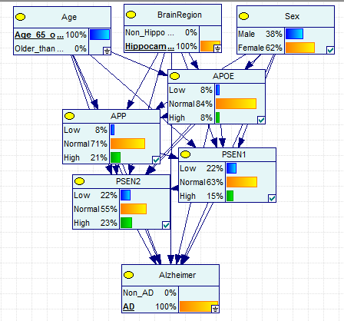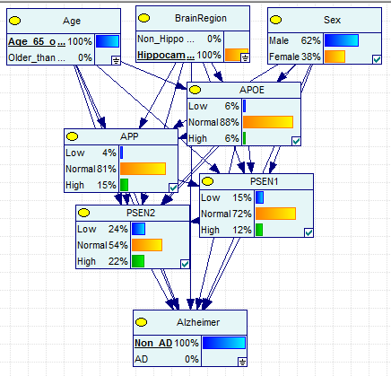
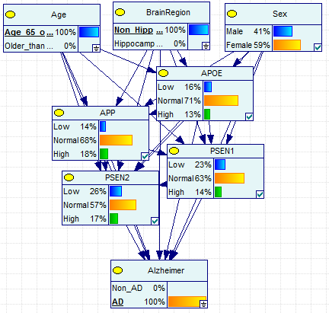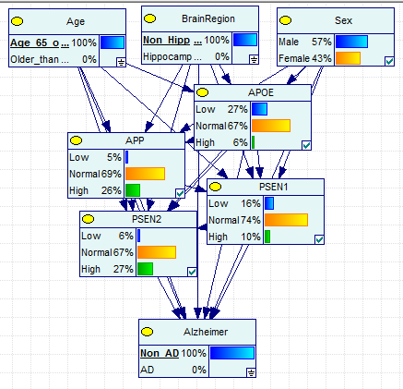
  - Hippocampus
    - APOE: AD has greater dysregulated expression
    - APP: AD has greater dysregulated expression, higher expression
    - PSEN1: AD has greater dysregulated expression, lower expression
    - PSEN2: less dysregulated, AD has greater expression
    - Sex: AD had more females
  - Non Hippocampus
    - APOE: AD has less dysregulation, greater expression
    - APP: AD has decreased expression
    - PSEN1: AD has greater dysregulated expression, lower expression
    - PSEN2: AD has lower expression
    - Sex: AD had more females
  - AD Hippocampus vs Non Hippocampus
    - APOE: Hippocampus has less dysregulated expression
    - APP: Hippocampus has less dysregulated expression, higher expression
    - PSEN1: Hippocampus has greater expression
    - PSEN2: Hippocampus has greater dysregulated expression, lower expression
    - Sex: Hippocampus has more females
  - Non AD Hippocampus vs Non Hippocampus
    - APOE: Hippocampus has less dysregulated expression, higher expression
    - APP: Hippocampus has less dysregulation, lower expression
    - PSEN1: Hippocampus has greater dysregulated expression, higher expression
    - PSEN2: Hippocampus has greater dysregulated expression, lower expression
    - Sex: Hippocampus has more females, more males total
Sex & Brain Region & Age
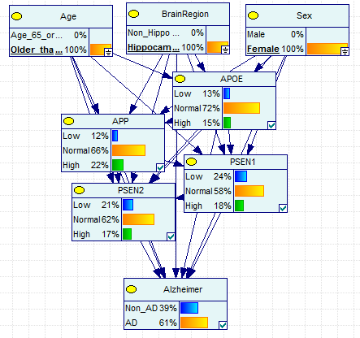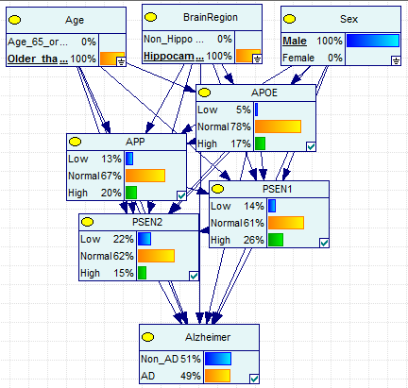
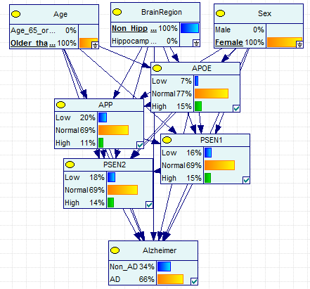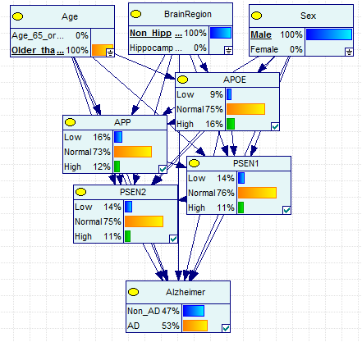
  - Age>65
    - Hippocampus
      - APOE: females have greater dysregulation, lower expression
      - APP: females have greater dysregulation, higher expression
      - PSEN1: females have greater dysregulation, lower expression
      - PSEN2: females have greater expression
      - AD: females have more AD cases
    - Non Hippocampus
      - APOE: females have less dysregulation, lower expression
      - APP: females have greater dysregulation, lower expression
      - PSEN1: females have greater dysregulation
      - PSEN2: females have greater expression
      - AD: females have more AD cases
    - Female Hippocampus vs Non Hippocampus
      - APOE: Hippocampus has greater dysregulation, lower expression
      - APP: Hippocampus has greater dysregulation, higher expression
      - PSEN1: Hippocampus has greater dysregulation, lower expression
      - PSEN2: Hippocampus has greater dysregulation
      - AD: Hippocampus has less AD cases
    - Male Hippocampus vs Non Hippocampus
      - APOE: Hippocampus has less dysregulation, higher expression
      - APP: Hippocampus has greater dysregulation, higher expression
      - PSEN1: Hippocampus has greater dysregulation, higher expression
      - PSEN2: Hippocampus has greater dysregulation, lower expression
      - AD: Hippocampus has less AD cases
Gene expression profiles:
APOE
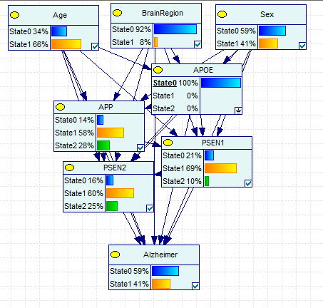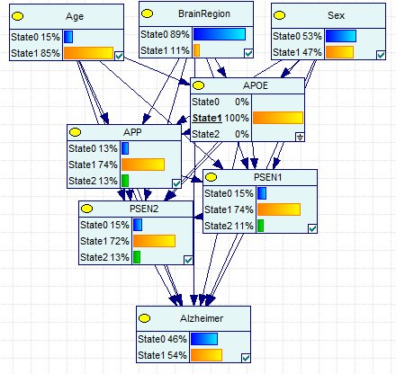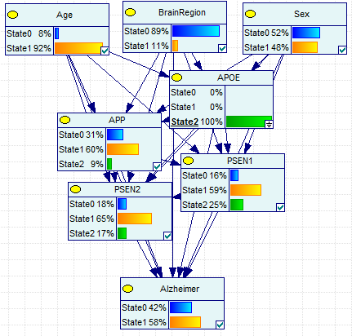
APP
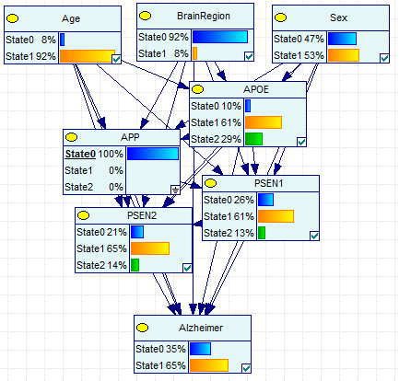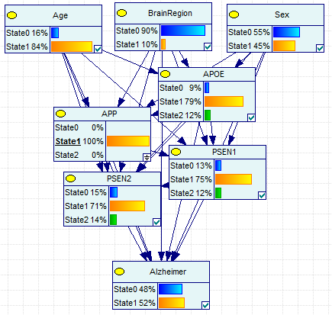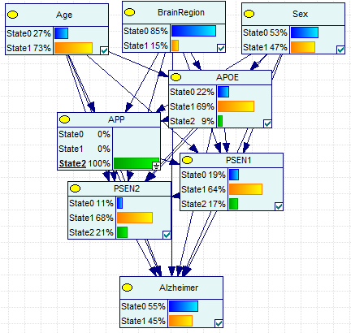
PSEN1
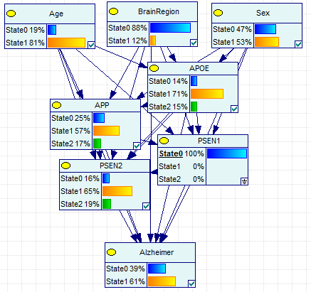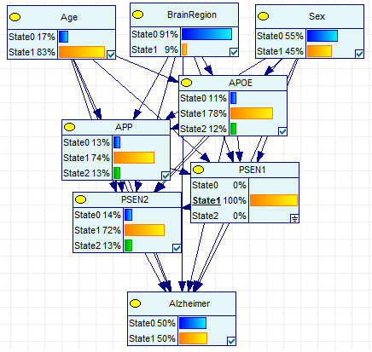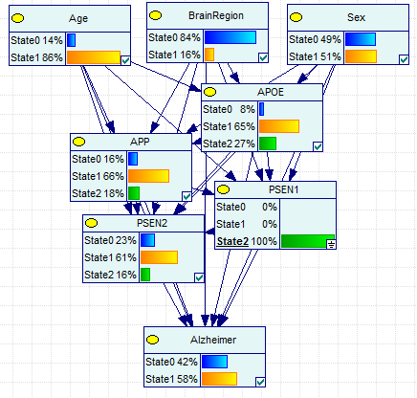
PSEN2


