- Descriptive Statistics of Female
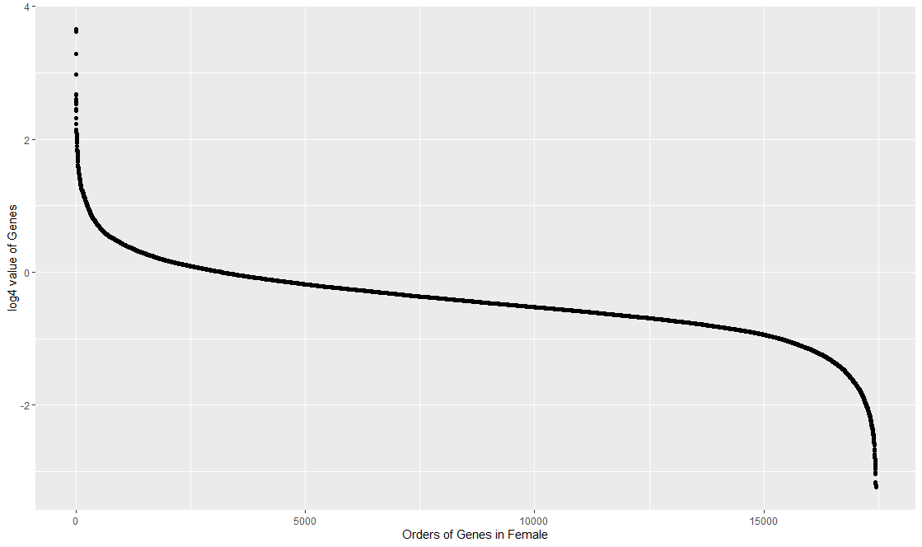
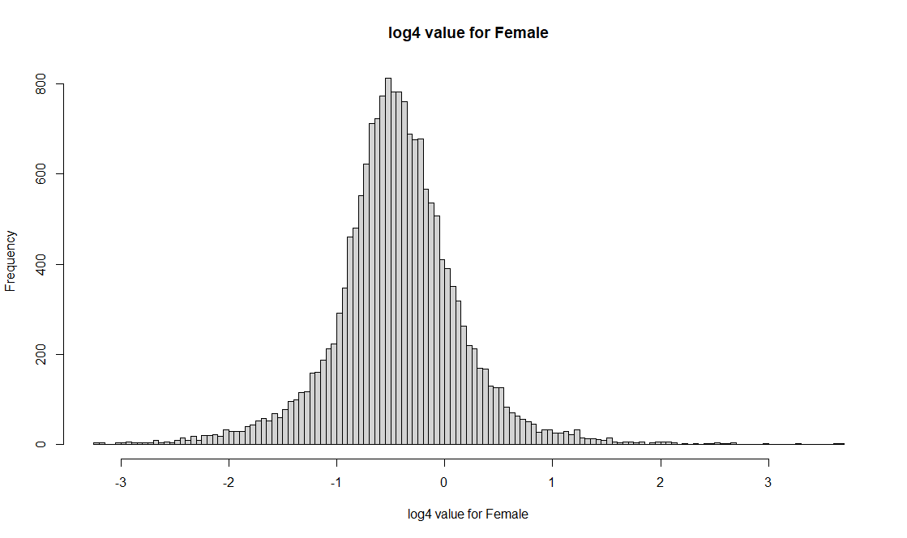
Top 50 genes with high value
[1] "MUC15" "SERPINH1" "NCAPH" "TOP2A" "DLGAP5" "CENPM" "HOXA1"
[8] "KIF20A" "COL3A1" "CRNDE" "WDR38" "CRIP1" "HLA-DRB4" "NDC80"
[15] "PBK" "RRM2" "TNC" "OTX2" "MELK" "FOXM1" "WEE1"
[22] "UHRF1" "NUSAP1" "IRX3" "DLK1" "HESX1" "COL6A3" "ST8SIA2"
[29] "SHOX2" "CCL13" "TFPI2" "RIBC2" "ASPM" "CEP55" "LHX8"
[36] "SOX11" "CC2D2B" "COL1A1" "CDK1" "PCOLCE" "C7orf57" "IGFBP2"
[43] "CPXM1" "BIRC5" "COL1A2" "SLC47A2" "SOX4" "CCND1" "LUM"
[50] "COL2A1"
Bottom 50 genes with low value (negative value)
[1] "GABRG2" "RP11-389G6.3" "ATP2B3" "STYK1" "SCN2B"
[6] "KRT222" "CTXN3" "CDH9" "SCN3B" "MAP7D2"
[11] "SOWAHA" "KCNJ9" "SV2B" "NAPB" "KIAA1045"
[16] "RP11-215H22.1" "CCK" "TMEM155" "KIF5A" "PACSIN1"
[21] "SAMD12" "ANKRD34C" "TESPA1" "CYP46A1" "SYN2"
[26] "GDA" "SULT4A1" "PTPN5" "RGS4" "FAM19A1"
[31] "ANO3" "SLC26A4-AS1" "GABRB2" "IPCEF1" "DNM1"
[36] "SLC12A5" "NRGN" "GPR26" "AK5" "SLC17A7"
[41] "CAMK2A" "PHYHIP" "GABRA1" "CABP1" "CHRM1"
[46] "VSNL1" "LINC00507" "GJB6" "CREG2" "DDN"

- Descriptive Statistics of Male

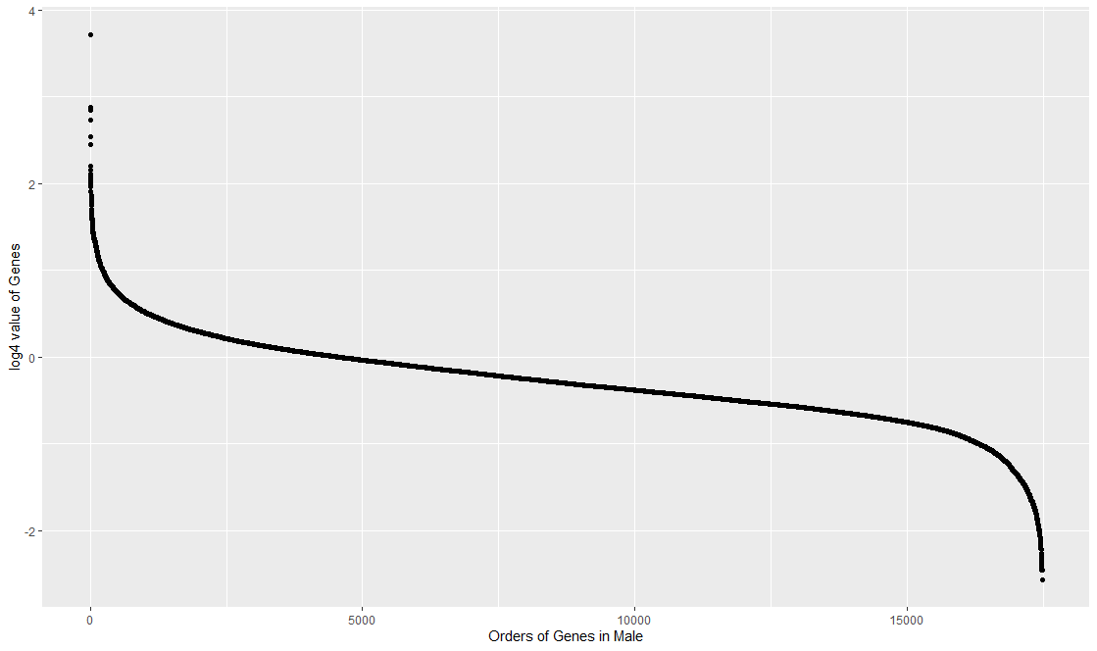
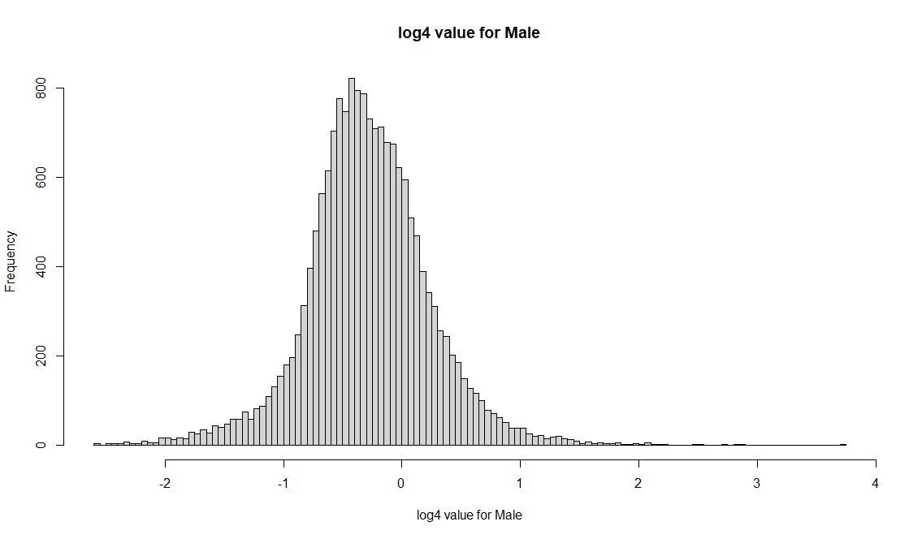

Top 50 genes with high value

[1] "LOC286178" "MFAP4" "LTF" "TOP2A" "COL3A1" "SERPINH1"
[7] "PCOLCE" "NDC80" "RRM2" "WEE1" "IGFBP2" "CRNDE"
[13] "SOX4" "PBK" "COL1A2" "NUSAP1" "OTX2" "RGS1"
[19] "MELK" "DLGAP5" "TNC" "SOX11" "LUM" "UHRF1"
[25] "MGP" "KIF20A" "CRIP1" "FOS" "NUF2" "COL1A1"
[31] "CDC45" "LYZ" "CCL20" "ID3" "CDK1" "PLEKHA4"
[37] "FGFBP2" "TTR" "CD163" "ANXA1" "LMNB1" "CEP55"
[43] "CENPM" "FOXD1" "HJURP" "TIMP1" "COL6A3" "CPXM1"
[49] "EZH2" "ANXA2"

Bottom 50 genes with low value (negative value)
[1] "CACNA1E" "CPNE6" "DDN" "MEG3" "DCTN1-AS1"
[6] "WBSCR17" "PACSIN1" "RBFOX1" "MFSD4" "NAPB"
[11] "MICAL2" "LOC285147" "CAMK2A" "CYP46A1" "VAMP1"
[16] "ITPKA" "UNC5A" "RGS7BP" "CORO6" "CTXN3"
[21] "GPR26" "ANKRD34C" "GDA" "NEFM" "KCNJ9"
[26] "SAMD12" "VSNL1" "ATP2B3" "NEFH" "LINC00507"
[31] "SV2B" "PHYHIP" "AK5" "SLC12A5" "PTPN5"
[36] "CABP1" "RP11-215H22.1" "RYR2" "MAP7D2" "KCNJ4"
[41] "DLGAP2" "DNM1" "FAM19A1" "BC040734" "GABRB2"
[46] "CHRM1" "CREG2" "COL24A1" "IPCEF1" "ANO3"

